**Title**

Stefan Kettemann1, Hideaki Obuse2, and Keith Slevin3

*1Department of Physics and Earth Sciences, Jacobs University, Germany*

*2Department of Applied Physics, Hokkaido University, Japan*

*3Graduate School of Science, Osaka University, Japan*

Email: localisation@eng.hokudai.ac.jp

This is the Microsoft Word template file for an abstract for Localisation 2022.

The preferred format is:

* Total length: 1 page
* Title: Times New Roman Bold, 18pt

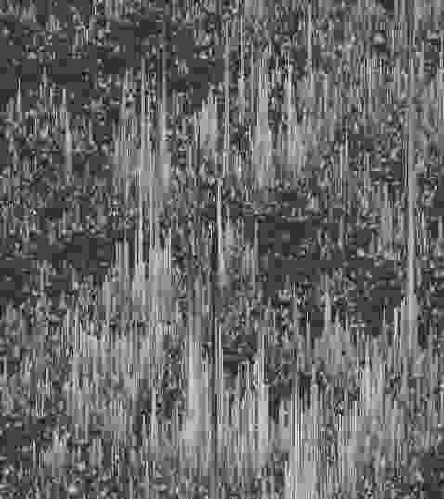

Fig.1: The figure caption.

* Authors: Times New Roman, 14pt
* Affiliations: Times New Roman Italic, 12pt
* Email: Times New Roman, 11pt
* Main text and references: Times New Roman, 12pt
* Figure caption: Times New Roman, 11pt

Please convert this file to PDF before submission. The file name should be {First name}-{Family name} of the author who gives the presentation followed by either “_Talk.pdf” or “_Poster.pdf”, depending on the type of presentation, e.g. Tomi-Ohtsuki_Talk.pdf or Dragana-Popovic_Poster.pdf. The email address given after the list of affiliations should be that of the presenter.

*For those who have a Google account,*

* please submit your abstract through the form [here](https://forms.gle/yLPmXWLpJbE7vG8eA).

*For those who do not have any Google account,*

* please fill in the form [here](https://forms.gle/MDQWBbnWaFY9gxLL7).
* please send the PDF of your abstract to [localisation@eng.hokudai.ac.jp](mailto:localisation@eng.hokudai.ac.jp) by the deadline. The subject of the email should be "Abstract".

*For those who cannot access to Google services,*

* please download the form through the mirror site (<https://subutu-ap.eng.hokudai.ac.jp/localisation2022>) and fill it in.
* please send the filled form and the PDF of your abstract to [localisation@eng.hokudai.ac.jp](mailto:localisation@eng.hokudai.ac.jp) by the deadline. The subject of the email should be "Abstract".

[1] P. Anderson, Phys. Rev. **109**, 1492 (1958).