Worksheet - Wireless Hotspot Problem
Solve It!

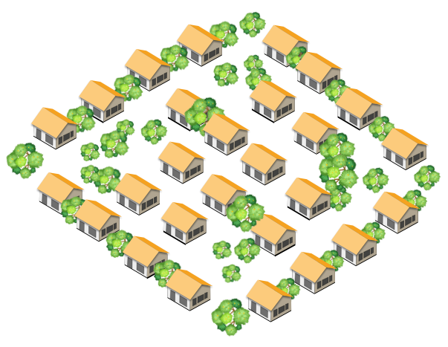
The Problem

A town has decided to provide free wireless access to its citizens. You have been hired to find the best places to install WiFi hotspots throughout the town so that everyone has coverage.

It costs $500,000 to install a hotspot, so the town would like to minimize the cost by installing the lowest number of hotspots necessary to give coverage to the entire town.

The town has a lot of buildings, trees and other obstacles that interfere with wireless communication, so placement might get tricky.
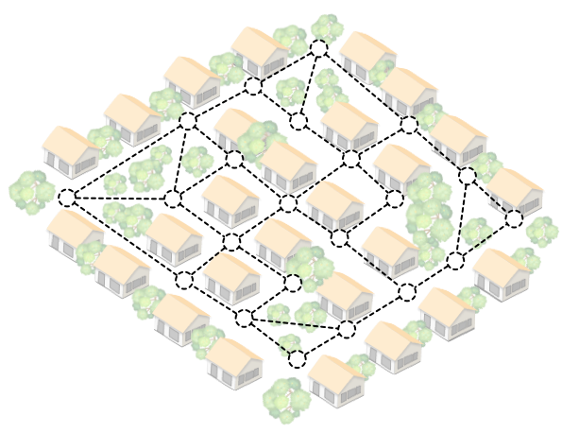

A Schematic Diagram of the Town

The town has provided you with the diagram shown to the right. Each circle indicates a location in town that must be reached by a WiFi signal. The dotted lines indicate clear paths where a WiFi signal can travel between circles; these are not blocked or interfered with by trees or buildings.

A hotspot can be placed on a circle and it provides coverage to that circle and any circle it’s connected to by a dotted line.

What to Do
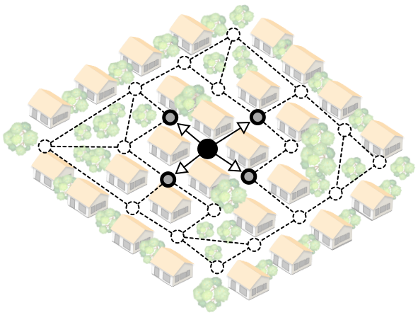
Shade in the circles of locations which should have hotspots installed. When you place a hotspot on a circle, it gives “coverage” to any circles it has a clear path to. The diagram to the right shows one circle filled-in with black to indicate a hotspot placement. It also shows the 4 other circles that get WiFi coverage when a hotspot is placed there.

The Goal

Because the town would like to minimize its costs, you must 1) find the minimum number of WiFi hotspots that you need to place, and 2) prove that it gives coverage to the whole town by marking on the diagram where you need to place them.

The following pages contain a few blank copies of the diagram you can use to work the problem.

