 | A Short Introduction to EIPM | 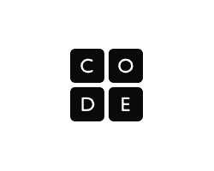

What is EIPM?
EIPM is a structured approach to teaching programming in Code.org's CSP Curriculum. It's designed to meet the needs of diverse learners, encourage collaboration, support independent creation, and clarify the role of the teacher throughout the learning process. Each letter represents a different type of lesson (E - Explore, I - Investigate, P - Practice, M - Make) which are taught in sequence for each major programming construct. A typical programming unit will feature 2 or 3 EIPM sequences, followed by a unit project and a multiple choice assessment. The visual below shows that structure for Unit 5 - Lists, Loops and Traversals, with each square being a separate lesson.

E
I
P
M
E
I
P
M
E
I
P
M
Lists
Loops
Traversals
Unit Project
✓
Assessment

Why did you develop EIPM?
The biggest motivator in developing EIPM was direct feedback from students and teachers. While they had many positive things to say about our programming units, we also heard some consistent concerns. Due to the way our programming units are designed, students were often working in isolation, teachers lacked clarity on their role, and classrooms would arrive at the end of the unit lacking the skills to take on major independent projects. We took this feedback, consulted research and experts in the field of computing education, and created a pathway for introducing programming concepts that is more collaborative, clarifies the teacher’s role, and more intentionally prepares students to create programming projects independently.

Explore
Investigate
Practice
Make

Leading

Supporting
Time a Teacher Spends Leading vs. Supporting
in a Typical EIPM Sequence

The Teacher’s Role in the Classroom
The EIPM structure provides more clarity on the way students are expected to learn in each lesson and your role in facilitating that learning. In the Explore and Investigate lessons you will spend relatively more time leading group activities and class-wide discussions. In the Practice and Make lessons you will spend more time circulating the room to provide support to individuals and small groups. This predictable transition clarifies your role in any individual lesson and encourages students to work with greater independence as they develop mastery over a new concept. The graphic to the right shows the gradual transition from leading students through activities to supporting students working more independently.

A Summary of Each Lesson Type

 | Overview | Goal
Explore  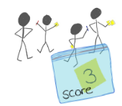 | Students explore the new concept through a teacher-led hands-on group activity.  - Typically uses physical manipulatives  - Teacher leads with support of slides and activity guides | Students begin to develop a shared mental model and understand the main ideas of the new concept.
Investigate  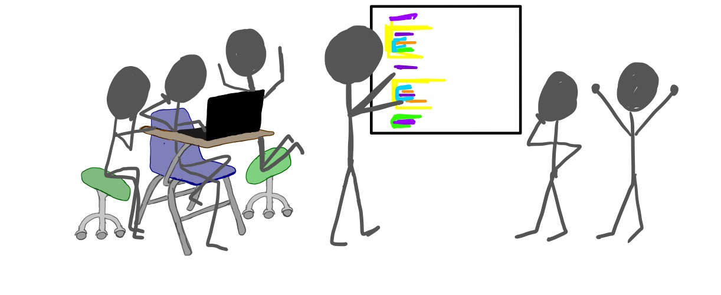 | Students investigate two or three sample programs that use the new concept.  - Close-reading of working programs  - Teacher-led discussions  - Tasks to modify apps | Students become comfortable reading and modifying programs that use the new concept.
Practice  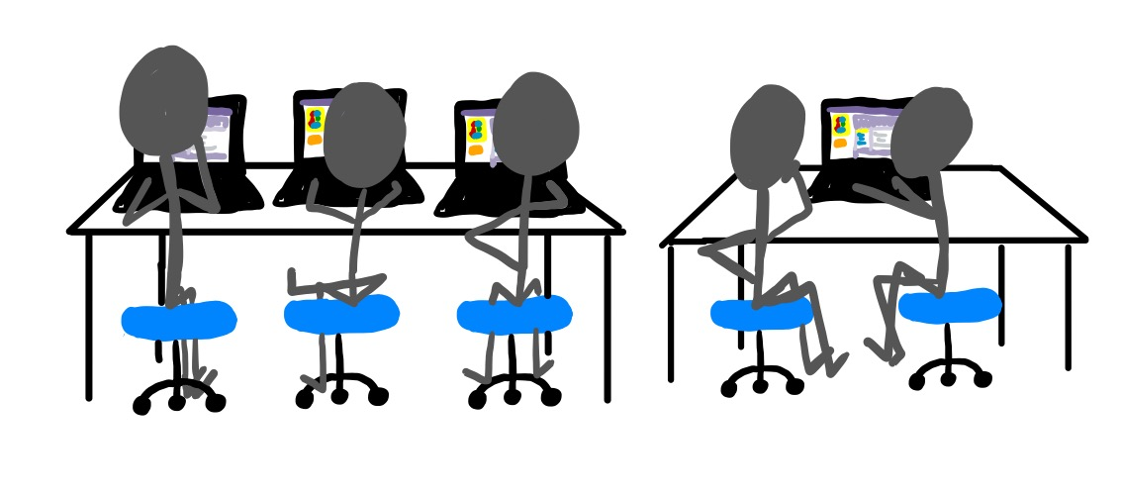 | Students practice using the new concept through a scaffolded series of programming activities.  - Students work independently or in pairs  - Teacher introduces debugging practices at the beginning of the Activity and circulates the room during the lesson to provide targeted support. | Students gain confidence in writing and debugging programs that use the new concept.
Make  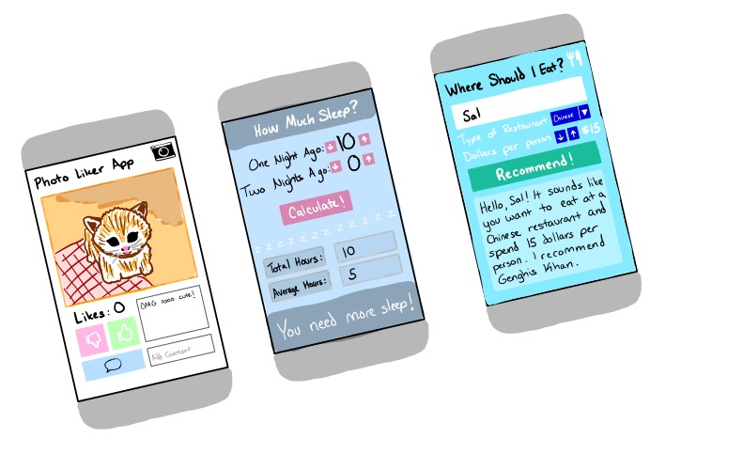 | Students make a target app for which they are given the screen elements but little to no starter code.  - Students are provided high-level steps to break down the project  - Teacher supports students by directing them towards notes, previous work, and debugging strategies practiced in earlier lessons. | Students are able to independently decide when and how to use the new concept in the context of a larger project.

