LECTURE 1
POSITIONS USED IN NURSING

INTRODUCTION
Good body posture or normal body alignment is very vital to the proper functioning of the body. Body alignment refers to the condition of the joints, tendons, ligaments and muscles in various body positions-whether standing, sitting or lying. When the body is in good alignment, undue strain is not exerted on the musculoskeletal system.
A healthy person assumes the position that is most comfortable without even thinking about the constant changes. However, in sickness, patients are not always able to independently move and position themselves hence need the assistance of the nurse.
Positioning a patient in bed is important for maintaining alignment and for preventing bed sores (pressure ulcers), foot drop, and contractures. Proper positioning is also vital for providing comfort for patients who are bedridden or have decreased mobility related to a medical condition or treatment. When positioning a patient in bed, supportive devices such as pillows, rolls, and blankets, along with repositioning, can aid in providing comfort and safety.
Positioning a patient in bed is a common procedure in the hospital. There are various positions possible for patients in bed, which may be determined by their condition, preference, or treatment related to an illness. It is the responsibility of the registered nurse to position the patient and change the position.
Definition of Positioning
Positioning in nursing is defined as a deliberate placement of the patient or a body part, to promote physiological and/ or psychological well-being. It is a deliberate and proper alignment of a patient’s body for the purpose of preventive, promotive, rehabilitative and curative aspects of health.
Reasons for Positioning Patients
- To maintain proper body alignment
- To provide comfort and safety for patient.
- To prevent contractures and pressure sores
- To promote patients health and wellbeing
The positions used in nursing in order to maintain proper alignment and provide comfort for patients include the following:
- Prone position
- Supine position
- Lateral position
- Fowlers position
- Semi-fowlers position
- High fowlers position
- Orthopnoeic position
- Trendelenburg position
- Lithotomy position
- Reverse Trendelenburg position
- Knee chest position
- Sim’s position
- Dorsal Recumbent position

- Prone position: This is one of the positions used in nursing. It is defined as the position in which the patient lies on his stomach with the head turned to one side. Pillows can be used to support the head and legs.

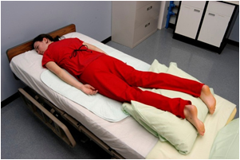

Indications for placing patient in prone position
- For drainage of the mouth after oral or neck surgery.
- It also allows for full flexion of knee and hip joints
- To relieve abdominal distension
- For patient with pressure sores, burns, injury and operations on the back

Contraindications of prone positions
- Open abdominal wounds
- Spine instability
- Pregnancy
- Unstabilized fractures

- Supine Position: This is a position where the patient is flat on his back. Supine is considered the most natural “at rest” position, it involves Lying on the back with arms at sides. Additional supportive devices example pillows may be used to place he feet and head.

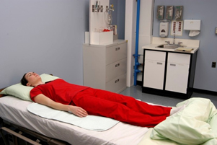

Indications for placing patients in supine position
- For physical examination,
- For Resting in bed
- Often used in surgery
- For abdominal and facial procedures
- To check vital signs
- To provide comfort to the patient

Contraindications
- Advanced pregnancy
- Spinal injury
- Vertebral and neck fractures

- Lateral Position: Lateral position involves positioning the patient either on the right side or left side of the body with the top leg over the bottom leg. Right lateral means the patient’s right side is touching the bed, while left lateral means the patient’s left side is touching the bed. A pillow is often placed in between the legs for patient comfort. Pillows maybe placed in between the two legs, also pillows are placed to support the head and also the hands.
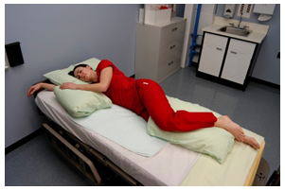

Indications
- For patient’s comfort
- To relieve pressure on the coccyx
- In pregnancy
- For procedures that involve the back
- For patients who require periodic position changes
- Used for examination of perineum
- For inserting suppositories
- For giving back care

- Fowler’s position: This is a sitting position in which the head is elevated at 45 to 60 degrees, and the clients knees are slightly elevated. A back rest and two pillows are used for the back and head. Pillows can also be used to maintain natural alignment of the hands, wrist and forearms.
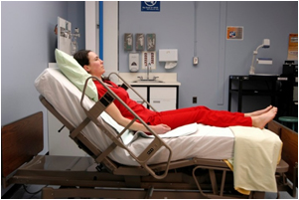

Indications
- For patients with cardiac problems
- To provide comfort and care to patients
- For dyspneic patients (patients with difficulty in breathing)

- Semi fowlers position: This is a position in which the head of the bed is elevated at a 30 degree angle. Pillows are used for the back and head and cam also be used to maintain natural alignment of hands, wrist and forearm

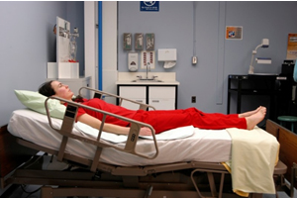
Indications
a. After abdominal surgeries to relieve tension on incision.
b. To relieve patients who have difficulty in breathing

- High fowlers position: This is a sitting position in which the head is elevated at an angle of 80 to 90 degrees, and the clients knees are slightly elevated. A back rest and two pillows are used for the back and head. Pillows can also be used to maintain natural alignment of the hands, wrist and forearms

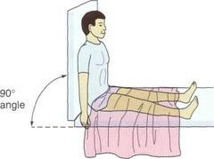
Indications
- To relieve dyspnea
- To improve circulation
- To relax the muscles of the abdomen, back and thighs
- To relieve tension on abdominal structure
- Orthopnoeic position: This is a high fowlers position with a bed table placed across the bed in front of the patient and several pillows placed on top of the bed table for the patient to lean on.

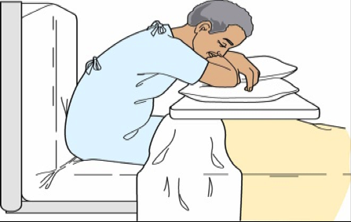

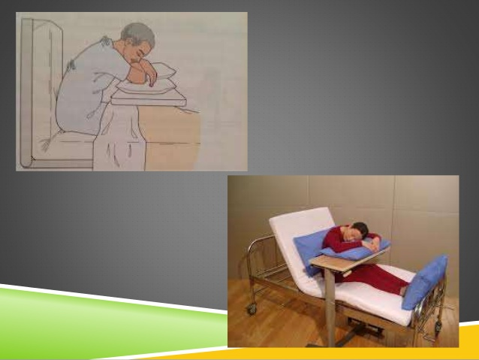

Indications
- For patients with severe dyspnea
- For patients with cardiac problems
- Patients with chest drainage tube

- Trendelenburg Position: In this position, the patient lies on the back with the head of the bed lower than the foot of the bed. The foot of the bed is elevated at a 45 degree angle and the entire frame of the bed is tilted with the head of the bed down.

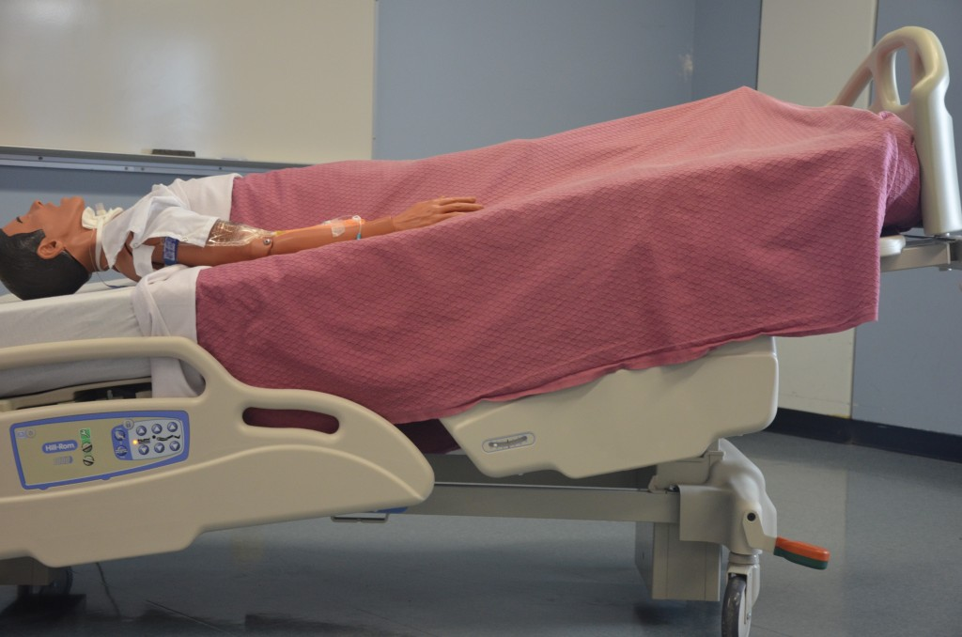

Indications
- For patients with hypotension (low blood pressure)
- For promotion of venous return to major organs such as the heart in emergency situations such as shock, haemorrhage etc
- For postural drainage
- Patients with deep vein thrombosis

- Lithotomy position: This is defined as a position in which the patient lies supine (with the back), with hips flexed. The legs are separated and thighs are flexed. The patient’s buttocks are kept at the edge of the table and legs are supported by stirrups.

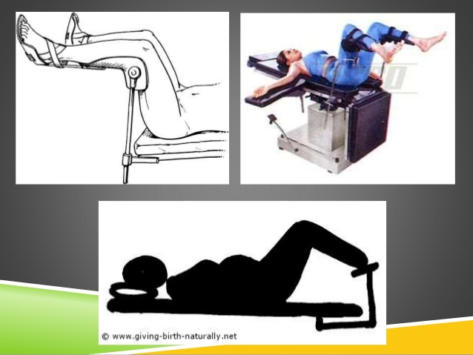

Indications
- For delivery of baby
- For vaginal examination and hysterectomy
- For rectal examination and surgeries

- Reverse Trendelenburg Position: This position is a reverse of the Trendelenburg position. In the Trendelenburg position, the body is laid supine, or flat on the back on a 15-30 degree incline with the feet elevated above the head. The reverse Trendelenburg position, similarly, places the body supine on an incline but with the head now being elevated.

Indications
- Used in abdominal surgeries
- Used in surgeries involving the genitourinary system as It allows better access to the pelvic organs as gravity pulls the intra-abdominal organs away from the pelvis
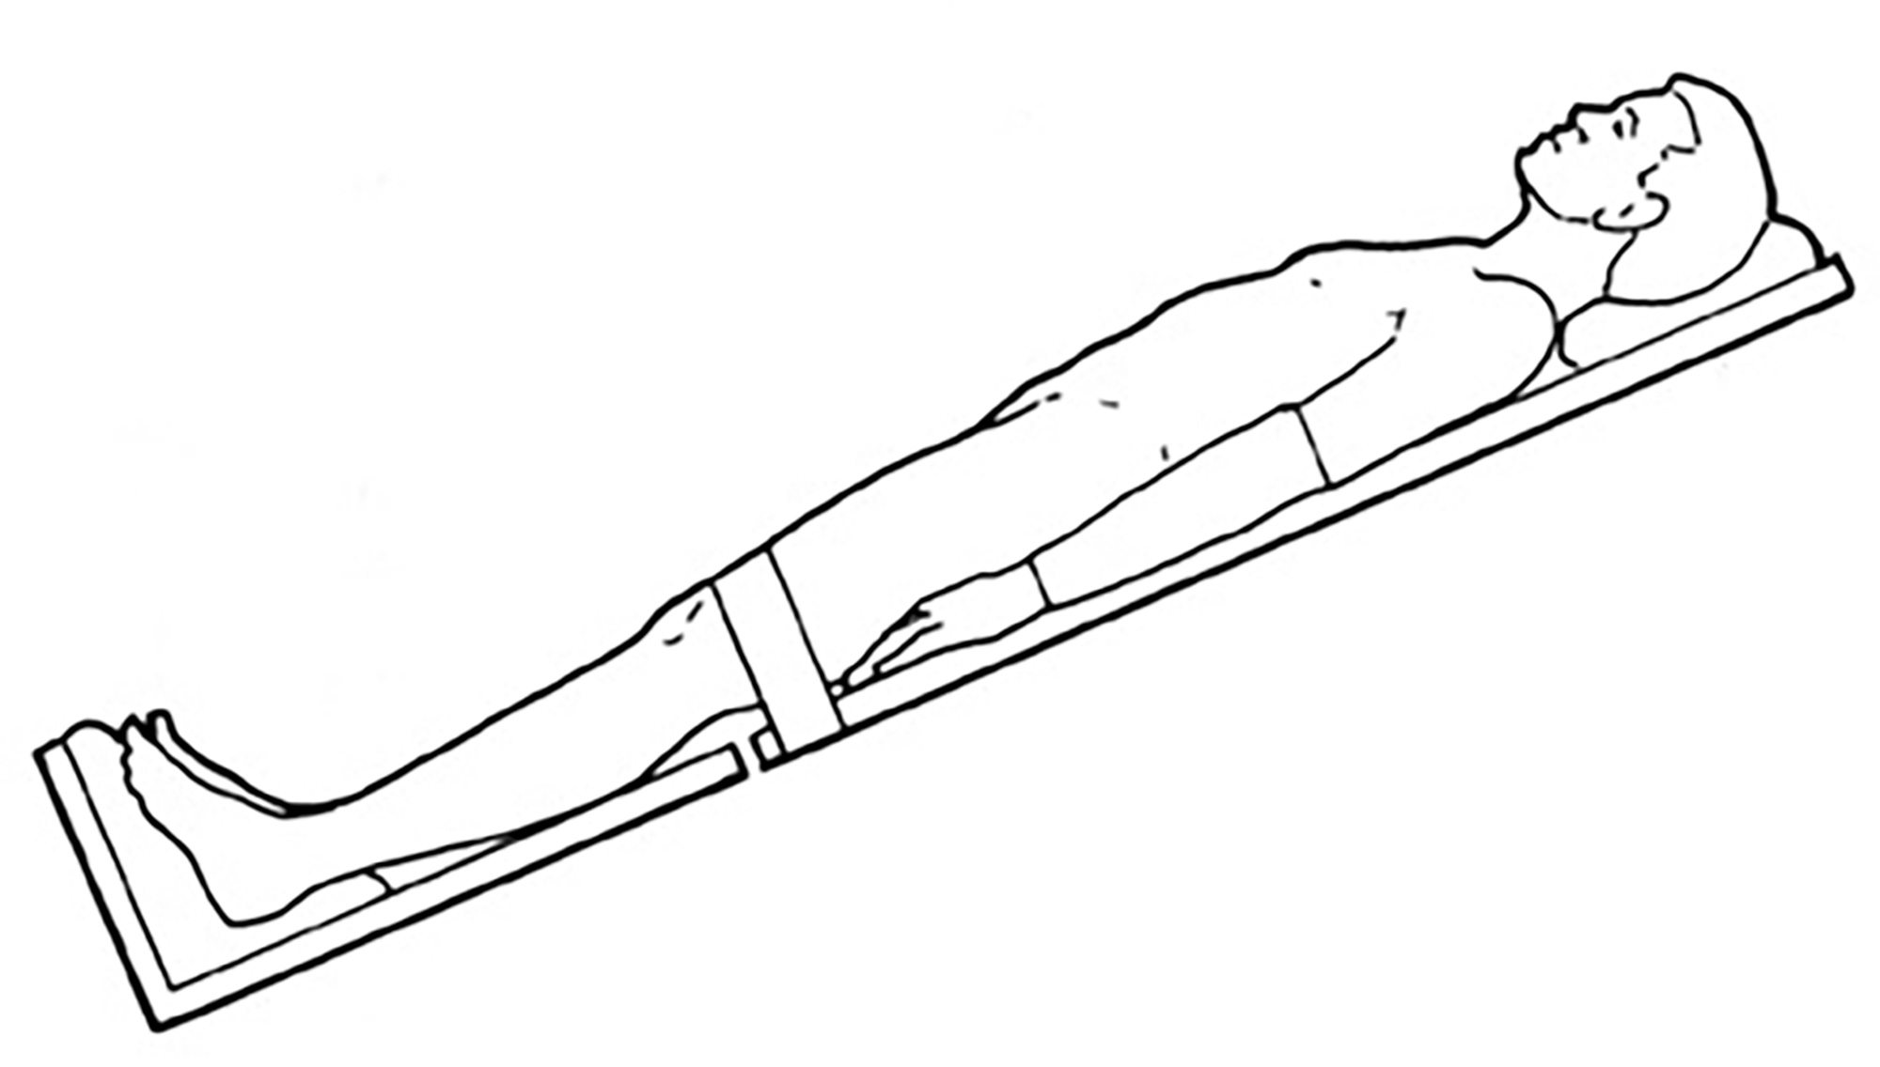
Reverse Trendelenburg position

- Knee- chest position: This is defined as the position in which the patient rests on the knee and the chest. The body is at a 90 degree angle to the hips with back straight, the arm above the head and the head turned to one side. The abdomen remains unsupported.
The knee-chest position is otherwise known as genupectoral position

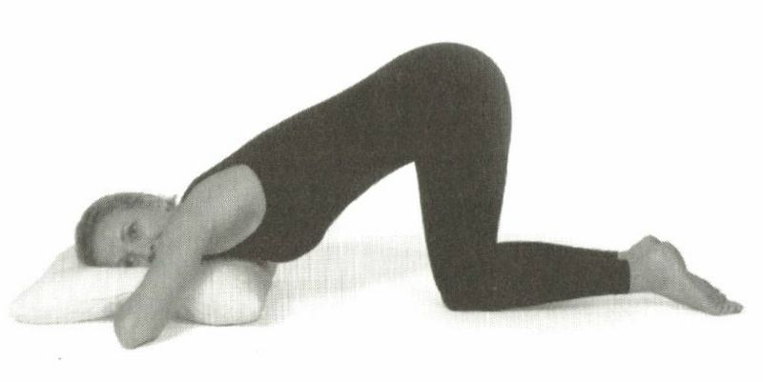
Indications
- Used during labour
- For vaginal and rectal examination
- Used in first aid treatment in cord prolapse or retroverted uterus
- As exercise for postpartum and gynecology patients

- Sim’s position: In this position, the client lies on either the right or left side. The lower arm behind the body and upper arm is bent at the shoulder and elbow. The knees are both bent with the upper most leg more acutely bent. This position is similar to the lateral position except that the patient’s weight is on the anterior aspect of the patients shoulder girdle and hip.

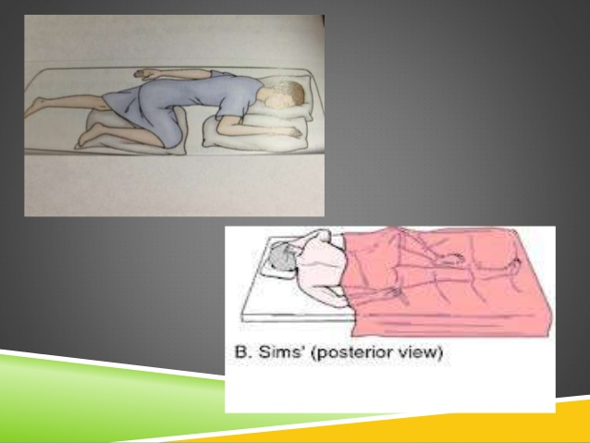

Indications
- For vaginal and rectal examination
- Administration of enema and suppository
- Used for relaxation in antenatal exercises
- Position for sigmoidoscopy and proctoscopy
- Dorsal recumbent position: In this position, the patient lies on back, knees fully flexed, thighs flexed and feet flat on the bed. In this position, clients with painful disorders are more comfortable with their knees flexed.

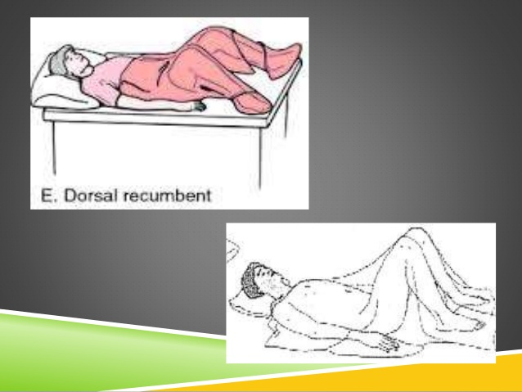

Indications
- Used for catheterization, vulva, vaginal and rectal examination.
- Used for vaginal operations and insertion of tampons.

