# Proposal for Undergraduate Certificates

## Definition and Purpose

An undergraduate certificate is a set of programmatic or thematically linked curricular and co-curricular activities that serves as a micro-credential distinct from majors and minors (see next section). The certificate provides a focused, structured, and interrelated set of experiences that enhances the participant’s expertise in an area of specific disciplinary, interdisciplinary, regional, or global topic or that addresses a defined professional development need for an internal or external population.

Certificates might broaden students’ ability to work across disciplines, deepen their ability to work within a discipline, and/or make their individualized academic work more distinctive and demonstrable on their academic record. These certificates also provide opportunities to serve external stakeholders who would benefit from knowledge and skills to investigate their academic interests or advance their careers. Creating strongly relevant and academically rigorous undergraduate certificates presents an opportunity to respond to the evolving environmental conditions in higher education and concurrent shifts in participants’ academic and workplace needs, and it responds to the 2030 Strategic Plan in multiple ways:

* Student Success Objective 1: Strengthen MSU’s ability to attract and meet the needs, goals and aspirations of dynamic undergraduate students from all backgrounds
* Student Success Objective 3: Increase the number and diversity of learners we serve through an online learning strategy that provides wider access through targeted programs
* Student Success Objective 4: Strengthen each student’s educational experience to eliminate opportunity gaps and support success through graduation and beyond
* Global Impact Objective 3: Develop and implement new strategies to recruit and retain highly talented and more diverse student and faculty researchers and scholars across all disciplines
* Stewardship Objective 5: Ensure faculty, staff, students, and community members have access to MSU and its resources to address current and emerging issues that affect Michigan and the world **(specifically names micro-credentials and certificates)**
* DEI Objective 5: Increase proactive engagement with historically underrepresented and underserved communities based on partnerships informed by shared goals and mutual learning

## UN Certificate Guidelines

Undergraduate certificate programs are constructed in selected areas as either complements to degree programs or as distinct offerings (Types 1 – 4). Undergraduate Certificates (Type 5) also exist within the Institute of Agricultural Technology (IAT), where the certificate and the degree program are one and the same.

The issuance of an undergraduate certificate signifies that the certificate holder has completed specified requirements and/or evidenced the specified skills or competency levels. Five types of graduate certificate programs are offered at Michigan State University (see point II below). The following information outlines the guidelines for creating an undergraduate certificate—Types 1 through 4.

Type 5 certificates are reserved for those academic programs created and administered by the Institute for Agriculture Technology (IAT); IAT certificate programs should continue to follow existing policies and procedures as approved by governance.

## Undergraduate Certificate Program Goals and Parameters

1. Undergraduate certificates should enhance existing programs and expand equitable educational opportunities for MSU stakeholders.
2. Sufficient resources—space, instructional, and financial—must exist to support the certificate without penalizing existing academic programs including subplans/options, cognates, and minors.
3. Certificates may be stand-alone or linked to an existing academic degree program.
4. Certificate proposals can include non-credit, co-curricular learning experiences or tracking of competency-based learning as part of the design if they:
   1. Use My Spartan Story or other specified system to document, track, and evidence participants’ learning.
   2. Publish any additional cost to the student or University for the experience and provide detail about how these costs will be covered by the program.
5. Certificates may be structured as either discipline-specific, interdisciplinary, or thematic.
   1. Academic units applying for certificates must consult with and/or obtain support from related programs and departments to ensure availability of courses required for the certificate, but offered by another department, and to avoid unnecessary duplication of content.
   2. Non-academic units may create certificates that are sponsored by APUE or an academic unit if it undergoes an academic program review.
   3. Non-academic units seeking to create certificates or intercollegiate/unit groups wanting to create certificates that would not clearly reside in a single college or department or focus on non-disciplinary themes should consult with APUE, which will administer pan-institutional certificate programs.

## Types of Undergraduate Certificates

* 1. Type 1 – certificates inclusive of MSU coursework and directly related to an MSU major or minor program; open only to MSU undergraduates; offered by a college, department, or school; and transcriptable. Goes through MSU governance for approval
  2. Type 2 – certificates inclusive of MSU coursework that are distinct from a specific degree program; open to MSU and guest students; offered by a college, department, or school; and are transcriptable. Goes through MSU governance for approval.
  3. Type 3 – certificates may or may not include MSU coursework and credits; designed for guest students and external stakeholders; offered by a APUE in collaboration with content-expertise units, college, department, or school; and are not transcriptable. If inclusive of MSU courses, then participant must be enrolled as lifelong education, and the coursework would appear on an MSU transcript. See guidance for Type 3 Certificates below.
  4. Type 4 -- certificates inclusive of MSU coursework and directly related to an MSU major or minor program; open only to MSU and guest students; university-wide and administered by APUE in collaboration with content-expertise units; and transcriptable. Goes through MSU governance for approval.

## Undergraduate Certificate Program Admissions & Eligibility

1. MSU units can design undergraduate certificates to serve one or more of the following audiences: current MSU undergraduate students, guest students, external stakeholders, and/or dual-enrolled individuals from high school, community colleges, or other colleges/universities.
2. Participants should follow a published admission process to add the undergraduate certificate.
   1. Students who have been admitted to an undergraduate degree program may add a certificate before completing their degree requirements by satisfying the admission requirements for the desired certificate and adding it to their academic plan. This process would align with the process of adding a minor.
   2. Students may start and complete a certificate program before, concurrent to, or after completion of an undergraduate degree program if they meet eligibility requirements and complete the program as outline in the certificate’s academic plan.
3. Participants must have no less than a high school diploma, GED, or the equivalent or be eligible for admission through a dual-enrollment program that MSU offers to qualifying high school and/or community college students.
4. The academic unit offering the certificate may set additional admission criteria. These criteria should be comparable to MSU admissions policies and standards and not higher or more rigorous than the requirements to enter a related major or minor.
   1. Certificate programs can limit eligibility to their certificates based on space, required background, or to ensure availability to specific courses, experiences, or intentional student populations.
5. To obtain an undergraduate certificate, participants must apply and be admitted (i.e., secondary admission) by the sponsoring unit as outlined in the certificate’s approved academic plan. Policy and procedure may vary by certificate. The university does not require that entry to certificate programs be selective or competitive; however, individuals must apply and be tracked as participating in the certificate curriculum.
   * + 1. Units should clearly outline the application requirements and selection criteria in their marketing materials.
       2. The Academic Programs catalog must clearly state if credits for the certificate are required to be “unique.” “Unique” credits for a certificate are defined as credits that do not count for a course taken to satisfy another university, college, major, or minor requirement.
       3. The Academic Programs catalog must clearly state if previous coursework, credits, or experiences are accepted for certificate completion.
6. Units should work with the appropriate MSU curricular and IT systems to create a student group code for each certificate and apply this code to all admitted participants.

## Undergraduate Certificate Program Requirements and Completion

1. The total number of credits required for an undergraduate certificate and completion requirements can vary based on design, but must align with the following criteria:
   1. Require a minimum of nine (9) and a maximum of twelve (12) course credits or the equivalent amount of contact time (see <https://tinyurl.com/3nr94k9c>) for fully non-credit certifications.
   2. Include learning outcomes and assessment requirements specific to the certificate, such as a project, portfolio, or comprehensive examination.
   3. Complete at least two-thirds of the engagement while admitted to the certificate program.
2. A 2.0 cumulative grade–point average for all credit-bearing experiences counting toward the Undergraduate Certificate is the minimum university standard; however, academic units may establish a higher minimum standard in the decision to award the certificate.
3. Completion credit-bearing activities will appear on an MSU transcript, and an undergraduate certificate award for Types 1, 2, and 4 will appear on a participant’s transcript.
   1. The co-curricular aspects of a certificate program should track the outcomes and competencies of certificate holders in My Spartan Story or equivalent tool.
   2. Type 3 Certificates obtained without formal course enrollment (i.e., online modules that do not require enrollment in an MSU class) will not be posted on an official MSU transcript. See guidance below for more information.
   3. Units with a Type 3 Certificate may create their own acknowledgement (i.e., certificate of completion) for participants who finish the certificate’s requirements as outlined in the academic plan. See guidance below for more information.
4. Undergraduate certificates will not be awarded retroactively without official admission to the program even if the student completed all certificate requirements.

## Undergraduate Certificate Program Cost and Financial Need

* + 1. Tuition and fees for certificate programs should follow MSU policies as appropriate for the participant and type of certificate.
  1. Undergraduate students in certificates will be charged the undergraduate based on their student status.
  2. Guest and non-student stakeholders admitted certificates should be charged the appropriate lifelong rate for any coursework.
  3. Program fees for certificates can be set and charged by the sponsoring unit to help defray the administrative and operational costs of a certificate and revenue should reside within the administering unit.

1. Any financial aid and student support for undergraduate certificates must comply with federal, state, and university policies and procedures.
   1. Degree-seeking, MSU students participating in activities associated with certificate programs that are part of their degree program can be covered by federal and state financial aid and scholarships.
   2. Guest students and participants not enrolled in degree-programs, but completing activities associated with certificates, are not eligible for federal and state aid unless approved through the Office of Financial Aid and federal agencies.

## Undergraduate Certificate Program Connection to Majors, Minors, and Transfer Credit

1. Some certificate requirements should be unique to the certificate and not fully overlap with a participant’s major or minor requirements.
   1. For Type 1 certificates that are concurrent with the undergraduate major or minor degree certification must have at least three unique credits.
2. Programs may create credit limitations based on discipline, purpose, and context relative to eligibility and overlap between certificate, majors, and minors.
   * 1. Units can disallow students from pursing a certificate in the same area as a minor or major.
     2. Units can require distinct courses and credit counts between a certificate and a major or minor beyond those stated in point VI.A.
3. If an individual engages in a certificate and continues into an MSU degree program, changes majors, or adds a minor in such a way that violates the certificates eligibility requirements or these guidelines, then they can withdraw from the certificate program and count the credits and experiences toward their intended major or minor.
4. Previously completed coursework, experiences, and transfer credits can count toward the certificate at the discretion of the program coordinator up to a limit of six (6) credits.
   1. Sponsoring units can set additional parameters on the amount of prior and transfer credit that can be counted toward a certificate.
5. Participants who take MSU coursework as a guest student may only transfer up to sixteen (16) credits to an undergraduate major or minor per MSU policy.

## Undergraduate Certificate Program Approval and Governance

1. All existing University policies apply to the activities encompassed by an undergraduate certificate, including but not limited academic, grading, admission, retention, contact hours, and eligibility to teach.
2. Activity associated with the certificate should be of the same rigor and quality as any parallel, non-certificate activities.
3. Proposals for new Type 1, 2, and 4 undergraduate certificate programs should be submitted through MSU governance in the same manner as proposals for other new academic programs (i.e., majors and minors).
4. The University Curriculum website will maintain a detailed description of the application details and approval steps. All undergraduate certificates will:
   1. Meet the definition of undergraduate certificates described in these guidelines.
   2. Have appropriate educational outcomes, related to MSU’s institutional learning goals, and achieve these outcomes in a well-defined manner, including assessment of student learning that is greater than just completion of individual courses.
   3. Be periodically reviewed on the regular academic program review cycle per university and department policies.
   4. Assessment data will be collected as part of MSU accreditation efforts.
   5. Require the number of credit hours that, in combination with any non-credit-bearing educational experiences, is appropriate to accomplish the certificate program’s goals and outcomes while staying with the guidelines.
   6. Maintain a public list of courses associated with the certificate. Departments should guarantee that courses are offered routinely and frequently enough to ensure timely certificate completion and ensure that the certificate program does not create bottlenecks for academic majors and minors using the same coursework.
   7. Maintain appropriate oversight, advising, and assessment for requirements beyond traditional classroom courses and/or not using approved MSU coursework (e.g. opportunities such as online modules, laboratories, service learning, practica, internships, research projects, independent study, etc.) in compliance with similar structures approved at MSU—including metrics such as safety and security protocols, contact hour requirements, and supervision by an approved MSU faculty or academic staff member.
5. Proposals for new Type 3 professional certificate programs should be submitted and approved through the unit’s undergraduate/curriculum committee and College and then submitted to the Associate Provost for Undergraduate Education office, which will take the certificate to UCUE for final approval. Non-academic units should submit their requests directly to the office of the Associate Provost for Undergraduate Education.
   1. All units are encouraged to work with the Associate Provost for Undergraduate Education office during the creation of the certificate.
   2. If a Type 3 certificate includes a course or learning experience administered by another unit, then the supporting units must be consulted and approve the academic plan.
6. If a program expires or is discontinued through moratorium, the sponsoring unit should follow MSU policies: no new students may be enrolled and options for those students currently in the program must be given options to continue to completion, switch to an alternative, or advised on how their credits may apply towards degree completion if no path to certificate completion or alternative is available.

## Types Undergraduate Certificates

| Name | Definition | MSU Transcript | MSU  Trackable | Eligibility | Relationship to Major | Requires Separate approval | Example |
| --- | --- | --- | --- | --- | --- | --- | --- |
| Type 1  Undergraduate Certification for | Course work, co-curricular experiences, and specified training associated with a specific college, department, or school. Designed to complement specified MSU degree programs. | Yes | Yes | MSU undergraduate students in specific academic programs who meet the eligibility requirements. | Directly related to, yet distinct from, a degree program or programs offered by an academic college, department, or school. | Admission and completion are granted by the academic unit and are separate from or concurrent with the degree certification process. | Certificate programs designed and administered by an academic college, school, or department for a specified target audience to explore a specific area in support of the degree program.   * Nanotechnology offered by College of Engineering * Social Media Administration offered by Department of Advising and Public Relations * Companion Animal Care offered by the Department of Animal Science |
| Type 2  Undergraduate Certificate Program in | Coursework, co-curricular experiences, and learning opportunities that are inter-disciplinary, competency-based, or related to professional skills not directly linked a degree program. | Yes | Yes | MSU undergraduate or guest students who meet the eligibility requirements. | Distinct entity not related to a degree program or minor. | Admission and completion are administered by the sponsoring unit and are separate from the degree  certification process. | Certificate programs designed and administered by an academic unit that involves coursework that can be taken by an MSU or guest student.   * Business ethics offered by College of Business * Music appreciation offered by College of Music |
| Type 3  *Sponsoring Unit* Professional Certificate in… | Co-curricular experiences, online modules, and/or specified professional training, skills, or  competency levels. | No | No | Fee-paying participants or guest students who meet specific admission criteria. | Distinct entity designed for external stakeholders and guest students not related to a degree program or minor. | Admission and completion are administered by sponsoring unit and are separate from the degree certification process. | Certificates that provide content typically associated with undergraduate degree programs but are designed for professionals. No formal, credit-bearing coursework included in the design.   * Diversity, Equity, and Inclusion certification for visiting international scholars * Cultural competence for health care professionals designed for Lansing-area nurses * DEI for Educators offered to Michigan teachers |
| Type 4  University Undergraduate Certificate in…. | Course work, co-curricular experiences, and specified professional training, skills, or competency levels that distinct from a major and serve a broad, pan-institutional audience. Designed to serve both MSU and guest students | Yes | Yes | MSU undergraduate or guest students who meet the eligibility requirements | Distinct entity designed for undergraduate students and guest students. | Admission and completion are administered by APUE in collaboration with sponsoring unit(s) and are unrelated to a degree certification process. | Certificate programs designed and administered multiple academic and/or non-academic units that focus on interdisciplinary, professional, and thematic topics available for a broad audience.   * Career readiness offered by APUE and Career Services. * Globally-Engaged Leadership offered by APUE and ISP. |
| Type 5 (IAT)  Certificates in… | Course work, co-curricular experiences, and specified professional training, skills, or competency levels for which the certificate and the academic program are one-in-the same. | Yes | Yes | Students who meet the eligibility requirements. | Directly related to a degree program as part of the degree program’s requirements. | Admission and final approval are managed by the degree program and integral to the degree certification process. | These certificates are full academic programs for which the awarding of the certificate ends the program and confers the certificate.   * IAT Certificate Programs |

Guidelines for Issuing Type 3 Undergraduate Certificates

# Definition

A Type 3 certificate is a professional certificate program that is a distinct entity not related to any degree program. The overall program is non-transcriptable and does not require approval in the same manner as other types of certificates. Type 3 certificates should seek approval thorough the following steps:

* Departments, schools, and colleges: unit committee 🡪 college committee 🡪 APUE 🡪 UCUE
* Non-academic units: APUE 🡪 UCUE

Only individual credit‐bearing courses taken as part of these programs will appear on an MSU transcript. For additional information regarding undergraduate certificates, see information above.

# Design Guidelines

Certificates should adhere to the [university’s branding standards](https://brand.msu.edu/). In addition, Type 3 printed certificates must have certain characteristics that distinguish them from a university‐level certificate and diplomas. These include:

* The certificate is 8.5 x 11 inches or smaller.
* At a minimum, include the following information: name of institution; name of unit(s) awarding certificate; participant’s name; name of the certificate program or series; issue or award date; and signatures of appropriate university officials.
* Michigan State University appears as the primary heading. The name of the unit awarding the certificate may also be part of the primary heading.
  + Use a font size less than 60.
  + Use a non‐calligraphy font.
* Examples of appropriate signature authorities include academic dean, assistant/associate dean, assistant/associate provost, program director or coordinator, and department chair.
  + Whereas the conferral of degrees occurs by authority of the State of Michigan, vested in the Board of Trustees, and delegated to the president of the university, signatures of the President of the University and Chairperson of the Board of Trustees are reserved for diplomas and certificates issued at the university level.

Units issuing certificates must maintain student academic records in accordance with Michigan State University Access to Student Information Guidelines: [www.reg.msu.edu/AcademicPrograms/Text.asp?Section=112#s542](http://www.reg.msu.edu/AcademicPrograms/Text.asp?Section=112&s542) and the university’s retention policy: <http://archives.msu.edu/records/general>‐ schedule.php?records_retention_general.

Units should be particularly mindful of instances when student records are neither maintained within the university’s Student Information System, My Spartan Story, nor within the Non Credit Registration System. In these instances, the issuing unit is responsible for ensuring that academic records, including but not limited to the following, are maintained permanently:

* requirements of the certificate program;
* courses, professional training, skills, or competency-levels used to fulfill the requirements;
* certificate award information including type of award (e.g. certificate name); and
* date of issuance for original certificate and duplicate or replacement certificates.

Units should keep track of the certificates requirements as they may change overtime. If certificate has a defined timeline or period for completion, then that information should be included in the application materials.

# Example Type 3 Documents

The following examples designed by Communications and Brand Strategy are reflective of the guidelines for issuing Type 3 undergraduate certificates.

Type 3 Certificate ‐ Example A

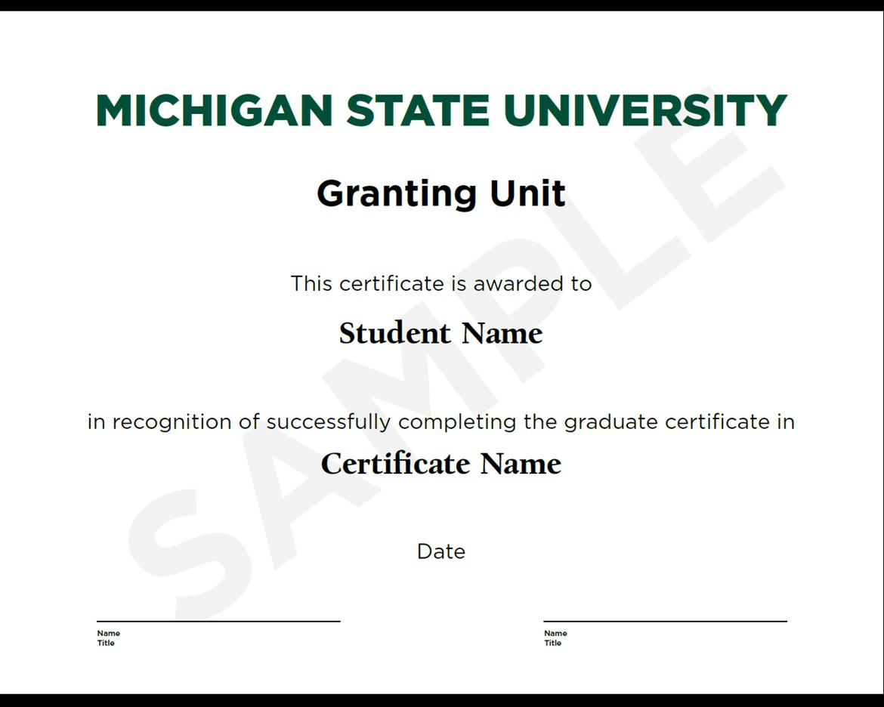

Type 3 Certificate ‐ Example B

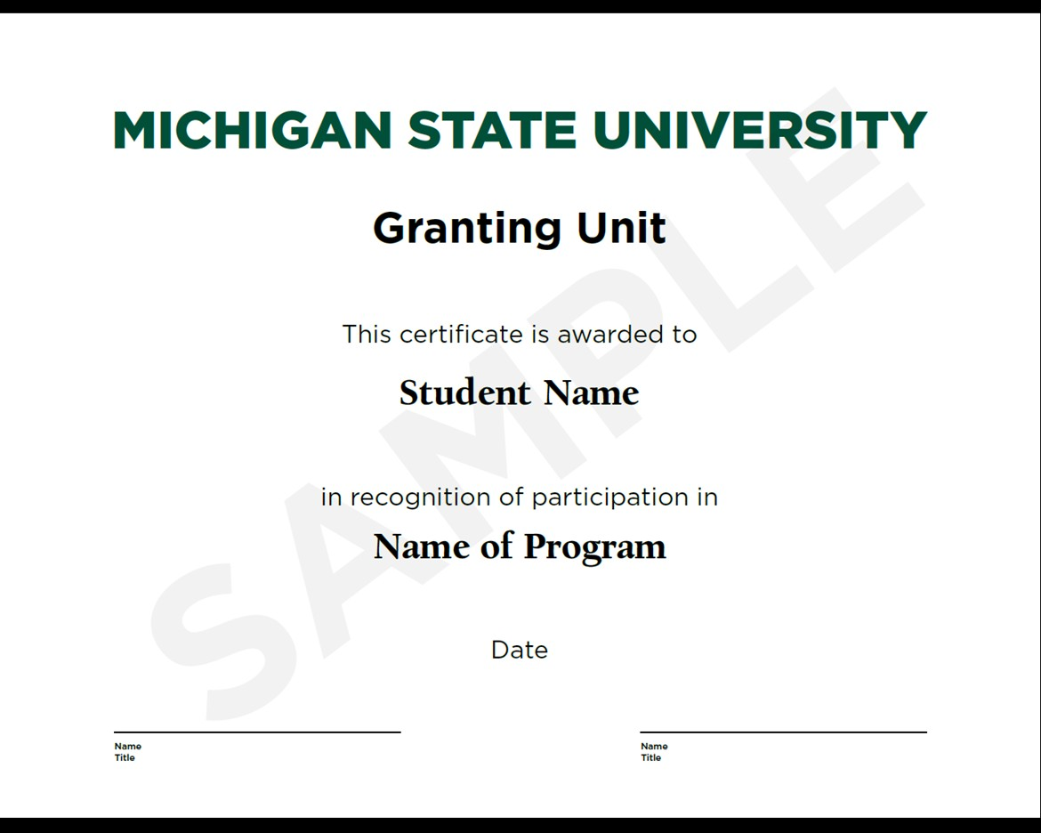

Type 3 Certificate ‐ Example C

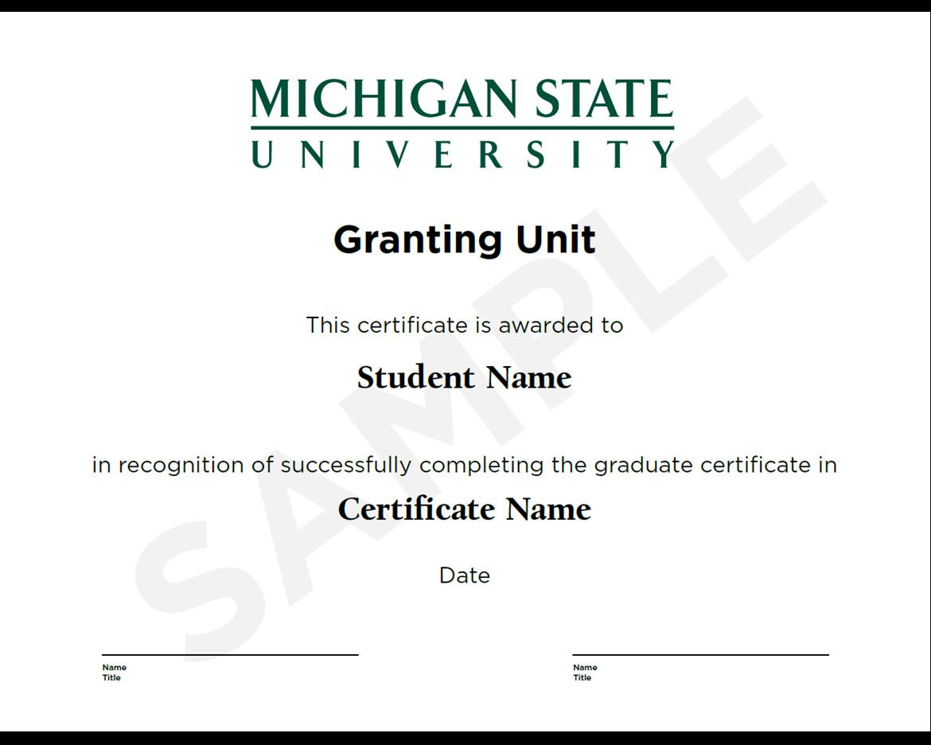

Type 3 Certificate ‐ Example D

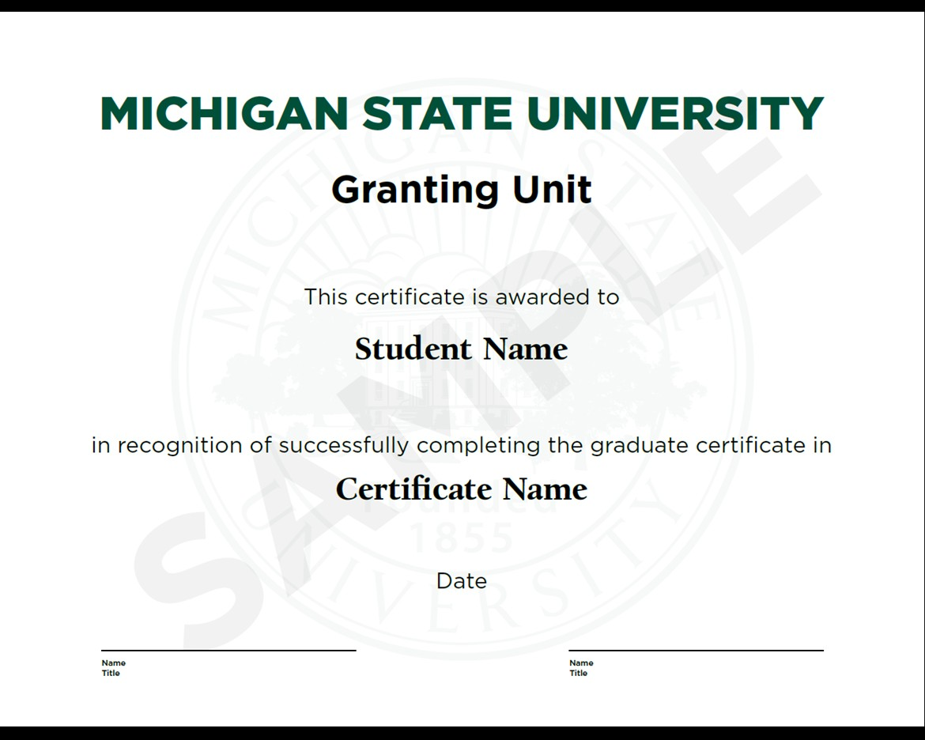

Type 3 Certificate ‐ Example E

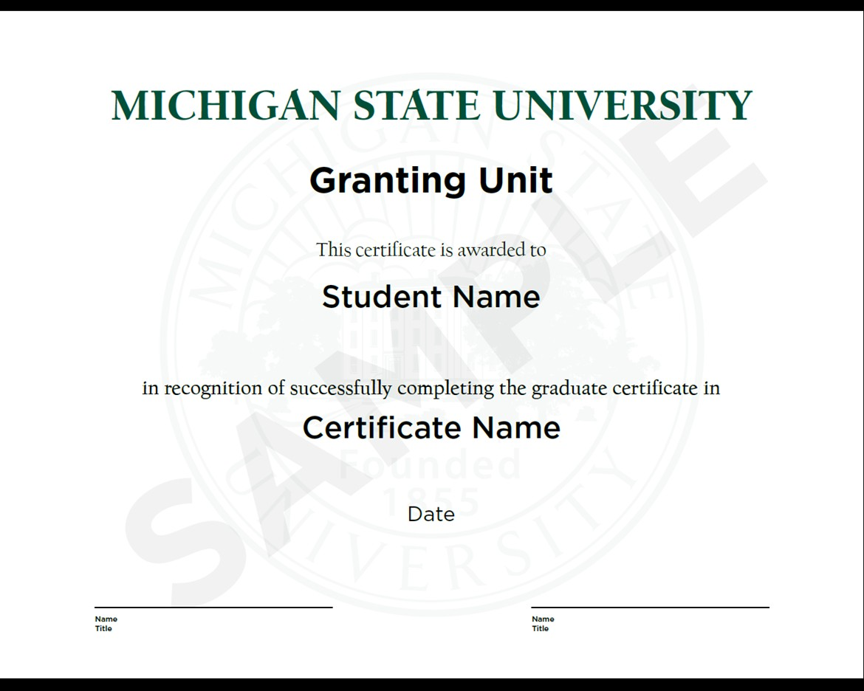

Type 3 Certificate ‐ Example F

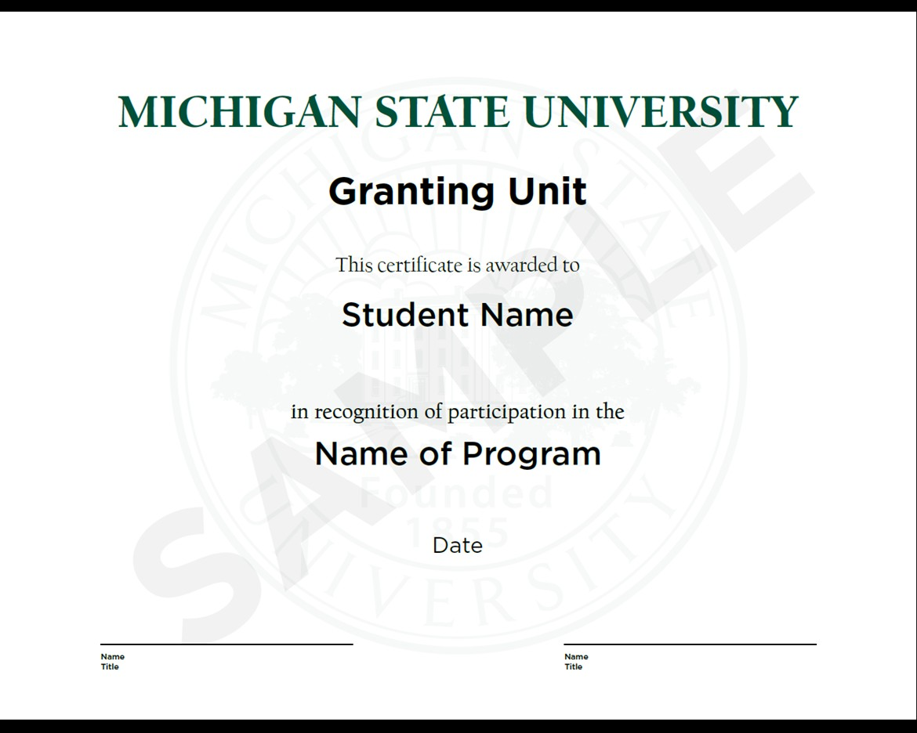

Type 3 Certificate ‐ Example G

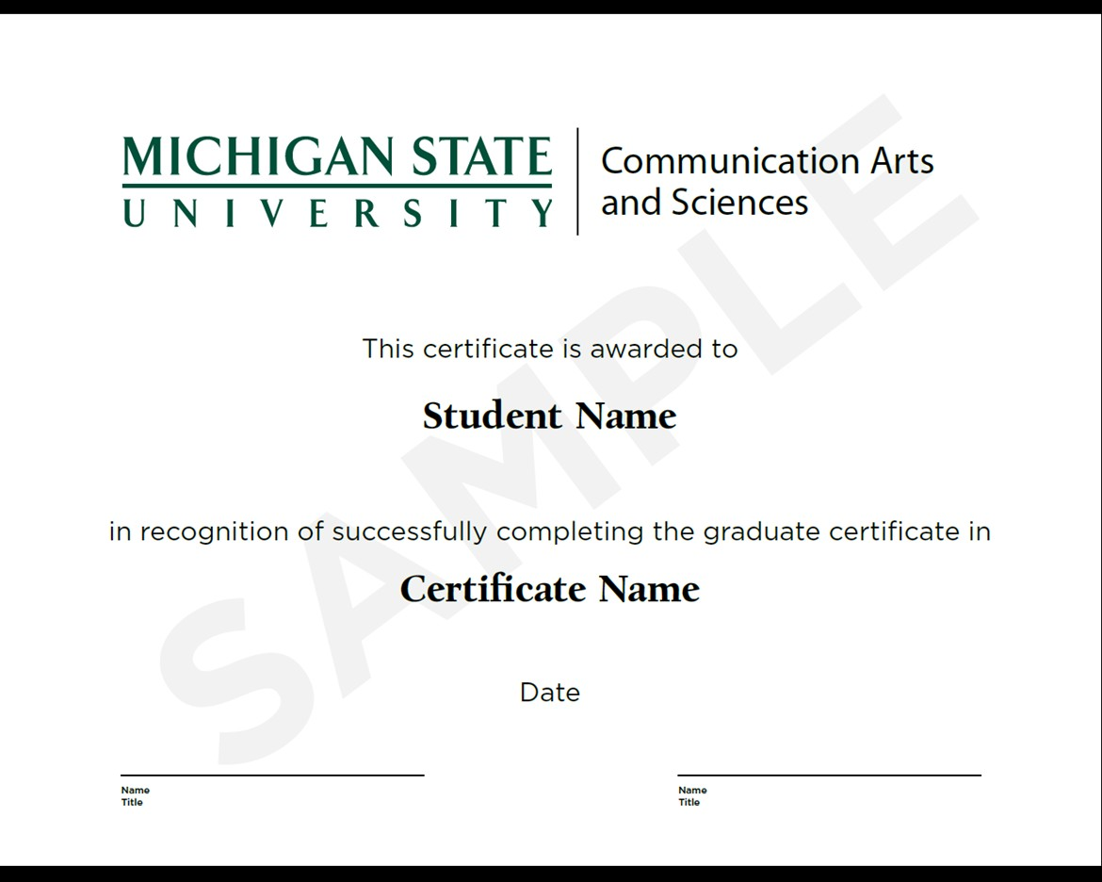

# Example Related Degrees and Certificates

The MSU Office of the Registrar produces University diplomas. As a point of reference, a sample diploma is provided below.

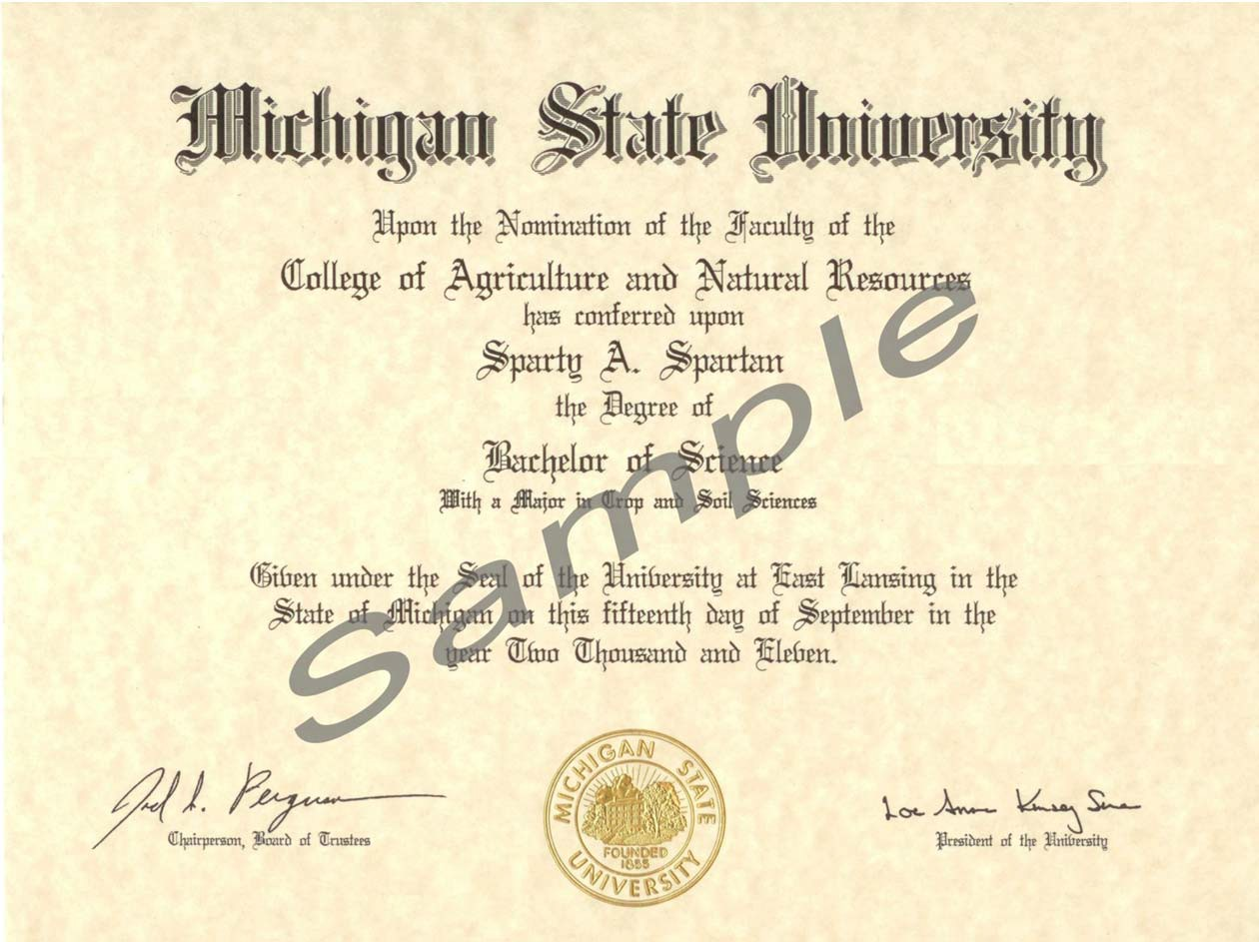

The following is an example of the diploma produced by the Institute of Agricultural Technology.

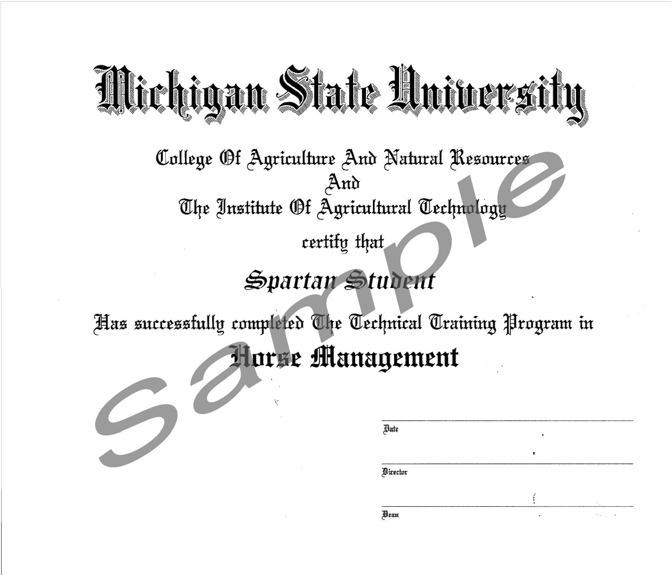

Effective Fall 2022, the Office of the Registrar will be responsible for producing Type 2 and Type 4 printed undergraduate certificates. Type 2 certificates are produced for a program that is a distinct entity not related to a degree program and is approved through academic governance. Type 2 certificates will be identical to the MSU diploma, with the following exception: the word “degree” will be changed to “certificate.”

