|  | Financial Aid: Part 2Making a Cost-Conscious College ListStudent Worksheet |
| --- | --- |

| Learning Objectives  * What are the “true” costs of college * How to estimate the cost of each college (for my household income level and academic performance) * How to integrate affordability, when making my college application list   *To get an editable version of this worksheet, click* ***Download as Docx*** *above.* | |
| --- | --- |

### 

| Want to find and apply to scholarships? [Sign up for Going Merry!](https://app.goingmerry.com/sign-up?utm_source=sendgrid&utm_medium=email&utm_campaign=worksheet&utm_term=counselor-referral#students) Scan the QR code to [sign up for a free Going Merry account.](https://app.goingmerry.com/sign-up?utm_source=sendgrid&utm_medium=email&utm_campaign=worksheet&utm_term=counselor-referral#students) |
| --- |

**Part 1: What’s the true cost of a college?**

| **Cost of Attendance** (Direct costs + Indirect costs)  *MINUS* **Grants / Scholarships** (Need- or Merit-based)  = **The true price** |
| --- |

Remember:

* **Grants and scholarships** are “free money” or “gift money” that you don’t need to pay back. It may be money from the government, your college itself, or some third party (like a company or foundation).
* **Loans** are money you need to pay later on. So when figuring out the “true price,” do NOT subtract out the loans. While it may mean your price TODAY goes down, you’re still paying this price (just in the future).

For the following college…

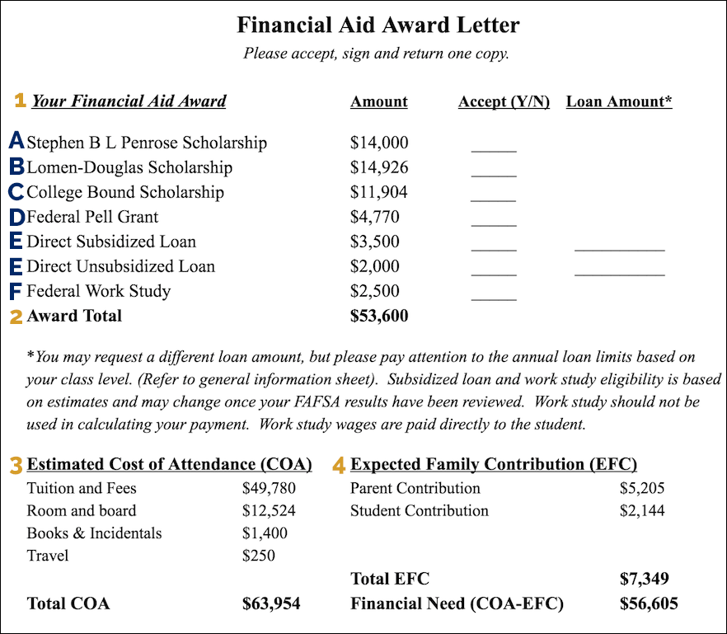

1. **What is the “sticker price” (cost of attendance) of the college?**
2. **What is the “true price” (the amount you need to pay or earn via work-study) for the college?**

*Remember: You have to repay loans eventually, so they are not “free money”!*

**Part 2. Cost of Attendance**

The **“Cost of attendance”** of a college should include two “types” of costs:

* Direct costs: Tuition, Fees, Room & Board (Accommodation & Meal Plan)
* Indirect costs: Textbooks, Technology, Transport, Other incidentals

*Remember to make sure your college doesn’t skimp on this. Some colleges incorrectly leave out the indirect costs (which are usually another $2000-$5000 per year) when discussing the cost of attendance.*

Look at these award letters:

| Award Letter A: | |
| --- | --- |
| Award Letter B: | |
| Award Letter C: | |

1. **a) Do each of these colleges correctly list their Costs of Attendance?**

**b) What is the Cost of Attendance for each of them?**

Even before you receive your financial aid award letter, you can research a college’s Cost of Attendance, usually by Googling. (Most colleges post this on their website.) Make sure you check for the same thing: direct AND indirect costs!

1. **Try this out now. Choose TWO colleges and look up their Cost of Attendance.**

**College 1:**

Cost of Attendance:

**College 2:**

Cost of attendance:

**Does this surprise you? Are they higher, lower, or about what you expected?**

**Part 3. Get a “True Price” Estimate!**

Most students don’t pay the full Cost of Attendance (sticker price) and instead get some form of grants or scholarships. So while you are figuring out your college list, even before you apply, you can estimate how much financial aid someone like you could get.

There are two ways of doing this:

* *The simpler way:* Department of Education’s College Scorecard
* *The more personalized (but complicated) way:* Net Price Calculator

We recommend starting with the simpler option: The College Scorecard ([look up any college here](https://collegescorecard.ed.gov/)). When they say “net price,” they mean “true price” (cost of attendance, minus grants/scholarships).

Each college’s profile will include a link to their Net Price Calculator, which is a somewhat lengthy form you can fill out to get a more personalized and specific estimate. However, this form will likely require your parents’ help, as you need to enter specific financial numbers (their income, deductions, investments, etc.) You’re welcome to do this at home, but for now, we will focus on the “simpler” scorecard.

For example, here’s what it looks like for NYU ([get the live version here](https://collegescorecard.ed.gov/school/?193900-New-York-University)):

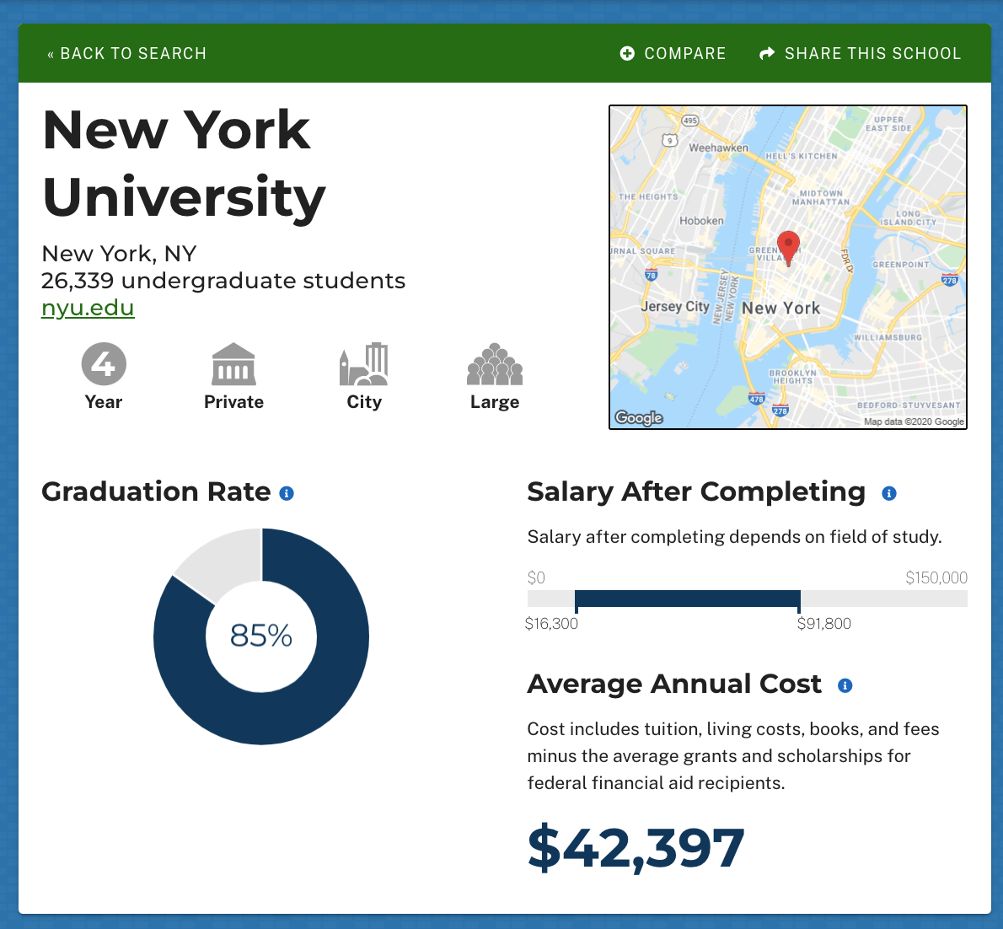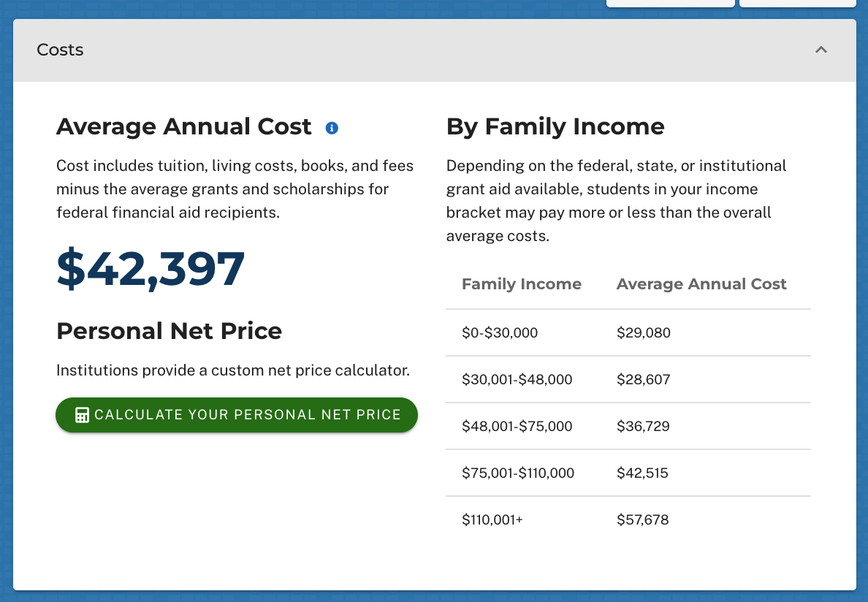

1. How does the true (net) price change at NYU, depending on your family income?
2. If your family earns $37,000 per year, about how much will NYU cost you per year?
3. Try this on your own! Look up the same TWO colleges you chose earlier (from question 4) and find out how much they will likely cost your family.

* How do the costs compare?
* Does this surprise you?
* Does it influence which college you are more interested in attending?

College 1:

College 2:

**Part 4. Don’t forget about Merit Scholarships!**

The College Scorecard and Net Price Calculators will only show you how much *need-based financial aid* you are likely to receive. You may also qualify for merit scholarships.

For instance, here are the annual costs for Centre College in Kentucky:

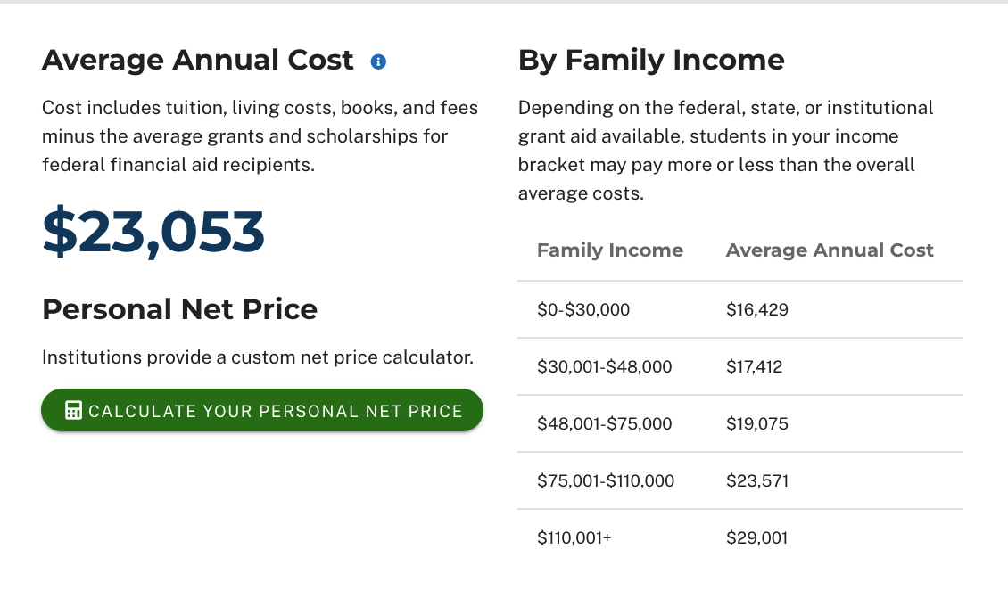

BUT they have a [Grissom Scholars program](https://www.goingmerry.com/scholarships/centre-college---grissom-scholars-program-2021-2022/9446) that provides a full-tuition scholarship *plus* an additional $5000 in merit “enrichment funds,” *all in addition to the need-based financial aid*. Many colleges have these sorts of merit-based scholarships based on GPA, class rank, or SAT/ACT scores. And sometimes the thresholds are not very high (GPA 2.5+, SAT 760+, etc.). [This article](https://blog.prepscholar.com/guaranteed-scholarships-based-on-sat-act-scores) has more examples of colleges that give you automatic merit scholarships based on academic performance.

1. **Look up the TWO colleges you’ve chosen (from previous questions), to see if they have merit scholarships that you might qualify for.** (Google for the college name + “merit scholarship”, or alternatively, check their financial aid websites.)

**Part 5. Future earning potential**

Some colleges cost more than others but also lead to a higher salary after graduation. So you might be willing to pay slightly more now (or borrow more in loans now), in order to earn way more later on. That’s totally reasonable!

That’s why, as a secondary consideration, you might want to look at how much graduates from each college earn (on average). If you already know what you’re going to study, you can even look up that salary data by major.

* WARNING: This is super speculative and based on averages. Remember that you might be way above or below the average. While the cost of the college is definite (if the bill says $10,000 - then you’re paying $10,000), your “future earnings” is not as sure of a thing. That’s why it’s still generally a good idea to consider the COST first, and the future earning potential second.

***All right - Now the fun part: How much might you earn?!?!?***

Let’s head back to [the College Scorecard](https://collegescorecard.ed.gov/) for this one.

* Look up a college.
* Check out the “Salary after completing” range - This is how much the median student earns, one year after graduating.
* Scroll down to “Fields of study” to look up the highest earning majors, or to look up your specific intended major.

For instance, here is the information for [UCLA](https://collegescorecard.ed.gov/school/?110662-University-of-California-Los-Angeles).

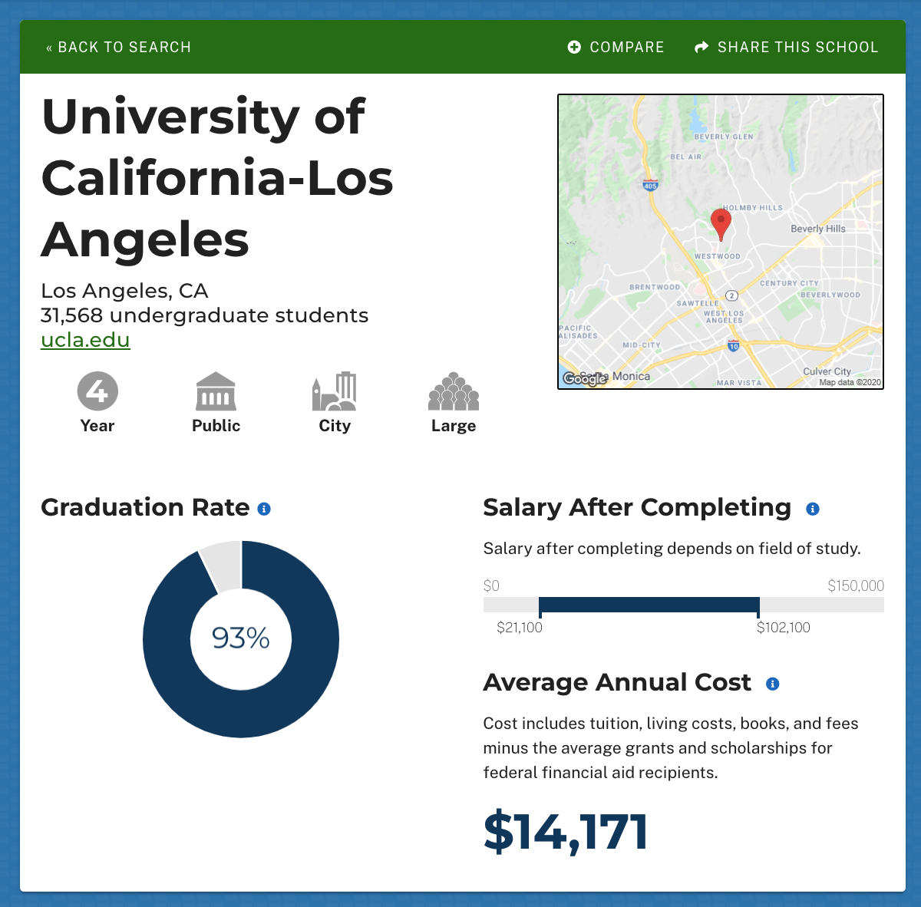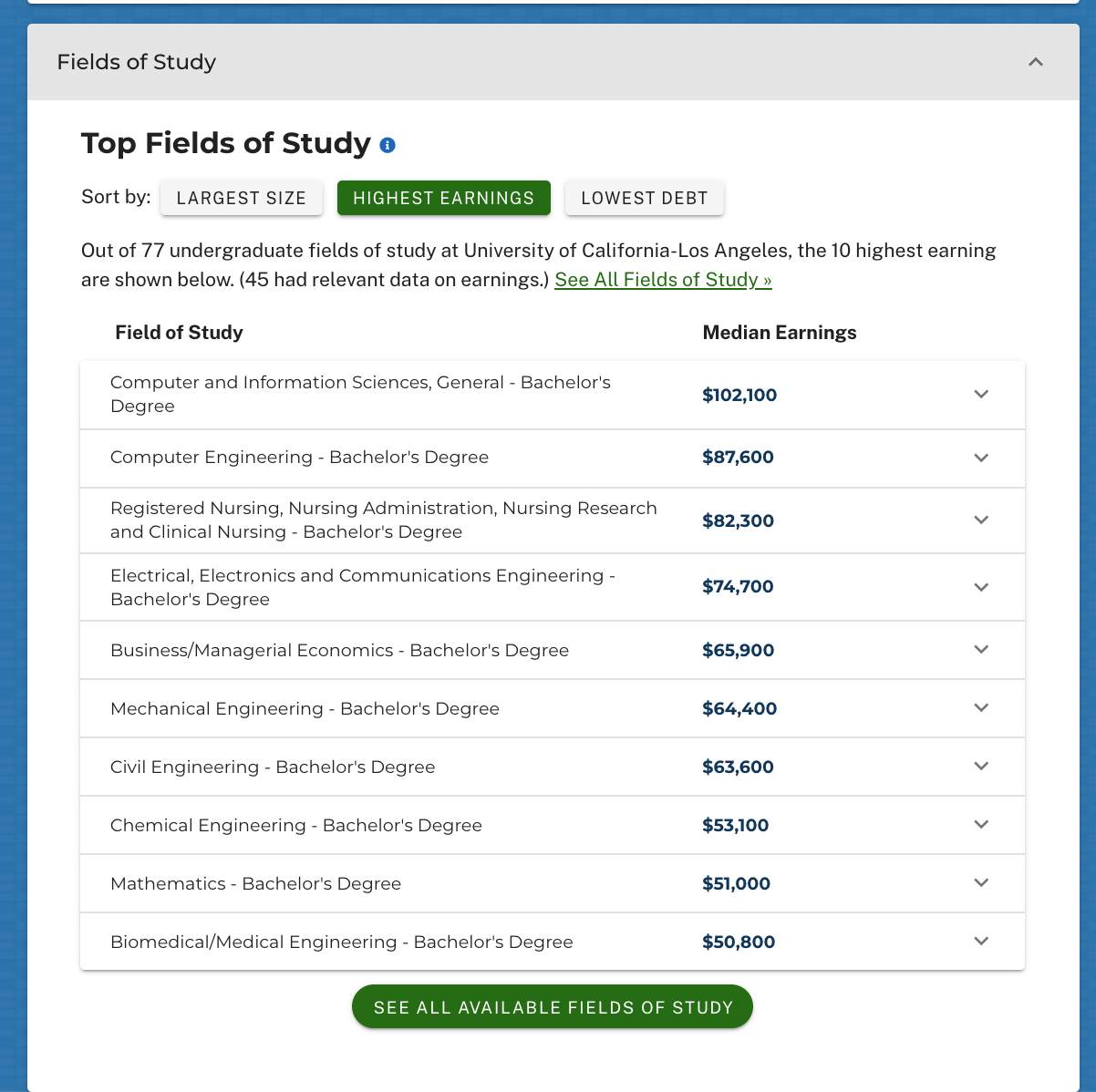

1. **How much do recent grads (one year after graduating from UCLA) earn? What’s the range?**
2. **What’s the highest earning field of study at UCLA?**
3. **How much do mathematics majors from UCLA earn, one year after graduating?**
4. **Try this with the TWO colleges you’ve looked up for the previous questions. What kind of future salary do graduates of those colleges have?**

College 1:

College 2:

**Part 6. Your Cost-Conscious Target College List**

When deciding on your college list, think about three things:

* Do you like it? (This may be for a variety of reasons.)
* Are you likely to get in?
* Can you afford it?

Often, students only consider the first two. This means they apply to colleges, get excited about them, get ADMITTED to them…. and then find out the cost of the college is too high. Sometimes they end up taking out lots of loans to pay for it (maybe not the best idea), OR they have to disappoint themselves and choose the more affordable option. Consider whether you want to instead apply only to colleges that you think you can afford.

1. **Discuss in pairs or in a small group:**

* How can students consider affordability (true/net price) when developing their college list?
* Did anything we did today change your mind about the two colleges you were considering? Why or why not?
* Do you think you will use any of these tools to look up OTHER colleges that you are considering? Why or why not?