**Lesson 6**

| **Based on the US Forest Service’s**  **“**[**FireWorks Northern Rocky Mountains & Northern Cascades Curriculum**](https://www.frames.gov/fireworks/curriculum/nrockies-ncascades)**”** |
| --- |
| **Smith, Jane Kapler; Abrahamson, Ilana; Berkowitz, Caitlyn; and McMurray, Nancy. 2018. FireWorks curriculum featuring ponderosa, lodgepole, and whitebark pine forests. Missoula, MT: U.S. Department of Agriculture, Forest Service, Rocky Mountain Research Station, Missoula Fire Sciences Laboratory (Producer).** |

| **FIRE LESSON:** Matches and stove lighters are used in this activity to model physical phenomena that students will investigate. Exercise caution when conducting this activity. This activity should only be conducted in an appropriate laboratory setting under instructor supervision. If this is the first time students will be investigating physical phenomena with fire, links to a safety checklist and a safety quiz are included in this activity’s “Materials and Preparation” section. |
| --- |



**Lesson Overview** In this lesson, students use a matchstick model of the cross timbers to investigate how fire behavior in a wooded area (or other standing fuel system) can be influenced by fuel density/continuity, wind, and slope.

**Lesson Goal** Develop a better understanding of fire behavior in woodlands and other standing fuel systems. Describe conditions that contribute to extreme fire behavior and fire spread. Increase knowledge of experimental methods.

**Objectives**

* Students will design a controlled experiment to investigate relationships among slope, wind, stand density, and fire spread.
* Students will write a hypothesis, conduct an experiment, summarize results, and draw conclusions.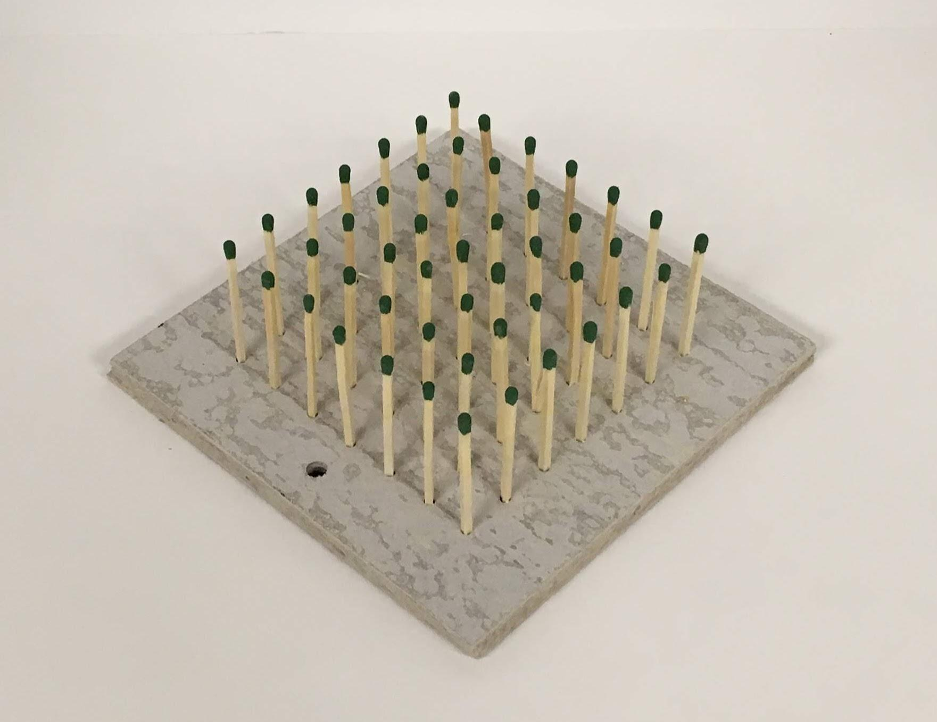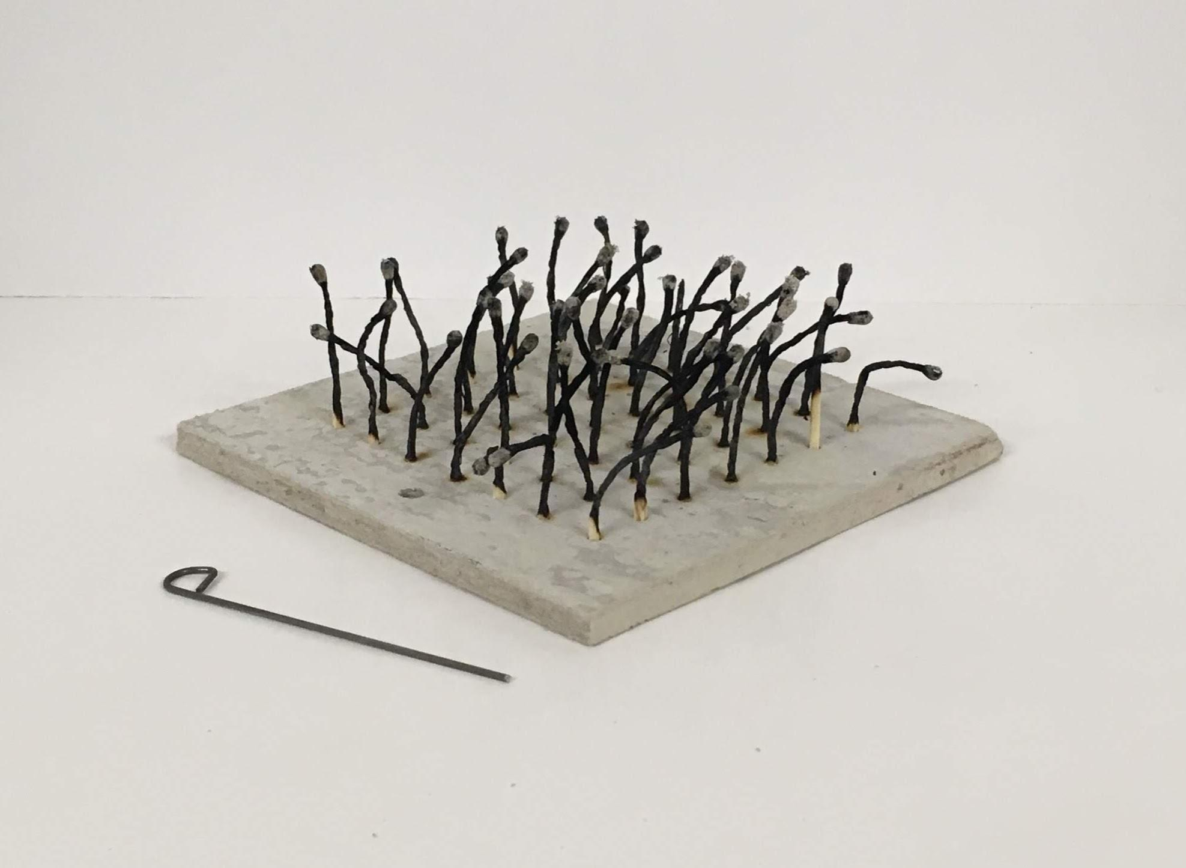
* Students will present their hypothesis, experimental design, results, and conclusions to their classmates with a brief presentation.
* Students will compare their experiment and results to those of their classmates.

**Academic Standards**

**Table 1: Next Generation Science Standards - High School - Disciplinary Core Ideas**

| **HS-PS3 Energy** | PS3.A, PS3.B, PS3.D |
| --- | --- |
| **HS-LS1 From Molecules to Organisms: Structures and Processes** | LS1.C |
| **HSLS2 - Ecosystems: Interactions, Energy, and Dynamics** | LS2.B |

**Table 2: Next Generation Science Standards - High School - Performance Expectations**

| **HS-PS3 Energy** | HS-PS3-4 |
| --- | --- |

**Teacher Background** In this activity, students design physical models of fuel arrays in which standing fuels are represented by matches. Because the model provides a demonstration of the way fire behaves in a woodland, it will be referred to as the “Cross Timbers” model. However, it could represent any array of standing fuels, including shrubs or conifers with highly flammable crowns and even grasses.

To complete this lesson, students will make brief class presentations. Prompts are provided on the student worksheet to assist students/groups.

**Note:** Flames in this experiment could reach 40-50 cm in height. Be sure that this activity is conducted in an appropriate space. If you choose to do the experiment outdoors, even the slightest breeze will dramatically affect fire behavior. Conducting this activity outdoors will probably illustrate that fire spread is complex and often unpredictable.

One objective of this activity is developing the skills to design an experiment.

* As you are discussing experimental design, stress that each group should only vary or change one independent variable for each investigation conducted. If there is enough time, groups might be able to perform additional investigations. However, all data analysis should be completed from the first investigation before students move on to working with other independent variables or situations described in **Extensions** below.
* Try not to give students too much guidance as they develop their experiments. However, when students come to get their experimental designs “okayed” before they begin, check to see that there is only one independent variable and that students have a plan for measuring the dependent variable(s). Check that the hypothesis or null hypothesis is simple and easy to support/disprove. Students may have more than one hypothesis or null hypothesis, so be sure that they are all appropriate. If there are multiple hypotheses and/or null hypotheses, they should not be about the same relationship. For example: Hypothesis - An increase in slope will decrease the time needed for complete fuel consumption; Null hypothesis - An increase in slope will have no effect on the time needed for complete fuel consumption. Both of these examples are legitimate, but one group should not use both of these. They should choose only one about this “slope-time” relationship. It would be okay for the group to include another hypothesis or null hypothesis about another relationship such as: Hypothesis - An increase in slope will increase maximum flame height; or Null hypothesis - An increase in slope will have no effect on maximum flame height.
* If time is not a major concern or if more time is available during another class period, class datasets could be developed. Groups that had the same independent variables could combine their data. Larger data sets from multiple groups could lead to some interesting discussions about reliability of data resources, experimental error, etc.

Students will use the matchstick model to investigate variables that affect the spread of fire (and are aspects of the Fire Environment Triangle). Here is a brief introduction to the three components of the Fire Environment Triangle.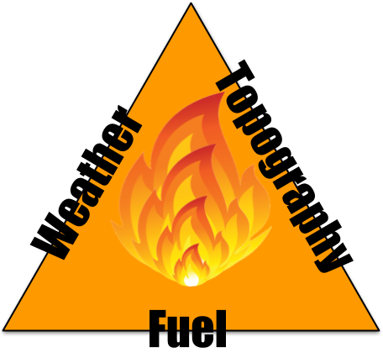

* Slope/topography: If a fire is burning on a hillside, the fuels above it tend to be dried and warmed by its convective heat, and the flames are quite close to the uphill fuels. They are likely to ignite very quickly. The fuels below the fire are affected very little – at least until burning materials roll downhill and ignite new fires there. Thus, fires tend to spread upslope, and a fire that starts at the bottom of a hill is likely to spread faster than one that starts on a hilltop.
* Fuel density and contagion: If a fire is burning in a dense forest, it may spread from treetop to treetop (crown fire). In more open forests, crown fires are less likely. (Here is a caveat, however: surface fires may spread more rapidly in open than dense forests because the wind speed is usually greater in openings.) Stand density has the same effect in other standing fuels, such as shrublands and thick grasslands: fire spread can be extremely rapid.
* Weather/Wind: The effect of wind on fire spread is analogous to that of slope. Wind bends the flames and the heat plume so they are no longer vertical but instead lean downwind into the fuels, heating them more rapidly and increasing the rate of fire spread.

Here are some of the fire “behaviors” or fire characteristics that can be easily quantified in this activity are:

* Maximum flame height: students can use a ruler held out to the side of the flames to determine the maximum flame height attained during an experimental trial.
* Rate of fire spread: students can use a stopwatch to determine the amount of time needed for fire to spread from the starting point to some end point or for all matches to be consumed.
* Fuel consumed: students can determine the percentage of matches that were consumed. The starting number of matches may change with each trial depending on a group’s experimental design.

**Table 5: Key Terms**

| **Slope** | Slope is the rise or fall of a land surface. For this activity, slope will be measured in degrees using a protractor. Slope describes the angle of a surface measured from the horizontal. Thus, a horizontal surface has a slope of 0o, and a vertical surface has a slope of 90o. |
| --- | --- |
| **Stand** | An aggregation of trees or other growth occupying a specific area and sufficiently uniform in species composition, size, age, arrangement, and condition as to be distinguished from the forest or other growth on adjoining areas. |
| **Standing Fuels** | Fuels that are arranged in a vertical, or nearly vertical, arrangement relative to the horizontal. Grasses, shrubs, and trees could be considered standing fuels. |
| **Stand Density** | The density of stand plants expressed as the number of plants per unit area. |
| **Trial** | A unique test of the relationship between the independent and dependent variables in a controlled experiment. A trial could have a change or variation in the independent variable, or a trial could repeat or replicate a specific value/setting for an independent variable. |
| **Treatment** | The way investigators change the independent variable from one trial to the next. |

**Materials and Preparation** Do this activity in a lab or outdoors. Note that even the air currents created by the laboratory’s ventilation system will affect the experimental results.

* If this is the first time students will be investigating physical phenomena with fire, slides 2-8 of the [slideshow for “**Lesson 2: The Heat Plume of a Fire**](https://docs.google.com/presentation/d/1sNjNaQIO3e6-u-o3pFbAvObkT1iqrgVH77Tyx6tU950/export/pptx)” must be shown and discussed.
* The day before the activity, review the “Safety Checklist for Fire Activities” and remind students to follow safety guidelines about clothing and hair when they get ready for school the day of the activity.
* Display the “[Safety Checklist for Fire Activities](https://docs.google.com/presentation/d/1rCCobPhsHWlOqnoHDdR4gbcDdhUk_KFYnBQE7LJ61OQ/export/pptx)” poster/slide so it is visible in the area where the activity will be conducted or review/discuss the poster.
* Get a box of wooden kitchen matches for each lab group/station. If there is more than one class, be sure to plan accordingly. **It is not appropriate for students to bring matches to school for this activity**.
* Make copies of the “Matchstick Cross Timber Woodland - Student Worksheet” for each group or for each student.
* Make copies of the “Matchstick Cross Timber Woodland - Rubric for Student Reference” for each group to assist with presentation preparations.
* Be sure that a fully-charged fire extinguisher is in the activity area.
* Have an empty metal bucket or metal trash can **without** a plastic liner available.
* Set up a lab bench or other safe space for each group, using the following equipment:
  + Safety glasses/goggles for each student
  + Leather gloves (one pair per group)
  + 1 metal tray (i.e., cookie sheet)
  + 1 spray bottle, filled with water
  + 1 box of matches
  + 1 stove lighter
  + 1 matchstick forest board with accompanying bolt, nuts, and washer
  + 1 ruler
  + 1 protractor
  + 1 “burnt match remover” (short piece of wire)
  + A copy of the “Matchstick Cross Timber Woodland - Rubric for Student Reference” to assist with presentation preparations.
  + Make sure each student team has a time keeping device such as a smartphone
  + Smartphones could also be used to video trials (videos could be incorporated into the class presentation)

A download of a template for the drilling needed to make a matchstick woodland is available in **Table 4** (below). Laminating this “plume-mapping” graph will allow it to be reused.

**Table 6: “Matchstick Cross Timber Woodland” Resources**

| **“Matchstick Cross Timber Woodland” Resources** |
| --- |
| [Drilling Template for a Matchstick Woodland](https://docs.google.com/document/d/1XNuYLqUaXrCKCsM5nHx0-VAQCvvvx3LXBSebENcL5EA/export?format=pdf) |

**Procedure**

* Assign students to groups appropriately sized for your laboratory area and amount of supplies. It is best for the students to be in their groups during the introductory slide show since, at the end of the slide show, they will begin designing their group’s investigation.
* Give each student a copy of the student worksheet.
* Go over this activity’s slideshow. This slideshow also includes the “FireWorks Safety” poster for a quick review.
  + A script is provided in the speaker notes for the slide show.
  + A document of the slide show’s speaker notes can be found in this activity’s folder.
* After students have had their experiments approved, have the groups do a practice run to become familiar with the lighting and data collection processes. At this point monitor for safety and correct students appropriately. If you have a small number of groups, it might be a good idea to have the groups observe each other as they burn their “woodlands” one at a time.
* After experiments have been concluded, be sure students appropriately dispose of burnt matches and clean/organize the laboratory area.
* Groups should use their results to address the prompts on the student worksheet.
  + Data should be graphed and analyzed. If possible, conduct this analysis using a spreadsheet application.
  + Use results to draw conclusions about the hypothesis/hypotheses.
  + Prepare for class presentation.
* Have groups present to the class. A rubric is included for evaluating presentations.
* Students should complete the “Class Presentation” table while other groups are presenting.

**Assessment**

* Presentation Rubric (included as a separate document)
* Sample quiz/review questions for “Matchstick Cross Timber Woodland”

1) Which of the following is **NOT** a “side” of the Fire Environment Triangle?

a) Fuel

b) Oxygen

c) Weather

d) Topography

Answer: b

2) Which of the following is **NOT** one of the “weather factors” discussed that could influence a fire’s behavior?

a) Relative Humidity

b) Wind Speed

c) Greenhouse Gas Concentration

d) Temperature

Answer: c

3) What material should clothing be made of when conducting an activity with a flame/fire?

a) Polyester

b) Nylon

c) Gore-tex

d) Cotton

Answer: d

4) How are the independent and dependent variables related to each other in an experiment?

a) There is no difference between the two variables if they are both part of the

same experiment.

b) Because it is changed by the investigator, the dependent variable differs in

each experimental trial and, since it is “independent,” the independent variable never changes.

c) The dependent variable could change between experimental trials as the

independent variable is changed by the investigator.

d) The independent variable could change between experimental trials as the

dependent variable is changed by the investigator.

Answer: c

5) Why does fire move more quickly uphill than downhill?

a) Because the concentration of oxygen increases as altitude increases.

b) The closer fuels are to the sun the warmer and drier they usually are allowing

them to ignite more easily.

c) Convection transfers the heat of the fire upward which preheats or dries out

fuels allowing them to ignite more easily.

d) This is a trick question. Fires move as quickly downhill as uphill.

Answer: c

**Evaluation**

Presentations

* In the file for this activity, there is a document with a table to be used as a

checklist or for recording points according to the rubric.

* In the files for this activity, there is a document with the rubric for presentations.

**Extensions** There are many variations students can develop for this activity. However, it is strongly recommended that students do not combine boards of matches together in any way. The heat, smoke, and flames from combined boards may be surprising and dangerous.

* Vary the length of fuels by breaking matches before adding them to the board.
* Place a “votive candle structure” on the board amid a fuel array. If the candle’s wax begins to melt, then the structure is damaged by the fire.

A class discussion or short, opinion essay could be done over the following prompts:

* What are some limitations of the matchstick model?
* What “real-world” influences on fire spread could not be tested with this model?
* Could this model be revised or a different model developed to test the “real-world” factors?
* Based on experimental results, what practices should be recommended to:
  + Firefighters
  + People with homes in fire prone areas
  + Land managers

**References/Resources**

**Teacher Background**

Stand definition

<http://www.uky.edu/~jmlhot2/courses/for350/Stand%20Descriptions%20and%20Supporting%20Material_UT%20Clatterbuck.pdf>

**Slide Show**

Images and diagrams by Bryan Yockers unless cited/listed below or in lesson

materials.

“Fuel load” definition

Pyne, S. J., P. L. Anderson, and R. D. Levin. 1996. *Introduction to Wildland*

*Fire*, New York: Wiley.

“Fuel continuity” definition

Cheney, P., and A. Sullivan. 1997. *Grassfires: Fuels, weather and fire*

*behavior*. Collingwood, Australia: CSIRO Publishing.

Image of incident meteorologists taking weather reading during a fire

NOAA

<https://scijinks.gov/imet/>

“Relative Humidity and Spotfires” slide

The graph and both images from

<http://factsheets.okstate.edu/documents/nrem-2903-prescribed-burning-spotfires-and-escapes/>