LJ Institute of Media & Communications
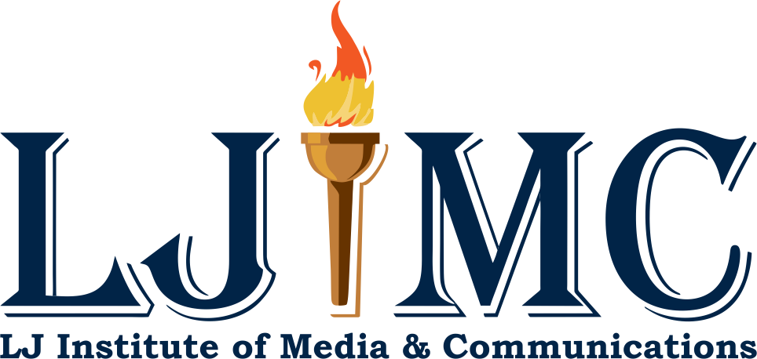

Event Report: LJ University Alumni Meet 2024

Date: 18th February, 2024 (Saturday)
Time: 6pm Onwards
Venue: LJ University

Introduction
The LJ University Alumni Meet, held on 18th February 2024 was a monumental occasion that brought together over 2800 alumni from various departments of LJ University. This gathering symbolised the enduring bonds forged within the LJ community and celebrated the shared experiences and achievements of its alumni across disciplines and generations.This gathering marked a significant milestone in fostering connections and celebrating the achievements of LJIMC alumni, alongside esteemed members of the LJ University community.

Objectives:
- To facilitate networking opportunities and collaborative ventures, and connections among LJ University alumni and the broader LJ University community.
- To provide a platform for alumni to reunite, reminisce, and share experiences.
- To showcase the achievements and contributions of LJ alumni to their respective fields.
- To strengthen the relationship between LJ University and its alumni network..

Event Details:
The LJ Alumni Meet was a vibrant and enriching gathering that celebrated the enduring bonds within the LJ community. Key highlights of the event included:

Distinguished Guests:
The event was graced by esteemed dignitaries, including the Honourable Vice Chancellor, Dinesh Awasthi; President, Dr. Manish Shah; Campus Director, Dr. Viral Shah; LJIMC Director, Dr. Divya Soni, and directors from different schools of LJ. Their presence added grandeur to the event and provided inspiration to the attendees.
Authentic Connections:
Alumni from diverse backgrounds engaged in meet and greet sessions, fostering authentic connections and meaningful conversations. These interactions transcended professional boundaries, allowing alumni to share personal anecdotes, career insights, and life experiences. These interactions also facilitated networking opportunities, allowing alumni to share experiences, insights, and aspirations across disciplines.

Career Development Discussions:
Alumni had opportunities for career development discussions with current students aimed at enhancing their professional skills and advancing their careers. These discussions covered topics such as resume building, interview preparation, networking strategies, and entrepreneurship, catering to the diverse needs and interests of attendees.

Networking Opportunities:
Networking was at the heart of the event, with structured networking sessions and informal gatherings facilitating connections among alumni. Alumni had the chance to expand their professional networks, explore collaboration opportunities, and reconnect with old friends and classmates, and current students fostering a sense of belonging and camaraderie within the LJ community.

Engagement with Faculty Members and Students:
Alumni had meaningful interactions with faculty members and current students, exchanging ideas, insights, and experiences. These interactions facilitated mentorship opportunities, allowing alumni to share their expertise and offer guidance to the next generation of LJ scholars.

Exploration of Ongoing Initiatives:
Attendees gained valuable insights into LJ University and LJIMC's ongoing initiatives, including community outreach programs, and industry partnerships. Alumni learned about the institutes' commitment to innovation, excellence, and social impact, inspiring them to contribute to the institutes' mission.

Fostering a Culture of Curiosity and Lifelong Learning:
By engaging with cutting-edge technologies, faculty members, and ongoing initiatives, alumni were encouraged to embrace a culture of curiosity and lifelong learning. The Alumni Meet served as catalysts for intellectual growth and professional development, empowering alumni to stay abreast of emerging trends and advancements in their fields.
Cultural Celebration:
The events culminated in a memorable cultural celebration, featuring a sumptuous dinner and dancing to a live orchestra. Alumni came together to celebrate their shared heritage and accomplishments, creating lasting memories and strengthening bonds within the LJ community.

Conclusion:
The LJ University and LJ Institute of Media & Communications (LJIMC) Alumni Meet 2024 were resounding successes, bringing together alumni from diverse disciplines and to celebrate their shared passion for media and communications to celebrate their shared heritage and forge new connections for the future. As LJ graduates continue to excel in their respective fields, the events served as a testament to the enduring spirit of excellence, innovation, and camaraderie within the LJ community.
The event not only provided a platform for networking and collaboration but also reaffirmed the strong bond between LJIMC alumni and their alma mater. As LJIMC graduates continue to excel in their careers, the institute remains committed to supporting and empowering its alumni community.

Attendees:
- Over 2800 alumni from various departments of LJ University and LJIMC alumni from various graduating classes and disciplines.
- LJ University and Distinguished guests included the Honourable Vice Chancellor, President, Campus Director, LJIMC Director, faculty members, and directors from different schools of LJ.

Enclosures:
