Name__________________________________________________ Period ______ Date ___________________

 | Activity Guide - Model Screen Design | 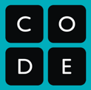

Translate from paper to digital
Using Design Mode in App Lab, create a digital version of this paper prototype. Make sure that the IDs you use match the IDs on the right. If an element on the screen isn’t labelled with an id, create one of your own.

