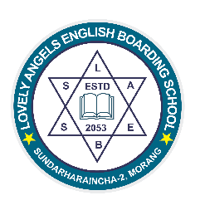

AWARD

2024
Certificate
Mr. Rukshal Ghimire
This Certificate is Awarded to

Chief Guest Principal
Achieving the Excellence in Art Award
For the year 2081 from class-2.
We wish him bright future in the days to come.
LOVELY ANGELS ENGLISH BOADRING SCHOOL
Sundarharaincha-2, sorang
Date:2081/07/25
Regd No.581

