The Title is Written With a Maximum of 20 Words Without Any Year of Research (Times New Roman, 16, Bold)

First Author Name¹*, Second Author's Name², Third Author Name³
¹ Department, Institution, City, Country
² Department, Institution, City, Country
³ Department, Institution, City, Country

*Corresponding Author: example@mail.com

ARTICLE ATTRIBUTE |  | ABSTRACT
Article history:  Received Month Date, Year  Revised Month Date, Year  Accepted Month Date, Year  [Left blank} |  | An abstract is a concise summary of the key elements of a scholarly work. It serves as an independent section that allows readers to quickly understand the purpose, scope, and outcomes of the study without reading the entire document. Generally written in a single paragraph of 200–250 words, the abstract should be clear, objective, and self-contained. The content of an abstract usually includes four main components. First, it outlines the background or purpose, explaining the problem addressed and the rationale for conducting the research. This section answers the question of why the study was undertaken. Second, it briefly describes the methods or approach used, specifying research design, data collection, and analysis techniques. This helps readers assess the study’s validity and appropriateness. Third, it presents the main findings or results, focusing on significant patterns, relationships, or outcomes without excessive detail or interpretation. Finally, it provides the conclusions or implications, highlighting the significance of the findings, their potential applications, and recommendations for further study. An effective abstract uses precise language, avoids jargon, and refrains from including information not found in the main text. It should be written last, after completing the research, to ensure it accurately reflects the study. In addition to guiding potential readers, an abstract plays a vital role in indexing for databases, improving the visibility of the work. By summarizing the essence of the research, it serves as both a gateway and a roadmap to the full document.
Keywords:
Keywords1; Keywords2; Keywords3; Keywords4;

This is an open-access article under the CC BY-NC license. 

- Introduction
The introduction in a scholarly article is the first substantive section that sets the stage for the research being presented. It is more than a mere opening; it serves as the foundation upon which the entire paper is built. Its primary purpose is to capture the reader’s interest, provide essential background, highlight the research problem, justify the study, and clearly present the research objectives or questions. A well-crafted introduction allows the reader to transition from a broad understanding of the subject area to a precise focus on the specific research being undertaken.
Typically, an introduction begins with general background information about the topic. This section establishes the context, outlines the current state of knowledge, and explains why the topic is relevant within its academic or practical field. Authors often present facts, statistics, or current trends to demonstrate the significance of the topic.
Following the background, the introduction narrows to a specific problem statement. This section identifies a gap in existing knowledge, a limitation in previous studies, or an unresolved question. It explains what is missing or unclear in the field and why this is an important issue to address.
Sub of Introduction 1
A brief literature overview often appears next, summarizing key findings from past research while noting any methodological weaknesses, inconsistencies, or unanswered questions. This shows the author’s awareness of prior work and frames the research within the broader academic conversation. The rationale or significance section then makes the case for why the study is needed. This could include potential theoretical contributions, practical applications, or policy implications. It is here that authors often highlight how their research will fill the identified gap or address the stated problem.
The introduction then moves to research aims, objectives, or questions. These should be clearly stated, concise, and aligned with the scope of the study. In some disciplines, hypotheses are also explicitly mentioned at this stage. Some introductions also include scope and limitations, briefly defining the boundaries of the study to avoid misinterpretation of the research’s reach.
In short, the introduction serves both an informative and persuasive function: it informs by presenting relevant background and the current state of knowledge, and it persuades by showing that the research problem is worth investigating and that the study will make a meaningful contribution. An effective introduction is logically organized, moving from broad to specific, and should be written clearly to engage both experts and non-specialist readers.
Sub of Introduction 2
In this journal, all references and in-text citations follow the Institute of Electrical and Electronics Engineers (IEEE) citation style. The IEEE style uses a numbered citation system, in which sources are cited in the text using bracketed numbers, such as [1], that correspond to a full reference in the bibliography or references section. The numbering is assigned in the order the sources first appear in the text, and each number corresponds to the same source throughout the article (see example in REFERENCES section).
In-text citations are placed inside square brackets, for example: according to the method in [2], or previous research [3], [4]. The reference list at the end of the article is arranged numerically (not alphabetically) according to the order of citation in the text.
Each reference entry adheres to the IEEE formatting rules, which vary depending on the type of source (e.g., journal article, conference paper, book, or website). Typically, the format includes the author’s initials followed by the last name, the title of the work in quotation marks (for articles or chapters) or italics (for books), the publication title, volume, issue, page numbers, publisher, place of publication, and year. For online sources, the DOI or URL and access date are included when applicable.
Tables and Figures
Tables and figures are essential elements in scholarly articles, used to present data, results, and illustrations in a clear and organized manner. In this journal, authors must follow the guidelines below to ensure uniformity and readability.
Tables and figures should be self-explanatory, meaning the reader can understand the content without referring extensively to the main text. Each table and figure must be numbered consecutively according to the order of appearance in the text (e.g., Table 1, Table 2; Figure 1, Figure 2). All tables and figures must be cited in the text before they appear (see example of Table and Figure in Results section).
Format of tables. All tables in this journal must be presented in single-line spacing (one spacing) to ensure compactness and clarity. The font size used for tables is 10-point, consistent across titles, headings, and table contents. The font style should match the main manuscript text (e.g., Times New Roman), ensuring uniformity throughout the document
Column titles should be bold and separated from the table body by a single horizontal line. Only the column headers and the bottom of the table should contain horizontal lines; vertical lines should be avoided to maintain a clean, professional appearance.
Table titles are placed above the table in 10-point font, single-spaced, and should clearly describe the table’s contents. Tables must be numbered consecutively (Table 1, Table 2, etc.) according to their first mention in the text.
Data within the table should be aligned consistently, numeric data right-aligned or centered, and text left-aligned or centered, depending on the nature of the content. Where applicable, include measurement units in column headers. If the data source is not original, an IEEE-style citation should be provided below the table (e.g., Source: Adapted from [3]).
Format of Figures. Figures must be positioned as close as possible to their first mention in the text to maintain logical flow and clarity for the reader. Each figure should be centered on the page and clearly separated from the surrounding text with adequate spacing before and after the figure.
All figure captions must be placed below the figure, written in 10-point font, single-spaced, and should concisely describe the figure’s content. Captions must be self-explanatory, enabling readers to understand the figure without extensive reference to the main text.
Avoid excessive decorative elements. Figures should be clear, precise, and focused on conveying the relevant data or illustration. If color is used, ensure that the figure remains distinguishable in grayscale printing. When using data, images, or diagrams from another source, proper attribution in IEEE style must be included at the end of the caption (e.g., Source: Adapted from [4]).
Figures should be prepared in proper resolution (96 to 300 dpi) to ensure clear reproduction in both print and digital formats. Acceptable file formats include JPEG, PNG, and TIFF. If a figure contains multiple parts (e.g., Figure 3(a), Figure 3(b)), label each part clearly within the image and describe them in the caption.

- Method
Research Type
For example, This study employs a quantitative research approach with an experimental design to evaluate the performance and efficiency of innovative engineering materials under varying environmental and load conditions. Controlled laboratory experiments were conducted to measure key parameters such as strength, durability, and thermal stability. Data were collected through instrument-based testing and analyzed using statistical methods to identify performance trends, correlations, and significant improvements compared to conventional materials.
Research Location
For example, The study was conducted in the Structural Engineering Laboratory and Materials Testing Laboratory of the Faculty of Engineering, [University Name], Indonesia. These laboratories were selected because they provide controlled environments and advanced testing equipment necessary for experimental analysis of engineering materials and structural behavior. The field study component was carried out within the laboratory setting, where specimens were prepared, tested, and monitored under various load and environmental conditions. This setup ensured accurate measurement of mechanical properties, performance characteristics, and failure patterns essential for engineering evaluation and validation.
Instrumentation or Tools
For example, To ensure accurate and reliable data collection, this study utilized a range of laboratory instruments and testing equipment appropriate for engineering analysis. The primary tools included a Universal Testing Machine (UTM) for measuring tensile and compressive strength, a Concrete Mixer and Curing Tank for specimen preparation, and a Digital Weighing Scale for precise material proportioning. Additional instruments such as a Thermal Chamber and Moisture Analyzer were employed to simulate environmental variations and monitor material responses.
Data Collection Procedure
For example: Data were collected through a series of controlled laboratory experiments conducted over several testing sessions. Specimens were first prepared according to standardized engineering procedures, ensuring uniformity in dimensions, composition, and curing time. Each specimen was then tested using specific instruments such as the Universal Testing Machine (UTM) and Thermal Chamber to evaluate mechanical strength, durability, and thermal performance under varying conditions. All measurements were recorded digitally using data acquisition software to ensure precision and consistency. Observations from each test were documented in detailed log sheets, supported by photographic and video records for verification and analysis. The experimental results were then compiled and processed statistically to identify performance trends and validate the research
Data Analysis
For example: The experimental data were analyzed using descriptive and statistical methods to interpret material performance accurately. Key parameters such as compressive strength, tensile strength, and elastic modulus were derived from load-displacement measurements. Descriptive statistics summarized mean values and variations, while inferential analyses (ANOVA and regression) assessed differences and correlations among variables such as material composition and curing conditions. Graphical tools, including stress–strain curves and performance charts generated in Microsoft Excel and MATLAB, were used to visualize and compare results, ensuring reliable evaluation of material behavior.

- Results and Discussion
3.1 Results
The results section should present the key findings of the study. For example, in this study, the compressive strength tests were conducted to evaluate the effect of curing age on the performance of the concrete specimens. Since curing duration plays a critical role in the hydration process and the development of strength, the specimens were tested at selected intervals to capture the progression of strength gain. The following results present the average compressive strength values together with their standard deviations at each curing age.
Table 1. Compressive Strength of Concrete Samples at Different Curing Ages
Experiments | Curing age (days) | Average Strength (Mpa) | Standard Deviation (MPa)
Station 1 | 3 | 18.5 | 1.2
Station 2 | 7 | 24.8 | 1.5
Station 3 | 14 | 30.2 | 1.8
Station 4 | 28 | 35.7 | 1.4
Station 5 | 56 | 38.9 | 1.6
Source: Adapted from [2]
Table 1 shows the compressive strength of concrete samples at different curing ages. The results indicate a consistent increase in strength over time. The relatively low standard deviations (1.2–1.8 MPa) suggest uniform sample quality and reliable testing procedures. Overall, the data confirm that longer curing periods significantly enhance the compressive strength of concrete.
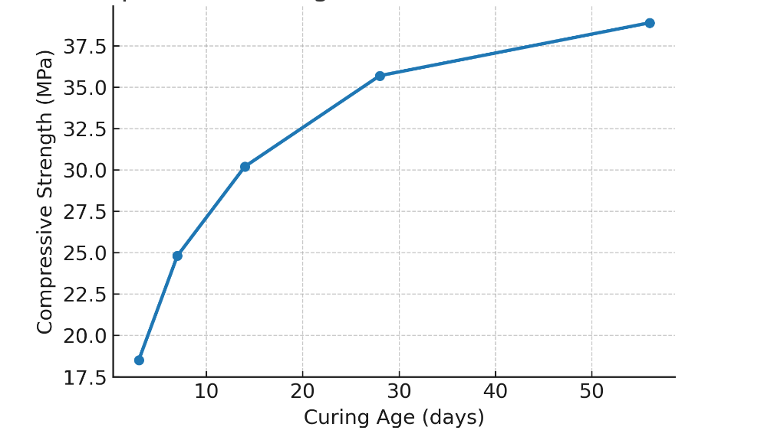
Figure 1. Compressive Strength of Concrete at Different Curing Ages

Figure 1 illustrates the increase in compressive strength of concrete specimens over different curing ages. A steady gain in strength is observed from 3 to 56 days, with the most rapid development occurring between 3 and 28 days. After 28 days, the rate of strength gain slows down, but the specimens continue to exhibit improvement, reaching their highest average strength of 38.9 MPa at 56 days. The trend confirms the strong influence of curing time on the mechanical performance of concrete.

3.2 Discussion
The discussion section interprets the findings of this study within the context of existing research, explores their practical implications, evaluates the strengths and limitations, and provides recommendations for future research.
Interpretation of Key Findings
The results of this study indicate that compressive strength develops rapidly in the early curing period and continues to increase, though at a slower rate, after 28 days. By 56 days, the specimens achieved their highest recorded strength, which aligns with the typical hydration process where early-age reactions contribute most significantly to strength gain. Similar findings have been reported in previous studies. For example, a study on concrete made with white and grey cements showed that compressive strength reached approximately 84–90% of its 28-day value by the 14th day and approached 97% at 28 days, confirming that the majority of strength is gained within the first month of curing [2].
Comparison with Previous Studies
Further evidence is provided by research on concretes incorporating supplementary cementitious materials (SCMs), which demonstrated that although early-age strengths (3–7 days) were lower, strength continued to develop beyond 28 days, with significant gains observed at later ages [4]. Another recent investigation highlighted that delayed strength gains in SCM concretes can be leveraged for cost efficiency and sustainability, as the materials continue to hydrate and densify well after the conventional 28-day benchmark [3]. These studies support the current finding that while the majority of compressive strength develops within the first 28 days, extended curing contributes to further improvements in long-term performance.
Limitations and Cautions (if any)
Although the results clearly demonstrate the influence of curing age on the development of compressive strength, certain limitations should be noted. First, the data were obtained under controlled laboratory conditions with consistent curing, which may not fully represent field conditions where temperature, humidity, and curing practices can vary. Second, the sample size was limited to the specimens tested in this study, which may restrict the generalizability of the findings to other concrete mixes, cement types, or environmental conditions.
Caution should also be exercised in interpreting the long-term strength development. While the specimens continued to gain strength up to 56 days, the rate of increase diminished after 28 days. This indicates that although extended curing contributes to improved performance, the practical benefits in the field may be less pronounced beyond one month of curing. Furthermore, additional factors such as mix design, water–cement ratio, and the use of supplementary cementitious materials could significantly alter the strength development profile.
Recommendations for Future Research (if any)
Future studies should explore strength development under varying environmental conditions and with different mix designs, water–cement ratios, and cement types. The influence of supplementary cementitious materials (SCMs) beyond 56 days also warrants further investigation. Microstructural analysis and large-scale field studies are recommended to clarify hydration mechanisms and validate laboratory findings for practical applications.

- Conclusion
This study investigated [insert research focus] and aimed to [restate research objectives]. The findings demonstrated that [summarize the main results], highlighting [specific trends or unique insights]. Notably, [mention any novel contributions or context-specific findings]. These results underscore [practical or theoretical implications], suggesting [recommend interventions, strategies, or broader relevance].

Ethical Approval (if any)
For example: This study did not involve human participants, animals, or sensitive data, and, therefore did not require approval from an ethics committee. All experimental procedures were conducted in accordance with standard laboratory protocols and occupational safety guidelines at [Institution Name]. The research complied with institutional regulations regarding the safe handling, storage, and disposal of construction materials and test specimens.

Acknowlegement (if any)
For example, The authors would like to express their gratitude to [Institution Name], [Laboratory/Department], and all technical staff who supported the experimental work. Appreciation is also extended to colleagues and reviewers whose constructive feedback contributed to the improvement of this manuscript.

References
The reference is written using the Institute of Electrical and Electronics Engineers (IEEE) citation style. It is recommended to use reference management software (Mendeley). The minimum number of references is 20, with 70% consisting of journal articles. For example:

[1] N. Librarians, “Research Guides: IEEE Citation Guide: Home”, Accessed: Oct. 04, 2025. [Online]. Available: https://researchguides.njit.edu/ieee-citation/home
[2] A. Ginting, D. H. Pradikta, B. Santosa, and P. Adi, “Comparison of Compressive Strength of Concrete Using White Portland Cement with Gray Cement,” Jurnal Teknik Sipil & Perencanaan, vol. 24, no. 1, pp. 1–7, 2022.
[3] W. S. de Jesus et al., “Leveraging Delayed Strength Gains in Supplementary Cementitious Material Concretes: Rethinking Mix Design for Enhanced Cost Efficiency and Sustainability,” Journal of Composites Science, vol. 9, no. 3, p. 110, Mar. 2025, doi: 10.3390/JCS9030110/S1.
[4] G. B. Bekkeri, K. K. Shetty, G. Nayak, and A. Kumar K A, “Durability performance of concrete incorporated with alkali-activated artificial aggregates,” Emergent Mater, vol. 8, no. 3, pp. 1895–1917, Mar. 2025, doi: 10.1007/S42247-024-00855-2/FIGURES/25.

