🌐 Ripple of Influence Worksheet

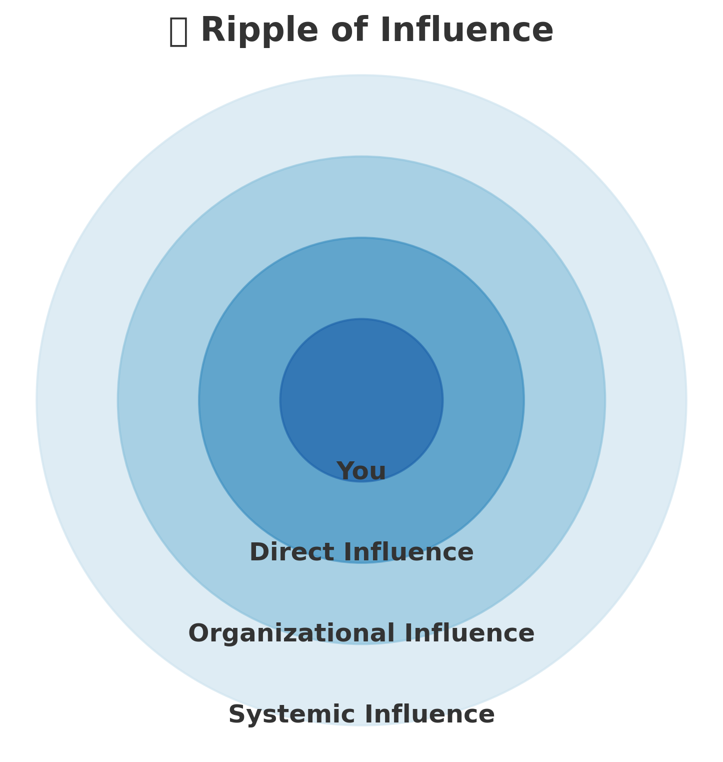

# Center: YOU

Your role + Personal strengths that coworkers appreciate (good listener, share home-cooked meals, sense of humor, etc.)

__________________________________________________________________________________  
__________________________________________________________________________________  
__________________________________________________________________________________

# Direct Influence

Who do you frequently come in contact with in your role? Who do you impact every day? How does your influence look? (e.g. your team, peers, colleagues, people served)

__________________________________________________________________________________  
__________________________________________________________________________________  
__________________________________________________________________________________

# Organizational Influence

What organizational policies, practices, groups or cultures do you shape—directly or indirectly?

__________________________________________________________________________________  
__________________________________________________________________________________  
__________________________________________________________________________________

# Systemic Influence

How might your actions, voice, and other influences ripple outward into the broader system(s), like routine system wide calls or informal contact with other agencies or facilities?

__________________________________________________________________________________  
__________________________________________________________________________________  
__________________________________________________________________________________

# Reflection

Which sphere or area do you most often focus your attention on? Which sphere do you want to increase your influence or focus?

__________________________________________________________________________________  
__________________________________________________________________________________  
__________________________________________________________________________________