
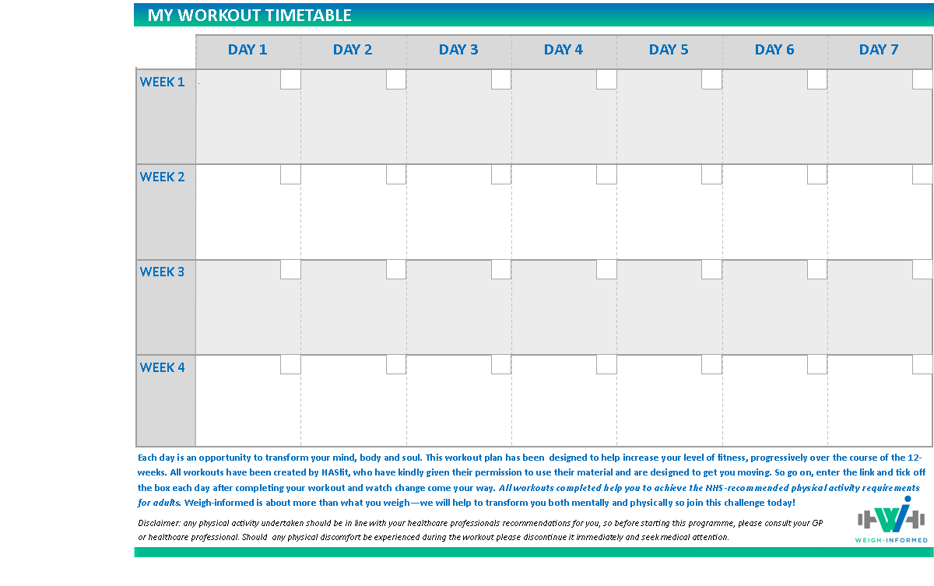

Week 1-4: You will…
Standing Abs and Low Impact Cardio for Beginners
Duration: 35 minutes
Optional: Dumbbells or water bottles!

Beginner Cardio and Strength Training
Duration: 25 minutes
Equipment required: Dumbbells or water bottles!

Active recovery day! Go on a brisk walk or do some light stretching using HASfit’s flexibility and mobility routines

Standing Abs and Low Impact Cardio for Beginners – No jumping
Duration: 40 minutes
Optional: Dumbbells or water bottles!

Beginner Strength Training
Duration: 30 minutes
Equipment required: Dumbbells or water bottles!

Low Impact Cardio Workout for Beginners
Duration: 20 minutes
Optional: Dumbbells or water bottles!

Active recovery day! Go on a brisk walk or do some light stretching using HASfit’s flexibility and mobility routines

Standing Abs and Low Impact Cardio for Beginners – No jumping
Duration: 40 minutes
Optional: Dumbbells or water bottles!

Beginner Strength Training
Duration: 30 minutes
Equipment required: Dumbbells or water bottles!

Active recovery day! Go on a brisk walk or do some light stretching using HASfit’s flexibility and mobility routines

Beginner Cardio and Strength Training
Duration: 25 minutes
Equipment required: Dumbbells or water bottles!

Standing Abs and Low Impact Cardio for Beginners
Duration: 35 minutes
Optional: Dumbbells or water bottles!

Low Impact Cardio Workout for Beginners
Duration: 20 minutes
Optional: Dumbbells or water bottles!

Active recovery day! Go on a brisk walk or do some light stretching using HASfit’s flexibility and mobility routines

Standing Abs and Low Impact Cardio for Beginners – No jumping
Duration: 40 minutes
Optional: Dumbbells or water bottles!

Beginner Strength Training
Duration: 30 minutes
Equipment required: Dumbbells or water bottles!

Active recovery day! Go on a brisk walk or do some light stretching using HASfit’s flexibility and mobility routines

Beginner Cardio and Strength Training
Duration: 25 minutes
Equipment required: Dumbbells or water bottles!

Standing Abs and Low Impact Cardio for Beginners
Duration: 35 minutes
Optional: Dumbbells or water bottles!

Low Impact Cardio Workout for Beginners
Duration: 20 minutes
Optional: Dumbbells or water bottles!

Active recovery day! Go on a brisk walk or do some light stretching using HASfit’s flexibility and mobility routines

Standing Abs and Low Impact Cardio for Beginners
Duration: 35 minutes
Optional: Dumbbells or water bottles!

Beginner Cardio and Strength Training
Duration: 25 minutes
Equipment required: Dumbbells or water bottles!

Active recovery day! Go on a brisk walk or do some light stretching using HASfit’s flexibility and mobility routines

Standing Abs and Low Impact Cardio for Beginners – No jumping
Duration: 40 minutes
Optional: Dumbbells or water bottles!

Beginner Strength Training
Duration: 30 minutes
Equipment required: Dumbbells or water bottles!

Low Impact Cardio Workout for Beginners
Duration: 20 minutes
Optional: Dumbbells or water bottles!

Active recovery day! Go on a brisk walk or do some light stretching using HASfit’s flexibility and mobility routines

Each day is an opportunity to transform your mind, body and soul. This workout plan has been designed to help increase your level of fitness, progressively over the course of 12-weeks. All workouts have been created by HASfit, who have kindly given their permission to share this material with you and are designed to get you moving. So, go on, download and click the link for your workout. Keep track of the workouts you have completed by ticking it off in your journal. All workouts completed help you to achieve the NHS-recommended physical activity requirements for adults. Weigh-informed is about more than what you weigh—we will help to transform you both mentally and physically so join this challenge today!
Disclaimer: any physical activity undertaken should be in line with your healthcare professionals’ recommendations for you, so before starting this programme, please consult your GP or healthcare professional. Should any physical discomfort be experienced during the workout please discontinue it immediately and seek medical attention.
MY WORKOUT TIMETABLE
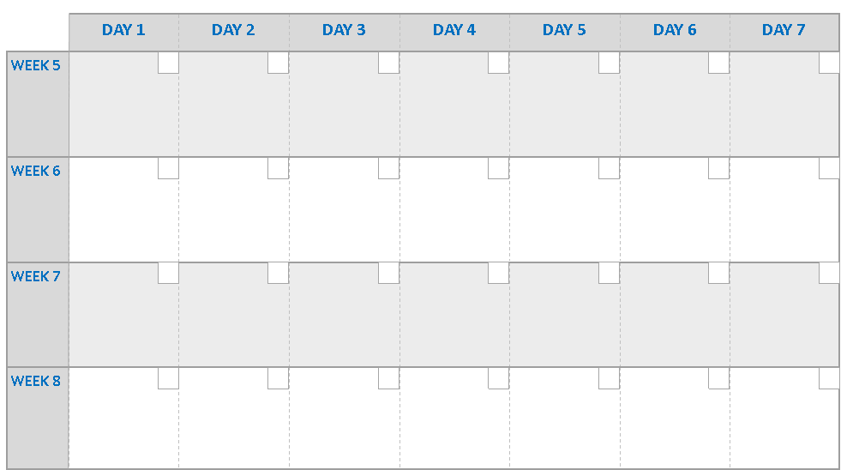
Week 5-8: …feel more energised
Cardio Kickboxing Workout
Duration: 30 minutes
Optional: Dumbbells or water bottles!

Total body workout with weights
Duration: 25 minutes
Equipment required: Dumbbells or water bottles!

Active recovery day! Go on a brisk walk or do some light stretching using HASfit’s flexibility and mobility routines

HITT Cardio Abs no equipment
Duration: 25 minutes

Full total body strength
Duration: 40 minutes
Equipment required: Dumbbells or water bottles!

Tabata Cardio with modifications (if required) – no equipment
Duration: 30 minutes

Active recovery day! Go on a brisk walk or do some light stretching using HASfit’s flexibility and mobility routines

Active recovery day! Go on a brisk walk or do some light stretching using HASfit’s flexibility and mobility routines

Active recovery day! Go on a brisk walk or do some light stretching using HASfit’s flexibility and mobility routines

Total body workout with weights
Duration: 25 minutes
Equipment required: Dumbbells or water bottles!

Full total body strength
Duration: 40 minutes
Equipment required: Dumbbells or water bottles!

Cardio Kickboxing Workout
Duration: 30 minutes
Optional: Dumbbells or water bottles!

Tabata Cardio with modifications (if required) – no equipment
Duration: 30 minutes

HITT Cardio Abs no equipment
Duration: 25 minutes

Cardio Kickboxing Workout
Duration: 30 minutes
Optional: Dumbbells or water bottles!

Total body workout with weights
Duration: 25 minutes
Equipment required: Dumbbells or water bottles!

Active recovery day! Go on a brisk walk or do some light stretching using HASfit’s flexibility and mobility routines

HITT Cardio Abs no equipment
Duration: 25 minutes

Full total body strength
Duration: 40 minutes
Equipment required: Dumbbells or water bottles!

Tabata Cardio with modifications (if required) – no equipment
Duration: 30 minutes

Active recovery day! Go on a brisk walk or do some light stretching using HASfit’s flexibility and mobility routines

Active recovery day! Go on a brisk walk or do some light stretching using HASfit’s flexibility and mobility routines

Active recovery day! Go on a brisk walk or do some light stretching using HASfit’s flexibility and mobility routines

Total body workout with weights
Duration: 25 minutes
Equipment required: Dumbbells or water bottles!

Full total body strength
Duration: 40 minutes
Equipment required: Dumbbells or water bottles!

Cardio Kickboxing Workout
Duration: 30 minutes
Optional: Dumbbells or water bottles!

Tabata Cardio with modifications (if required) – no equipment
Duration: 30 minutes

HITT Cardio Abs no equipment
Duration: 25 minutes

MY WORKOUT TIMETABLE

Each day is an opportunity to transform your mind, body and soul. This workout plan has been designed to help increase your level of fitness, progressively over the course of 12-weeks. All workouts have been created by HASfit, who have kindly given their permission to share this material with you and are designed to get you moving. So, go on, download and click the link for your workout. Keep track of the workouts you have completed by ticking it off in your journal. All workouts completed help you to achieve the NHS-recommended physical activity requirements for adults. Weigh-informed is about more than what you weigh—we will help to transform you both mentally and physically so join this challenge today!
Disclaimer: any physical activity undertaken should be in line with your healthcare professionals’ recommendations for you, so before starting this programme, please consult your GP or healthcare professional. Should any physical discomfort be experienced during the workout please discontinue it immediately and seek medical attention.

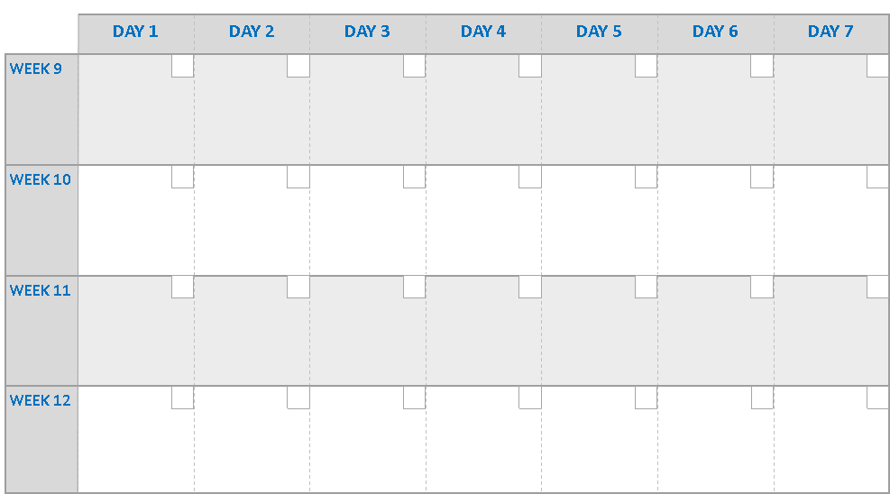
Week 9-12: …confident and healthier - than last time!
Tabata cardio workout – full body HITT with no equipment and modifications (if required)
Duration: 40 minutes

Full body strength training
Duration: 30 minutes
Equipment required: Dumbbells or water bottles!

Active recovery day! Go on a brisk walk or do some light stretching using HASfit’s flexibility and mobility routines

Active recovery day! Go on a brisk walk or do some light stretching using HASfit’s flexibility and mobility routines

Active recovery day! Go on a brisk walk or do some light stretching using HASfit’s flexibility and mobility routines

Active recovery day! Go on a brisk walk or do some light stretching using HASfit’s flexibility and mobility routines

Cardio Kickboxing workout
Duration: 40 minutes
Optional: Dumbbells or water bottles!

Full body strength workout
Duration: 30 minutes Equipment required: Dumbbells or water bottles!

Standing Abs workout
Duration: 10 minutes
Optional: Dumbbells or water bottles!

Full body strength training
Duration: 30 minutes
Equipment required: Dumbbells or water bottles!

Full body strength workout
Duration: 30 minutes Equipment required: Dumbbells or water bottles!

Tabata cardio workout – full body HITT with no equipment and modifications (if required)
Duration: 40 minutes

Cardio Kickboxing workout
Duration: 40 minutes
Optional: Dumbbells or water bottles!

Standing Abs workout
Duration: 10 minutes
Optional: Dumbbells or water bottles!

Tabata cardio workout – full body HITT with no equipment and modifications (if required)
Duration: 40 minutes

Full body strength training
Duration: 30 minutes
Equipment required: Dumbbells or water bottles!

Active recovery day! Go on a brisk walk or do some light stretching using HASfit’s flexibility and mobility routines

Active recovery day! Go on a brisk walk or do some light stretching using HASfit’s flexibility and mobility routines

Active recovery day! Go on a brisk walk or do some light stretching using HASfit’s flexibility and mobility routines

Active recovery day! Go on a brisk walk or do some light stretching using HASfit’s flexibility and mobility routines

Cardio Kickboxing workout
Duration: 40 minutes
Optional: Dumbbells or water bottles!

Full body strength workout
Duration: 30 minutes Equipment required: Dumbbells or water bottles!

Standing Abs workout
Duration: 10 minutes
Optional: Dumbbells or water bottles!

Full body strength training
Duration: 30 minutes
Equipment required: Dumbbells or water bottles!

Full body strength workout
Duration: 30 minutes Equipment required: Dumbbells or water bottles!

Tabata cardio workout – full body HITT with no equipment and modifications (if required)
Duration: 40 minutes

Cardio Kickboxing workout
Duration: 40 minutes
Optional: Dumbbells or water bottles!

Standing Abs workout
Duration: 10 minutes
Optional: Dumbbells or water bottles!

Each day is an opportunity to transform your mind, body and soul. This workout plan has been designed to help increase your level of fitness, progressively over the course of 12-weeks. All workouts have been created by HASfit, who have kindly given their permission to share this material with you and are designed to get you moving. So, go on, download and click the link for your workout. Keep track of the workouts you have completed by ticking it off in your journal. All workouts completed help you to achieve the NHS-recommended physical activity requirements for adults. Weigh-informed is about more than what you weigh—we will help to transform you both mentally and physically so join this challenge today!
Disclaimer: any physical activity undertaken should be in line with your healthcare professionals’ recommendations for you, so before starting this programme, please consult your GP or healthcare professional. Should any physical discomfort be experienced during the workout please discontinue it immediately and seek medical attention.

MY WORKOUT TIMETABLE

