**🛑You do not need permission to download this file🛑  
Google Doc: To make a copy of this document: Go to File and select- “Make a copy”.   
Word Doc: To download a copy of this document- Go to File and select “Download as” choose .doc or .rtf. Save it on your computer and you can then complete your work. You may need to click “enable editing”.**

5.01 It's Manifest Destiny!—Guided Notes

Directions: Your Guided Notes are a tool to use as you read your lesson pages in the course. These important notes will help you complete your lesson assessment, as well as prepare you for Discussion-Based Assessments, unit exams, and segment exams. You do not need to submit your Guided Notes for grading.

**Key Vocabulary**

| **Word** | **Meaning (use context clues)** |
| --- | --- |
| Manifest Destiny |  |
| Treaties |  |
| Ceded |  |

**Questions and Answers**

1. Why were people from the East interested in moving West?

2. What was the impact on Native Americans?

**Two-Column Note Chart**

Use this chart to note important facts and events about early government action. Some subtopics are provided for you to add notes and details.

| **Section Headings** | **Details from Section Headings**  **Elaboration of Subtopics** |
| --- | --- |
| Determining Borders | · Importance of border locations    · 49th parallel    · Maine    · Native Americans |
| New Additions | · Adams-Onis Treaty    · Monroe Doctrine |

Unless Otherwise Noted All Content © 2022 Florida Virtual School. FlexPoint Education Cloud™ is a trademark of Florida Virtual School.

**5.02 A Native Dilemma—Guided Notes**

**Key Vocabulary**

| **Word** | **Meaning (use context clues)** |
| --- | --- |
| Assimilation |  |
| Culture |  |
| Paternalism |  |
| Controversial |  |
| Exposure |  |

**Questions and Answers**

What was Knox's main goal for creating treaties?

Outline the *Cherokee Nation v. Georgia* court trial of 1831 below in your words.

What was the Trail of Tears?

What challenges did the survivors of the Trail of Tears face?

5.03 Keep the Peace—Guided Notes

**Key Vocabulary**

| **Word** | **Meaning (use context clues)** |
| --- | --- |
| Fraud |  |
| Arsenal |  |

**Questions and Answers**

Slavery created issues that required the attention of the federal government to settle because they affected people in multiple states or territories at the same time. How did the government choose to address the issues?

When the Northern states passed laws banning slavery, what was the response from the Southern states? What was the impact on the entire nation?

**Compromises and Consequences**

| **Event** | **Notes** |
| --- | --- |
| Missouri Compromise |  |
| Compromise of 1850 |  |
| Kansas-Nebraska Act |  |
| Dred Scott v. Sandford |  |
| Fugitive Slave Act |  |
| Nat Turner's Rebellion |  |
| Bleeding Kansas |  |
| Harpers Ferry |  |

5.04 New Land!—Guided Notes

**Key Vocabulary**

| **Word** | **Meaning (use context clues)** |
| --- | --- |
| Manifest Destiny |  |
| Migration |  |
| 54-40 or Fight! |  |
| 49th Parallel |  |

**Answer Questions**

Use information from the lesson to answer these questions. You may write phrases or draw pictures to help you learn.

| **Why did people move west?** |
| --- |
| **How did they get there?** |
| **What was the journey like?** |
| **What did they bring with them?** |
| **What was life like at their new home?** |
| **How would you describe California culture?** |

Unless Otherwise Noted All Content © 2022 Florida Virtual School. FlexPoint Education Cloud™ is a trademark of Florida Virtual School.

5.05 Train's Leavin'!—Guided Notes

**Key Vocabulary**

| **Word** | **Meaning (use context clues)** |
| --- | --- |
| Economic |  |
| Macadam |  |
| Industrialization |  |
| Discrimination |  |
| Railroad ties |  |
| Everglades |  |

Unless Otherwise Noted All Content © 2022 Florida Virtual School. FlexPoint Education Cloud™ is a trademark of Florida Virtual School.

**Transportation Changes**

Use the chart below to fill in details about 19th century transportation changes.

| **Transportation Type** | **Notes** |
| --- | --- |
|  |  |
|  |  |
|  |  |
|  |  |

### 

### What were some of the effects of the progress being made in transportation?

Unless Otherwise Noted All Content © 2022 Florida Virtual School. FlexPoint Education Cloud™ is a trademark of Florida Virtual School.

**5.06 Friend or Foe, Mexico?—Guided Notes**

**Key Vocabulary**

| **Word** | **Meaning (use context clues)** |
| --- | --- |
| Annex |  |

Unless Otherwise Noted All Content © 2022 Florida Virtual School. FlexPoint Education Cloud™ is a trademark of Florida Virtual School.

**Label the Map**

Label and shade areas of the map related to events in the lesson. Be sure to include the areas of Texas, the Mexican Cession, and the Gadsden Purchase.

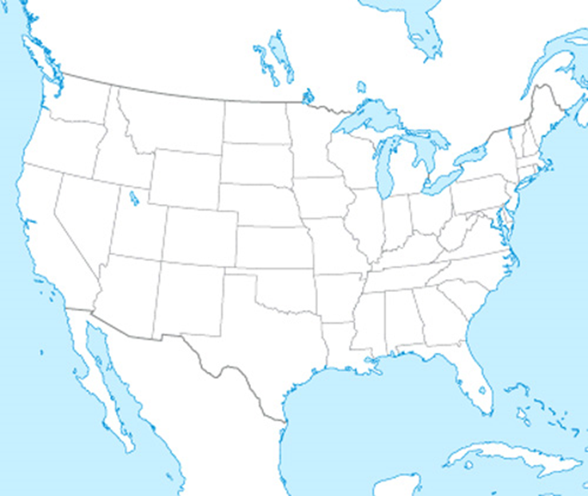

**Graphic Organizer**

Fill in important facts from the lesson about the time before, during, and following the Mexican-American War.

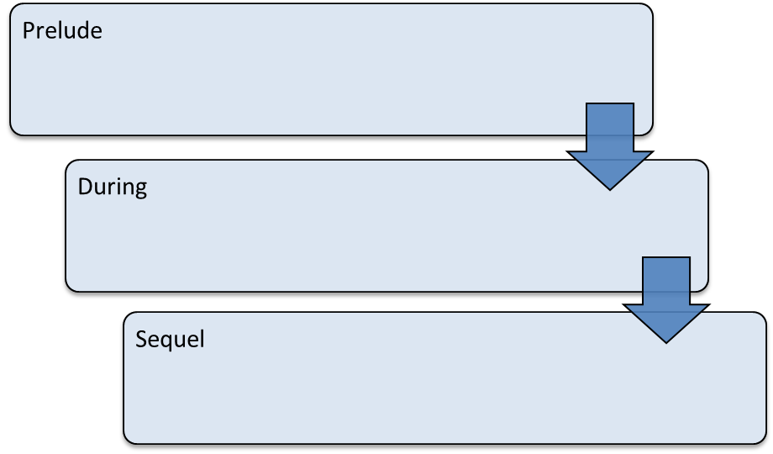

5.07 Set Sail Discussion-Based Assessment—Guided Notes

**Reviewing the Lessons**

Use your guided notes, the interactive on the introduction page of the lesson, and what you remember from Module Five to complete this chart.

| **Island of Exploration** | **Lesson** | **What is something you learned in this lesson that you think is important?** |
| --- | --- | --- |
| Manifest Destiny Point | 05.01 It’s Manifest Destiny |  |
| Native Inlet | 05.02 A Native Dilemma |  |
| Balance Bay | 05.03 Keep the Peace |  |
| Homestead Junction | 05.04 New Land! |  |
| Transport Canal | 05.05 Train’s Leavin’! |  |
| Hidalgo Territory | 05.06 Friend or Foe, Mexico? |  |

**Making Connections**

Use your guided notes, the interactive on the introduction page of the lesson, and what you remember from Module Five to complete this chart.

| **Question** | **Response** |
| --- | --- |
| How did the government encourage the idea of Manifest Destiny? | What did the government do to make moving west easier? |
| How did Americans and Native Americans interact? | What goals did the government have for Native Americans and their lands?          What was the Trail of Tears and how did it affect Native Americans? |
| How did the country deal with arguments over slavery? | How did the addition of new territory to the U.S. affect the question of slavery?          What compromises were made relating to slavery in the 1800s? What were their effects? |
| Why did people move west? | How did the gold rush change California? |
| How did transportation change in the 1800s? | What were some effects of improvements in transportation? |
| Why did the U.S. go to war with Mexico? | How was Texas involved in the war?          What were the effects of the war? |

Unless Otherwise Noted All Content © 2022 Florida Virtual School. FlexPoint Education Cloud™ is a trademark of Florida Virtual School.

Unless Otherwise Noted All Content © 2022 Florida Virtual School. FlexPoint Education Cloud™ is a trademark of Florida Virtual School.