

Resume example
Hello Valued Applicant,
Creating a standout resume has never been easier! Our resumes feature clean, modern designs tailored to make a lasting impression. Crafted by certified resume writers and optimized for ATS compatibility, they’re built to help you succeed in today’s competitive job market.

Here’s how we can help you:
Build Your Resume – Our simple tool makes creating a standout resume quick and stress-free.
Browse Resume Templates – Choose from modern, eye-catching designs tailored to impress.
Explore Resume Examples – Get inspired by samples made for every industry and role.
Write the Perfect Cover Letter – Complete your application with a compelling cover letter that wins interviews.
Job Search – Visit our blog for expert tips and strategies to help you land your dream job.
Take the guesswork out of job applications and start creating your future today. We’ll make sure you’re ready to seize every opportunity with confidence!
Your next chapter starts here – let’s get started.

Warm regards,
The Resume Example Team

How to write a Production Worker Resume

1. Start with a Strong Resume Summary
Your resume should begin with a compelling summary highlighting your experience, key skills, and work ethic.
🔹 Keep it short (2–3 sentences).
🔹 Showcase your most relevant experience and contributions.
🔹 Use action words like "operated," "assembled," "maintained," "inspected," etc.

2. Highlight Relevant Skills
Employers look for specific hard and soft skills when hiring production workers. Make sure to include:

🔧 Hard Skills (Technical Skills):
✔ Machine operation & maintenance
✔ Assembly line production
✔ Quality control & inspection
✔ Forklift operation (if applicable)
✔ Workplace safety compliance
✔ Inventory management
✔ Packing & labeling

💡 Soft Skills (Workplace Abilities):
✔ Attention to detail
✔ Teamwork & collaboration
✔ Problem-solving skills
✔ Ability to follow instructions
✔ Time management
✔ Physical stamina

3. Structure Your Work Experience Effectively
Use reverse chronological order (most recent job first). Each job entry should include:
🔹 Job title & company name
🔹 Dates of employment
🔹 Key responsibilities and achievements (use bullet points)

4. Education & Certifications
If you have relevant education or certifications, list them here.
Example:
- High School Diploma – Springfield High School, Springfield, IL
- OSHA Safety Certification – Completed 2023
- Forklift Operator Certification (if applicable)

5. Tailor Your Resume for Each Job Application
📌 Pro Tip: Customize your resume for each job using keywords from the job posting. Many companies use Applicant Tracking Systems (ATS) to filter resumes based on relevant terms.
Example: If a job description mentions "experience with CNC machines," include that in your skills or work experience (if applicable).

6. Format Your Resume for Readability
✅ Use a simple, clean layout (no fancy fonts or graphics).
✅ Stick to one page, especially if you have less than 10 years of experience.
✅ Use bullet points to enhance readability.
✅ Save as a PDF or Word document to ensure compatibility with ATS systems.

Production Worker Resume Example

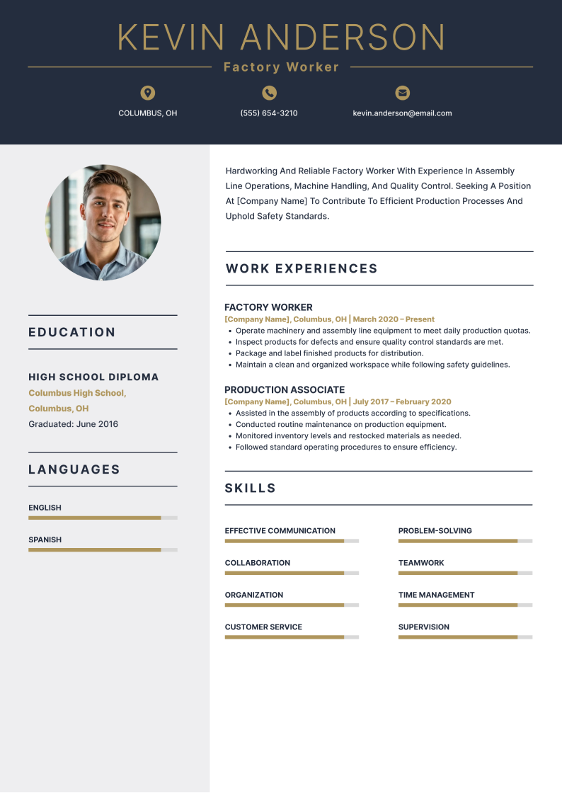

Production Worker Resume Checklist

Check your production worker resume if it has all the critical elements:

✅ Professional Contact Information (Name, Phone, Email)
✅ Strong Resume Summary (2–3 impactful sentences)
✅ Relevant Skills Section (Technical & Soft Skills)
✅ Work Experience with Measurable Achievements
✅ Education & Certifications (if applicable)
✅ ATS-Optimized Keywords (from the job posting)
✅ Proper Formatting & Proofreading

If you're unsure about writing your resume or want to save time, we're here to help.
Use our resume builder to create a professional, ATS-friendly resume in minutes—boosting your chances of landing an interview and securing your dream job.

Good Luck!

