Web Source Analysis Assignment

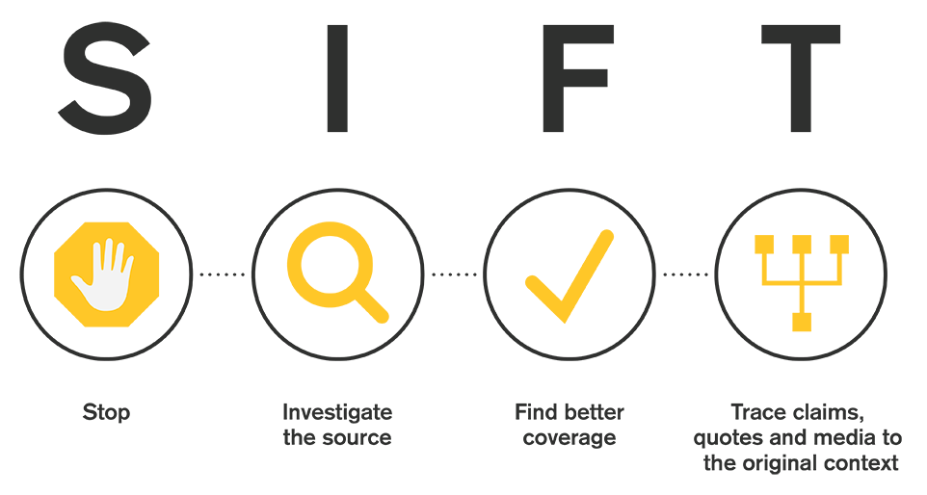
Use the SIFT method to analyse your source.

Stop
Do not use the source in your research until you know what it is, and you can verify it is reliable.

- What is the title of the article or webpage? What website is it from?

- Do you already know and trust this website? Why or why not?

Investigate the source
Look OUTSIDE of the website to investigate the source of the information; this is usually the website publisher/media company.

- What did you find out about the source that you didn’t already know? Does it match what you initially thought about the website? Does it match what the website says about itself?

- What can you find out about the author? Do they have a record of fairness and accuracy?

- If you can not find any additional information about the author or source, what does that tell you?

Find trusted coverage
Trade up! Find the best reporting on the topic. Skim results list for a source that has a verification process in place.

- After scanning multiple sources on a claim, is there a consensus among others?

- What do other sources say about the claim and what does that tell you about your original source?

Trace claims, quotes, and media back to the original context

If the article refers to an original study or news article, follow the links to the original claim.

- Is the source original reporting or re-reporting from another website?

- What evidence is presented to support the claim? Can you find the evidence, and if so, does the source accurately summarize it? If not, what is left out and have details been added to it?

