 | Activity Guide: Invent a Binary Protocol for Battleship | 

Overview
Previously you came up with a method for exchanging messages on an open broadcast channel to play multiple games of Battleship at once. Now that you’ve played Battleship this way, with your group or with a partner, describe an efficient binary protocol for playing a 3-person game of Battleship that can be played accurately over the Internet Simulator.

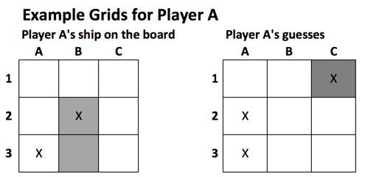
Let “efficient” mean that your protocol uses the smallest reasonable number of bits (0s and 1s) to make messages for Battleship that still contain all of the necessary information for playing the game.
Directions
- List all of the information (data) that you will need to communicate in order to play Battleship. You will need to express all of this with your protocol, so think about how you can express each piece of data in binary.

- Make a diagram or chart that explains the protocol, what the bits represent, and how to use the protocol to play Battleship. Don’t worry about coming up with a “correct” protocol -- just one that works! Make sure that the diagram shows some example encodings of things that can happen during play.

While developing your protocol here are some questions and suggestions to think about:
- Remember that ultimately you are making a communication protocol for a computer to read, so if it’s hard for a human to decipher, but would be easy to describe for a computer, that’s fine.

- A message you send over the Internet is just a string of 0s and 1s -- so your protocol should indicate how the bits work (i.e. what is the binary representation?)

- You can also invent other rules or standards of play that would help make the protocol work well.

- Think about using numeric addresses rather than people’s names.

- Think about what else you can communicate with binary to reduce the total number of bits. How “efficient” can you make your message? How small can you make the size of a message?

- You might consider testing out your protocol with the Internet Simulator to see if it’s viable.

Rubric
Criteria | Yes | No | Comments
All data required for a Battleship message is represented as a binary protocol.
An example of a Battleship message is given and explained.
All data required for a Battleship response is represented as a binary protocol.
An example of a Battleship response is given and explained.
The overall protocol is explained clearly.

