Name(s)_______________________________________________ Period ______ Date ___________________
Activity Guide - Using the Problem Solving Process

Word Search

Overview
Working with a team find the following words in the grid. They may be horizontal, vertical, or diagonal in any direction.
DEFINE, PREPARE, TRY, REFLECT, PROBLEM, SOLVE, COMPUTER, SCIENCE

Objective
Find and circle all 8 words as quickly as you can!

E S Q H J H R C F A X M G M U E B L N I
S R K E R E T U P M O C E C M Z T Y J C
D X A P N X Q L Y V K L S X X N C E H N
J M X P K W W O J Q B B O Q M H E E H T
B I U O E Y H K M O A N L F R D L P H A
N J H T Y R A E R C F L V M S C F A J M
T I R Y Q W P P H D X Q E Q U N E R G S
H Y R I M I X D Z K B M N G O J R B K U
P U B U E U J E G D T F B D T I M V V P
H V W S K F D G K V D M S O X Y O R S F
S C I E N C E W P Q T E O R I A S Q M U
H R G X Y V N H I J D C F G V H E M Z M
U O H H N A G X O Q K K B I G M T W O L
O P E I O Q G B A R V H P N N A Z E X V
Y I S W N R N U U W G H X H A E B O P N
L X D J X R P V Y J H U H X D Y F O I D
F U D J X V U K F C V D Q B P D Z I B D
F B R D S I W P K F K V T R D R G Y C R
Y E T Y O D M X H L L V P T J V I J C D
H E X K R O I P B W E T O Y X I B W V O

Once You’re Done
Head to the last page of the activity guide and fill in the row there for the “Word Search” in the table.

Birthday Guests

Overview
A big group of 15 guests is getting together at a restaurant for a birthday. The restaurant has 3 tables that can each seat only 5 people. Below you can find some information about the people who are attending the party.

Aysha, Ben, Carla, Damien, Eric, Fan, Genaro, Hannah, Isaias, Jessica, Kyla, Laila, Max, Nazek, Owen

Close Friends (Try to put them together)  Aysha and Damien  Max and Isaias  Nazek and Laila  Owen and Genaro  Ben and Jessica  Genaro and Eric | In a Fight (Try to keep them apart)  Aysha and Genaro  Ben and Hannah  Fan and Max  Damien and Laila  Isaias and Owen  Kyla and Jessica

Objective
Find the best possible arrangement of guests at the party. Draw your solution in the space below. To help you can cross out the letters of the names you’ve assigned in the row below.

A | B | C | D | E | F | G | H | I | J | K | L | M | N | O
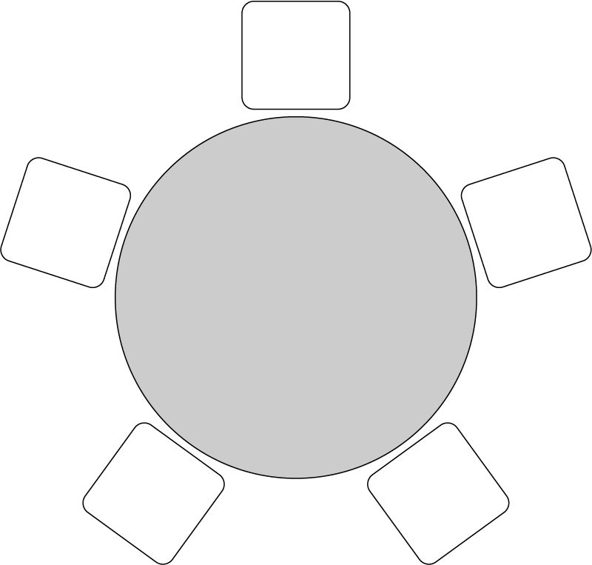
O
G
E
J
B
A
F
K
C
D
H
M
I
N
L

Note: This is one of many possible
solutions.

Once You’re Done
Head to the last page of the activity guide and fill in the row there for the “Birthday Guests” in the table.

Plan a Trip

Overview
You and your friends will be going on a trip. You’ve got the entire school day to travel, and you need to get back to school by the end of the trip, but otherwise how your trip goes it up to you. Plan the best trip that you can!

Explore the Tool
Head to https://www.google.com/maps and search for your school. Look at the different options for finding directions to other locations. Don’t worry about making a plan yet, but make sure you understand what kinds of information are available.

Develop Criteria
Talk with your group for a few minutes. What matters when assessing different possible trips? Do you care what you see? How you get there? How long it takes? What it costs? Write down the criteria you’ll use to assess different possible plans.

Criteria | Goals | How My Plan Accounts for It
Total Time for the Trip | One school day | My trip only takes one day
Total Travel Time | 2 hours of driving each direction | According to my directions it’s 56 minutes in each direction.
Types of Things We Want To Do | Something outside. Something that everyone can join in on. | The amusement park is outside and there’s lots of different things to do there.
What Food We’ll Eat | Something most people like | Pizza! Large pizza is only $15 each so we can get one for every 5 people and be under budget.
Costs | Shouldn’t be more than $20 a person to participate. Ideally free. | Tickets are only $15 a person. This is a little close to our limit.

Make a Route
Every member of your group should separately start planning your trip. You should select what places you want to go and what activities you want to do along the way. Try to make it the best possible trip based on the criteria you and your group agreed upon. For each criteria your group chose, list how your trip accounts for it in the right column. In the space below record all the stops along your trip.

Stops on My Trip
- Leave from school
- Head straight to amusement park
- Eat pizza at the park
- Head back to school

Things We’ll See
- Amusement park!

Share Your Route and Get Feedback
Share the route you developed with your teammates and explain why you think it is the best possible route given the criteria you chose. Afterwards record their feedback and reactions to your route in the space below. Is there anything that needs to change? How could your route improve?
It turns out that a lot of my friends actually DON’T want to go to the amusement park. It’s probably going to be more expensive than I thought too. I like my classmate’s suggestion that we go to the beach an hour away though since it’s free.

Improve and Finalize
Using the feedback from your teammates update your route. In the space below write any changes to how your new route addresses the criteria you selected.

I have updated my route to go to the beach instead. It now takes 45 minutes to go each direction. We can still order pizza to the beach though!

Once You’re Done
Head to the last page of the activity guide and fill in the row there for the “Road Trip” in the table.

Problem Solving Process Notes

Reflecting on Using the Process
How did you use each step of the problem solving process to solve this problem? Give examples of what each step looked like as you were solving that problem.

 | Define | Prepare | Try | Reflect
Word Search | I felt like this problem was already defined. | We didn’t prepare we just jumped right in! | We just tried to find the words | We realized we should split the word search into areas for each person to search in.
Birthday Guests | It took longer to understand the problem. I read it a couple times. | We used some scratch paper to understand how to group people. | We split the work among multiple people. | We probably could solve the problem faster if we grouped friends before seating them.
Plan a Trip | We needed to decide what was important for our trip. | We considered a lot of possible places to go. | We went out and saw if the actual places we wanted to go made sense. | We showed our trips to one another.

The Purpose of Each Step
For each step in the problem solving process write one sentence explaining its purpose.

Define: We need to understand the problem we’re trying to solve before we just jump right in.

Prepare There’s usually many ways we could approach a problem so we need to first think about those

and make a plan.

Try Once you make a plan you need to actually try it.

Reflect Sometimes the first way you solved a problem wasn’t the best way so you need to reflect and

decide if you can do it better next time.

Defining Problems with Questions
Before starting to solve a problem it’s important that you have defined it well. What questions or strategies can you use to better define or understand a problem? Record them in the space below.

How will I know when I’m done? Ask “Why” to understand the way things currently work.

