

B3Networks
Product Specification for the CPaaS Contact Center Solution

Table of Contents
Product Summary 4
Product Features 5
Key Features 5
Generic Features 6
Features on the Devices 7
Auto Attendant 8
Contact Center 11
Inbound Contact Center 11
Outbound Contact Center 13
Product License Requirements 14
Functional Specs 15
Elements 15
Auto Attendant 15
Queue Management 16
Outbound Campaign 16
Communication Hub 17
Dashboard 17
Workflow Sample -1 (Inbound) 18
Workflow Sample -2 (Inbound) 18
Workflow Sample -3 (Outbound) 19
Use Cases In Various Industries 19

Document control versioning

Document History
Date | Version | Applicable BMOs | Author | Comments
19 Sept 2022 | Version 1.0 | All | Hilary | Document creation
19 Sept 2022 | Version 1.1 | All | Hallie | Amendment
14 Oct 2022 | Version 1.2 | All | Hallie | Added Outbound Contact Center
20 Dec 2022 | Version 1.3 | All | Muneeb | Call in Queue Ended  In Call Action  Survey Template

Product Summary

Our all-in-one contact center solution delivers the features of a complete professional call center, which includes all of the characteristics of a full-service, professional call center. You will be able to monitor and control performance indicators with this solution, allowing you to significantly increase work productivity while also empowering your organization to enable your workers to communicate at any time and from any location.

Your customers will be able to more easily contact the appropriate departments or agents who can quickly resolve their issues if you provide them with a number of different self-service options and an intelligent interactive voice response system that are both integrated with functionality for smart routing.



Product Features

Key Features
(Describe the key features of CPaaS Contact Center Solution)
Feature | Description
Auto Attendant | Personalize customer journeys and offer self-service voice options with a graphic, flexible IVR solution.
Queue Management | A plethora of features to optimize queue management in your contact center. Service-level, skill attribution, personalized queues, automatic callback options, etc.
Advance Call Routing | With this feature you can make use of Ring All / Round Robin / Skill-based Routing / Sticky Agent.
Announcement Message | Customize the message content by text and mp3 file, play when the customer waiting in the queue.
Communication Hub | Monitor your call center data when the agent is on the call to make quick decisions and improve your operating efficiency.
Dashboard | Custom dashboards turn a matrix of numbers into actionable insights that match customer unique needs. Organize data with custom dashboards and reports.
Supervisor Tools | With special tools, supervisors have access to active call monitoring (call barge, call spy, whisper), queue management, with detailed agent performance history.
Agent Tools | Agents are able to add notes for calls on the portal pop-up box, view the call history for customer inquiries and expectations.
Outbound Campaign | Act as auto-dialer for the campaigns with the uploaded number list.
Call in Queue Ended | Allows you to send an SMS survey to your callers after the calls finish.
In Call Action | Allows you to trigger an IVR post-call survey played to your callers.
Survey Template | Draft Survey Templates to be used later during the In-Call Action and/or Call in Queue ended.

NOTE: These features are applicable to All Countries.

Generic Features
(Describe the generic features of CPaaS Contact Center Solution)

Feature | Description
Extension Key | - User's Phone Extension Number  - Each user can have only one extension number
Multiple DIDs per user | Allow more than one DID to be set for a single user
Supports calls to International Numbers, Toll-Free, Landline, and Golden Numbers | Able to make outgoing calls to different types of numbers
Call Recording (purchased license) | - Auto record all calls to queues  - 1-year unlimited call recording storage on the Cloud  - Play & Download Call Recording Files
Organization Link | Connect two or more organizations so that they can communicate using extension keys
VIP mode | Able to hide the VIP users on the sharing Call Directory list
Customizable Outbound Rules:  - Dial Plans  - Country Whitelist | - Able to set dial plan for users  - Able to create country whitelist
NOTE: These features are applicable to All Countries.

Features on the Devices
(Describe the CPaaS Contact Center Solution features that work on the supported devices)
Feature | Description | Web Phone | Desktop App | IP  Phone | Mobile App | Supervisor | Agent
Make and Receive calls | Able to make outgoing and receive incoming calls from the registered devices | ✅ | ✅ | ✅ | ✅ | ✅ | ✅
Internal Call | Able to make internal calls from Extension to Extension | ✅ | ✅ | ✅ | ✅ | ✅ | ✅
Call Transfer | Able to perform call transfer to an extension number or external number using blind or attended transfer | ✅ | ✅ | ✅ | ✅ | ✅ | ✅
Call Hold/retrieve | Able to put the call on hold/retrieve | ✅ | ✅ | ✅ | ✅ | ✅ | ✅
Call Return (Last Number Redial) | Able to redial the last number | ✅ | ✅ | ✅ | ✅ | ✅ | ✅
Speed Dial | Allow the set of speed dial to a number, and using that number a fast key to dial the full range number | ✅ | ✅ | ✅ | ✅ | ✅ | ✅
Call Passcode | Users have to press their passcode when they call a specific destination | ✅ | ✅ | ✅ | ✅ | ✅ | ✅
Hot Desking | Users can use the same device in one station and log in to their own accounts | ✅ | ✅ | ❌ | ✅ | ✅ | ✅
Call history | Able to check call history on the device | ✅ | ✅ | ✅ | ✅ | ✅ | ✅
Play/Download Call Recording/Voicemail | Able to play/download call recording/voicemail from the call history | ✅ | ✅ | ❌ | ✅ | ✅ | ✅
Add Contacts | Able to add/delete Contacts on the Desktop App | ❌ | ✅ | ❌ | ❌ | ✅ | ✅
Flexibility to manage outgoing Caller ID / Private Caller ID | Able to select the caller ID (Assigned / Private) from the app | ✅ | ✅ | ❌ | ✅ | ✅ | ✅
Submit Diagnostic Reports/Logs for Debugging | Allow users to submit the diagnostic reports from their apps when there is a technical issue happening | ❌ | ✅ | ❌ | ✅ | ✅ | ✅
Auto-provisioning for supported IP Phones (allows for easy, plug-n-play deployment) | The phone will be provisioned automatically with the settings pre-set on the portal. The auto provision only allows the certified phones to be auto-provision. | ❌ | ❌ | ✅ | ❌ | ✅ | ❌
Team Chat (purchased license) | Allow users to communicate with other users within the organization | ✅ | ✅ | ❌ | ✅ | ✅ | ✅
Custom note template | Allow agents to add notes/details to the call which reflects in the Call History for report & review purposes | ❌ | ✅ | ❌ | ❌ | ✅ | ✅
Inbound call pop-up | Pop-up for incoming calls to queue and to fill in a predefined note template | ❌ | ✅ | ❌ | ❌ | ✅ | ✅
Active call management:  - Call barge  - Call spy  - Call whisper | The device will ring according to the enabled devices of the supervisors | ✅ | ✅ | ✅ | ✅ | ✅ | ❌
NOTE: These features are applicable to All Countries.

Auto Attendant
(Describe the CPaaS Auto Attendant features)
Feature | Supervisor | Agent | Description
Unlimited layers of automated phone attendant | ✅ | ❌ | Able to create multiple layers of call flow
Visual call flow designer | ✅ | ❌ | The call flow can be created via visual flow
Supports TTS or MP3 file upload for IVR message | ✅ | ❌ | - Max MP3 File Size - 5MB  - 1 MP3 file is allowed per message
Customizable language and speech settings | ✅ | ❌ | 34 different languages with multiple accent options
Call hunting - ring queue and ring group | ✅ | ❌ | A business phone system strategy that connects calls to multiple phone lines either simultaneously or one after the other
Call transfer | ✅ | ❌ | Ability to transfer the call from Auto Attendant to extension user, queue, or external number
Missed call notification with voicemail | ✅ | ❌ | Missed call notification via email
Missed call notification via SMS (purchased license) | ✅ | ❌ | Missed call notification via SMS
Gather caller’s input | ✅ | ❌ | - Play a message and gather the input from the caller to route the call accordingly.  - Support exact matching, no matching, list matching, or pattern matching.
Forward | ✅ | ❌ | Forward the call to any previous block
Set conditions for your call flow | ✅ | ❌ | Define the matching condition and open different call flow branches depending on the result of it.  Available matching parameters:  - Pattern  - Caller's calling day in a week  - Caller's calling time  - Day of the week  - Upload numbers  - Validate Expression
Number black-list management | ✅ | ❌ | With this being activated, the number, either anonymous or inserted number, will be blocked from accessing the hotline
Office hours, After Office hours and Holiday customization | ✅ | ❌ | Ability to customize different flows for working hours, after working hours, and holidays
Show multiple version histories for reverting purposes | ✅ | ❌ | Fallback features which allow the previous flow to be re-activated
Backup and restore flows | ✅ | ❌ | - Export the call flow to a JSON file to backup  - Import the JSON file to restore
Third-party integration | ✅ | ❌ | Custom Third-Party Software (CRM/Ticketing System) Integration [e.g. Freshdesk, Zendesk, AgileCRM] via Webhook for Data Push /HTTPS integration only
Schedule / Real-time deployment | ✅ | ❌ | Deploy a specific flow at specific time or opt to deploy it real time
Holidays settings | ✅ | ❌ | Set public holidays so that inbound call will react based on the setting of public holidays
NOTES:
- These features are applicable to All Countries.
- The Auto Attendant can be managed by the members with Admin rights (the admin does not need to have the Contact Center Supervisor license). The above illustrates, a supervisor with admin rights can manage the Auto Attendant feature.
- These features above are configured on the supported Web Portal (recommended web browser: Google Chrome with the newest version).

Inbound Contact Center
(Describe the CPaaS Inbound Contact Center features)
Feature | Supervisor | Agent | Description
Queue Management
Queue priority | ✅ | ❌ | Queue priority settings based on business value
Max queue size & wait time configuration | ✅ | ❌ | Allow to request a callback/leave a voicemail or simply hang up when the max queue size or the max wait time is reached
Assignment of agents to multiple queues | ✅ | ❌ | Agents can be added to multiple queues
Callback | ✅ | ❌ | Automated callback with a valid number
Queue code | ✅ | ❌ | Allow agents to transfer calls to a queue using a queue code
Call in Queue Ended | ✅ | ❌ | Allows you to send an SMS survey to your callers after the calls finish.
In Call Action | ✅ | ❌ | Allows you to trigger an IVR post-call survey played to your callers.
User management
User status update | ✅ | ✅ | Update user status with reasons
Ring time per agent | ✅ | ❌ | Able to set max ring time per agent in a queue (in seconds)
Inbound call assignment | ✅ | ❌ | Only assign inbound calls to agents with “Available” status
Call control & Note taking
Custom note template | ✅ | ❌ | Create different types of notes for agents to handle calls. Allow agents to add notes/details to the call which reflects in the Call History for report & review purposes
Inbound call pop-up | ✅ | ✅ | Pop-up on the desktop app for incoming calls to queue and to fill in a predefined note template
Wrap-up time setup | ✅ | ❌ | Duration an agent has after a call to add notes and/or prepare for a new incoming call
Advance call routing
Ring all | ✅ | ❌ | Assign the incoming call to all available agents.
Round robin | ✅ | ❌ | - Distribute calls evenly among the team.  - The call is first routed to the agent who is in the first position on the pre-decided order, and if the agent is not available, it is transferred to the second agent, and so on.  - The last ring agent is remembered. The next call received rings the next agent on the list.
Proficiency Level | ✅ | ❌ | The incoming call will be assigned to the agent with the highest proficiency
Sticky agent | ✅ | ❌ | Call will be transferred to the last assigned agent if the caller calls for the second time onwards
Announcement message
Message configuration | ✅ | ❌ | - Adjustment of no. of times a message is repeated  - Text to speech / MP3 file upload for interactive response  - Multi-lingual capabilities & speech settings  - Support Queue Position announcement  - Support Estimated-Wait-Time (EWT) announcement
Communication Hub
Agent Performance Reports | ✅ | ❌ | View user status and SLA statistics to get insight on individual performance
Agent Activity Logs | ✅ | ❌ | Real-time in-queue agent activity logs report
Active call management | ✅ | ❌ | - Call barge  - Call spy  - Call whisper  - Force hangup
Callback request management | ✅ | ❌ | Keep track of all queues' callback requests.
Call history | ✅ | ✅ | Comprehensive call history with call details and voicemail/call recording file
Dashboard
User State Overview | ✅ | ❌ | Real-time user state report
Advanced Call Reporting | ✅ | ❌ | Real-time report for completed calls in the organization
Inbound Queue Performance Reports | ✅ | ❌ | Real-time dashboards & reports on queue and agent level with customizable metrics
Active Calls Report | ✅ | ❌ | Monitor your call queue in real-time
NOTE:
- These features are applicable to All Countries.
- These features above are configured on the supported Web Portal (recommended web browser: Google Chrome with the newest version).

- Maximum 1000 agents can be added per Queue
- Maximum 100 queues can be created per Organization

Outbound Contact Center
(Describe the CPaaS Outbound Contact Center features)
Feature | Supervisor | Agent | Description
Outbound Campaign | ✅ | ❌ | Unlimited Outbound Campaigns (maximum 50,000 numbers/campaign)
Caller ID | ✅ | ❌ | Flexibility to manage Caller ID for each campaign. (1 particular Caller ID for the whole campaign/respective agent’s caller ID)
Campaign Monitoring | ✅ | ❌ | Able to monitor the current status of the campaign, whether is is completed/paused/ready/draft/in progress
Campaign Log | ✅ | ❌ | Check call log of the campaign
Schedules Start Time for campaigns | ✅ | ❌ | Able to schedule run time for the campaign
Work Time | ✅ | ❌ | Campaigns can be run within the Work Time only
NOTES:
- These features are applicable to All Countries.
- These features above are configured on the supported Web Portal (recommended web browser: Google Chrome with the newest version).

Product License Requirements
(CPaaS Contact Center Solution SKU List Requirements)
SKU Name | SKU Type | Unit of measure | Free/Paid
Auto Attendant | Base License | per organization per month | Free
Concurrent Call | Add-on License | per concurrent call per month | Paid
Number (for hotline) | Addon License | per organization per month | Paid
*SMS (for missed call notification via SMS) | Addon License | per organization per month | Free
Phone System | Base License | per seat per month | Paid
Contact Center | Addon License | per seat per month | Paid
IP Phone | Addon License | per line per month | Paid
Mobile App (iOS/Android) | Addon License | per line per month | Paid
Desktop App (Windows/Mac) | Addon License | per line per month | Paid
Web Phone (Google Chrome with newest version) | Addon License | per line per month | Free
*Number (for extension) | Addon License | per extension per month | Paid
*Call Recording (up to 1 year unlimited call recording storage) | Addon License | per extension per month | Paid
*Unlimited Call Recording Storage  (up to 7 year unlimited call recording storage)  - This is an Add-on license to the basic Call Recording license above - | Addon License | per extension per month | Paid
*Team Chat | Addon License | per extension per month | Free
*Microsoft Teams Direct Routing | Addon License | per extension per month | Paid
*Microsoft Teams Direct Routing Resource Account | Addon License | per extension per month | Paid
*CTI | Addon License | per extension per month | Paid
(*): optional

Functional Specs

The CPaaS Contact Center solution comprises the following elements that work together to give a unique cloud solution.

Elements

Auto Attendant
Personalizes customer journeys and offers self-service voice options with a graphic, flexible IVR solution. No coding or IT skills are needed!
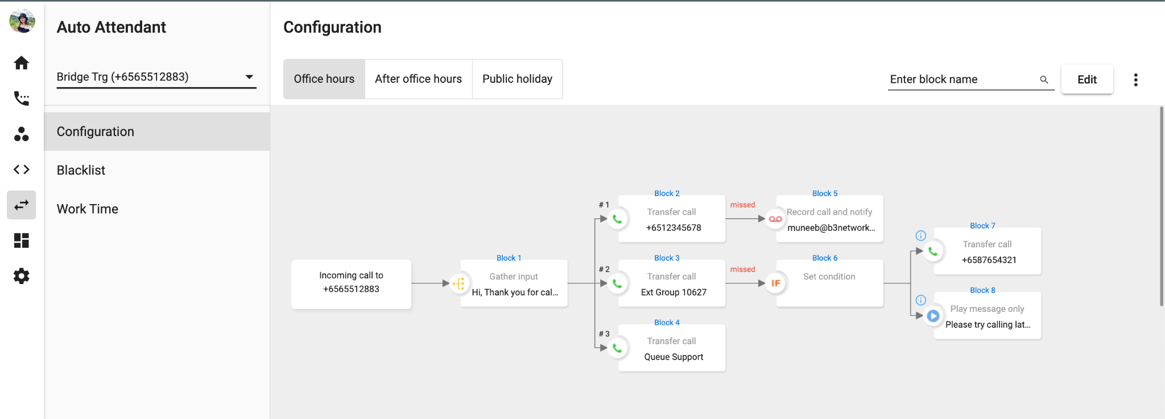

Queue Management
Skill attribution, personalized queues, automatic callback options, service-level, and many more options. A wealth of features to optimize the queue management of your Contact Center.
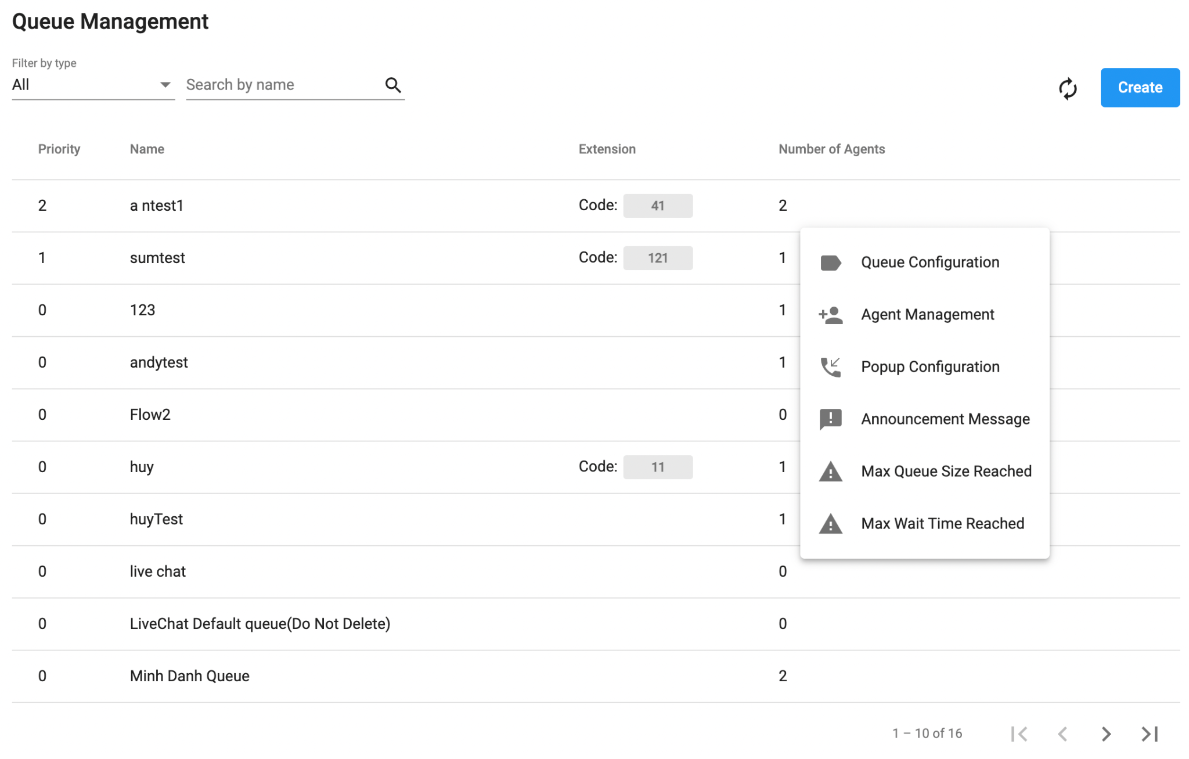

Outbound Campaign
Build an array of Outbound Contact Center campaigns, each of which can be tracked in fine detail with a single glance.
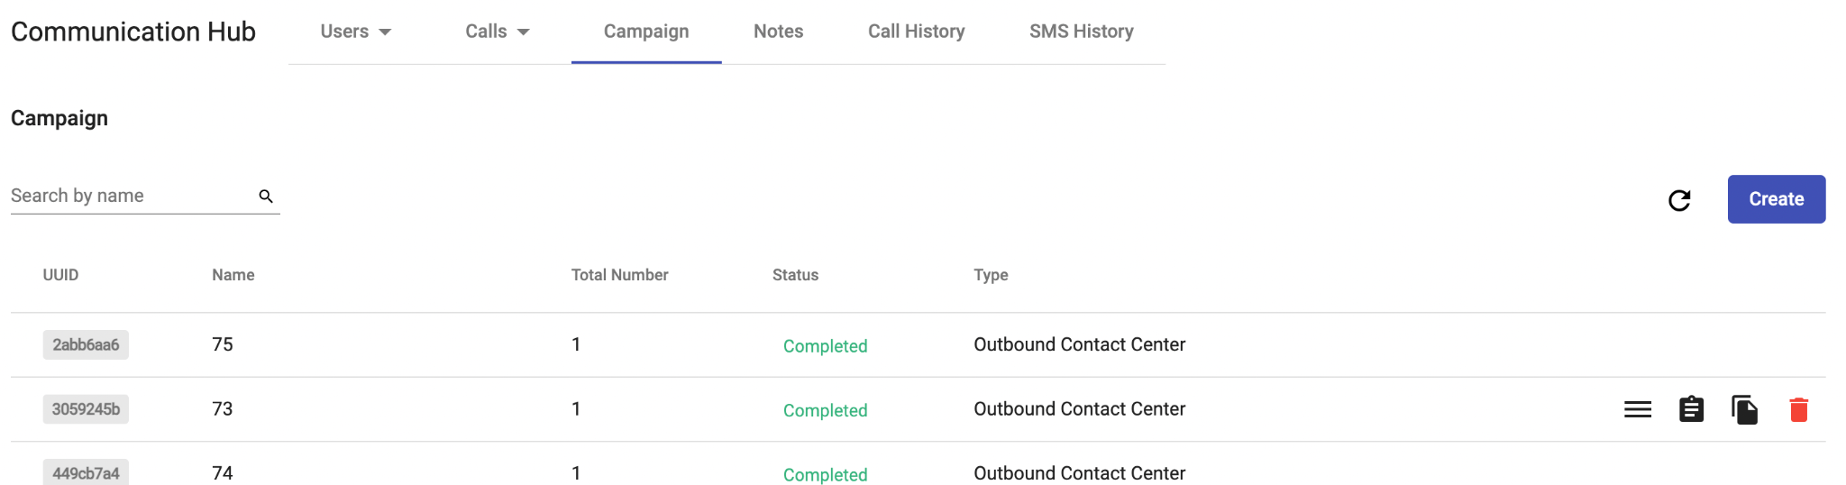

Communication Hub
Monitor your Contact Center data in real-time to make quick decisions and improve your operating efficiency.
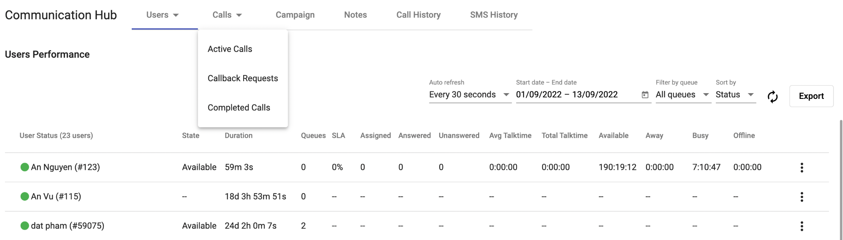

Dashboard
Gain actionable insights to make the right decisions with Dashboard - a visual reporting tool that uses powerful analytics features to help you monitor your call data.
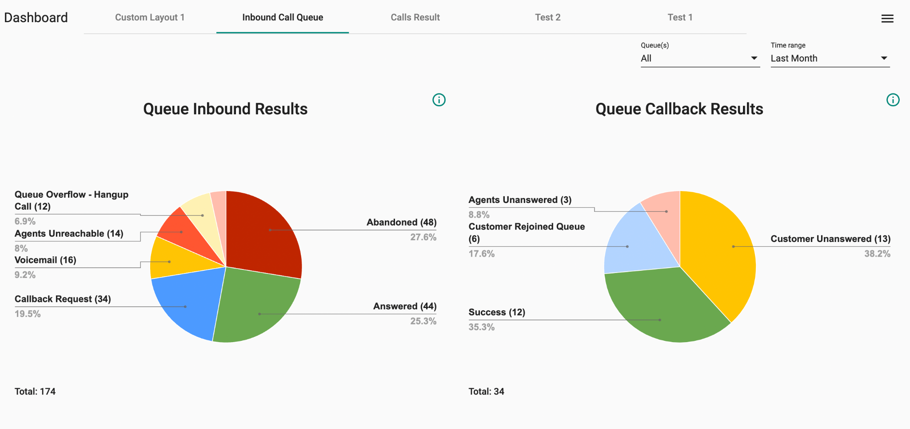

Workflow Sample -1 (Inbound)

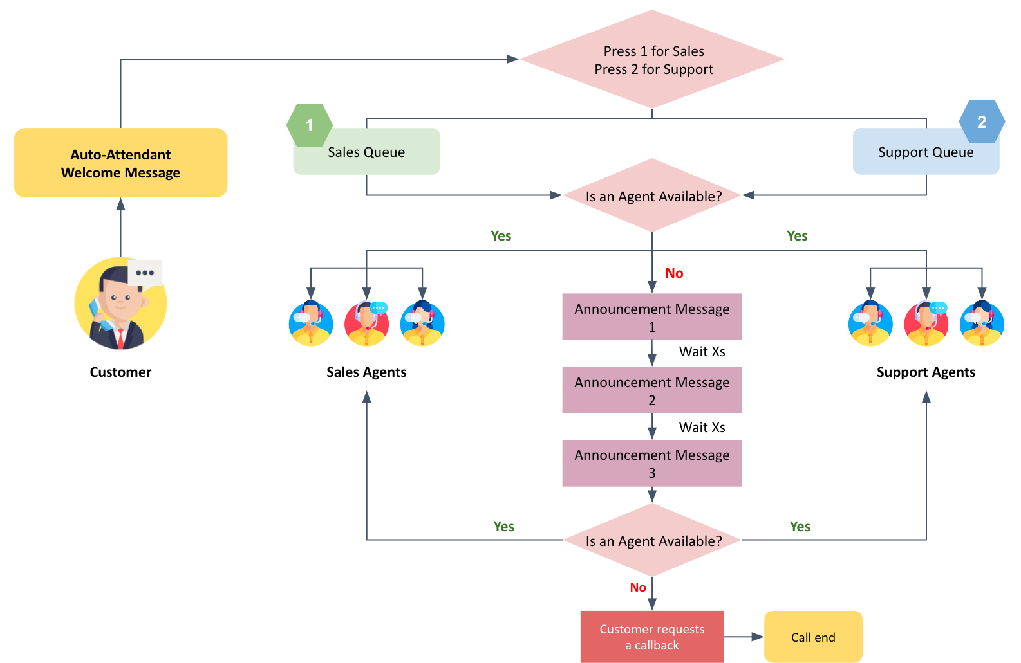

Workflow Sample -2 (Inbound)

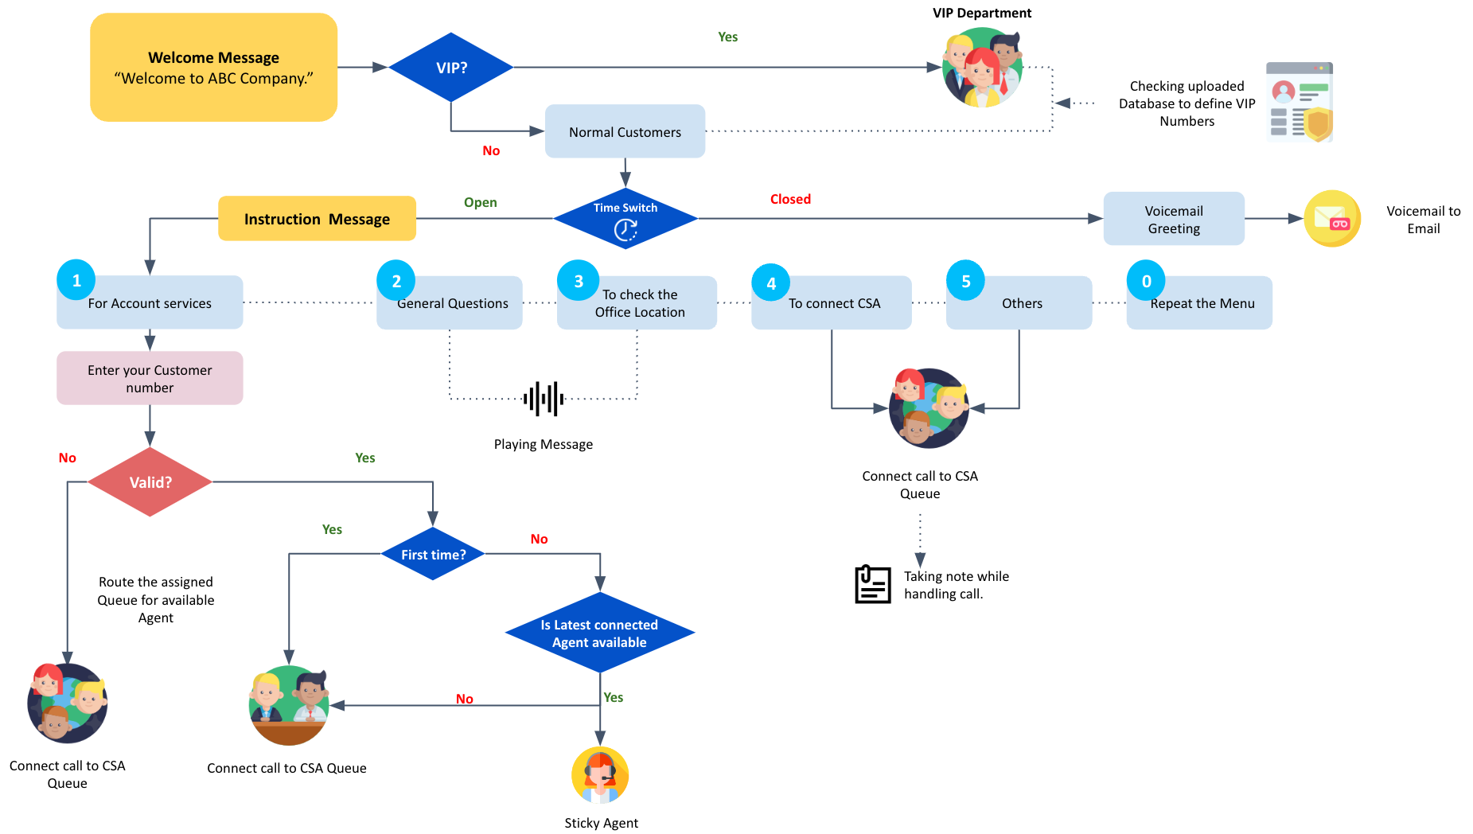

Workflow Sample -3 (Outbound)

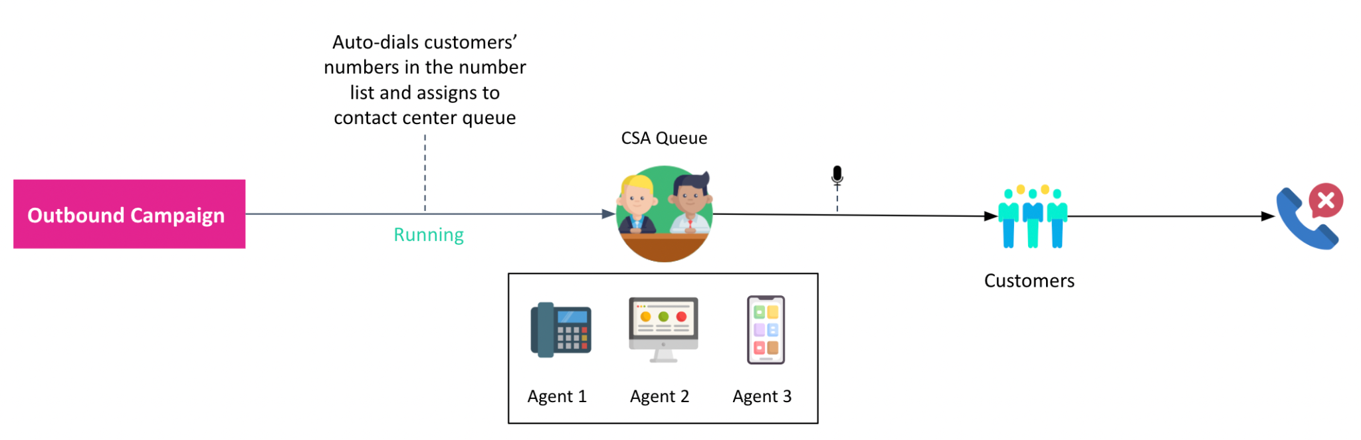

Use Cases In Various Industries

CPaaS Inbound Contact Center Solution can meet your communication requirements with flexible and scalable solutions across all industries.
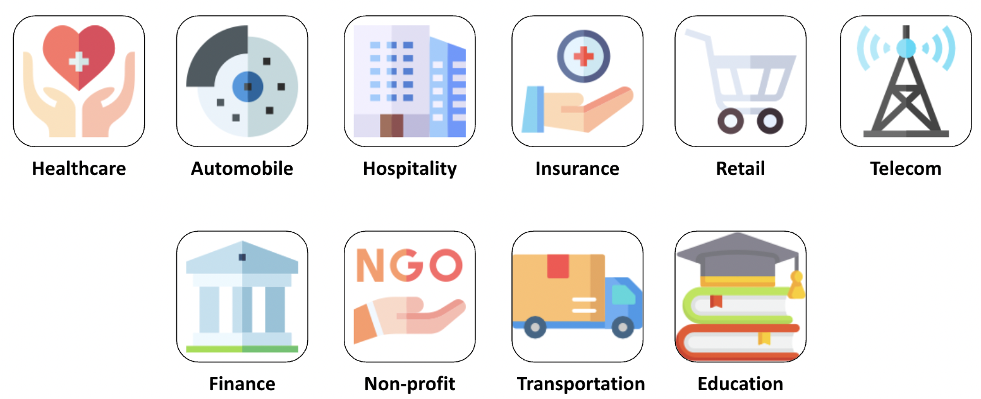
- Healthcare: CPaaS Inbound Contact Center powered up the Covid-19 Response center with a seamless setup for hundreds of agents, which manages the daily high call volume supporting public concerns.
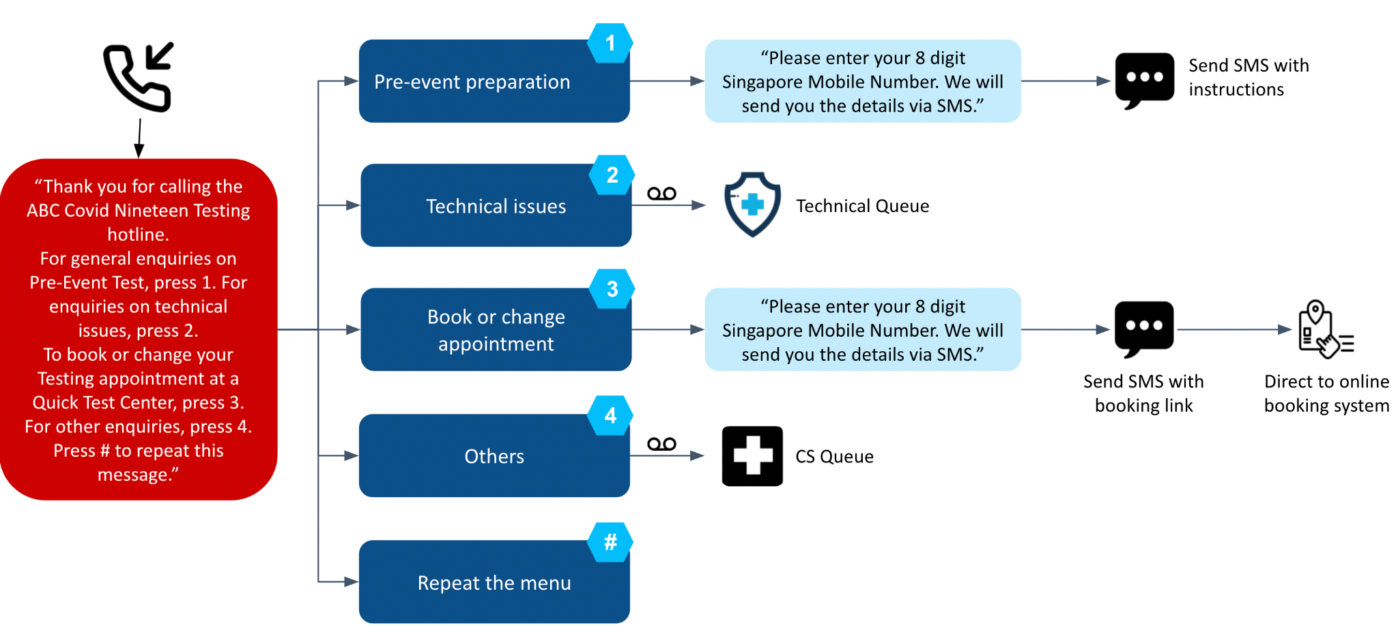
- Insurance: CPaaS Inbound Contact Centers are setups that provide customer service to users. It empowered agents to take large volumes of calls, respond to customers’ queries, assist people, and give guidance on new policies and prospects.
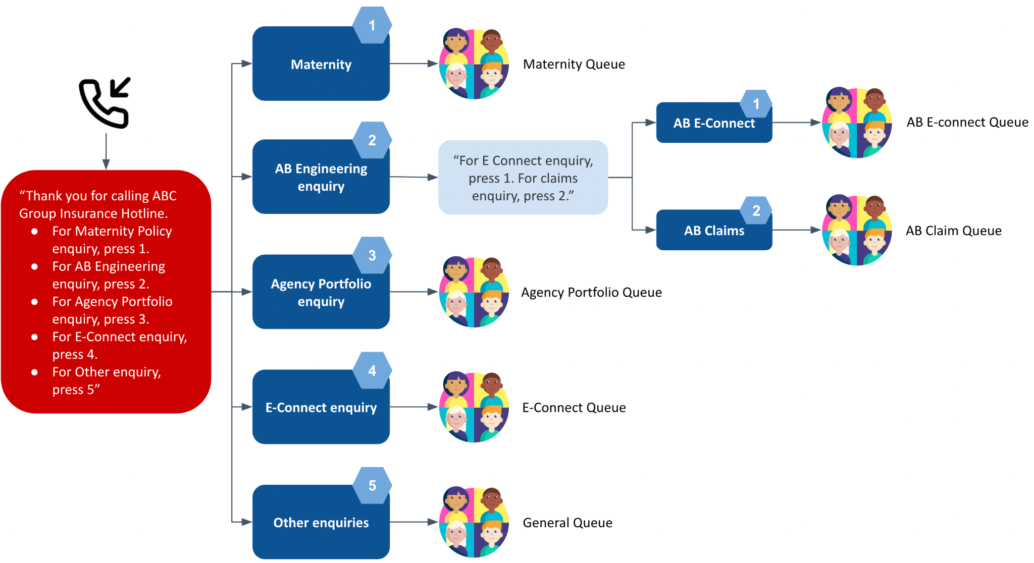
- Education: We are well-versed in serving the educational sector as a contact center. Our extensive background in working with schools of all levels enables us to offer you comprehensive contact center services that will meet the needs of your entire academic community, including teachers, administrators, students, and parents.
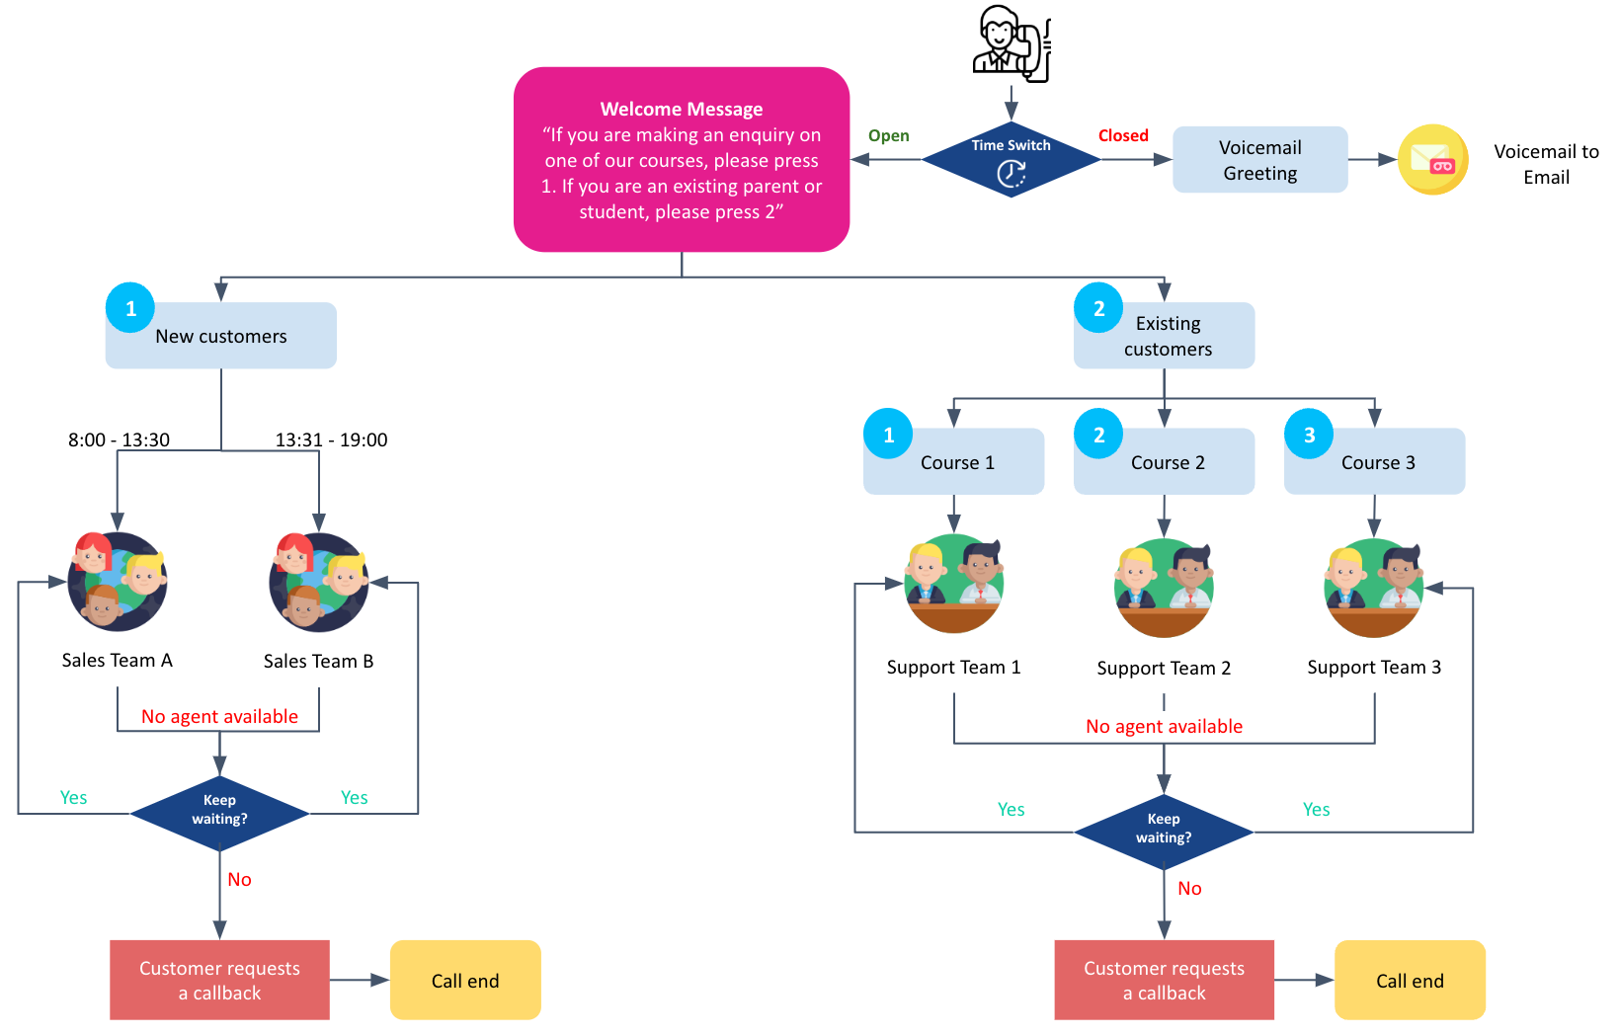
- Retail: Drive business results by calling customers to offer discounts and new products. With note configuration, you can get an insight on what your customers feel about the purpose of the call.
