Vermillion Lake (Chelmsford)
Sunday, August 11, 2019
Entry Fee - $250.00⁽¹⁾ (includes Big Fish and Lucky Duck)

Make Cheque payable to:
Top50 Pike Series
175 Metcalf Avenue
Garson, ON P3L 2L3
Tel. 705-665-4718
mpitre@persona.ca
PLEASE PRINT AND FILL IN ALL INFORMATION

Angler 1
Address

City
Postal Code
Phone
email

Angler 2
Address

City
Postal Code
Phone
email

Signatures

Angler 1____________________________________

Angler 2 ___________________________________

Notes
- No post dated cheques | Late entries are cash only.

DISCLAIMER CLAUSE:
The Top 50 Pike Series, the executive board members and host clubs will not be deemed responsible for injury, death, loss or damage incurred by any person either in traveling to the tournament location, before, during or after the tournament event, for any reason including negligence. Competitors should be present to move equipment and open all compartments for boat inspections. Tournament officials will exercise caution when conducting the boat inspections, however, the Top 50 Pike Series, its Executives and host club officials will not be responsible for any accidental damage during the inspection.

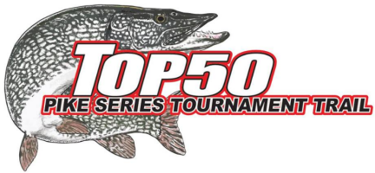
AGREEMENT CLAUSE:
We are familiar with all series rules.
In signing this application, I hereby agree to be bound by and comply with all Tournament rules and regulations.

I agree to assume all risks while participating in any Top 50 Pike fishing tournaments or other events including traveling to and from the events. I agree to waive the Top 50 Pike executives and host clubs, of all responsibility and liability, including negligence, for any damages or injury of any description.

Any tournament angler(s) under the age of 19 should have a legal guardian signing (see below)
I am expected to follow standards of sportsmanship, courtesy, safety and conservation on and off the water. All contestants must adhere to all Provincial, Federal and local laws governing water activities. Any infraction of these fundamental sporting principles may be deemed cause for disqualification.
I hereby grant permission to the Top 50 Pike Series and host clubs to take pictures, videos that include me and boat for the purpose of advertising and marketing the series online, on paper and at Sportsman shows. I will receive no royalties whatsoever.

This form must be signed and initialed by each angler before he/she fishes this tournament
_____________ Date: ____________
(Initials)
Guardian & Signatures (If angler is under 18 years):

___________________________________________

