|  | **Worksheet - Intro to the Traveling Salesperson Problem** |  |
| --- | --- | --- |

# The Traveling Salesperson Problem (TSP)

## Background:

The Traveling Salesperson Problem imagines that a salesperson, starting at his home or office, needs to visit a number of customers at different locations. The goal is for the salesperson to visit each location exactly once and end up back where he started, as efficiently as possible, without retracing any part of the route.

**The problem:** Given a graph of nodes and edges, where the weights of the edges represent some cost (distance, time, money, etc.), find the set of edges that make the lowest-cost “tour” of all the nodes. A tour is a route that visits each node *exactly once* and returns to the starting node.

**History:** The problem was first formulated in 1930 and is one of the most intensively studied problems in optimization because it has many applications in the real world. Almost any business that involves transportation of any kind is concerned with this problem because there are direct costs (in time, money, resources) to taking inefficient paths to visit all the nodes you need to get to. For example, a mail carrier delivering mail must go to each house exactly once, needs to end up at the starting location, and wants to minimize the length of the route. When you are running errands to different stores, or picking up friends to bring them to your place for a party, you need to visit each location once, return to where you started, and want to minimize your route. Can you think of a similar problem or example from real life?

**Example:**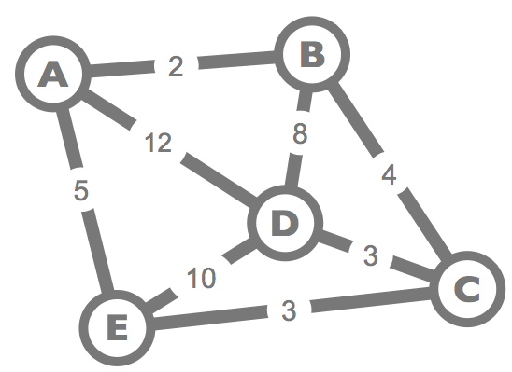

| This graph shows the direct routes between stores, and the distance of each route. You can assume any node is your home, the starting point.  Here are some possible routes, with their total distances, that visit every node once and return to wherever you started are:.  BADECB 2+12+10+3+4 = 31  AEDCBA 5+10+3+4+2 = 24  The shortest route that visits every node once and returns to wherever you started is:  AECDBA 5+3+3+8+2 = 21 |  |
| --- | --- |

## Try It Out!

For all of the examples below, you’re also going to try to solve the traveling salesperson problem to find the shortest route that visits every vertex once and returns to where you started. You are encouraged to mark up these diagrams as you go.

**...but you should be thinking...**

* **Remember:** In computer science, “solving a problem” doesn’t mean finding an answer to an instance of a problem; it means finding an algorithm that might be able to solve *any instance* of that problem.
* As you look at the problems, your brain is working to find a solution. You might think you’re just trying “random stuff” but you’re not. You are using your human intelligence to help you.
* ***Think about your own thinking process.***
* ***Could you express a way to solve this route-finding problem as an algorithm?***

## Directions

* Find the shortest path that visits each node exactly once (i.e. makes a cycle) in each of the graphs below. Highlight the route and make a note of the total distance.
* When you’re done, compare with a partner to see if you found the same things.
* In the “Algorithms Notes” area, jot down a few ideas for how an algorithm to find the shortest route might work. Maybe make a few notes about what’s potentially tricky, what things you want to be sure to remember.

| Graph 1: | Graph 2: |
| --- | --- |
| Graph 3: | Graph 4: |

**Algorithm Notes:**

|  |  |
| --- | --- |