Name(s)_______________________________________________ Period ______ Date ___________________
Activity Guide - Using the Problem Solving Process

Word Search

Overview
Working with a team find the following words in the grid. They may be horizontal, vertical, or diagonal in any direction.
DEFINE, PREPARE, TRY, REFLECT, PROBLEM, SOLVE, COMPUTER, SCIENCE

Objective
Find and circle all 8 words as quickly as you can!

E S Q H J H R C F A X M G M U E B L N I
S R K E R E T U P M O C E C M Z T Y J C
D X A P N X Q L Y V K L S X X N C E H N
J M X P K W W O J Q B B O Q M H E A H T
B I U O E Y H K M O A R L F R D L P H A
N J H T Y R A E R C F L V M S C F A J M
T I R Y Q W P P H D X Q E Q U N E R G S
H Y R I M I X D Z K B M N G O J R B K U
P U B U E U J E G D T F B D T I M V V P
H V W S K F D G K V D M S O X Y O R S F
S C I E N C E W P Q T E O R I A S Q M U
H R G D Y V N H I J D C F G V H E M Z M
U O H H N A G X O Q K K B I G M T W O L
O P E I O Q G B A R V H P N N A Z E X V
Y I S W N R N U U W G H X H A E B O P N
L X D J X R P V Y J H U H X D Y F O I D
F U D J X V U K F C V D Q B P D Z I B D
F B R D S I W P K F K V T R D R G Y C R
Y E T Y O D M X H L L V P T J V I J C D
H E X K R O I P B W E T O Y X I B W V O

Once You’re Done
Head to the last page of the activity guide and fill in the row there for the “Word Search” in the table.

Birthday Guests

Overview
A big group of 15 guests is getting together at a restaurant for a birthday. The restaurant has 3 tables that can each seat only 5 people. Below you can find some information about the people who are attending the party.

Aysha, Ben, Carla, Damien, Eric, Fan, Genaro, Hannah, Isaias, Jessica, Kyla, Laila, Max, Nazek, Owen

Close Friends (Try to put them together)  Aysha and Damien  Max and Isaias  Nazek and Laila  Owen and Genaro  Ben and Jessica  Genaro and Eric | In a Fight (Try to keep them apart)  Aysha and Genaro  Ben and Hannah  Fan and Max  Damien and Laila  Isaias and Owen  Kyla and Jessica

Objective
Find the best possible arrangement of guests at the party. Draw your solution in the space below. To help you can cross out the letters of the names you’ve assigned in the row below.

A | B | C | D | E | F | G | H | I | J | K | L | M | N | O
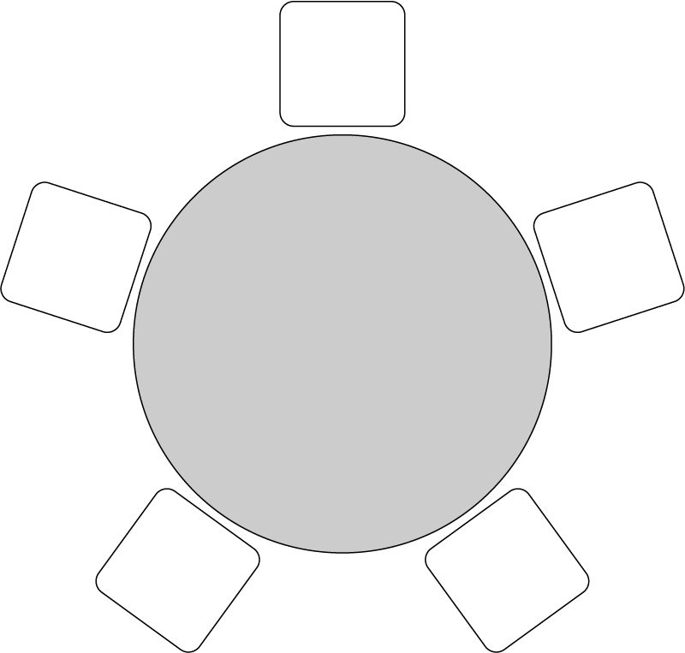
O
G
E
J
B
A
F
K
C
D
H
M
I
N
L

Note: This is one of many possible
solutions.

Once You’re Done
Head to the last page of the activity guide and fill in the row there for the “Birthday Guests” in the table.

Plan a Trip

Overview
You and your friends will be going on a trip. You only have one school day to make it happen, but otherwise how you plan it is up to you. Plan the best trip that you can!

Explore the Tool
Head to https://www.google.com/maps and search for your school. Look at the different options for finding directions to other locations. Don’t worry about making a plan yet, but make sure you understand what kinds of information are available.

Develop Goals
Talk with your group for a few minutes. What are the most important things about your trip? Do you care what you see? How you get there? How long it takes? What it costs? Write down the goals you’ll use to decide what makes a good plan.

Goals | How My Plan Helps Reach this Goal
Trip should only take one school day | My trip only takes one day
We want to go to __something fun__ | We go to the amusement park
The time we spend getting there should  be less than ___two hours____ | The amusement park is only an hour and a half away.
Shouldn’t be more than $20 a person to participate. Ideally free. | Tickets are only $15 a person. This is a little close to our limit.
Lunch should be something most people like | Pizza! Large pizza is only $15 each so we can get one for every 5 people and be under budget.

Make a Route
Every member of your group should separately start planning your trip. You should select what places you want to go and what activities you want to do along the way. For each goal your group chose, list how your trip helps to reach it in the right column. In the space below record all the stops along your trip.

Stops on My Trip

- Leave from school
- Head straight to amusement park
- Eat pizza at the park
- Head back to school

Things We’ll See
- Everything at the park

Share Your Route and Get Feedback
Share the route you developed with your teammates and explain why you think it is the best possible route given the goals you chose. Afterwards, record their feedback and reactions to your route in the space below. Is there anything that needs to change? How could your route improve?

We can’t order pizza into the park, so we will need to get the pizza after we are finished there. But we might be hungry before that. Also, it turns out that a lot of my friends actually DON’T want to go to the amusement park. It’s probably going to be more expensive than I thought too. I like my classmate’s suggestion that we go to the beach an hour away though since it’s free. We can still have pizza.

Someone also suggested we can have a biology activity in case we have to do a school thing, like we can look for animals in the ecosystem.

Improve and Finalize
Using the feedback from your teammates update your route. In the space below write down the new trip that you and your group agreed on.

Stops on Our Trip

- Leave from school
- Head straight to the beach
- Do biology activity there
- Have fun
- Head back to school

Things We’ll See

- Beach and beach animals

Once You’re Done
Head to the last page of the activity guide and fill in the row there for the “Plan a Trip” in the table.

Problem Solving Process Notes

Reflecting on Using the Process
How did you use each step of the problem solving process to solve this problem? Give examples of what each step looked like as you were solving that problem.

 | Define | Prepare | Try | Reflect
Word Search | I felt like this problem was already defined. | We didn’t prepare we just jumped right in! | We just tried to find the words | We realized we should split the word search into areas for each person to search in.
Birthday Guests | It took longer to understand the problem. I read it a couple times. | We used some scratch paper to understand how to group people. | We split the work among multiple people. | We probably could solve the problem faster if we grouped friends before seating them.
Plan a Trip | We needed to decide what was important for our trip. | We considered a lot of possible places to go. | We went out and saw if the actual places we wanted to go made sense. | We showed our trips to one another.

The Purpose of Each Step
For each step in the problem solving process write one sentence explaining its purpose.

Define: We need to understand the problem we’re trying to solve before we just jump right in.

Prepare There’s usually many ways we could approach a problem so we need to first think about those

and make a plan.

Try Once you make a plan you need to actually try it.

Reflect Sometimes the first way you solved a problem wasn’t the best way so you need to reflect and

decide if you can do it better next time.

Defining Problems with Questions
Before starting to solve a problem it’s important that you have defined it well. What questions or strategies can you use to better define or understand a problem? Record them in the space below.

How will I know when I’m done? Ask “Why” to understand the way things currently work.

