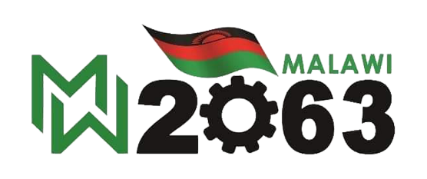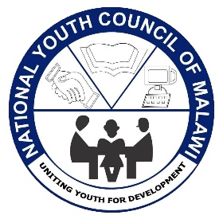

**2025 MALAWI NATIONAL YOUTH SUMMIT**

**Exhibitor Application Form**

**Theme**: Harnessing Youth Innovation for Economic Empowerment and Sustainable Job Creation Towards Malawi 2063  
**Dates**: 2nd – 4th July 2025  
**Venue**: Bingu International Conference Centre (BICC), Lilongwe, Malawi

**SECTION 1: APPLICANT INFORMATION**

1. **Full Name of Applicant/Representative**:  
   (First Name, Last Name)

|  |
| --- |
|  |

1. **Position/Role in Business/Organization**:

|  |
| --- |
|  |

1. **Age** (for youth-led businesses/organizations):

(Note: Applicants must be between 18-35 years old for youth-led category.)

|  |
| --- |
|  |

1. **Phone Number**: (Include country code)

|  |
| --- |
|  |

1. **Email Address**:

|  |
| --- |
|  |

1. **Physical Address**:

|  |
| --- |
|  |

1. **District**:

|  |
| --- |
|  |

1. **Website (if applicable)**:

|  |
| --- |
|  |

**SECTION 2: BUSINESS/ORGANIZATION DETAILS**

1. **Name of Business/Organization**:

|  |
| --- |
|  |

1. **Business/Organization Type** (Tick the relevant option):
   * ☐ Youth-led Business/Startup/Organization
   * ☐ NGO/Non-profit
   * ☐ For-Profit Organizations/Private Company
   * ☐ Social Enterprise
   * ☐ Community Organization
   * ☐ Other (Please specify):
2. **NYCOM affiliation Status**: (for Youth led organisations only)
   * ☐ Registered
   * ☐ Pending Registration
   * ☐ Unregistered
3. **Business/Organization Description** (max 200 words):  
   *(Provide a brief description of your business or organization and its objectives)*

|  |
| --- |
|  |

**SECTION 3: EXHIBITION PROPOSAL**

1. **Exhibition Title**:  
   *(What will be the title or name of your exhibition?)*

|  |
| --- |
|  |

1. **What do you plan to exhibit?**  
   *(Provide a detailed description of the products, services, or initiatives you plan to showcase.)*

|  |
| --- |
|  |

1. **How does your exhibition align with the conference theme: “*Harnessing Youth Innovation for Economic Empowerment and Sustainable Job Creation Towards Malawi 2063”*?**  
   *(Explain how your exhibition contributes to youth development and national growth in line with the Malawi 2063 Vision.)*

|  |
| --- |
|  |

1. **Target Audience**:  
   *(Who do you aim to engage with during the exhibition?)*

|  |
| --- |
|  |

1. **Exhibition Needs** (Tick relevant options):
   * ☐ Booth/Pavilion
   * ☐ Table
   * ☐ Chairs
   * ☐ Electricity supply
   * ☐ Internet access
   * ☐ Display board/stand
   * ☐ Other (Please specify):
2. **Do you require financial support to exhibit?** *(for youth exhibitors only)*
   * ☐ Yes
   * ☐ No  
     *(If Yes, please provide a brief justification for the financial support request.)*

|  |
| --- |
|  |

**SECTION 4: PAYMENT INFORMATION**

1. **Exhibition Booth Fee**:
   * ☐ MWK700,000.00 *(Seven hundred thousand Malawi Kwacha Only)*
2. **Payment Method**:  
   *Exhibition fees should be paid to the following account*

* Account Name: *National Youth Council of Malawi*
* Account Number: *1004989852*
* Bank: *National Bank of Malawi PLC*
* Branch: *Capital City*

**SECTION 5: TERMS & CONDITIONS**

* Exhibitors are responsible for the setup and security of their booths.
* NYCOM reserves the right to select exhibitors based on the relevance of their exhibition to the conference theme and objectives.
* Exhibitors must adhere to all conference rules and regulations.

**SECTION 6: DECLARATION**

I, the undersigned, declare that the information provided in this application is true and accurate to the best of my knowledge.

* **Full Name**:
* **Signature**:
* **Date**:

**SUBMISSION INSTRUCTIONS:**

Please submit your completed application form to [**2025youthsummit@nycom.mw**](mailto:2025youthsummit@nycom.mw)on or before **Friday 16th May 2025.**