
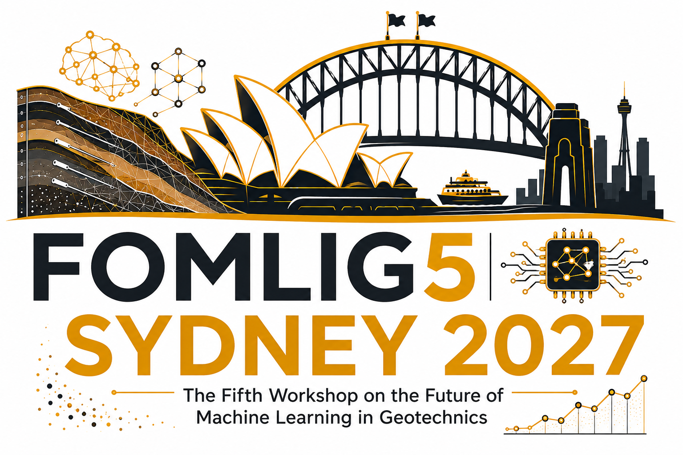
FOMLIG 2027
The Fifth International Workshop on the Future of
Machine Learning in Geotechnics

ABSTRACT SUBMISSION
Title of paper Here

Authors here
Affiliations here

ABSTRACT
Content here,
All text in Times New Roman 10, justified, single spacing, 6 pt spacing between paragraphs. All text content hereafter the same.
The abstract may be up to 500 words. Authors may also include a figure in the abstract if desired.

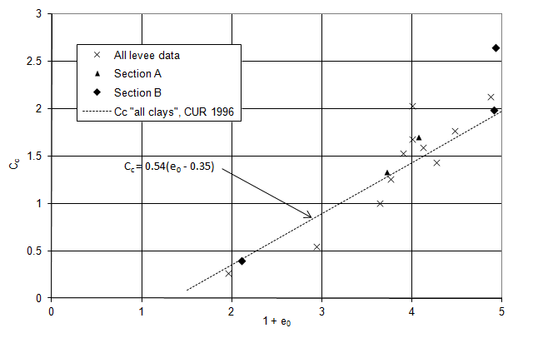
Figure 1: Figure caption
Single Figures or sets of 2 smaller Figures to be within margins and centred on page. Figure to be an imported scan or jpeg. Graphs are NOT CONTRUCTED on the page

Please Visti our website for more information about submission: Click Here
For general information about conference: Click here

ABSTRACT SUBMISSION
Special Session & Research Theme Classification
Please complete this section when submitting an abstract to FOMLIG 2027.
1. SPECIAL / THEMED SESSION
Is this abstract being submitted for an approved FOMLIG 2027 Special Session?
☐ Yes ☐ No ☐ N/A
Special session title | If Yes, enter/select the approved Special/Themed Session title.
Session Lead | If Yes, enter the name of the Special/Themed Session Lead.
Approved session list | To be updated as Special/Themed Sessions are approved.

2. FOMLIG 2027 RESEARCH THEMES
Which research theme(s) are relevant to this abstract? Select all that apply.
 T01 Machine Learning & AI in Geotechnics ☐ |  T02 Large Language Models & Foundation Models ☐
 T03 Physics-informed Machine Learning ☐ |  T04 Digital Twins for Geotechnical Structures ☐
 T05 Explainable AI (XAI) ☐ |  T06 Rock Mechanics & Tunnelling ☐
 T07 Geotechnical Risk Assessment ☐ |  T08 Smart Construction & Infrastructure ☐
 T09 Data Analytics & Visualization ☐ |  T10 Computational Mechanics ☐
 T11 Geospatial & Remote Sensing ☐ |  T12 Laboratory & Field Testing ☐
 T13 Climate & Environmental Geotechnics ☐ |  T14 Micro & Nano-scale Geomechanics ☐
 T15 Automation & Robotics ☐ |  T16 AI-Assisted Numerical Modelling and Automation ☐
 T17 AI for Geotechnical Data Management and Interpretation ☐ |  T18 AI in Ground Investigation and Site Characterisation ☐
 T19 AI for Risk Assessment and Decision Support ☐ |  T20 AI in Construction Monitoring and Digital Twins ☐
 T21 AI for Engineering Documentation and Knowledge Management ☐ |  T22 Ethical, Reliability, and Governance Aspects of AI in Engineering ☐
 T23 Educational and Training Applications of AI in Geotechnical ☐
☐ Others (please specify): _______________________________________________________________
Note: Authors may select more than one research theme. The approved Special/Themed Session list can be updated as the program develops.

If your abstract is accepted, would you be interested in submitting a full paper for possible publication in a journal special issue or a book chapter published by Elsevier, Springer, or CRC Press? Yes ☐ No ☐
Please note that you must be registered for the conference to be considered for these publication opportunities.

