Vision Zero ready amendment - discussion paper
1 General remarks to the proposition
1.1 AEB for pedestrians and cyclists: should be advanced by two years and should be impossible to be shut off
1.2 AEB for pedestrians and cyclists: should be mandatory for all M and N classes
1.3 Event data recorder for all vehicles
2 Why we need to add a generic regulation article about Vision Zero driving
2.1 The shortcomings of the current study based regulation
2.2 The societal benefits of Vision Zero driving are immeasurably large
2.3 Why all new models can and should be updatable and/or upgradable as of 2022
2.4 The case for a ‘drunk man’ test of vehicle safety
2.5 Liability of the European Institutions: better safe than sorry
3 The proposed amendment: concepts in detail
3.1 Update: disruptive technological neutral ADAS proposition for Vision Zero from Mobileye at CES 2019
3.2 What do we mean by ‘Vision Zero ready’?
3.3 Driving with a guardian angel: parallel automation
3.4 Some examples of low cost Vision Zero capable setups
3.5 The importance of advanced ISA
3.6 In pursuit of Vision Zero: the need for Automatic emergency steering (AES) and driver monitoring
3.7 Speedlocks for urban zones and individuals must be possible with current hardware
3.8 The dooring problem is an immense source of suffering and permanent stress for cyclists: let’s put an end to it
3.9 Reliable low latency connectivity: an additional safety net which opens up a myriad of possibilities
4 Economics and timing
4.1 The BCR of a guardian angel setup is order of magnitude 10
4.2 Vision Zero in 2050, 2040, or 2030?
4.3 Some official announcements of mainstream manufacturers
4.4 Why Waiting for Perfect Autonomous Vehicles May Cost Lives
5 FAQ
5.1 Will high precision localisation and HD real time maps be available a low cost around 2022?
5.2 What to respond to the car industry arguments that ‘we are already doing the best we can’ and the timing is ‘not realistic’?
5.3 Will there be enough scalable and affordable computing, sensing and controlling components from different vendors in the timeline foreseen?
5.4 Does a higher price tag will slow down uptake of new vehicles?
5.5 Why not wait for C-ITS regulation?
6 Annex: solutions ready for scalable market deployment
6.1 L2+ assistance: the low cost building blocks we need for Vision Zero driving
6.2 S32 Automotive Processing Platform: a future-proof solution
6.3 Smart Vehicle Architecture: A Holistic Approach to a Fail-Safe Car
6.4 Some timelines and predictions
About this document and the author
About this document
I’m writing this document in support of my proposal of a Vision Zero ready amendment, answering hopefully most questions. I’m a bit short on time, so forgive me my shortcuts and my rudimentary English. On the heart of the matter, I have no doubt of the effectiveness and soundness of the proposition.

An earlier version of this document was also submitted officially on the 3th of July 2018 to the Commission, see feedback section at:

https://ec.europa.eu/info/law/better-regulation/initiatives/ares-2017-3576663/

About me
I would introduce myself an independent ‘road safety advocate’.
I’m working as an ICT-engineer on matters not related to road safety. However, in my spare time, I have been following the road safety topic for more than 10 years. I’m an active volunteer at the Fietsersbond (Belgian cyclists advocacy group, member of ECF). I’m riding my bike most of the time (commute of 80km round trip) but bought an electric Renault ZOE for car sharing and for getting some proper ‘car’ road experience. I attended a lot of road safety seminars, I have a (Dutch) blog on sustainability (focus mobility and road safety), and was an active speaker on road safety on numerous occasions.
The last five years, I was actively engaged in the road safety policy of my local Belgian village Begijnendijk as a member of the mobility council. There, again and again, I can only take note that the way vehicles are currently designed, combined with human psyche and fallibility, lead to immense life quality problems and suffering. Since it is impossible to make people infallibile, we should fully use proper regulation of the vehicle.
The last two years, I’m actively following up on ADAS and AI developments, and studied the EC proposal(s) and background reports.
I’m not considering myself an ‘expert’, but I’m on a lot of mailing lists on the topic, I try to fall back to ‘first principles thinking’, keep an eye on the market, I identified hopefully some major players and experts, looking at their track record, and try to at least double check the economics.
So please, if you see a flaw or a possible enhancement, send your comments to dominique.demunck@gmail.com or give me a sign so we can have a chat.

1 General remarks to the proposition

1.1 AEB for pedestrians and cyclists: should be advanced by two years and should be impossible to be shut off
In the current Annex 2, we risk losing two precious years mandating a life saving technology which is already mature technology in series production (eg. 2017 VW Polo, 2017 Honda Civic, new Nissan Micra, … )!
I also refer to the statements of probably thé expert in the field, prof Amnon Shashua at CES 2018:

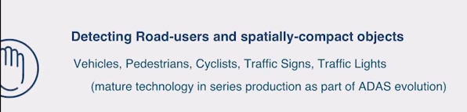

So in the annex, it should definitely go from timeline C to timeline B, or even A.
It should also not be possible to switch it off, unless eg. a maximum speed is set to 5km/h or for special applications requiring OEM permission (police).

1.2 AEB for pedestrians and cyclists: should be mandatory for all M and N classes
In the proposal of the EC, AEB with pedestrian and cyclist detection, is only mandatory for classes M1 and N1. Since detecting VRUs is mature and cheap technology, I see no reason why to exempt the other classes.
Trucks are able to emergency brake, as this video shows. So it’s just a question to apply the “See, think, act’ paradigm to all classes with algorithms tailored to the specific vehicle class.
Especially since pedestrians and cyclists are often victim of collisions with trucks and buses. As Waymo and others prove, trucks can be made autonomous, which certainly includes automatic braking!

‘Any system which depends on human reliability is unreliable’
Gilb’s Second Law of Unreliability
ZF, one of the biggest suppliers for bus and truck manufacturers, has, in line with its Vision Zero roadmap, declared war on blind spot accidents. A world first, it will be offering systems that do not rely on the human driver to be perfect and respond appropriately to all the warnings:
‘To prevent collisions even more effectively when making turns, ZF is developing the turn assist system to be an active system.” explains Mayer. The Side Vision Assist will not only warn drivers, but also intervene if necessary – like emergency braking or an evasive maneuver. The system has not only radar sensors, but also cameras and thus monitors everything that is happening around the truck. This is a decisive advantage for the driver who receives the information which is transparently displayed on a screen’. ZF Vision Article & ZF Press Release September 2018.

Aptiv is now also offering an advanced cyclist detection (360° radar) and actuation system for commercial vehicles.

1.3 Event data recorder for all vehicles
Apparently, for trucks and busses this is only mandatory for automated vehicles? I see no reason why to exempt those classes.

2 Why we need to add a generic regulation article about Vision Zero driving

2.1 The shortcomings of the current study based regulation
The cost/benefits estimates done in the preceding studies for the European Commission proposal and those of the final impact assessment have great value, but suffer from three major issues.
First off, they are based mainly on studies and models examining existing technology. Scientific studies are thus the best way to stay behind the facts. If we only base our regulation, which will be mandatory at least three years in the future (timeline agreed by EC with manufacturers), on technology which has been used on a large scale and long enough to get reliable data for scientific analysis, we are keeping regulation at least five years behind the facts.
As ADAS technology is advancing at breakneck pace, this is the best guarantee to undershoot the potential of adequate legislation. Indeed, disruption is bound to happen and not modelled, as also indicated by the authors. One could instead try to incorporate different scenarios and trends.

Secondly, they focus (almost) entirely on casualties prevention and reduction, whereas in the case of ‘vision-0 driving’, avoiding dangerous situations to occur is the main focus. And for this ‘collision avoidance’, the benefits are a multifold (see 2.2 The societal benefits of Vision Zero driving are immeasurably large).

And thirdly, focusing merely on cost benefits of existing technology, limits the notions of what we can mandate. For example, remote updateability is clearly the way forward as it allows to update our existing vehicle fleet on the go, instead of waiting over fifteen years for replacements, but how are we going to prove this using scientific studies?
This becomes particularly problematic when technologies are reinforcing each other, and would be applicable on existing vehicles only if the are remotely upgradable.
It is clear that the combination of advanced ISA with some future services (for which there is no doubt they will arrive), like HD maps, cm-level positioning accuracy and the full penetration of (5G) C-V2X (which would deliver a ‘total knowledge’ scenario), will have a tremendous positive impact on road safety.

An alternative policy making approach, which we follow in this document, would be to look at market developments, and see what the industry itself is saying it will come up with in the coming years, and than add some margin.
Note that in the remainder of this document we do not take into account real disruption (see chapter Vision Zero in 2050, 2040 or 2030?).

2.2 The societal benefits of Vision Zero driving are immeasurably large
What would a society gain if it would have (nearly) no crashes and vehicles would not violate the law?
The Opinion of the Regulatory Scrutiny Board (SEC/2018/0270 final), already gives a list of benefits which are not accounted for in the impact assessment:

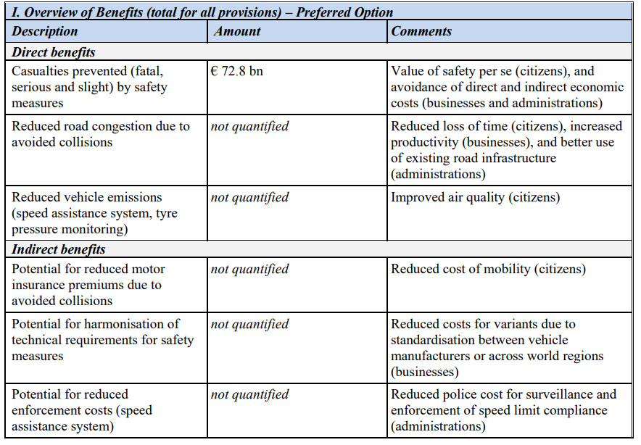
This is recognized in the final impact assessment by argumenting that those costs are impossible to estimate for each technology measure, but in the rest of the report this fact somehow gets forgotten.
Some of the additional benefits of lowering the number of accidents are estimated (in grand total) in other studies. They constitute more than double of what is taken into account in the impact assessment (casualties only), if we take for example the broader cost calculation of accidents in the Netherlands.
In the impact assessment, one reads:
‘The social cost due to road casualties (i.e. rehabilitation, healthcare, death, material damages, among others) is estimated to be at least in the order of € 100 billion per year and as such, the problem of road safety remains an urgent one.’
It’s unclear where this number comes from, but the estimation I read most is that accidents are costing society at least 2% of GDP, which at the EU level would amount to at least € 300 billion per year! This is a serious flaw, invalidating most of the calculations done in the impact assessment!
Even more societal gains are at reach if we only allow ‘vision-0 ready’ vehicles, which by our definition do not violate the law and will have a tremendous effect on road security:

- Reduced road security infrastructure costs, for example speed bumps, elevated crossroads, ...; for a lot of EU countries there is still almost nothing in place; and these measures, apart from their costs, also have a lot of disadvantages and have a limited effect (because of the road length, the need to have trucks and busses passing, noise, …)
- Avoiding stranded assets: if we do not make vehicles future-proof, the upcoming arrival of safe autonomous cars probably will result in an interdiction to use traditional vehicles without vision-0 capabilities. This not only results in stranded assets for companies, but, just as is the case for the low emission zones in a lot of cities, for especially the poorest part of EU citizens
- Increased societal benefits by having more people who cycle and walk (health, life quality, lower transportation expenses, less pollution, more effective climate policies, ...). Traffic insecurity is a major cause (in some regions and groups thé major cause) of not cycling. ECF calculated the current level of benefits for the EU at over € 500 billion a year, so even a small increase in cycling will generate huge benefits.
- Reduced anxiety and stress among all citizens, higher feeling of security
- Reduced cost of mobility for citizens: TCO drops (less insurance, longer vehicle life) and sharing of cars can increase multifold, which can have a tremendous impact on transportation costs for EU citizens
- More freedom of movement for all who are afraid to use the roads now
- ...

2.3 Why all new models can and should be updatable and/or upgradable as of 2022
Nobody would buy a smartphone if it would not be updatable. As vehicles have a much longer lifespan and impact on life and death, it is of the utmost importance they should be updateable too.
It is clear that with the arrival of reliable, high bandwidth and low latency smartphone communication (LTE, 5G) a myriad of safety features will become available in the following decade (see section Reliable low latency connectivity). In order to grasp the benefits of those services, every vehicle on the streets should be able to fully tap in into this potential when they become available. For this, we need our cars to be updatable and/or upgradable.

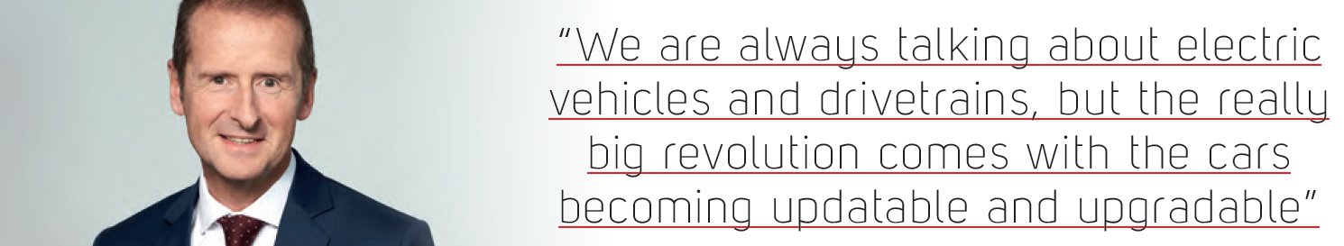
VW Group CEO, dr Herbert Diess

Concerns about system integrity, reliability and cyber security are legitimate. It should be very clear however that adequate solutions exist and are available on the market as of today. One has to bear in mind that OTA for vehicles is coming anyway and is even a necessity for autonomous transport. This means a rapid regulation effort is in place and thus it would be much, much more cost effective to let all vehicles take advantage of this ‘future-proofing’ feature. Take a look at the following observations and statements of major players:

- Already in 2012, the Tesla Model S was updatable over the air. The computing hardware can be upgraded at no cost from Autopilot 2 to 3. See also this post about the new AI chipset.
- VW: Volkswagen has written to all its German dealers explaining their agreements would be canceled in 2020, to make way for a smaller dealer body, more direct interaction with customers and over-the-air software delivery. ‘We are always talking about electric vehicles and drivetrains, but the really big revolution comes with the cars becoming updatable and upgradable. ... When we have the operational system in the car, you will receive an update to your system every year or so.’ Interview with Herbert Driess, January 2018
- Bosch (1st worldwide OEM supplier): ‘Over-the-air software updates will soon be a standard feature’. … ‘In the future, car owners will be able to enhance their car’s security, intelligence, and performance without getting up from the sofa. Updating their car’s software will be as simple as updating apps on their smartphones today. A swipe of the smartphone will be enough to automatically update vehicle software or to download new functions directly from the cloud – without any need to visit the repair shop. “In a few years from now, automatic software updates will be possible in every new car,” says Dr. Markus Heyn, a member of the Bosch board of management. “Wireless over-the-air updates are extremely convenient for drivers. In addition, Bosch is making these online updates secure and fast', Press release, September 2017
- Renesas/Airbiquity: ‘It’s clear that future connected vehicles will require a combination of sophisticated on-board processing power and the ability to securely perform software updates remotely’, Press Release, December 2017
‘We see OTA functionality as the key for software-driven vehicles. OTA enables safe and secure program updating/diagnosis/recovery’ - Renesas Guns for Extreme Safety, No-Wait OTA
- Here:
‘OTA technology is the next big advancement in keeping vehicles safe and up-to-date with less cost to both automakers and car owners. HERE OTA Connect provides cost- and time-saving benefits by enabling automakers to update vehicles remotely, such as in large recall campaigns. It also opens up revenue streams for automakers by giving their customers the ability to purchase new vehicle upgrades and features at the touch of a button.’ Here Press Release, May 2018
- Baidu is offering a complete OTA solution as part of there Apollo suite
- eSync Alliance: ‘The eSync Alliance creates a high-confidence multi-vendor path to creating end-to-end secure OTA and data services for the connected car through a global network of co-operating suppliers’, including as a member now ZF (4th OEM supplier)
- NXP: ‘Over-the-Air Updates – The S32 platform allows zero downtime OTA capability with full roll back options to any S32 enabled car domains via a secure gateway and common domain architecture.’, NXP Announces New Automotive Processing Platform that Brings Future Vehicles to Market Faster, Press Release Octobre 2017
See also annex S32 Automotive Processing Platform: a future-proof solution
- Aptiv: What automotive can learn from your smartphone ; see annex Smart Vehicle Architecture: A Holistic Approach to a Fail-Safe Car

2.4 The case for a ‘drunk man’ test of vehicle safety
Looking at every ADAS component separately, is good, but not good enough. We should add a generic test requirement: if someone with bad intentions drives a car, can he put in danger the life of another citizen, when the car is operating normally?
One could call this the “occasional terrorist” or “drunk man” test, in analogy of the Turing test. In the Turing test, an AI computer only passes, if a human cannot make the distinction between this computer and a real human, by only asking natural language questions, of his choice, via a texting interface.
Off course, this does not mean we should stop traditional testing and benchmarking or step back on drinking policies. Drinking and driving should remain forbidden, as for this we would need full autonomy. The vehicle simply should provide a layer of security which make it impossible to cause deliberate harm without messing with the vehicle hardware.

The vehicle itself should do integrity tests all the time, and when a certain integrity level (eg. because of sabotage or major malfunction) is not reached, refuse to start the engine or revert to a safe state.
Probably, some very sophisticated terrorist will find a way, but he can also build a smart bomb, and those terrorists are luckily very rare.

One could think of a lot of use cases which will be executed always in a test procedure, but I would certainly leave room for black box testing. The appointment of an independent quality chamber to perform this testing could be an idea.

2.5 Liability of the European Institutions: better safe than sorry

‘In principle everyone has the right to use roads and streets without threats to life or health. This includes access for everyone to equal, safe and sustainable mobility, with due attention for vulnerable road users, including the elderly and children.’ - Impact assessment

The right of health is deeply rooted in EU legislation. This is why, very recently, legal actions were taken against the EU institutions because they did not did what was in their power to guarantee the right of life and health to a sufficient degree. Paris, Madrid and Brussels did this (indirectly) for the regulation of exhaust emissions. In the People’s Climate Case, the litigation action is initiated by 10 families from numerous countries. Their homes, livelihoods, traditional family occupation and culture are affected by climate change and they are taking the EU institutions to court to protect their fundamental rights and to prevent dangerous climate change.
The case for road security is, for me, even clearer. With the vehicles currently on our streets, and even with vehicles which would pass the currently proposed regulation, it is simply impossible to guarantee an acceptable level of security for every citizen. One can even state that the way most vehicles are designed , powered and marketed, incentives speeding and reckless behaviour. What has the EU done to enforce its proper regulation, more specifically, in the current regulation, No 661/2009, Article 5:
‘Manufacturers shall ensure that vehicles are designed, constructed and assembled so as to minimise the risk of injury to vehicle occupants and other road users’.
Just take a look at the immense speeding problem and the problematic surge of SUVs and pickups to see why this constitutes a huge liability problem of regulation not being enforced. Which reminds me of the analysis regarding Dieselgate and EU responsibility.
‘We Know SUV Design Kills Pedestrians, But We Still Let Carmakers Sell Them’
The member states have not the means to enforce and are not in the possibility to regulate the vehicles, and so are left to other measures which lack the effectivity of ambitious regulation. Look at the Netherlands, they invested billions and billions of Euros in road safety, and still have over 200 cycling deaths (most of which related to vehicle collisions) and a major life quality problem caused by the improper use of vehicles.

So, now is the time to take up responsibility, and, by leveraging the AI revolution, bring a halt to the tragedies on our roads and bring life quality to every living environment.

3 The proposed amendment: concepts in detail

3.1 Update: disruptive technological neutral ADAS proposition for Vision Zero from Mobileye at CES 2019

At CES 2019, Mobileye presented its Vision Zero ADAS implementation model (1h, but see CES 2018 first), which essentially brings the same message as my proposition: with an advanced ADAS solution using technologies developed for AVs, we can reach a near Vision Zero scenario at “negligible costs”. The estimated costs of Mobileye are even smaller than my original estimations (“hundreds of dollars”), although it is not clear if they are only counting the sensors. What is called APB by Mobileye, is an similar concept as my “advanced ISA” in my proposal.
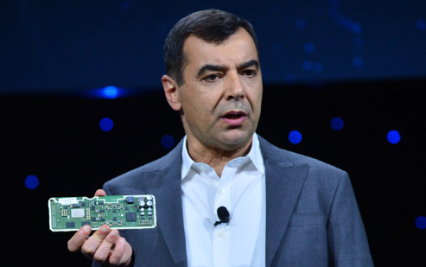

Amnon Shashua, probably thé expert on technical and economic feasibility of ADAS and AVs, holding the first EyeQ5 enabled motherboard which enables Vision Zero driving at low costs.

I’ve made a summary of the transcript for those short of time. At 8 min:

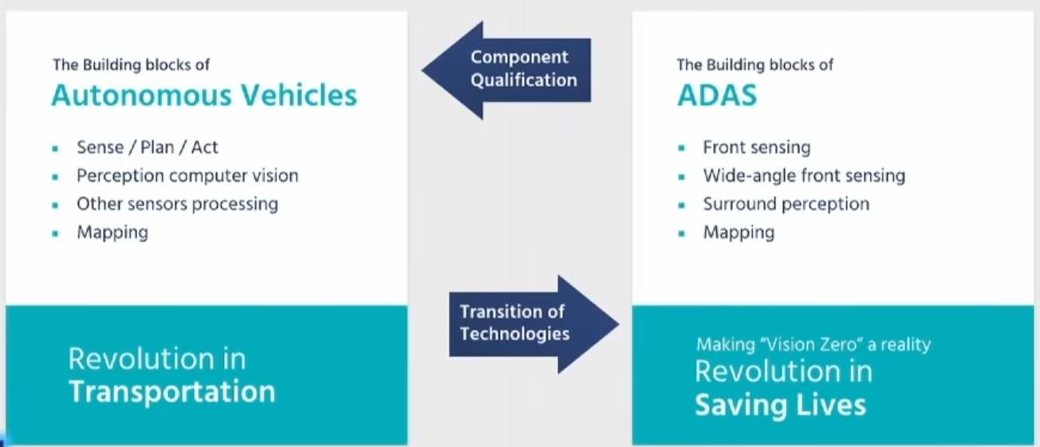

‘For any function we develop as part of our autonomous driving activity we think how it
can be migrated to affect the evolution of driving assists. Now in driving assist we have a very, very
strong constraint and that is the constraint of cost. Driving assist is volume production. Every cent
matters, you cannot put exotic sensors in that cost thousands of dollars. In driving assist
you have to think in terms of hundreds of dollars that's it.
So how do we go and migrate technologies from autonomous driving, where cost is not an issue, at
least not for our competitors, and migrating it towards driving assist where cost is a very very big issue There are two types of revolutions that that people tend to coalesce into one.
Bucket one is revolution of transport and that's a revolution really promoted by autonomous driving, the way people will be moved will be disrupted, less parking lots and and so forth.
There's another revolution and that revolution is saving lives. Now people tend to associate autonomous driving also with the revolution of saving lives. When all cars will be autonomous then no one will get
killed on the road, which is true but I'll not be standing here when all cars will be autonomous.
On the other hand driving assist has begun a revolution of saving lives and the point that I'm making here that it has not finished not revolution. We can create the right science in which we can create a horizon of a truly Vision Zero using just driving assists. Truly vision zero means
that that the probability of a fatality, the probability of an accident if all cars would have that particular
driving assist that I'll talk about will be negligible.
The revolutions of saving lives can evolve through ADAS”

At 55 min:
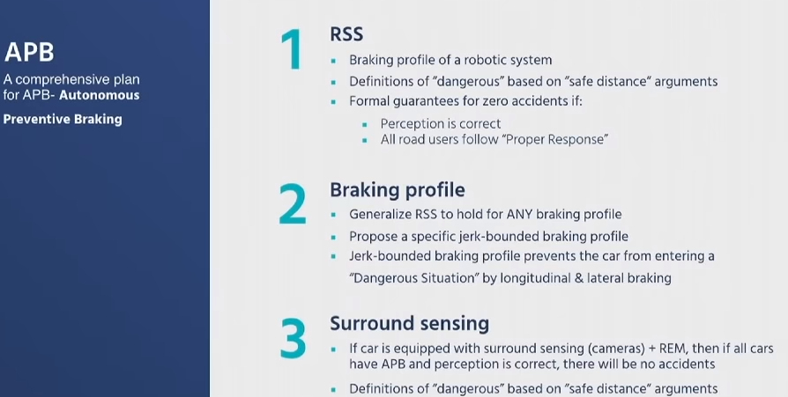

“The message is that we can we can create a revolution of Vision Zero of saving lives as a separate bucket of the revolution of changing transportation. …
Saving lives is another revolution and can be implemented at the cost structure of driving assist, hundreds of dollars it's not thousands it's not tens of thousands of dollars and we can do that.
If there's one take-home message from this long hour, it’s this message”

In his article Technologies Developed for Fully Autonomous Vehicles Can Improve the Advanced Driver Assistance Systems Already in Wide Use, Amnon Shashua states very clearly:

‘If APB were installed in every vehicle using an affordable forward-facing camera, we believe this technology can eliminate a substantial proportion of front-to-rear crashes resulting from wrong driving decision-making. And if we add surround camera sensing and the map into the equation so that preventative braking can be applied in more situations, we can hope to eliminate nearly all collisions of this nature.

We believe preventative technologies like APB hold the key to reaching “Vision Zero” and hope that ubiquitous adoption could lead to nearly zero fatalities and injuries from road accidents resulting from wrong driving decision-making. It would stand apart from other tools in the global Vision Zero toolkit in that it would be resident in the car – not in the surrounding infrastructure. Rather than inserting obstacles that interfere with traffic flow – like speed bumps or reduced speed limits – APB will proactively adjust the vehicle’s speed to maintain safety only when necessary, therefore improving safety without sacrificing traffic flow.’

The research paper main takeaways:

“Our goal is to put on the table a complete proposal with a clearly stated goal, which is fully accessible to the public and to regulatory bodies, and which comes with some formal mathematical guarantees”

“We envision two stages of deployment where at first we propose merely an enhancement of existing AEB systems in the sense of handling front-to-rear crashes only using existing front-facing sensing (camera or camera+radar). Our proposal for stage 1, can lead to a significantly higher elimination rate of front-to-rear crashes, comparing to existing AEB systems. The main improvement of stage 1 is due to the preventive approach, which will allow technology providers to balance the false positive / false negative tradeoff in a better way. By considering the sensing capabilities of existing systems, we estimate that the elimination rate of front-to-rear accidents will be roughly 99%. For the second stage we envision a full surround camera sensing fused with a crowd sourced map, to enable the full implementation of RSS. The advantage of the full implementation is that RSS comes with the elegant mathematical guarantee, stating that if all players fully comply with RSS rules, then accidents resulting from driving decision making process would become rare, thus achieving Vision Zero for all possible crashes. The cost of installing a camera surround system, in high volume, would be around 5 − 10 times the cost of existing AEB systems which is negligible compared to the cost of accidents to society”
…

4 Utopia is (almost) Possible — Toward Reaching Vision Zero
The premise of RSS is that “utopia is possible”, in the sense that if all agents fully comply with RSS’s proper response,6 then accidents resulting from wrongful driving decisions would become rare. And so, geographic regions enforcing RSS on all vehicles (by regulation), will benefit from a substantially high level of road safety. It should be noted that accidents can still occur as a result of conditions outside the driving decision making process, such as accidents caused by vehicles that do not apply proper response due to a hardware failure (e.g. malfunctioning braking system) or due to perception mistakes (e.g., a system does not detect a car at a non-safe distance in front of us). However, suppose that the probability of such a failure is one in every 100 dangerous situations. While this level of accuracy is insufficient for autonomous driving (an accident once in every 100 dangerous situation is a very bad result), it can be shown that if this failure rate is maintained in ADAS systems, where the driver is still active and responsible, we can obtain an elimination rate of roughly 99% of car accidents. This is a huge step toward fulfilling the “Vision Zero” initiative.

3.2 What do we mean by ‘Vision Zero ready’?

A vehicle is capable of Vision Zero driving if, starting at some point in time, it never causes an accident of its responsibility while driving. Another way to phrase this, is that it will never cause a dangerous situation, and respond properly to a dangerous situation. For the concept of responsibility, I would reference, as the OECD/ITF does, to the notions proposed by the published RSS model of Intel/Mobileye:

‘Responsibility-Sensitive Safety (RSS) is a safety concept for automated driving developed by Mobileye which formalises the common sense of human judgement with regard to the notion of “who is responsible for causing an crash”. RSS is interpretable, explainable, and incorporates a sense of “responsibility” into the actions of a automated driving system. The definition of RSS is agnostic to the manner in which it is implemented — which is a key feature to facilitate the goal of creating a convincing global safety model. RSS is motivated by the observation that agents play a non-symmetrical role in a crash where typically only one of the agents is responsible for the crash and therefore is to be blamed for it. The RSS model also includes a formal treatment of “cautious driving” under limited sensing conditions where not all agents are always visible. The goal is to guarantee that an agent acting under RSS will never cause a crash, rather than to guarantee that an agent will never be involved in an crash (which may be impossible). RSS is not a formalism of blame according to the law but instead it is a formalism of the common sense of human judgement. For example, if some other car violated the law by entering an intersection while having the red light signal, while the robotic car had the green light, but had time to stop before crashing into the other car, then the common sense of human judgement is that the automated car should brake in order to avoid the crash. In this case, the RSS model indeed requires the automated driving system to brake in order not to cause a crash, and if it fails to do so, it shares responsibility for the accident’
...
“Utopia is Possible
Consider a utopic future, where all cars (and other road users) somehow are able to successfully
verify that they will never be responsible for an accident. Since by definition, for every accident there is at least one car to blame, the meaning is that there will never be any accidents, leading us to a utopic future of absolute safety”.

The RSS model is rapidly gaining influence: it will even be integrated by Intel/Mobileye competitor Baidu:
“Our team recognizes the value and critical role that Mobileye’s RSS model plays in safely deploying autonomous driving. Project Apollo will integrate RSS to successfully enable safe driving today, and drive further autonomous research on China’s roadways.”

Note that this definition also implies the vehicle satisfies the legal speed limits at a minimum.
A vehicle rolling out of the factory might not be able to satisfy this capability right away, it may require some updates, new legislation, services.

For L4/L5 self driving cars, the RSS model proves, when sensing does it jobs, it can avoid entering in a dangerous situation. Mobileye aims for its system of autonomous driving at a safety improvement of factor 1000x using a scalable and affordable solution.
For most vehicles rolling out of the factory around 2022, we still have the human driver as the main actor, so we cannot choose every movement the vehicle does, and the driving should remain comfortable for the driver. But the car can intervene when the driver would enter an unsafe state, I think it is safe to say this would prevent a vast majority of accidents from happening all together.

3.3 Driving with a guardian angel: parallel automation
As Amnon Shashua of Mobileye explained at CES 2018 and CES 2019, a lot of technology which is developed for L4/L5 self driving, can also be used for creating a ‘safety net’ for the driver and thus offer enormous safety improvements. The big advantage of this setup, is that, since it functions only as a backup system itself, it needs much less hardware and redundancy, making for a very affordable solution which can be rolled out at scale starting around 2020.

What we are aiming for, is that every vehicle has a very high degree of ‘guardian capability’. Let’s look at a definition of ‘guardian capability’ driving of Toyota:
‘Guardian Capability is a measure of how much the automated driving system helps to protect vehicle occupants while the human is driving – both from mistakes or other errors by the driver and from external factors on the road such as vehicles, obstructions, or traffic conflicts. The higher the Guardian capability, the greater the number and types of crashes it can help protect against. For example, at a modest level of Guardian capability, systems like Lane Departure Alert (LDA) and Automatic Emergency Braking (AEB) can help prevent some crashes. At the highest level, Guardian capability would help ensure a vehicle driven by a human being would never cause a crash, regardless of any error made by the human driver, and steer a vehicle to avoid many crashes that would otherwise be caused by other vehicles or external factors.’

Off course, we should include the protection of other road users and especially VRUs in this definition.

‘Toyota is seeking a middle ground with a system it calls Guardian, which would harness the machine-intelligence and sensor capabilities that make full self-driving theoretically possible and bundle them in vehicles designed for human drivers. These cars and trucks would be able to see much farther ahead and behind, across multiple lanes of traffic, than any human would, and would be more adept at anticipating the behavior of other cars and pedestrians. Actual people would continue to steer and brake, but when Guardian detected potential danger, it would assume control and swerve, slow, stop, or otherwise act to avoid the problem.’ Bloomberg - Toyota’s Vision of Autonomous Cars Is Not Exactly Driverless,19/9/2018

‘But what Pratt calls the “technological equivalent to Level 4” is coming much faster. It’s called Guardian, and he says it’s a lot better than today’s advanced driver assistance systems (ADAS), which offer lane keeping, active cruise control, and emergency braking. “We think Guardian features will trickle into production vehicles soon,” he says.
Guardian uses a diversity of sensors and maps which, though they might be a little out of date, at least tell the system the most likely environment it’s in and the location of the car in that environment. A prediction system figures out how the environment around the car is likely to evolve, and then a planner works out the car’s trajectory and other behaviors.
“It asks if there’s an unprotected left-hand turn or a highway merge coming up,” he says. “When the system’s functioning as Guardian, it’s there to warn or nudge the driver, and if things are really bad, to take over temporarily. In Guardian, we’ve flipped the whole nature of who guards whom: We have the person drive.’ Gill Pratt, IEEE Spectrum blog

Toyota announced in its presentation at CES 2019 that it is planning to offer the ‘altruistic’ Guardian solution to other parties, ‘Guardian for all’ (script by Gill Pratt ; summary).

Some industrial players propose solutions with a high level of guardian capability:

- NVIDIA used to market a solution named ‘AI Copilot’, but now calls it’s system ‘DRIVE IX’. It neatly shows how it can prevent dooring of cyclists at CES 2018.
DRIVE IX is a turnkey solution including numerous “Guardian Angel” services.
- VW won an innovation award with its Emergency Assist, which takes over control of the car if the driver does not respond. It is clear that the version two of this system introduced in december 2017 just barely scratches the upcoming possibilities.
- Baidu is offering a solution DUEROS, which is an AI system centered at a human driver and supports (most likely) the possibility of guardian mode driving
- As we saw, Toyota is working very hard on the ‘Toyota Guardian automated vehicle mode'
- Mobileye makes a clear case for applying technology developed for L4/L5 in ‘normal’ cars. Amnon Shashua refers to “L2+” at CES 2018 when they use features such as high definition maps and accurate positioning for large scale deployment in vehicles as of 2019, see the Annex about L2+ for more details.
- Hyundai Mobis DDREM:
‘If DDREM determines that the driver has fallen asleep, it transitions vehicle control to level 4 autonomous driving mode. The software uses vehicle hardware already found on most new cars – including electronic brakes, electric power steering, radars, and camera systems – as well as basic mapping and GPS to identify a safe place for the vehicle to pull over and stop. In most “rescue” cases, DDREM will only need to function in full autonomy mode for less than a mile, minimizing the exposure and complexity of the self-driving system’. … Because DDREM is solely focused on using autonomous driving to save lives – rather than as convenience technology – the solution could be introduced in new vehicles across OEMs much more quickly and cost effectively. .. DDREM could bring specific safety-related autonomous technology to the public by 2022’

- The supplier of automotive systems ZF (number 4 worldwide) is embracing the concept of Vision Zero very strongly. Their Vision Zero vehicle includes and ‘Electronic Guardian Angel for Distracted Drivers’: ‘If the system recognizes that the driver is distracted in a critical situation, it first issues a visual warning in the central display panel, followed by an acoustic signal and, lastly, a haptic warning signaled by the safety belt actively tightening. At the same time, the assistant supports steering, also staying on track in curves. If the driver does not respond to repeated warnings, the assistant takes over throttle response and brings the vehicle to a safe place to stop.’
ZF also recently declared the war on blind spot truck accidents:
The active system from ZF can thus contribute toward greater safety for cyclists and pedestrians. Furthermore, the Side Vision Assist is an important prerequisite for autonomous trucks. Through ZF's open system approach, the control unit can be directly connected to the truck’s actuators. If the driver does not hear the warning, the system can independently brake the vehicle, bring it to a full stop or maneuver around the obstacle. ZF’s Side Vision Assist brings us one step closer to “Vision Zero” – zero-accident and zero-emission mobility.
ZF Vision Article & ZF Press Release September 2018
Further recommended reading:
https://www.wired.com/story/self-driving-car-autonomous-guardian-angels/
http://www.thedrive.com/opinion/20082/the-half-life-of-danger-the-truth-behind-the-tesla-model-x-crash

‘That perfect car requires two things we don't yet have on the ground: universal autonomy/self-driving, and parallel automation. Broadly, it would include an Airbus-type system: series automation (autopilot) and parallel automation (flight envelope protections). An Airbus won't let you exceed the limits of the airframe. Why should a car let you steer into a wall?’

3.4 Some examples of low cost Vision Zero capable setups
Using a setup of 8 to 12 cameras (3 forward looking, 2 on each side, one looking at the back and 4 close range sensors for parking), reliable positioning and crowdsourced HD maps, a low power-high performance processing device, a car is capable of L4 driving.
For full autonomy, this is not sufficient because it lacks the required redundancy and people expect probably a 100 to 1000 fold improvement over average human driving capabilities.
But as a safety net for a human driver, it can reduce the accident rate tremendously, depending on the state of the technology and the interventions allowed for smooth driving. If we add in the virtual sensing system of C-V2X (see the section Reliable low latency connectivity), where vulnerable road users will also broadcast their presence (thus not even requiring line of sight), we should be able to reach even higher safety improvements at almost zero extra cost.
Setups in use/under development

- Tesla is aiming at a tenfold security increase using only cameras and a radar.
- Mobileye is testing a vision only L4 self driving system, since it aims for true redundancy, and will add LIDAR and radar later on. This setup is presented in the this Mobileye presentation of Amnon:
: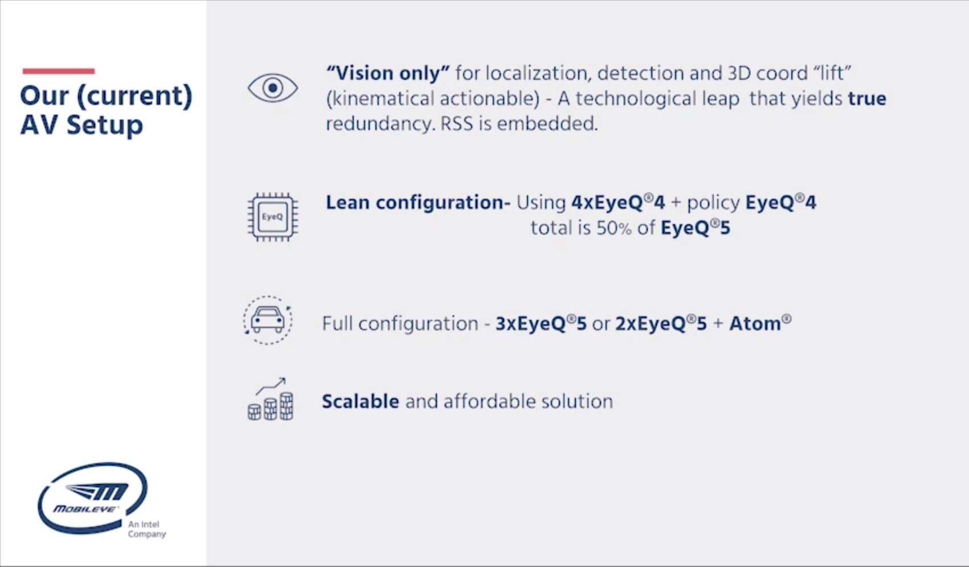

An accessible overview and video of this setup can be found at the CNET article ‘How Intel and Mobileye are taking a simpler path to autonomy’ and at Bloomberg ‘The Autonomous-Car Company That’s Selling Safety First’.

The surround computer vision kit of Intel/Mobileye will also be integrated by Baidu (12 camera setup).

The ultimate goal, which Mobileye plans around 2021, is a scalable solution, which will be 1000x safer then the average human driver:
The processing equipment they are proposing for OEMs to go L5 is described in this product brief.

- As described in detail in the annexes, the NXP’s S32 platform as well as the Aptiv Smart Vehicle Architecture are examples of platforms which will make cars future-proof and Vision Zero ready
- A European company which is also working on a low cost and scalable solution (in collaboration with amongst others PSA), is AIMotive, and its CEO is also suggesting making some systems mandatory:

‘To increase road-safety lawmakers may even make elements of self-driving technology compulsory for all road cars produced after a certain date. These could range from already common collision avoidance systems to full highway autonomy.’ - AIMotive blog

3.5 The importance of advanced ISA
The problem with ISA as it is now proposed, is that there is nothing Intelligent about it.

‘While AVs will obviously follow the speed limit, we seek for stronger notions of safety’ - RSS Model

When we traditionally talk about ISA, the speed which should not be surpassed is the maximum allowed speed on that road segment. Off course, it is dangerous to always drive at this maximum speed. A prudent driver, and thus also an intelligent and responsible (RSS) vehicle, lets the maximum speed depend on, at least:

- Allowed speed
- Road and weather circumstances
- Presence of other road users
- Visibility of the trajectory, but also the presence of objects that might hide other road users
- Occurence of bend, a crossroad, ...

It is this ‘safe and legal speed’ which should be or main focus, and not the maximal allowed speed.
Actually, every driver is already expected to drive at this speed, as illustrated by this excerpt from the 1968 Vienna Convention on Road Traffic, Article 13:
‘Every driver of a vehicle shall in all circumstances have his vehicle under control so as to be able to exercise due and proper care and to be at all times in a position to perform all manoeuvres required of him. He shall, when adjusting the speed of his vehicle, pay constant regard to the circumstances, in particular the lie of the land, the state of the road, the condition and load of his vehicle, the weather conditions and the density of traffic, so as to be able to stop his vehicle within his range of forward vision and short of any foreseeable obstruction. He shall slow down and if necessary stop whenever circumstances so require, and particularly when visibility is not good.’ Source: UNECE Sustainable Transport Division

If everybody would drive at this ‘appropriate’ speed, almost no accidents would happen. The disadvantage that the average speed would drop, becomes much less in a (parallel) automated world, as the reaction times are reduced to almost zero.

This is also indicated in the report of the 2018 ITF/OECD report about Autonomous driving:

‘Combining the demands from the Vienna convention and the imperatives of the Safe System approach helps to guide operational parameters for automated driving systems. In order to meet these imperatives, the automated driving system must always plan and act so as to remain within the normal driving envelope. The energy level can never be higher than the allowed speed limit, but it is further restricted by the demand to be able to stop short of any foreseeable obstruction. The sensors and their limitations will restrict possible speeds.‘

It is clear that a cheap setup of accurate positioning combined with HD maps and cameras will allow to determine this safe and appropriate speed in great detail and accuracy. Additional knowledge about other road users brought by the communication device (V2X) can also be taken into account. We can then use the haptic feedback mechanism which is proposed in the EC regulation. When the momentum is right, we can even make this a hard limit for certain drivers and locations.

Driving at this safe speed, in combination with AEB, will result in the biggest reduction of accidents of the whole setup, and be much more effective than traditional ISA. I can’t wait to have one in my car.

3.6 In pursuit of Vision Zero: the need for Automatic emergency steering (AES) and driver monitoring

Most of the components I’m proposing are also put forward in the excellent Euro NCAP roadmap: Road Map 2025 - In Pursuit of Vision Zero (PDF). It makes for example a clear choice for steer by wire, which would, in combination with the other proposed components, enable AES:
‘Current AEB systems show potential to avoid or mitigate many crashes but Automatic Emergency Steering, or AES, although technically more demanding, may deliver a further significant reduction in crashes and casualties, in particular for single vehicle and small overlap crashes and accidents involving vulnerable road users. … The hardware needed for automated steering (e.g. automated parking, steer by wire) is available and on sale, as is the vehicle support for driver initiated emergency steering. However, very few automatic steering intervention systems are currently offered. Despite challenges in market introduction and cost effective manufacturing, AES technology is expected to land into the market in the coming years’

The foreseen Euro NCAP 2025 timeline gives a clear and challenging insight on what OEMs should deliver if they want a high safety rating:
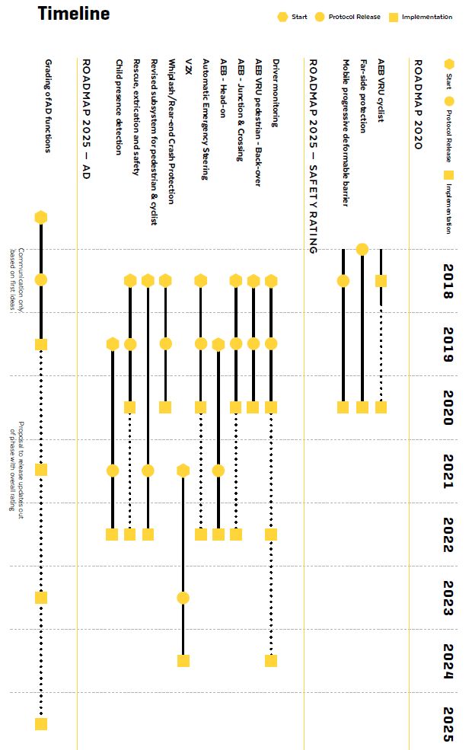

3.7 Speedlocks for urban zones and individuals must be possible with current hardware
Majors around Europe are begging to have vehicles which respect ‘zone 30km/h’, because they realize it is simply not feasible with infrastructural measures. I don’t think the current supportive ISA will prove to be sufficient. Once autonomous cars will enter our cities, people will ask, even more then today, why people are still speeding in their neighborhoods, and the pressure will mount to do something. It would then be extremely effective to say that in certain zones, say in 2027, no one can actually drive faster than 30km/h using a software update. Older cars could be retrofitted with a virtual driver assistant and an effective remuneration/penalty scheme.
Research done about speedlock and speed monitoring systems in the Netherlands shows they are also a very effective measure for problematic speed offenders, which the current proposed ISA will not solve at all. The main problem encountered in the project setup was that other traffic participants did not follow the speeding rules which created frustration. Exactly this will be solved once the assisting ISA with haptic feedback will be activated on more and more cars. It is important to include this in the regulation, because the algorithms should be able to take in this vehicle specific parameters.

3.8 The dooring problem is an immense source of suffering and permanent stress for cyclists: let’s put an end to it
In a recent study for the Brussels region, the dooring of cyclists was found to be one of the most occuring accident types (15%, p.32). In Germany, the UDV found that 7% of bike related accidents had a cause of dooring, and recommends to put in systems in place which would prevent this.
While often only resulting in slight injury, it sometimes has permanent consequences for the cyclist and creates a permanent state of anxiety. A sudden fall on the road can (and has led to) lead to a fatal overrun by passing traffic which can have zero time to react.
The number of accidents of this type is also severely underestimated since often no police is involved.

Now is the time to get rid of this dreadful problem once and for all, by leveraging the pedestrian and cyclist detection in combination with a warning and automatic locking, as showcased by NVIDIA. This does not require a substantial investment, and two car brands are already offering such systems.
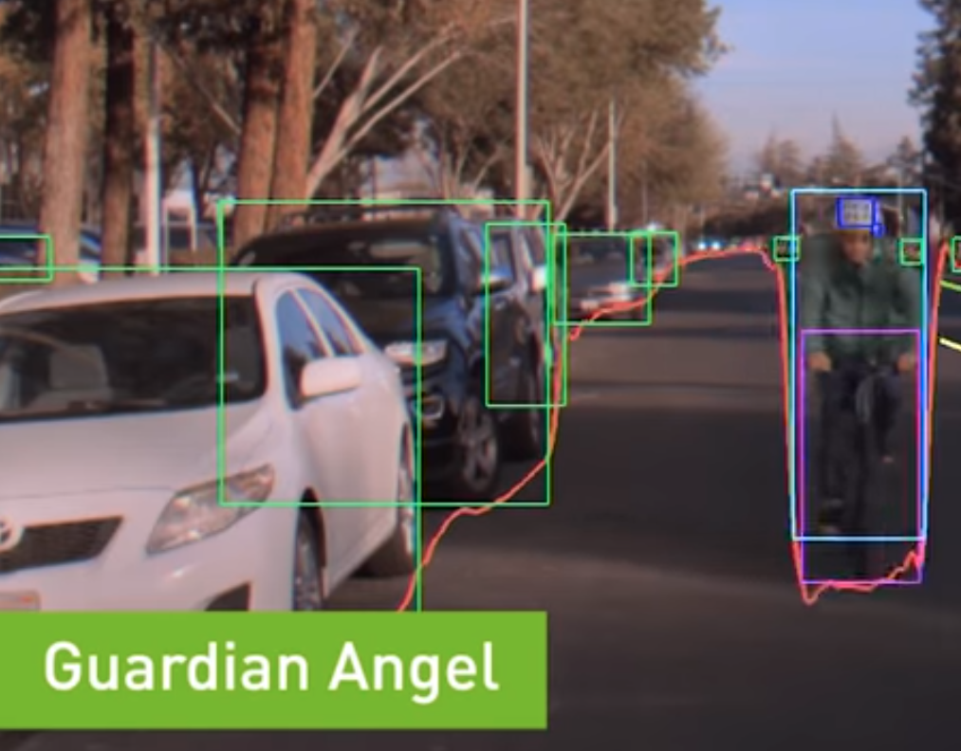

It should be clear that a automated solution in the car is the only viable solution, again:

“Any system which depends on human reliability is unreliable.”
Gilb’s Second Law of Unreliability

3.9 Reliable low latency connectivity: an additional safety net which opens up a myriad of possibilities
We can drive extremely safe using only on vehicle sensors, as Mobileye (RSS model, true redundancy approach), Waymo, GM/Cruise, Voyage and others have documented. But in a lot of cases, adding external knowledge about the position and heading of other road users, and probably including negotiation, would allow for either more fluent traffic, increased safety, lower hardware costs or a combination.

The 5G Automotive Association has done a tremendous effort in pointing out the potential benefits for road safety of connecting road users using mobile communication technology. Here are the key figures of their white paper ‘An assessment of LTE-V2X (PC5) and 802.11p direct communications technologies for improved road safety in the EU’:
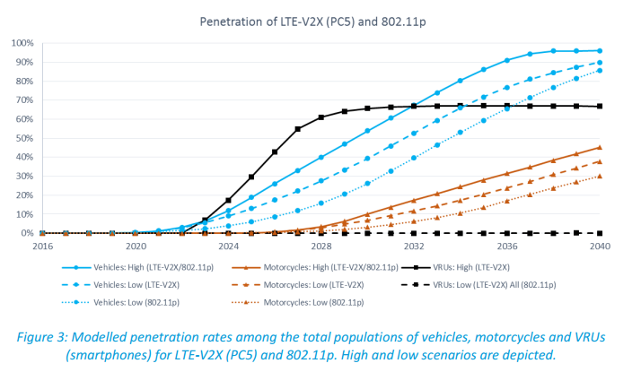
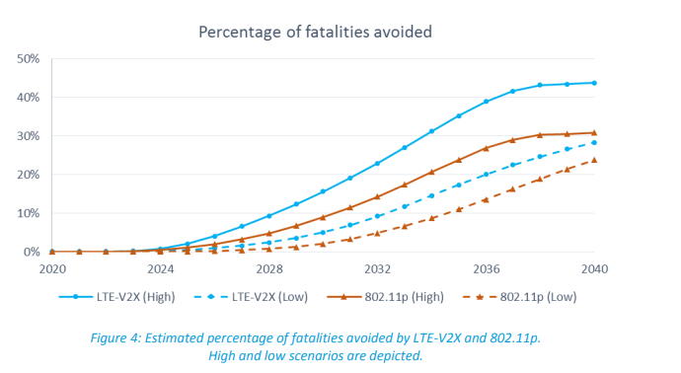

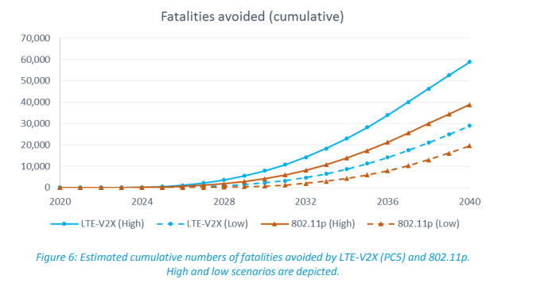

I’m much more optimistic about the penetration rate of smartphones among VRUs: as soon as people realize the added value of adding a (security) smartphone/device in the rucksack of their children, when bicycles have integrated LTE-V2X devices, penetration rates among VRUs can easily reach 95% or more.
It is important to note that this is an additional layer of safety, and that precaution should remain a basic principle of the driving policy.

If we look at the timeline provided in the February 2018 Timeline update of 5GAA, we see that 2021 is indeed a very reachable target to mandate such type of communication device in every car:
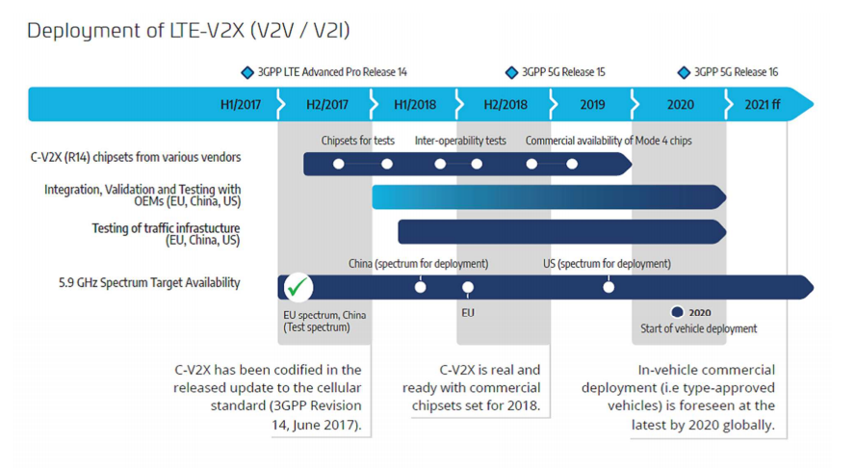

Note that, at the first Galileo User Assembly conference, the Road Transport Subpanel lead by ERTICO, it was put forward that smartphone localisation should be one of the major applications:

‘The role of smartphones in broadcasting vulnerable road user presence to vehicles is expected to become more prominent, hence GNSS performances should be considered for safety relevant applications’ (Summary Minutes).

’The smartphone can also be used for detection or providing the presence of a vulnerable road user (VRU), meaning pedestrian or cyclist. Because a cloud platform will be developed for automated driving, this information can be easily pushed to this cloud platform and then be pulled down to the vehicles and so the vehicle can detect a venerable road user even without a camera’ (video presentation)

Already today, the first dual frequency GNSS smartphones, offering the required accuracy at dm level in urban environment, are available on the market, with obvious price drops in the following years. See the GPSWorld article ‘Dual-frequency GNSS smartphone hits the market’, June 2018:

‘Until now, mobile location-based applications have been powered by single-frequency GNSS receivers whose location accuracy is limited to a few meters. However, in recent years GNSS systems have been launching satellites broadcasting signals on new frequencies to open up new possibilities. Specifically, Galileo has the majority of satellites with E1/L1 and E5/L5 frequency capabilities.
The E1/L1 + E5/L5 GNSS chip can compute location with an accuracy of up to a few decimeters.
According to the company, users of the Xiaomi Mi 8 and future models with dual-frequency GNSS will benefit from better positioning and navigation experience in urban environments. This is due to the unique shape of the E5/L5 frequency, which makes it easier to distinguish real signals from the ones reflected by buildings, reducing the multipath effect, a major source of navigation error in cities and other challenging environments.
Leveraging Galileo for increased accuracy
The numerous Galileo satellites broadcasting E5 make this improvement available for users all around the world. In addition, the simultaneous use of two frequencies reduces other sources of error, such as those due to the ionosphere, and the frequency diversity is more robust to interference and jamming. In addition to making existing applications more accurate, the enhanced position precision offered by dual-frequency GNSS will also create opportunities for new applications in areas such as augmented reality, vehicle navigation and mapping. Commenting on the product launch, European GNSS Agency (GSA) head of market development Gian Gherardo Calini said that the arrival of the first dual-frequency GNSS smartphone to the mass-market represents a breakthrough for users all over the world.
“The enhanced accuracy provided will empower developers to create new applications that meet the growing high-accuracy location requirements of users and also open up applications that previously only ran in dedicated devices intended for professional use,” Calini said’.

4 Economics and timing

4.1 The BCR of a guardian angel setup is order of magnitude 10
Because I did not found a model which takes in all the known costs of traffic collisions and incorporated the latest technological advances, I developed a simplified model myself.

For simplicity reasons (and lack of time), it is only looking at accidents where cars were involved (but takes this into account in the final calculation), and assumes that vans, trucks and buses will follow a similar implementation path. If it takes a price surplus of €2000 for a ‘Vision Zero equipment’ compared to a car which has no ADAS system, this gives us for the Netherlands a Benefit to cost ratio of 10, with default conservative parameters about the evolution of the car fleet and uptake of eg sharing and increased mileage per car. Even putting in € 3000 for the extra costs still results in a BCR of 7.
Update 2019: costs will probably be substantially lower as we saw in the Mobileye CES 2019 update.
Importantly, the cost of processing is dropping at a stunning pace, and the sensors we need aren’t expensive, Michael Wang gives some prices estimates in his blog:
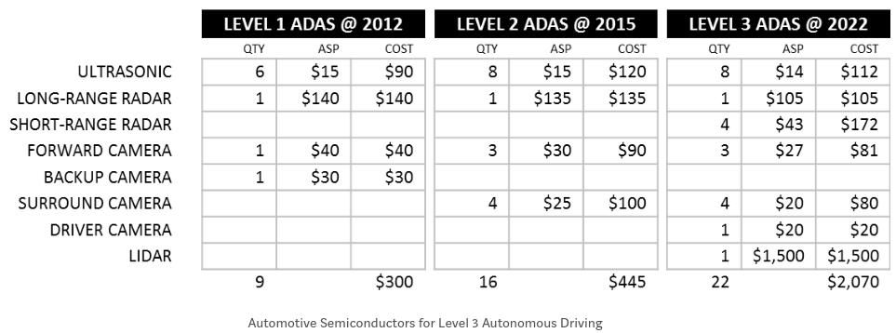

Of course, our BCR-model has not the underpinning and complexity of the model of TRL (see the impact assessment), but it takes in much more accident related costs (although long not all!), is online and transparent, hopefully very understandable and allows everyone to play with parameters or the model itself (download or make a copy).
Note that even very expensive, well documented and complex models do not have any guarantee whatsoever of a reliable prediction of the future, or even of the present, as the PRIMES and other models prove. See also the section Vision Zero in 2050, 2040, or 2030?.

In this BCR calculation, I use the Netherlands because of the availability of data, the fact that vehicles are renewed at an European average pace and also because this could be seen as a worst case for this kind of technology, because they already have an excellent road safety record. The total cost of accidents in the Netherlands used (€ 14.5 billion a year), is also an underestimation because not accounting for all the costs of minor accidents. So, if anything, we will probably underestimate the (easily measurable) benefits.

4.2 Vision Zero in 2050, 2040, or 2030?
A common target year for a road safety Vision Zero society is 2050. It’s the target of the EC but also shared by ACEA and CLEPA.
However, by focusing vehicle (business) development on road safety, I’m convinced we can reach this target 10 years early, EU wide, as I show in my BCR calculations.
It is important to note that I’m taking conservative assumptions in the default parameters of the BCR calculation, not taking into account any real disruption, although a lot of signs are pointing in the direction of disruption.
For example, Waymo will start offering autonomous ride sharing in 2018, and will serve 1 million rides A DAY in 2022 using only 20 000 electric jaguars (article), GM Cruise and Daimler will start urban ride sharing in 2019, pure electric cars are already representing 37% of sales in Norway, companies Amber are working on electric cars which can last one million mile. Actually, the drivetrain of the Model 3/Semi is already built for it, showing no wear after one million mile.

‘According to Boston Consulting Group, automated vehicles should represent 20% of global vehicle sales in 2025’ - taken from the EC paper ‘On the road to automated mobility: An EU strategy for mobility of the future’ COM/2018/283
Whereas too old cars used to pose environmental and safety questions, with (parallel) autonomous and electric cars you just can keep on driving in an extremely clean and safe way possible. The marginal improvements in safety and efficiency will never outweigh the replacement costs of such a car.
Ben Rutten gave a nice presentation of the disruption that he sees coming.
Tony Seba and his team even estimated in their 2017 report quite audaciously that around 2030 in the US, 95% of kms driven will be fully automated and electric (Spectrum article). Watch him tell his story in his entertaining keynote (PDF slides) of the EV Congress in march 2018 in Amsterdam.

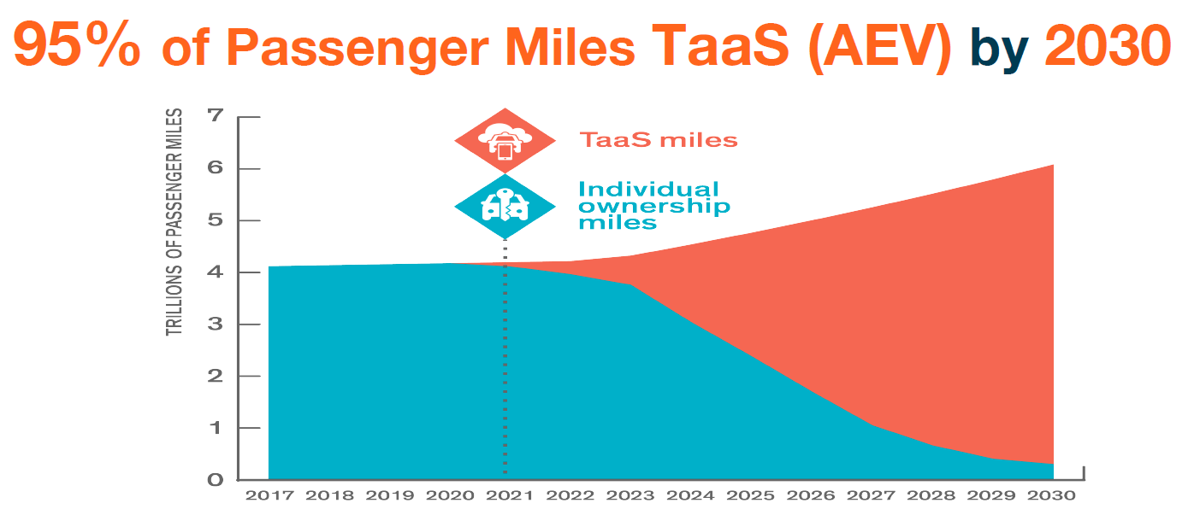
RethinkX has some very strong points, and a lot of very well documented and expensive studies have indeed been way off with their predictions. I personally think he is too aggressive in his timeline and scope. Even in 2040, a lot of people in not so dense urban areas will still drive around the cars they bought in 2028, unless we start taxing private car ownership very hard or the purchase power drops very hard. Why? TaaS is still no match for the instant service you have on your driveway in the form of your personal car, as these authors also suggest.
Further analysis in the academic articles ‘Cost-based analysis of autonomous mobility services’ and ‘Mobility disruption’:

‘Based on current trends there doesn’t seem to be an imminent disruption of mobility. The private owned vehicle is still holding its dominant position. Still there are niches for new innovations that are slowly growing and the mobility space is changing rapidly, creating an environment where a disruption actually could happen fast. Shared mobility per se might not be attractive enough to truly disrupt the transportation system, but it is necessary to ensure that the other innovations, electrification and automation, disrupt in a sustainable direction. However, we can’t rely on that technological innovations alone will lead to a desirable disruption from society’s point of view. It is necessary to steer these to create the transportation system that society wants and that can ensure clean accessibility and mobility to its citizens.’

When a distinguished but elderly scientist states that something is possible, he is almost certainly right. When he states that something is impossible, he is very probably wrong.
Arthur C. Clarke’s first law

It’s Difficult to Make Predictions, Especially About the Future

4.3 Some official announcements of mainstream manufacturers

Here are some official statements of ‘average car’ manufacturers which make clear that the foreseen timeline 2022 for new models and 2024 for all cars is realistic. I also include statements about electrifications because electrifying a model demands more industrial effort than the propositions of this amendment:

- Renault-Nissan-Mitsubishi Alliance: ‘Alliance 2022 plans a major expansion in shared electric vehicle technologies, alongside the development and deployment of advanced autonomous drive systems, vehicle connectivity and new mobility services. Twelve new zero-emission electric vehicles will be launched by 2022, utilizing new common electric vehicle platforms and components for multiple segments. Over the same period, 40 vehicles will be introduced with different levels of autonomy, all the way to fully autonomous capability. (Alliance 2022 plan)
- Groupe PSA: Starting in 2019, every new model will also systematically come in a hybrid or all-electric version. Fifteen new electrified vehicles will be launched in just two years.
Our product offensive is well launched today and 100% of PEUGEOT, CITROËN, DS, OPEL and VAUXHALL line-up will be electrified by 2025. (PSA September 2018 Press event PHEV Edito)
Groupe PSA vehicles will be equipped with a smart assistant starting in 2020, thanks to SoundHound. The new generation voice assistant will enable Peugeot, Citroën, DS, Opel and Vauxhall customers to converse naturally with their vehicle. (PSA Press September 2018)
- VW brand: In future, Volkswagen intends to make new driver assistance systems production-ready even faster, also using virtual validation. The assistance systems of the next generation will then learn from virtually generated driving and traffic situations. The brand expects this approach to make development processes even faster and more efficient. (VW Press)

- Ford: At Ford, 150 years later, we are excited to continue advancing this type of thinking by committing to deploy cellular vehicle-to-everything technology — or C-V2X — in all of our new vehicle models in the United States beginning in 2022.(Ford, CES 2019)

4.4 Why Waiting for Perfect Autonomous Vehicles May Cost Lives
An interesting line of thought can be found in this blog which is summary of the Rand report - The Enemy of Good Estimating the Cost of Waiting for Nearly Perfect Automated Vehicles. Note that I’m much more optimistic about the potential of accident prevention in the short term, notably via the systems proposed in the amendment.

5 FAQ

5.1 Will high precision localisation and HD real time maps be available a low cost around 2022?
There is no question about it:

- Mobileye has developed the REM mapping system, from the RSS scientific paper:
‘In contrast, REM follows a semantic-based approach. The idea is to leverage the large number of vehicles that are equipped with cameras and with software that detects semantically meaningful objects in the scene (lane marks, curbs, poles, traffic lights, etc.). Nowadays, many new cars are equipped with ADAS systems which can be leveraged for crowd source based creation of the map. Since the processing is done on the vehicle side, only a small amount of semantic data should be communicated to the cloud. This allows a very frequent update of the map in a scalable way. In addition, the autonomous vehicles can receive the small sized mapping data over existing communication platforms (the cellular network). Finally, highly accurate localization on the map can be obtained based on cameras, without the need for expensive lidars.’
Together with VW, BMW, Nissan, crowdsourcing of the road network will start in 2018 with 2 million cars. The updating and access of this map requires low bandwidth (10 kbytes/km), which is fully scalable width today's networks and will cost only about € 1 / year in data costs.
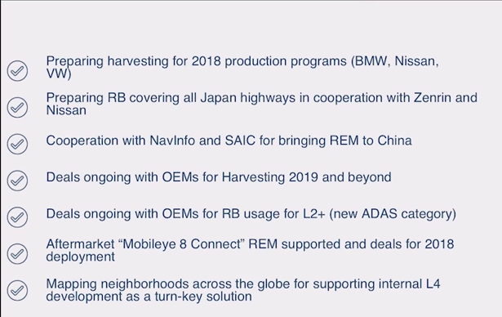

- Here:
‘The four companies today announced that they have formed the OneMap Alliance to offer a global, standardized and dynamic high definition (HD) map from 2020.
HD Live Map is a dynamic digital representation of the road environment that utilizes camera and other sensory observations of millions of cars to self-heal. This means that, as the world changes, the map corrects and calibrates itself to ensure it stays useful and trusted. It is designed to give vehicles an uninterrupted picture of the road environment – even when there’s a truck or building blocking their view – with awareness of upcoming lane configurations and their meaning.’
- Tom Tom RoadDNA : ‘The TomTom HD Map is not limited to autonomous driving, but can also be leveraged to fulfill a broad range of ADAS applications such as Predictive Powertrain Control, Highway Pilot, and Adaptive Cruise Control.’
- NVIDIA is also delivering HD mapping solutions and accurate positioning (see demo at Computech 2018), supporting data for Here
- Baidu: same approach as Mobileye for precise positioning and mapping, but apparently using Lidar, see CES 2018 announcement : ‘In Apollo 2.0, we solved this problem, by using adaptive fusion LIDAR, gps and ... It can achieve state of the art accuracy of 5 to 10 cm. Even in urban canyons and tunnels. Apollo 2.0 localisation module, is always accurate, no matter the place’.

5.2 What to respond to the car industry arguments that ‘we are already doing the best we can’ and the timing is ‘not realistic’?
The vehicle manufacturers have made truly tremendous achievements in the area of vehicle safety. Yet, we are nowhere near to what is technically and societal possible to ensure article 2 of the European Charter of fundamental rights, ‘Right to life’, to an acceptable degree. Or even to adhere to Article 5 of the current EU regulation (see 2.5 Liability of the European Institutions).
There is way too much R&D and industrial effort going in more and more options, more and more models, more and more motorisations, larger and heavier vehicles, ever mounting racing budgets … Just try to choose and configure a car on the website of VW, BMW, Mercedes, PSA, Renault, Toyota, Kia, Nissan, Hyundai, Ford, GM, … without getting a headache and wondering if we are really trying to reach the Paris Climate targets. OEM groups are not solely to blame: they are in fierce competition with each other, and are pushed by market forces, as many consumers are looking for the latest gadgets, models, the most powerful engines, the car bigger than the one next door… .
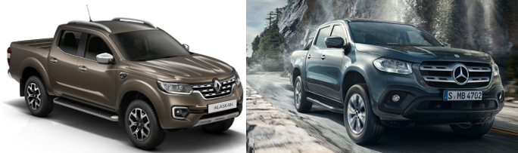
So, it is the public authority, in our case the EU, which should create a level playing field of vehicle safety in concordance to the best available technology at the moment of regulation. This will only increase the competitiveness, innovation, economic growth and well being in the EU.

By setting the bar straight, all manufacturers will have to focus in the next five years on vehicle safety and environmental performances, instead of adding yet another SUV/Pick up (vehicle classes which did not even exist not so long ago in Europe) to their already ludicrously large offer.
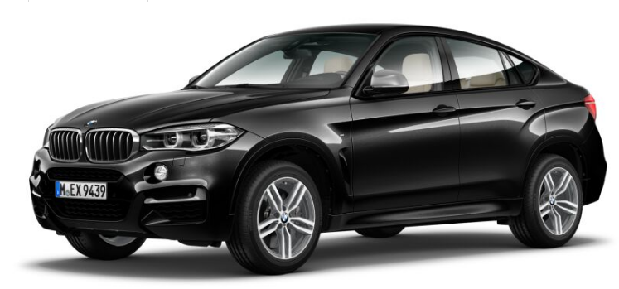
Yes, there probably will be complaining by OEMs, but is it really impossible to only produce vehicles which cannot harm in a meaningful way our citizens, at the state of AI at the end of 2023, after five year of R&D and industrial evolution? In five years, an entire World War was fought. What if Roosevelt had listened to the arguments of the industrial representatives who did not want to enter WWII because it would be very detrimental to the industry?
‘According to the conventional view of World War II, American business made all this happen simply because it rolled up its sleeves and went to war. As is so often the case, however, the conventional view is mostly wrong. … ‘

Luckily, Roosevelt persevered, and in a few years tanks and bombers were rolling out of the factories which used to produce consumer goods.
When the EU put up fuel consumption limits in the past, industry responded that it would be nearly impossible to reach and very costly to the consumer. The reality was quite the opposite, as can be found in the impact assessment (p130).

The lesson is: when you put in enough pressure, it is remarkable how swift industry can react on a large scale.
Wouldn’t it be better to start a, regulation pressed, ‘race for the safest car’, instead of a race for the largest car? Or should we really continue on the path to an American car park? Production follows demand, and demand can be steered by smart, ambitious industrial policy and regulation.

‘Drivers have been running an “arms race” on American roads by buying increasingly
large vehicles such as sport utility vehicles and light trucks. But large vehicles
pose an increased danger to occupants of smaller vehicles and to pedestrians, bicyclists,
and motorcyclists. … For each 1 million light trucks that replace cars, between 34 and 93 additional car occupants, pedestrians, bicyclists, or motorcyclists are killed per year. The safety gain that families obtain for themselves from driving large vehicles comes at a very high cost: for each fatal crash that occupants of large vehicles avoid, at least 4.3 additional fatal crashes involving others occur.’ - THE “ARMS RACE” ON AMERICAN ROADS: THE EFFECT OF SPORT UTILITY VEHICLES AND PICKUP TRUCKS ON TRAFFIC SAFETY

So, to conclude, for the OEMs having difficulties meeting environmental and road security requirements: less is more. Focus on a handful of models, and limit the number of variants, motorisations and options. As some VW executive told: “VW has only three iconic models, the VW Beetle, the Golf, and the Van”. Add max a few, and one can satisfy the needs of any customer. The well marketeered desires will never be satisfied, no matter how large the offer. Currently, the VW brand alone has more than 15 different models… The VW group has so much models and variants, that they even have to to rent giant parking spaces because they cannot certify all those configurations in time for the new WLTP procedure… The skill shortage is the wrong excuse: to a large extend, it is caused by having too much bright people working on too much models with too much options.
If you look at the current offer of all brands, and compare it to what was available in the 90’s, the evolution is stunning, without, however, increasing general well being, if we may believe numerous studies on the topic. Or just take a look at the happiness score of Denmark, a country which is still holding back the SUV surge due to an ambitious eco taxation.

5.3 Will there be enough scalable and affordable computing, sensing and controlling components from different vendors in the timeline foreseen?
It will if regulation asks for it. I cannot exclude some short term shortages of for example high end processing components, this is the reason for clause B in the amdenement.
Clearly disruption is taking place with respect to performance and digitalisation. Some key players (sorry for the ones I do not mention) and their products which are already available or will enter the market any time soon:

NXP: ‘NXP Announces New Automotive Processing Platform that Brings Future Vehicles to Market Faster
The NXP S32 platform is the world's first fully-scalable automotive computing architecture. Soon to be adopted by both premium and volume automotive brands, it offers a unified architecture of microcontrollers/microprocessors (MCU/MPU) and an identical software environment across application platforms. The NXP S32 architecture addresses the challenges of future car development with a host of architectural innovations designed to allow carmakers to bring rich in-vehicle experiences and automated driving functions to market much faster than before.’ Press Release Octobre 2017
and
‘NXP Processors Deliver Performance and Safety for Next-Generation Electric and Autonomous

NXP has announced a new family of high-performance safe microprocessors to control vehicle dynamics in next-generation electric and autonomous vehicles. The new NXP S32S microprocessors will manage the systems that accelerate, brake and steer vehicles safely, whether under the direct control of a driver or an autonomous vehicle’s control. …
Large integrated flash memory (up to 64M bytes) supporting on-the-fly, over-the-air update capability with zero processor downtime ‘ Press release June 18, 2018

See also Annex 7.2 S32 Automotive Processing Platform: a future-proof solution

Aptiv: Ready for the Future: Smart Vehicle Architecture

The Turning Point.

As vehicle manufacturers add more and more features to each model year, and with each of those features requiring its own physical “box,” the traditional vehicle architecture has literally run out of space to house them all.

Put another way, automotive technology has reached an architecture break, and it’s happening right now, years before the critical mass we predicted with Level 4 and Level 5 autonomy.

Enter Aptiv Smart Vehicle Architecture (SVA), a radically new approach to creating the more advanced vehicles of tomorrow (and even today).

“And the interesting thing is, when you look at it holistically, and you break it down to its parts, solutions arise, that make the entire system cost less” Lee Bauer, Aptiv

See also Annex 7.3 Smart Vehicle Architecture: A Holistic Approach to a Fail-Safe Car

Renesas:
‘We are now preparing solutions for autonomous driving, which will go in volumes after 2020’
'Ready to go into advanced city driving autonomous vehicles in 2020, the new SoC will start sampling in 2019'. See also this Renesas press release.

‘Renesas and Magna Bring Advanced Safety Features to More Vehicle Segments and Consumers’ Cost-Efficient 3D Surround View System for Mass-Produced Vehicles

Denso: ‘The automotive industry is in an era of profound transformation, particularly in technologies for electrification, automated driving and connected driving. In the field of automated driving and vehicle dynamics control, greater acceleration in technology development is needed to support the development of future mobility solutions that will revolutionize how society moves.

The integrated ECU manages components, such as sensors, brakes, and steering, which are basic driving functions and critical for automated driving. Through this joint company, DENSO, AISIN, ADVICS and JTEKT will focus on expediting the development of more sophisticated software required for larger and more complex integrated ECUs.’ Denso

Intel/Mobileye/ST
With the large scale production of the EyeQ5 chip foreseen for 2020/2021, L4 and L5 will be supported, as well as L2+ (starting already in 2019, see also L2+ assistance: all the components we need for Vision Zero driving).

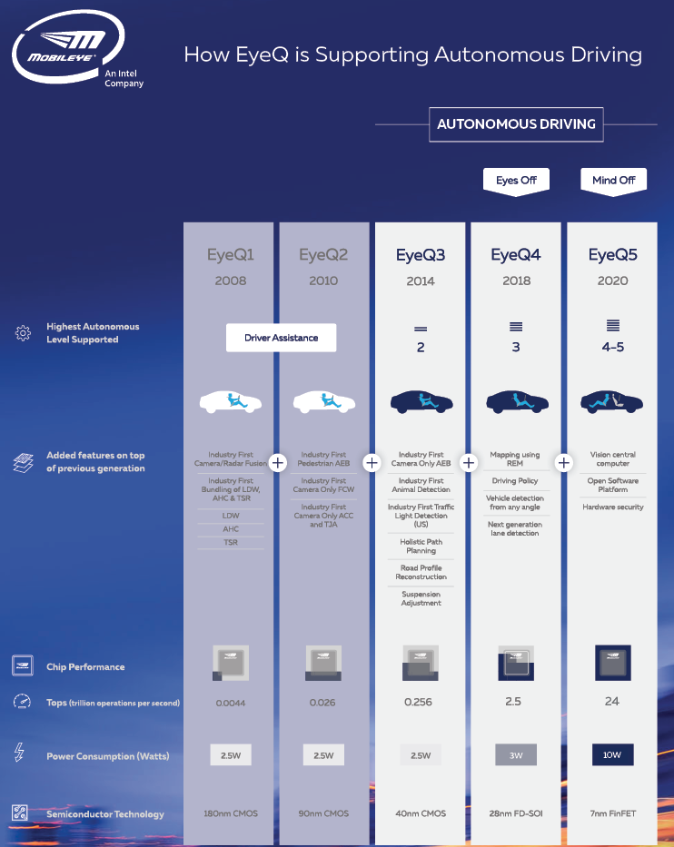
https://www.mobileye.com/our-technology/evolution-eyeq-chip/
http://www.st.com/content/st_com/en/about/media-center/press-item.html/p3832.html &
https://www.eetimes.com/document.asp?page_number=1&doc_id=1333029
Mobileye timeline from CES 2018:
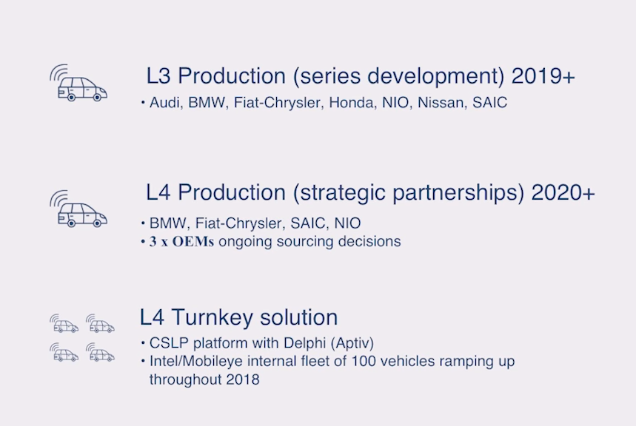

Latest presentation of Amnon Shashua (May 2018), timeline of L5 autonomy:

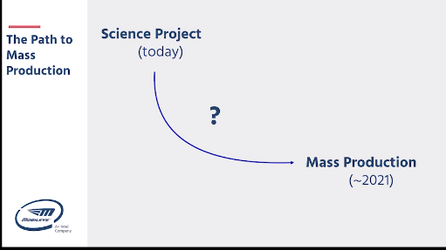

NVIDIA: is aiming at very large uptake rates of autonomous hardware among its 320 partners, notably via the Xavier SoC. Watch CEO Jenssen Huang at CES 2018 or GTC 2018, where he is speaks about the need for equipping 150 million vehicles with autonomous processing per year.

Bosch: partnering up with amongst others Nvidia, Let’s Go Driverless: Daimler, Bosch Select NVIDIA DRIVE for Robotaxi Fleets and Daimler and Bosch press release, July 2018

Baidu at CES 2018: Apparently, Baidu is providing, with their Apollo ecosystem, a scalable and open turnkey solution available for large scale deployment in 2020. Baidu is aiming to be the ‘Android’ for autonomous vehicles. The CEO of Baidu talks about the incredible progress of the last year ‘We have three vehicles that will be available for volume production. This is simply amazing. This is the China's speed that we talked about. Because, if you ask the question when will L3 and L4 vehicles be commercially viable and ready on the market, if you would have posed this question less than a year ago, nobody, I mean nobody, would have believed it would be this early’

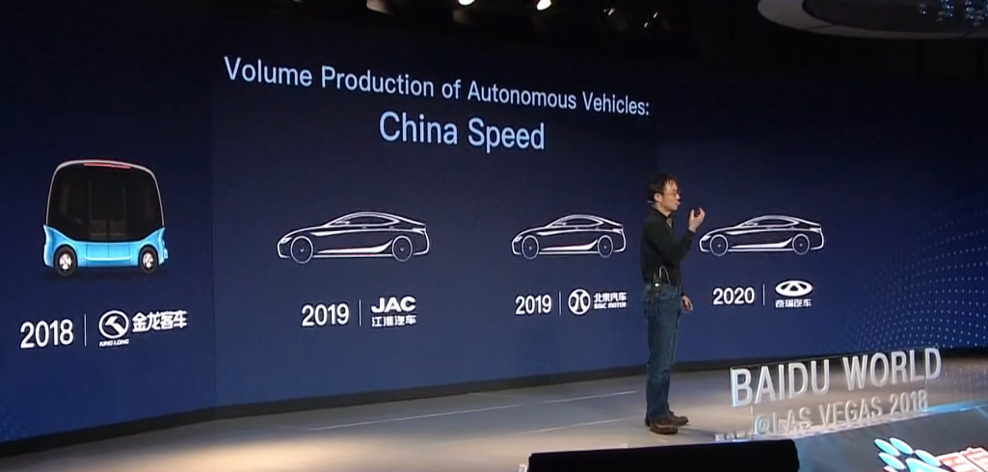

Valeo is partnering up with Baidu and Mobileye for making autonomous solutions
ZF:
‘ZF Enables Autonomous Driving for Everyone:‘For the first time, deep learning algorithms enabled by the supercomputing power of the ZF ProAI will be available in affordable cars. The collaboration is of particular relevance because it contributes to the democratization of autonomous driving functions in one of the most important automotive markets of the world. This helps to enable autonomous driving for everyone’.
‘Our scalable and modular approach enables us to upgrade to our new ProAI based on NVIDIA DRIVE Xavier, and integrate the Baidu Apollo Pilot. Our second generation ZF ProAI could be customised accordingly and scaled up with a Xavier board…’
ZF is now using the See Think Act paradigm as its baseline, this means it already decided to make its future products compliant with the current proposal of amendment:



NXP: S32 platform + Blue box architecture
Hella: ‘Steering systems and steering angle sensors with CIPOS® technology suitable for autonomous driving’, Hella press release June 2018…

5.4 Does a higher price tag will slow down uptake of new vehicles?

“Consumers Want – and Will Pay for Active Safety – It Just Might Save Their Lives” - Aptiv CTO

The TCO of almost all ‘Vision Zero’ cars will be lower than that of a simple car. In addition, this car will also offer premium services, such as smart adaptive cruise control, it will be able to park itself, .... It will also last longer, since it will be able to communicate with self driving cars and other road users and offer the minimum level of road safety guarantees which will be required by cities around 2025-2035.
The biggest cost of a car is not the purchase price, it’s the fact that 94% of the time it’s standing still doing nothing, and when it’s on the move, its average utilisation factor is around 25%. Also, most cars are oversized for their daily usage.
The equipment proposed will make car sharing much more accessible, as owners will have safety guarantees and the elimination of the car key problem.
Also, the cheaper you make the purchase price tag of a car, the more people will continue to operate a private car instead of reverting to some kind of sharing or using MaaS, a behaviour which encompasses large ecological and economic costs.
It is well known that consumers overvalue the price at purchase time with respect to fuel economy which generates savings on the long term (see eg Why the market for new passenger cars generally undervalues fuel economy). Consumers also don’t value the safety benefits (especially for the society!) of additional safety equipment, according to the findings mentioned in the CPB Policy Brief of September 2018.
Importantly, a dedicated pricing policy on vehicles or tolling can eliminate any non-rational retarded renewable of vehicle fleets.

5.5 Why not wait for C-ITS regulation?
We should not wait for upcoming C-ITS regulation. By incorporating the connected car in generic terms now, and ensuring updatability, we make sure that (automated) actuation services, which are much more effective then just warnings, will be applicable to the largest possible number of vehicles as soon as the services become operational. This is of the utmost importance.
One of the reasons why the ‘mandate by EC’ scenario does not show up as the most effective in the socio economic cost benefit analysis of the 5GAA report on the matter, is exactly that they do not expect the ‘actuation services’ to be part of the mandate:
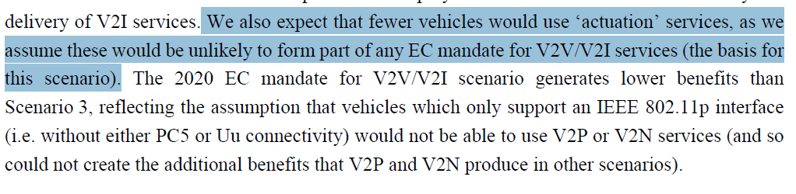
But by introducing the concept of updatebility, we can provide actuation services for every new model starting in 2022!

6 Annex: solutions ready for scalable market deployment

6.1 L2+ assistance: the low cost building blocks we need for Vision Zero driving
Update: NVidia (and Volvo, ZF, ...) are also putting L2+ forward
The Mobileye concept of L2+assistance gives a good indication of what a low cost scalable ‘vision zero’ car would need to support, together with a rollout of C-V2X. However, as we would like to have the driver to keep his focus on the driving (he needs to be occupied sufficiently with the driving task, see the JRC C-ART research of the OECD report), I would not propose to put it in market as a L2 service, but as a L1 service, with some exceptions like highway queuing (for classifications see ERTRAC Automated Driving Roadmap).

Amnon Shashua about L2+ in 2017 ( original presentation):
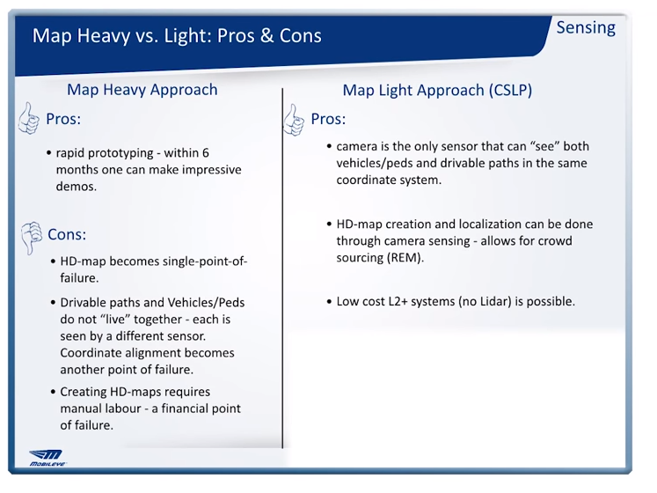

“The High Definition map creation is done using camera sensing using crowdsourcing, the cost is is almost zero. … We call this level 2 plus systems, these are level 2 in terms of the driver is responsible but you can provide features that feel like level 3/level 4 and you can do that without a LIDAR. So for example, imagine the Tesla 8 camera system with a front rader, this is something like a level 2 plus, it cannot satisfy the safety requirement, there isn't redundancy, there's no fail operational, the driver still needs to be responsible but you can get a very strong performance, and you don't need a LIDAR for it so this opens up business possibilities. The disadvantage: it is very, very difficult. As I said the third part of the sensing, that's where a lot of artificial intelligence is required so the right, hand side is difficult to implement but, in the long run this is the right approach, the left hand side is easy to implement but in the long run it's not scalable. Again if we don't build a business we will not have autonomous driving.”

At CES 2018 he added:

‘We have deals on going with car manufacturers for the high-definition map use for a new
category which we call level 2 plus and it's a new ADA's category that will start in 2019.
….
So what is level 2 plus, it's a new category. The definition of level 2 today is driving assist: the driver is fully in control and is fully responsible if there's a malfunction. …
So you can see that from one suite there's a big jump from level 2 to level 3 in terms of system integrity because in level 3 the driver there's those 10 seconds that the driver does not need to be responsible and it's very very tricky in terms of system integrity but level 2 is where we are today.
We would like to make a big jump in the performance of these functions by adding a very very small cost to the overall system, a big jump would be that you can have your Lane Keeping Assist work also inside the city where the lanes are not clear or they are not even well defined.
… What we need to add is the map as this high-definition map because the high-definition map contains the lanes that even if you don't see them they are in the map and all what you need is just to localize the vehicle inside the map project those lanes onto the image frame and then fuse it with your sensing so even if your sensing is not that sure about where the line is it is in the map so you can get a much better lane-keeping assist and also the map contains the traffic lights and the relevancy and and so forth so you can get a much better ACC and the cost is minimal because our map the bandwidth is very very small for example if you take an area of 100 kilometer square 10 by 10 kilometers the size of the map in a city density of say munich is about 4 megabytes so sending that amount of information by tiles is not such a big deal so it's a very very low cost addition to the way the system is today
… you are raising the availability to 2 plus, so this is a new category that will start in 2019 leveraging the fact that we build the map and this is exactly the point I said at the beginning of
trickling down technologies that were designed for level 4 level 5 and we want to bring them down to today's features. The road-book the high definition map, the crowdsourcing was not designed for
this, it was designed to support level 4 level 5 automation and a even level 3 but what we're doing by taking this technology and saying how can we use it today and this is an example of such a desire’

6.2 S32 Automotive Processing Platform: a future-proof solution
Automakers can make upcoming models future-proof by using for example NXP’s S32 platform.
It is launched with the baseline ‘BRINGING FUTURE VEHICLES TO MARKET FASTER’, exactly what we need for our fast lane to Vision Zero. If we may believe NXP, ‘8 of the top 15 car makers have already adopted NXP S32 platform for upcoming models’.
Some highlights from the presentation PDF and the website, remark the words ‘faster, upgradable, scalable and future proof):
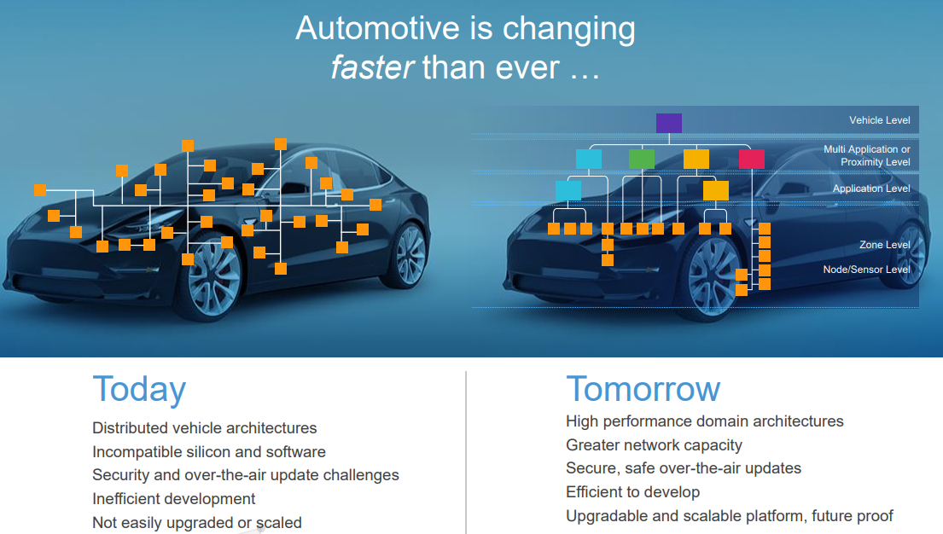

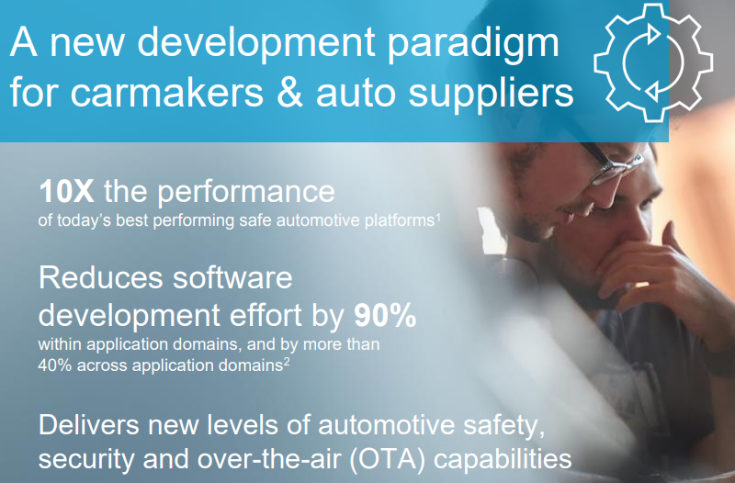
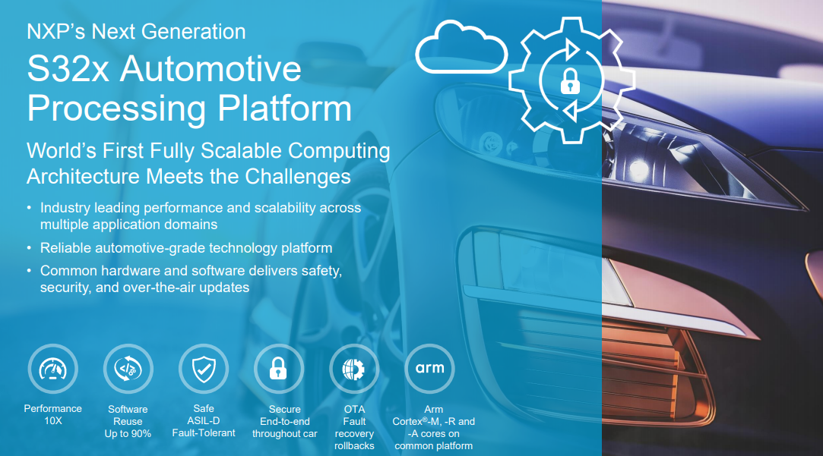

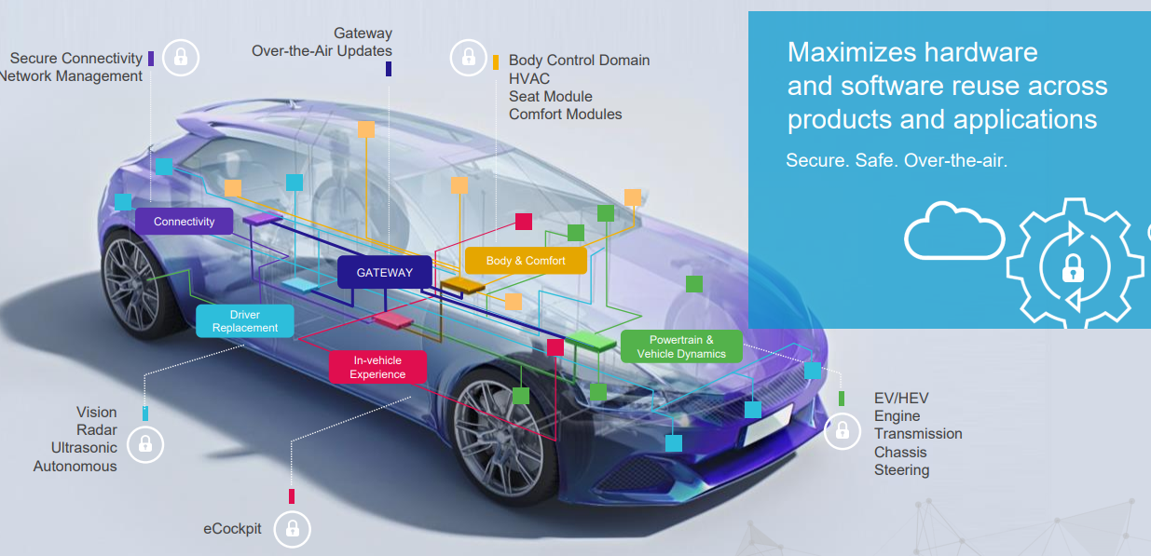
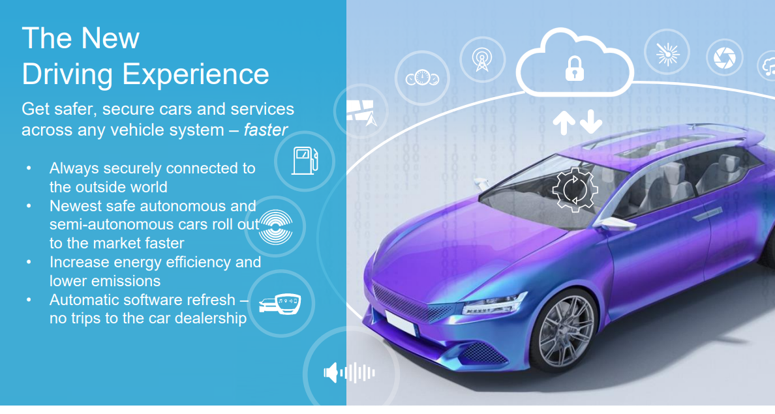

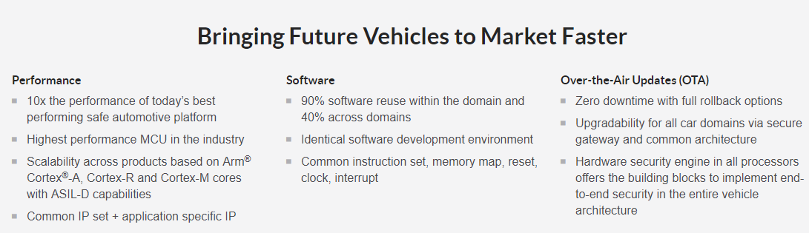

6.3 Smart Vehicle Architecture: A Holistic Approach to a Fail-Safe Car
One of the global leaders in AV technology is Aptiv, the successor of Delphi after the split off of the powertrain division. It is now offering a complete ‘smart vehicle architecture’ which would support all the requirements of the amendment. From the website of Aptiv:
https://www.aptiv.com/smart-vehicle-architecture/ (the Turning Point video series give a nice overview)
https://www.aptiv.com/media/article/smart-vehicle-architecture-the-backbone-of-the-future

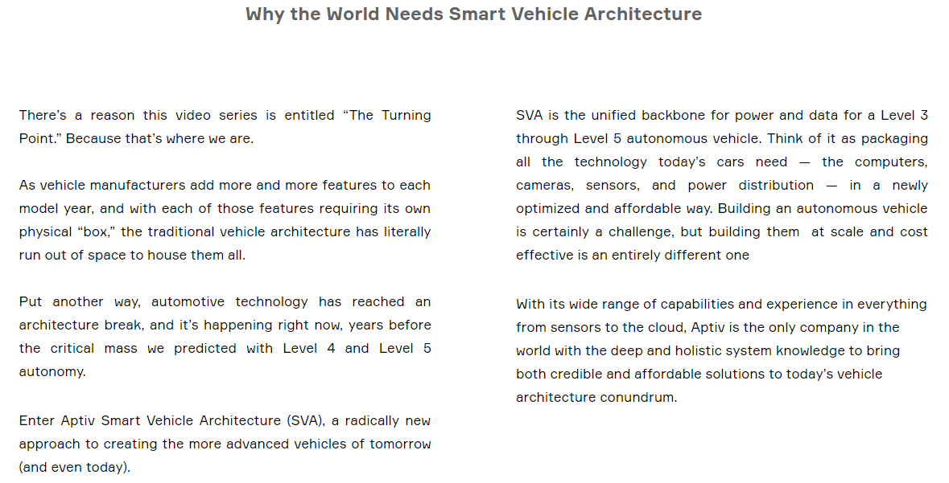

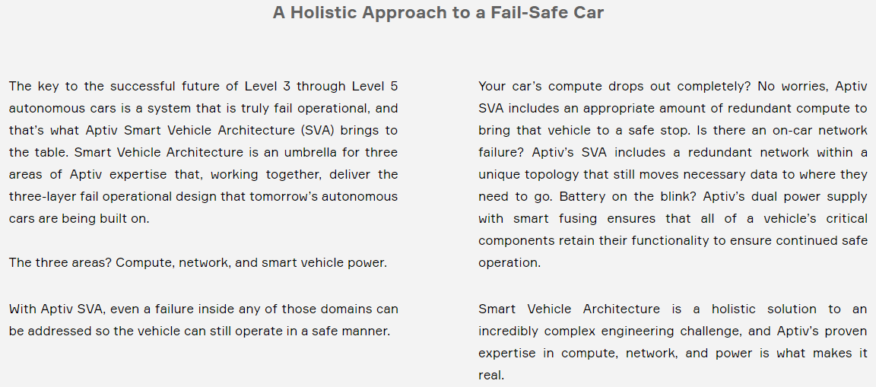

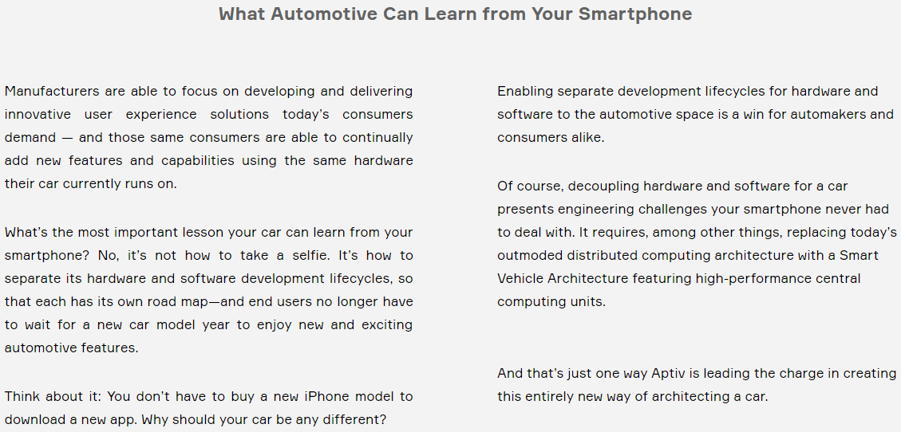

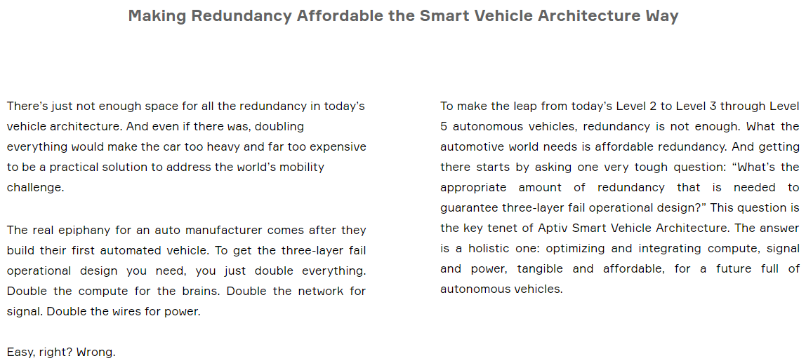

6.4 Some timelines and predictions

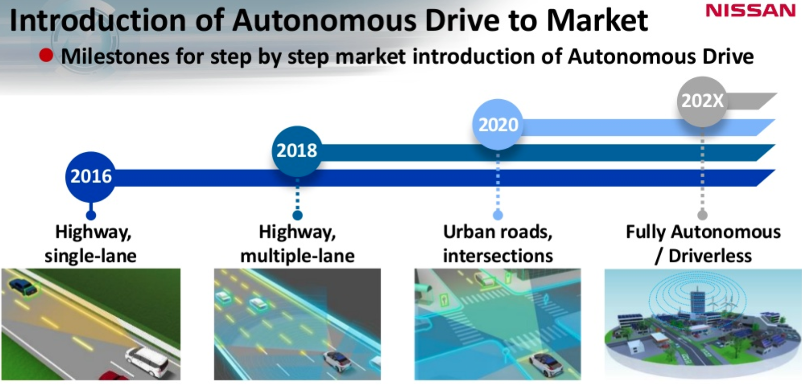
°EuroNCAP

https://360.here.com/enabling-autonomy-from-country-to-country
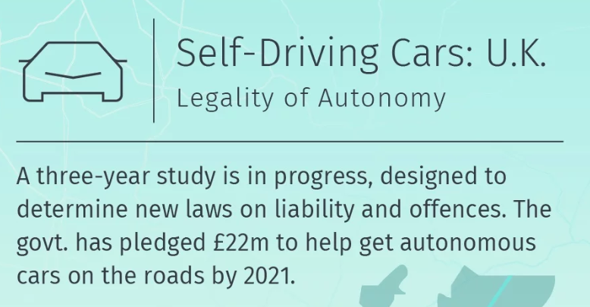

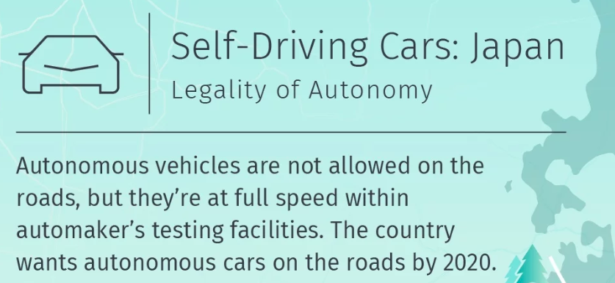

Some overviews of predictions of manufacturers:
https://www.techemergence.com/self-driving-car-timeline-themselves-top-11-automakers/
https://www.theregister.co.uk/2018/05/09/first_autonomous_vehicles/

Prof Amnon Shashua is probably thé expert on the technical and economic feasibility of ADAS solutions and self driving systems, therefore I quote him often. Prof. Shashua has more than 20 years of experience in the ADAS field, has written numerous scientific publications about computer vision and AI, is co-author of the RSS model and is founder, CEO and CTO of Mobileye, the global leader in ADAS sensing solutions, providing 80% of the AEB market. Mobileye is probably the company with the largest impact on road safety in the EU in the last few years. What’s nice about Mobileye is that they are very transparent and open. Here are some presentations of Amnon which given a tremendous insight in what is happening in the domain: https://newsroom.intel.com/talks-interviews-mobileyes-prof-amnon-shashua/
One could compare this approach with the totally unreliable IEA (and others) forecasts on renewable energy penetration. We need another approach for predicting and legislating disruptive technology, as illustrated in the chapter ‘How to make Better Predictions of Radical Innovation’ of the following article: https://steinbuch.wordpress.com/2017/10/20/better-predictions-in-renewable-energy/
See eg http://automatedtoyota.com/ ; Whitepaper and http://corporatenews.pressroom.toyota.com/releases/toyota+research+institute+demonstrates+progress+advanced+technology+research.htm http://corporatenews.pressroom.toyota.com/releases/toyota+research+institute+video+first+demonstration+guardian+chauffeur+autonomous.htm
Documentation and presentations can be found at the RSS page of Mobileye, including the background document ‘Implementing the RSS Model on NHTSA Pre-Crash Scenarios’ Global uptake in January 2019 See also the Intel announcement for a layman’s summary paper. And the comments of Amnon and the latest documentation of Intel An EETimes article about a safety envelope and RSS
Electric & Hybrid Vehicle Technology International, January 2018, p60, PDF, magazine
Volvo Vision 2020 presentation
Total costs of accidents in 2016 was about € 14 billion/year, and the authors say this probably even is an underestimation: https://www.kimnet.nl/mobiliteitsbeeld#verkeersveiligheid-en-milieu-article4
Taken from Volvo Vision 2020 presentation
See again the excellent analysis of prof. Hoekstra about way off IEA predictions and how to account for disruption (actually Tony Seba’s predictions on renewables where one of the most accurate): https://steinbuch.wordpress.com/2017/10/20/better-predictions-in-renewable-energy/
Extract from Box 3 in the OECD report ‘Safer Roads with Automated Vehicles?’
From the the academic paper
See Benefit and feasibility of a range of new technologies and unregulated measures in the field of vehicle occupant safety and protection of vulnerable road users (2015) And In depth cost-effectiveness analysis of the identified measures and features regarding the way forward for EU vehicle safety (2017) ; Annex 4.4.1 Guide to interpreting the results - “Benefit is the expected monetary benefit from prevented casualties each year.”
Market imperfections (eg. insurance fees not reflecting accident risk) might prevent or delay a lower TCO. Also, although we have a very societal beneficial BCR, most accident costs (two thirds is my estimate) are not accounted for in the price of the insurance. So, for cars doing low number of kms the TCO might still be higher for the safer car but more expensive car.
Although the Netherlands have an excellent urban planning (most people live in urban setting isolated from volume traffic) and have invested incredible amounts of money into speed bumps and other ‘slow down’ measures, speeding still remains the number one neighbourhood problem for Dutch citizens!
My excuses: having two very small children, a full time job and a lot of other obligations at work and on a local community level
It might also be interesting for OEMs to make some of the hardware upgradable (easily replaceable, retrofitting), if this is cost beneficial for them. Tesla is apparently already applying a modular approach and a startup company like Fairphone is building modular smartphones for easy replacements (eg. camera) since more than three years. But, this is not a necessity if the OEMs chooses to equip the vehicle right away with powerful hardware
A) ‘For the 28 EU member states costs are estimated at about €270 billion if the results of the value transfer approach are applied. This corresponds to 1.8% of the GDP. This is still an underestimation, because many countries have not corrected the numbers of casualties/crashes for underreporting. If unreported casualties and crashes are taken into account, we expect that total costs are in the order of magnitude of at least 3% of GDP’ SafetyCube project as cited in SWOV analysis 2017. B) An earlier SWOV international analysis with EN summary, which comes at 2% to 4% GDP, Netherlands is around 2%, but this is a very safe country! C) See also this presentation of Ben Rutten and the BCR BCR economics chapter
In Belgium this is about two thirds of the population!
The proposed ISA system will hopefully put an end to the major design flaw of almost every vehicle: the permanent seduction of going to fast. But I’m quite sure that this will not be effective for all drivers
The 5G Automotive Association (5GAA) is a global, cross-industry organisation of companies from the automotive, technology, and telecommunications industries (ICT), working together to develop end-to-end solutions for future mobility and transportation services. Created on September 2016, the 5GAA unites a large member base, including 8 founding members: AUDI AG, BMW Group, Daimler AG, Ericsson, Huawei, Intel, Nokia, and Qualcomm Incorporated. Since its inception, 5GAA has rapidly expanded to include key players with a global footprint in the automotive, technology and telecommunications industries. This includes automotive manufacturers, tier-1 suppliers, chipset/communication system providers, mobile operators and infrastructure vendors. Diverse both in terms of geography and expertise, 5GAA’s members are committed to helping define and develop the next generation of connected mobility and automated vehicle solutions.
Owners will more easily share cars because of the certainty the car will not be ruined by a mistake of the driver, and the fact that the equipment needed for Vision Zero makes sharing more practical (no key sharing problem, … )
Combining this number with the recently released Dutch CPB Policy Brief around fiscal stimuli for vehicle safety, we can estimate the accident reduction potential of a single car in the Netherlands over its lifetime at around € 15,000 in 2016. See the calculation, sheet ‘Netherlands Costs per Vehicle’
Rough estimate based on three different sources, see the sheet, and confirmed by a senior road safety expert, my guess is that the surplus will be even lower given the amendment is passed and scaling effects take off
As it is built to support level 3 to 5, it might not be the most cost effective solution for the solution proposed. I’m not enough expert to make that kind of analysis.
Seel also there Magazine of 2017 and this article in particular of the strong notion towards ‘zero crashes’
A basic setup can be to have a “babysit” or “checker” control unit, which is not updatable and checks if the main operation instructions are ‘safe’.
From https://www.livinglabsmartcharging.nl/nl/Nieuws/electric-trucks-economically-and-environmentally-desirable-but-misunderstood
The required rear view cameras might even come at zero net costs, as new regulation would no longer require to have side rear view mirrors when a replacement camera is present, offering costs savings in fuel consumption and lowering the surface prone to collisions..

