Name(s)_______________________________________________ Period ______ Date ___________________
 | Activity Guide - Representing Information | 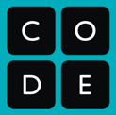

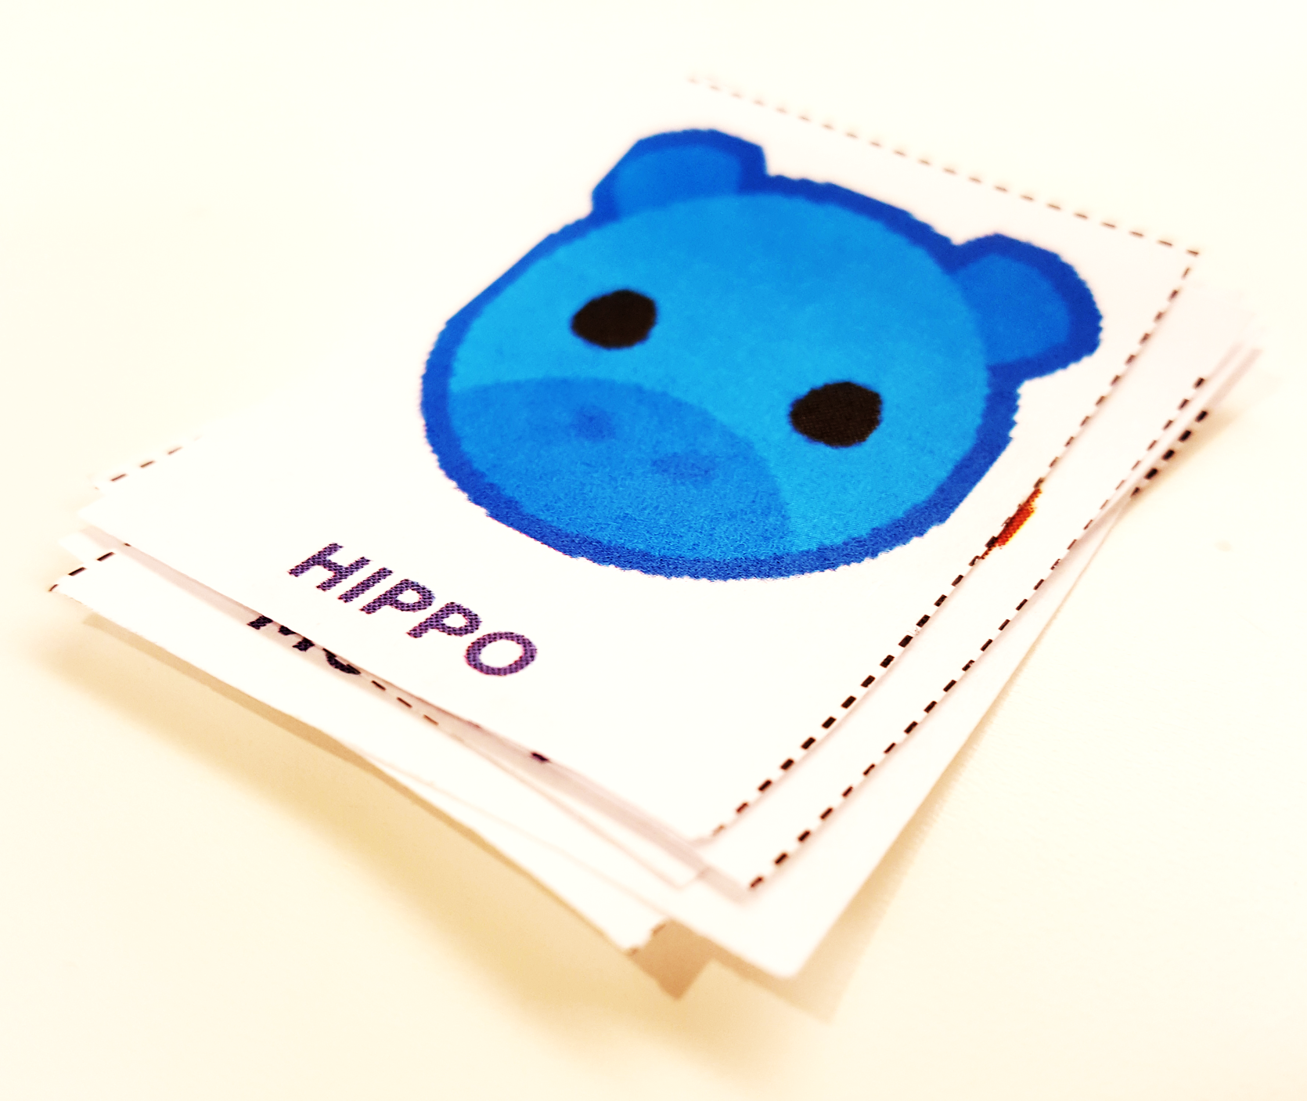
Challenge
You need to create rules that let you represent any word you want using a single stack of cards. Another person should be able to use the rules you write on this activity guide to read the words represented by your stack of cards without talking to you.

How to Make a Stack
Place cards in a single neat stack, all face up and in the same direction. The first card should be on top.

Representing Letters
Write how each letter will be represented below.

A: _____________ | J: _____________ | S: _____________
B: _____________ | K: _____________ | T: _____________
C: _____________ | L: _____________ | U: _____________
D: _____________ | M: _____________ | V: _____________
E: _____________ | N: _____________ | W: _____________
F: _____________ | O: _____________ | X: _____________
G: _____________ | P: _____________ | Y: _____________
H: _____________ | Q: _____________ | Z: _____________
I: _____________ | R: _____________

Your Rules:

____________________________________________________

____________________________________________________

____________________________________________________

Make Your Message
Choose a word and make a stack of cards that uses your rules to represent that word. Leave it next to this activity guide and then switch with another group to see if you can decode their message.

