 |  | How to Make a Flippy Do | 

Instructions for how to make the Flippy Do
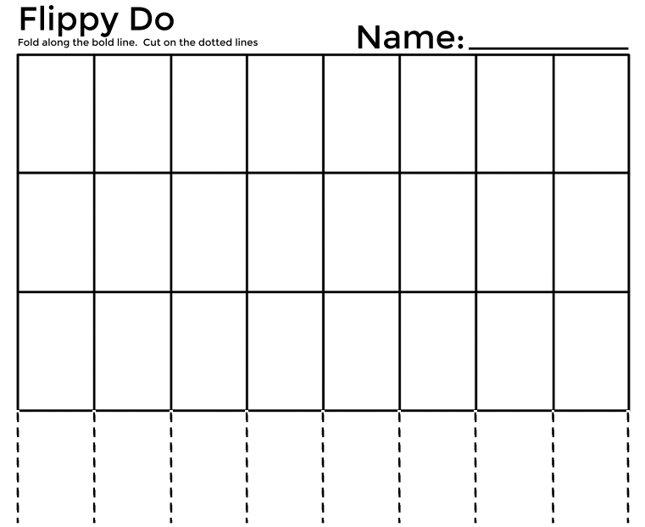

BEFORE →
Blank Template

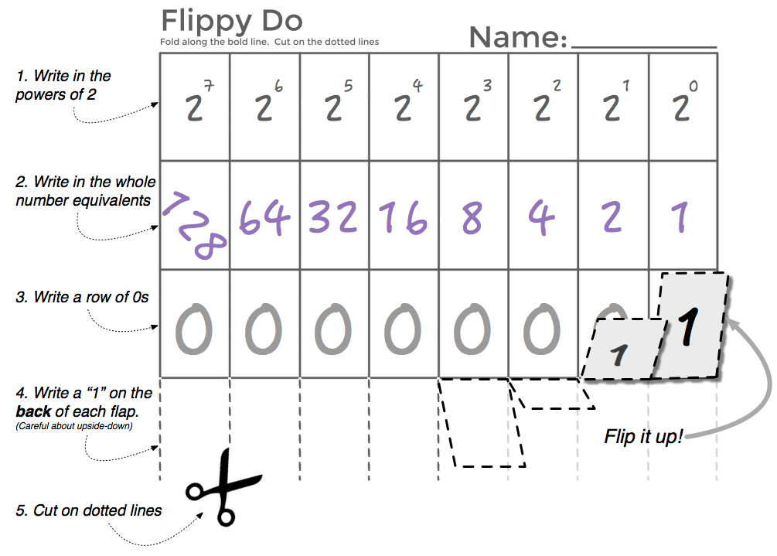
AFTER
⤵

