Darknet Diaries #52: Magecart

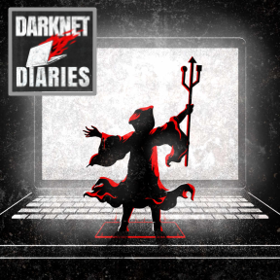
BACKGROUND
In the good old days, it was only ATMs and gas pumps that leveraged “skimmers” to capture information from bank cards. But with the explosion of e-commerce, it became commonplace for bad actors to use skimming technology via software.
In this lab, you will listen to a podcast episode from the podcast the Darknet Diaries and then craft a response to it. I highly recommend subscribing to this podcast; it is consistently riveting.

REQUIREMENTS
A web browser and an internet connection.

PART I: Listen to the podcast
- If you have a podcast app, you can subscribe to the Darknet Diaries (it’s free!) and find Episode 52: Magecart. Alternatively, you can listen to the episode online here. Note that there is no official transcript for this episode yet (it is coming soon). In the meantime, you can look at the official transcript. By the way, you should totally subscribe to this podcast - it is reliably one of the finest podcasts today.
- Craft a response to the podcast. Address the following:
List three things that are AWESOME. Things you were surprised by, amazed by, or something new you learned.

List two things that you will ADVOCATE with your family, friends, and co-workers. What are things that you should tell them to help them understand the importance of information security?

List one thing that is ACTIONABLE. After listening to this podcast, what is one thing you will do? Is there a quick thing you can do to be safer? Is there something you can do to change your behavior?

SUBMIT A LINK TO THIS DOCUMENT IN BLACKBOARD.

