The Title is Written with Book Antiqua Bold (16 pt) and Preferably Not More Than 14 Words

Wayan Sudiarta^{1*}, Lily M Angraini^{2*}, Nova³ (book Antiqua 11)
¹ Physics department, Faculty Mathematics and Natural Science University of Mataram, Indonesia (book Antiqua 10)
² Faculty of Science, National Taiwan University, Taiwan
³ Tallinn Science School, Tallinn University of Technology, Estonia.

Corresponding Authors E-mail: wayan.sudiarta@unram.ac.id, lilyangraini@unram.ac.id

Article Info |  | Abstract
Article info:  Received: xx-xx-20xx  Revised: xx-xx-20xx  Accepted: xx-xx-20xx  Keywords:  FDTD Method; TDSE; Energies; Wave functions  How To Cite:  I. W. Sudiarta, L. M. Angraini, and N. Anggarani, “Comparison of Infrared and Optocoupler Sensors performance for Lab-Scale RPM Measurement System”, Indonesian Physical Review, vol. 5, no. 2, p 130-136, 2022.  DOI: |  | Abstracts are written in English. Font Book Antiqua (10 pt) Italic and preferably not more than 300 words. The abstract should be clear, concise, and descriptive. This abstract should provide a brief introduction to the problem, objective of paper, followed by a statement regarding the methodology and a brief summary of results. For example: The finite difference t1ime domain (FDTD) method has been successfully applied to obtain energies and wave functions for two electrons in a quantum dot modeled by a three dimensional harmonic potential. The FDTD method uses the time-dependent Schrodinger equation (TDSE) in imaginary time. The TDSE is numerically solved with an initial random wave function and after enough simulation time, the wave function converges to the ground state wave function. The excited states are determined by using the same procedure for the ground state with additional constraints that the wave function must be orthogonal with all lower energy wave functions. The numerical results for energies and wave functions for different parameters of confinement potentials are given and compared with published results using other numerical methods. It is shown that the FDTD method gives accurate energies and wave functions.  Copyright © 20xx Authors. All rights reserved.

Introduction
The introduction should be clear and provide the issue to be discussed in the manuscript. Before the objective, authors should provide an adequate background, and very short literature survey in order to record the existing solutions, to show which is the best of previous researches, to show the main limitation of the previous researches, to show what do you hope to achieve (to solve the limitation), and to show the scientific merit or novelties of the paper. At the end of the paragraph, the author/s should end with a comment on the significance concerning identification of the issue and objective of the research. Reference numbers should be indicated in the text by square brackets, e.g. [1], or [1,3], or [1-3].

Theory and Calculation (if any)
Theory section should extend, not repeat, the background to the article already dealt with in the Introduction and lay the foundation for further work. In contrast, a Calculation section represents a practical development from a theoretical basis. Units, Symbols, Abbreviations and Equations. SI units should be used throughout but other established units may be included in the brackets. Abbreviations should be defined when they first appear in the text. Equations should be numbered at the right side of the paper in ordinary bracket (no.). Use either the Microsoft Equation Editor or the MathType add-on (http://www.dessci.com/en/products/mathtype/) for equations in your paper (Insert | Object | Create New | Microsoft Equation or MathType Equation). “Float over text” should not be selected.
Number equations consecutively with equation numbers in parentheses flush with the right margin, as in (1). First, use the equation editor to create the equation. Then, select the “Equation” markup style. Press the tab key and write the equation number in parentheses. To make your equations more compact, you may use the solidus (/), the exp function, or appropriate exponents. Use parentheses to avoid ambiguities in denominators. Punctuate equations when they are part of a sentence, as in

$F=m a$ (1)

Be sure that the symbols in your equation have been defined before the equation appears or immediately following. Italicize symbols (T might refer to temperature, but T is the unit tesla). Refer to “(1),” not “Eq. (1)” or “equation (1),” except at the beginning of a sentence: “Equation (1) is ... .”
Experimental Method
Provide sufficient detail to allow the work to be reproduced. Methods already published should be indicated by a reference. Only relevant modifications should be described.
Result and Discussion
Results should be clear and concise. Discussion should explore the significance of the results of the work, not repeat them. A combined Results and Discussion section is often appropriate. Avoid extensive citations and discussion of published literature.
Tables and Figures are presented center and cited in the manuscript. The figures should be clearly readable and at least have a resolution of 300 DPI (Dots Per Inch) for good printing quality. Table made with the open model (without the vertical lines) as shown below:

Table 1. Numerical Eigen-Energies for a Particle in an Infinite Square Well Potential Computed by the FDTD Method (standar scheme), the NSFDTD Method, the Numerov-FDTD Method and Numerov-NSFDTD (modified Numerov) are compared with the exact values.
No | FDTD | NSFDTD | Numerov  FDTD | Numerov  NSFDTD | Exact
1 | 4.894348 | 4.934802 | 4.934601 | 4.934802 | 4.934802
2 | 19.098301 | 19.739209 | 19.726195 | 19.739209 | 19.739209
3 | 41.221475 | 44.413220 | 44.262411 | 44.413220 | 44.413220
4 | 69.098301 | 78.956835 | 78.091632 | 78.956835 | 78.956835
5 | 100.000000 | 123.370050 | 120.000000 | 123.370050 | 123.370055

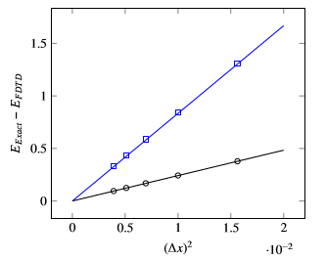
Figure 1. Numerical Error in Eigen as a Fuction for (1) Ground State (Circle) and (2) First Excited State (Squares). Line are Regression Lines.
The following examples show how to format a number of different figure/caption combinations. Note that the table borders are shown as broken lines for guidance only.

 | 
 | Figure 3. Figure with short caption (caption centred).
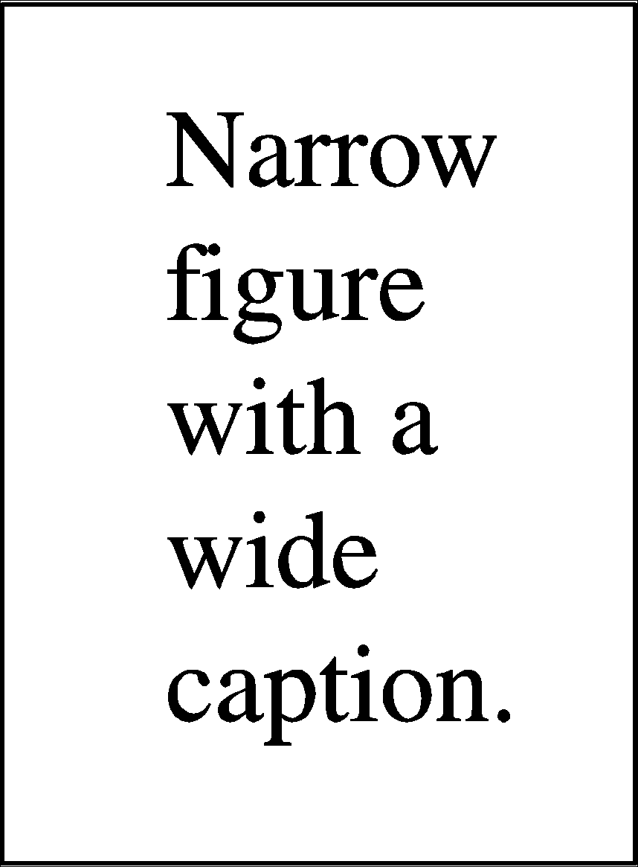 |  | Figure 4. This is a figure with a caption that is wider than the actual graphic. To save space you can put the caption to the right of the figure by placing the graphic and justified caption in a table with one row and two columns.

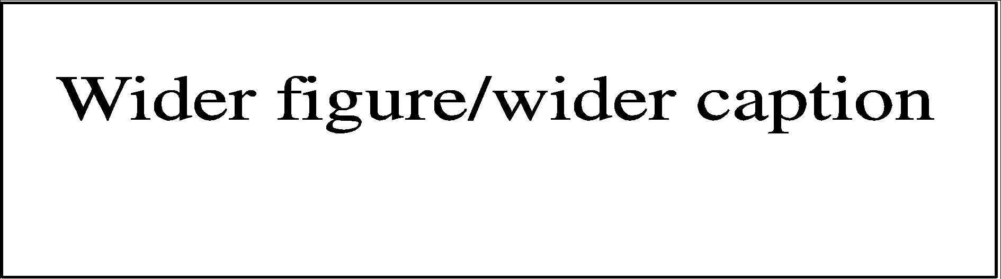
Figure 5. In this case simply justify the caption so that it is as the same width as the graphic.
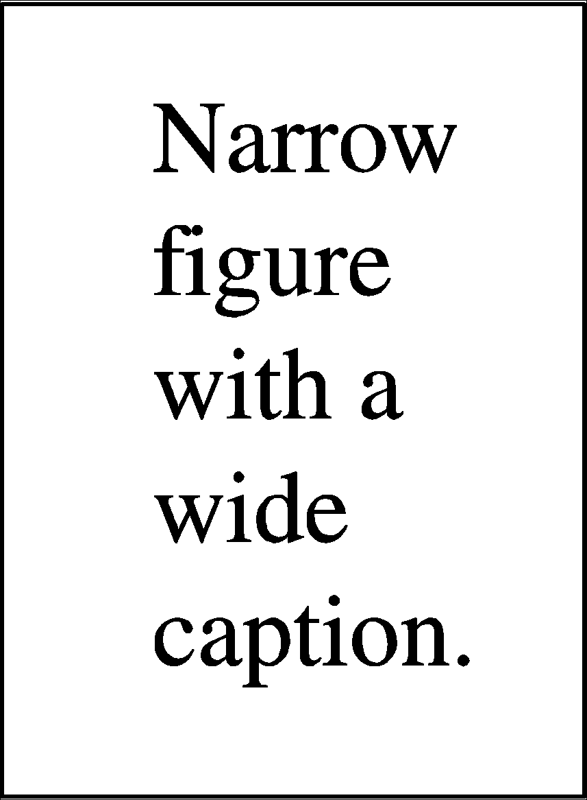
Figure 6. These two figures have been placed side-by-side to save space. Justify the caption. |  | Figure 7. These two figures have been placed side-by-side to save space. Justify the caption.

Conclusion
A conclusion contains the main points of the article. It should not replicate the abstract, but might elaborate the significant results, possible applications and extensions of the work.

Acknowledgment
Recognize those who helped in the research, especially funding supporter of your research. Include individuals who have assisted you in your study: Advisors, Financial supporters, or may other supporter i.e. Proof-readers, Typists, and Suppliers who may have given materials.
References
References at the end of the manuscript should be written in IEEE Citation Style. Cite only items that you have read. Please use Reference Manager Applications Mendeley, Zotero, etc. Use other published articles in the same journal as models. All publications cited in the text should be included as a list of Bibliography, arranged alphabetically by author.
Book
[1] J. K. Author, “Title of chapter in the book,” in Title of His Published Book, xth ed. City of Publisher, (only U.S. State), Country: Abbrev. of Publisher, year, ch. x, sec. x, pp. xxx–xxx.
Books, Monographs (Online)
[2] J. K. Author, “Title of chapter in the book,” in Title of Published Book, xth ed. City of Publisher, State, Country: Abbrev. of Publisher, year, ch. x, sec. x, pp. xxx–xxx. [Online]. Available: http://www.web.com
Book Translated
[3] J. K. Author, “Title of chapter in the book,” in Title of Published Book, X. Editor, Ed., xth ed. City of Publisher, State (only U.S.), Country: Abbrev. of Publisher (in Language), year, ch. x, sec. x, pp. xxx–xxx.
Book With Chapter Title
[4] J. K. Author, “Title of chapter in the book,” in Title of Published Book, X. Editor, Ed., City of Publisher, State (only U.S.), Country: Abbrev. of Publisher, year, ch. x, sec. x, pp. xxx–xxx.
Book With Editor(s)
[5] J. K. Author, “Title of chapter in the book,” in Title of Published Book, X. Editor, Ed., City of Publisher, State (only U.S.), Country: Abbrev. of Publisher, year, pp. xxx–xxx
Book With Series Title, Volume Title, and Edition
[6] J. K. Author, “Title of chapter in the book,” in Title of His Published Book, X. Editor, Ed., xth ed. City of Publisher, State (only U.S.), Country: Abbrev. of Publisher, year, ch. x, sec. x, pp. xxx–xxx.
For a Journal Article:
[7] J. U. Duncombe, "Infrared navigation - Part I: An assessment of feasibility," IEEE Trans. Electron. Devices, vol. ED-11, pp. 34-39, Jan. 1959.
For an eJournal from an Online Database:
[8] H. K. Edwards and V. Sridhar, "Analysis of software requirements engineering exercises in global virtual team setup," Journal of Global Information Management, vol. 13, no. 2, p. 21+, April-June 2005. [Online]. Available: Academic OneFile, http://find.galegroup.com. [Accessed May 31, 2005].
Online Citation for an eJournal:
[9] A. Altun, "Understanding hypertext in the context of reading on the web: Language learners' experience," Current Issues in Education, vol. 6, no. 12, July 2003. [Online]. Available: http://cie.ed.asu.edu/volume6/number12/. [Accessed Dec. 2, 2004].
For a Conference Paper:
[10] L. Liu and H. Miao, "A specification-based approach to testing polymorphic attributes," in Formal Methods and Software Engineering: Proceedings of the 6th International Conference on Formal Engineering Methods, ICFEM 2004, Seattle, WA, USA, November 8-12, 2004, J. Davies, W. Schulte, M. Barnett, Eds. Berlin: Springer, 2004. pp. 306-19.
For the Conference Proceedings:
[11] T. J. van Weert and R. K. Munro, Eds., Informatics and the Digital Society: Social, ethical and cognitive issues: IFIP TC3/WG3.1&3.2 Open Conference on Social, Ethical and Cognitive Issues of Informatics and ICT, July 22-26, 2002, Dortmund, Germany. Boston: Kluwer Academic, 2003.
Citation for Online Articles of a Newspaper:
[12] J. Riley, "Call for a new look at skilled migrants," The Australian, p. 35, May 31, 2005. [Online]. Available: Factiva, http://global.factiva.com. [Accessed May 31, 2005].
For a Technical Report:
[13] J. H. Davis and J. R. Cogdell, “Calibration program for the 16-foot antenna,” Elect. Eng. Res. Lab., Univ. Texas, Austin, Tech. Memo. NGL-006-69-3, Nov. 15, 1987.
Patent Citation:
[14] J. P. Wilkinson, “Nonlinear resonant circuit devices,” U.S. Patent 3 624 125, July 16, 1990.
For a Standard:
[15] IEEE Criteria for Class IE Electric Systems, IEEE Standard 308, 1969.
For a Thesis or Dissertation:
[16] J. O. Williams, “Narrow-band analyzer,” Ph.D. dissertation, Dept. Elect. Eng., Harvard Univ., Cambridge, MA, 1993.
Video Citation:
[17] Title. City: Publisher, Year Published.
Example:
[18] She's the man. Andy Fickman, 2006.
Image Citation:
[19] Author Initial. Author Surname, Title. Year Published.
Example:
[20] Aurora Australis from Space. 2014.

World Wide Web
[21] Emarketer.com, 'Social Networking Reaches Nearly One in Four Around the World', 2014. [Online]. Available: http://www.emarketer.com/Article/Social-Networking-Reaches-Nearly-One-Four-Around-World/1009976. [Accessed: 23- Jun- 2014].
Citation Website with No Author:
[22] “Engineering Triumph That Forged a Nation: Panama Canal Turns 100,” Aug. 15, 2014. Accessed on: Nov. 3, 2016. [Online]. Available: http://www. msnbc.msn.com/news/world/engineering-triumph-forged-nation-panama-canal-turns-100-n181211

