  GRADES 1 to 12  DAILY LESSON LOG | School: | DepEdClub.com | Grade Level: | III
 | Teacher: | File Created by Sir LIONELL G. DE SAGUN | Learning Area: | ENGLISH
 | Teaching Dates and Time: | JANUARY 4 – 6, 2023 (WEEK 7) | Quarter: | 2ND QUARTER

 | MONDAY | TUESDAY | WEDNESDAY | THURSDAY | FRIDAY
I.OBJECTIVES
A.Content Standards | Beginning Literacy
B.Performance Standards | Oral Language | PWR | Writing Composition | Writing Composition
C.Learning Competencies/Objectives | Recall and share experiences ,film viewed and story read /listened to as springboard for writing | Read words with initial and final consonant digraph ch | Use appropriate punctuation marks. | Write a descriptive paragraph about their favorite character
Write the LC Code for each | EN3WC – Iig-h-2.1 | EN3PWR – Iig –h -22 | EN3WC – Iii-j-2.6 | EN3WC –Iia –j -7
II.CONTENT | Litarature: The Adventures of the Animal Band | Initial and Final Consonant Digraph CH. | Using appropriate punctuation marks | Descriptive Paragraph | Summative Test
III.LEARNING RESOURCES
A.References
1.Teacher’s Guides/Pages
2.Learner’s Materials Pages
3.Textbook Pages
4.Additional Materials from Learning Resources (LR) portal
B.Other Learning Resources
IV.PROCEDURES
A.Reviewing previous lesson or presenting the new lesson |  |  |  | Recall the uses of the five senses.  Ask the pupils: How do you describe the things around us?  (We use our senses in describing our surroundings.)
B.Establishing a purpose for the lesson | Unlocking of Vocabulary and Concept Development  (life vest, sinking ,abandon )  What comes on your mind when you hear the word” band “? | Write the chocolate on the board. Then underline the sound ch. Follow by much. | Do you remember the characters of “The Adventure of the Animal Band”? Let’s have a guessing game. I am going to flash a strip of cartolina and you read the sentences and guess who said that. | Use of Clustering  - Show an apple (or any fruit) to the pupils.  Let them describe the fruit using their senses
C.Presenting examples/instances of the new lesson | Read aloud the story with pause and stop using the questions. | Present a video about initial and final digraph ch. | 1.We swam all day and all night.  2.Who knows how we can stop the next ship?  3.Would you like another adventure?  4.Ouch! My belly was hit by a sea-urchin.  5. We walked and ran! Ducky flew at times. | Show a picture of the cartoon/movie character “Spiderman”.  Use concept web.  Ask the pupils: What do you know about Spiderman?  How would you describe Spiderman?
D.Discussing new concepts and practicing new skills #1 | - Where did the horse and his friends go? | How are ch sounded? Can you hear the sound / ch/ ? | Let us talk about each sentence  What kind of sentence is in number 1?  What punctuation mark is used? | - Have the class look at the descriptions of Spiderman written on the board.  - With the guidance of the teacher, the class shall organize a paragraph based on the descriptions given.  - Look at the paragraph you have written about Spiderman. How did you write it?  - Discuss how a paragraph is written.
E.Discussing new concepts and practicing new skills #2 | - If you would be asked to join the animals to their trip to the island, would you do it? Why?
F.Developing mastery  (Leads to formative assessment) |  | Teaching Chart: Words with /ch/  chips check Chop choose  chin chest chocolate chew  chick cherry Chair cheese  chicken champ  children |  | Original File Submitted and Formatted by DepEd Club Member - visit depedclub.com for more
G.Finding practical/applications of concepts and skills in daily living | Engagement Activities (Small group)  Group 1 – Act it  Group 2 - Draw it  Group 3 –Sing it  Group 4 – Make it  Make cut-outs of the happy faces of the members of the animal band. | Divide the class into three groups. Let them write or draw the things with digraph / ch /. | Mini – tour  Group yourselves into 4. Have a mini-tour outside the room. Each member writes sentences on his own task card. Then the group agrees on the 6.  My Sentences (Individual)  Declarative Sentence (Using a period) Imperative sentence  Declarative Sentence (Using a comma and period) Interrogative sentences  Exclamatory Sentences (Using Exclamation point) Exclamatory Sentences (Using a comma and exclamation point) | - Ask the pupils: Do you have other favorite characters you have heard of or seen in movies?  - On cut-out circle cartolinas, the teacher shall write down at least four characters commonly known to the pupils.  The class shall be divided into four groups.
H. Making generalizations and abstractions about the lesson | What lesson did you learned today? | How /ch/ sounds found on the word? | What punctuation marks is used in every sentences? | To be able to describe well a character in a movie/television show/story, you need to;  - Observe carefully how the character looks.  - Pay attention to what the character does, says, feels and thinks.  In writing a paragraph, observe proper capitalization, indention and punctuation marks.  - The first letter of a sentence should be capitalized.  - The first sentence of a paragraph is indented.  - Each sentence ends with a punctuation mark.
I.Evaluating Learning | Make a composition writing related to the topics discussed. | Write the name of pictures that is sounded ch .in the beginning and in the end.  1. pictures of church  2. chair  3. bunch | Write sentences about the picture using the kind of sentences. And punctuation marks.  (declarative sentence ) 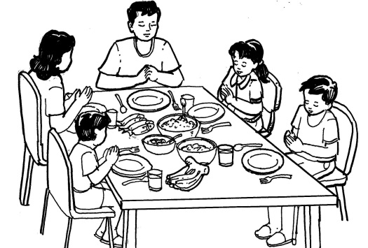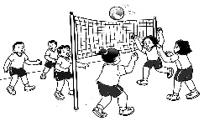( imperative sentences ) | Write a paragraph describing your favorite character. (The character can be from a cartoon movie or show. He/she could also be a historical hero/heroine or could also be a person close to you)
J.Additional activities for application or remediation | Reflect your experiences on the story you heard. Write a simple story like the animals in the story. | Cut pictures that is sounded with digraph / ch /. | 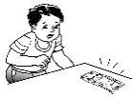Write sentences to the pictures .Use appropriate punctuation marks. | Write a paragraph about your best friend in school.
V.REMARKS
VI.REFLECTION
A.No. of learners who earned 80% of the formative assessment
B.No. of learners who require additional activities to remediation
C.Did the remedial lessons work?No. of learners who have caught up with the lesson
D.No. of ledarners who continue to require remediation
E.Which of my taching strategies worked well?Ehy did these work?
F.What difficulties did I encounter which my principal or supervisor can help me solve?
G.What innovation or localized material did I use/discover which I wish to sharewith other teachers?

