Effect of the selected parameters in idealizing material failures under tensile loads in FE approach: Marine accident cases

A. Firstauthorfamilyname 1, Aditya Rio Prabowo 2,3 *, B.B. Thirdauthorfamilyname 4

1 Department, University, City, Postal Code, Country

2 Department of Mechanical Engineering, Universitas Sebelas Maret, Surakarta, 57126, Indonesia

3 Laboratory of Design and Computational Mechanics, Faculty of Engineering, Universitas Sebelas Maret, Surakarta, 57126, Indonesia

4 Department, University, City, Postal Code, Country

The main purpose of this study was to determine the highest failure strain among the three failure criteria. The tensile test was used as a failure model, and the use of the specimen was also investigated to obtain satisfactory results. The following procedure is applied in the finite element method [1]. The procedure concerns the global discrete equilibrium equation, where the conservation of mass can be written in matrix form for a given time t. For the quasistatic case, the input in matrix form is the working load or force. The relationship between the residual vector *RU* and the force can be written as:

(1)

where *FU* and *Fσ* are the external and internal force vectors, respectively. *RU* is calculated for the initial configuration by employing the total Lagrangian method [2,3].

Recently, several failures of marine structures, such as ship structures, have occurred. For instance, in 2013,

the container ship MOL Comfort (316 m length) suffered a structural failure, as shown in Figure 1a. The analysis results showed that the bottom shell plates experienced plastic deformation in the transverse direction just before the longitudinal hull girders of the ship experienced the maximum load. Furthermore, the crack in the middle of the ship was exacerbated by bad weather at the time. Figure 1b shows a failure in the ship hull panel under indentation in the experimental laboratory.

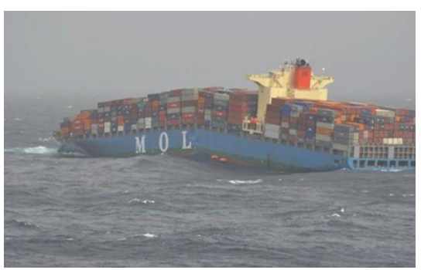 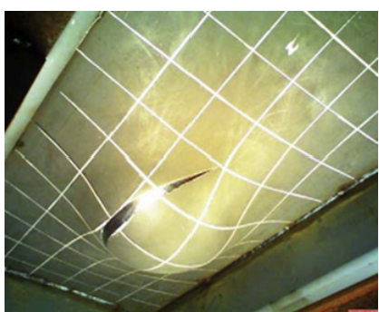

1. (b)

Figure 1. (a) Collapsed structures of MOL Comfort container ship, and (b) indentation of ship hull panels after fracture.

At a laboratory scale, failures in marine structures are generally analyzed using the finite element analysis (FEA) method as a solver. In 2020, the failure mechanism of a tanker’s side structures under indenter pressure was investigated using the FEA method. The use of FEA can reduce the cost of experiments while providing fairly accurate results. However, aspects such as failure criteria, boundary conditions, and mesh size selection are crucial considerations.

# References

[1] Ehlers S. The influence of the material relation on the accuracy of collision simulations. Mar Struct. 2010;23(4):462–74.

[2] Crisfield MA. Non-linear Finite Element Analysis of Solids and Structures. Chichester: John Wiley & Sons; 1991.

[3] Simo JC. Numerical Analysis and Simulation of Plasticity. Amsterdam: Elsevier Science Publishers; 1995.