Name(s)_______________________________________________ Period ______ Date ___________________
 | Activity Guide - ASCII Text | 

Why Binary?
In order to input, output, store, and process information computers need to represent it first. Engineers used the tools they had at hand, which was wires carrying electricity. It’s easy to tell if a wire does or doesn’t have electricity flowing through it, so engineers needed a system based on just two states electricity, or no electricity, or in other words on / off.

ASCII
There’s lots of possible binary systems for representing the letters in binary information, but the most popular is called ASCII. You can see the way patterns of ons and offs represent each letter in the table below.

Binary: anything that can only be one of two options
ASCII: a popular system for representing text in binary

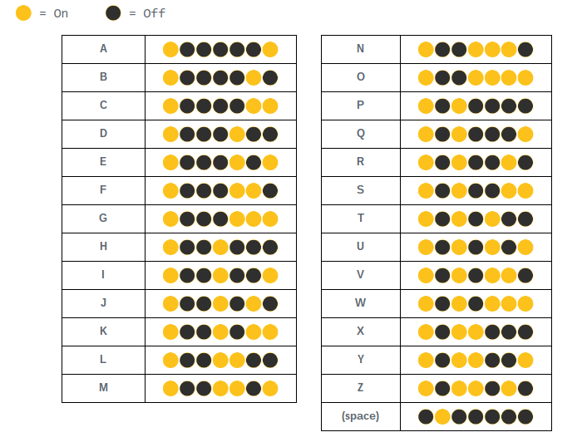

Challenge
In each of the challenges below the ASCII system has been used to represent a secret message. Luckily you now know the ASCII system so you’re going to be able to decode the messages. Each challenge is representing the letters in a different way though.
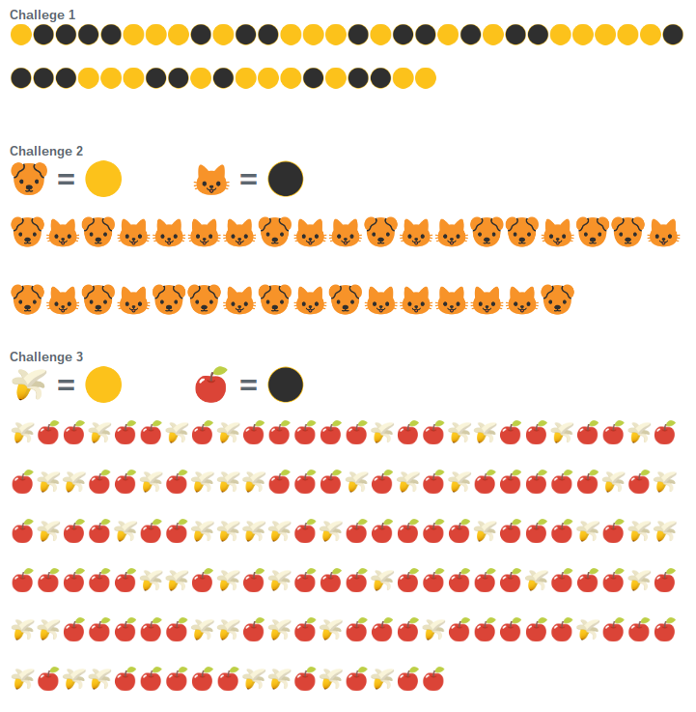
CSROCKS
PIZZA
I LIKE TO EAT EAT EAT
Create a Puzzle


