**🛑You do not need permission to download this file🛑  
Google Doc: To make a copy of this document: Go to File and select- “Make a copy”.   
Word Doc: To download a copy of this document- Go to File and select “Download as” choose .doc or .rtf. Save it on your computer and you can then complete your work. You may need to click “enable editing”.**

**5.06 Friend or Foe, Mexico?—Guided Notes**

Directions: Your Guided Notes are a tool to use as you read your lesson pages in the course. These important notes will help you complete your lesson assessment, as well as prepare you for Discussion-Based Assessments, unit exams, and segment exams. You do not need to submit your Guided Notes for grading.

**Key Vocabulary**

| **Word** | **Meaning (use context clues)** |
| --- | --- |
| Annex |  |

Unless Otherwise Noted All Content © 2022 Florida Virtual School. FlexPoint Education Cloud™ is a trademark of Florida Virtual School.

**Label the Map**

Label and shade areas of the map related to events in the lesson. Be sure to include the areas of Texas, the Mexican Cession, and the Gadsden Purchase.

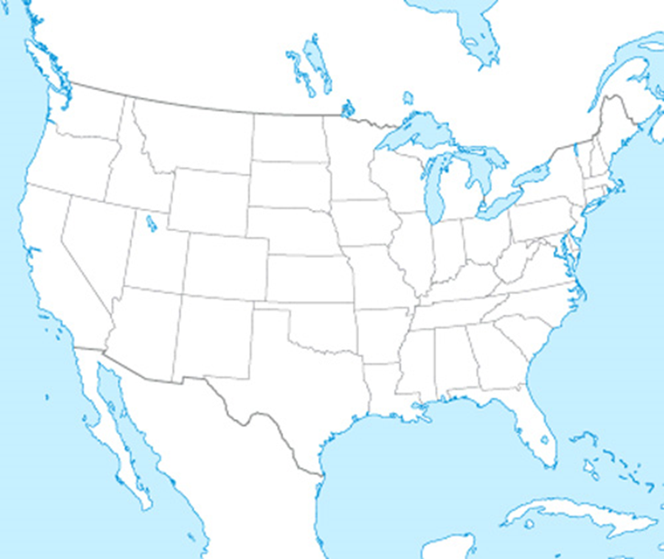

**Graphic Organizer**

Fill in important facts from the lesson about the time before, during, and following the Mexican-American War.

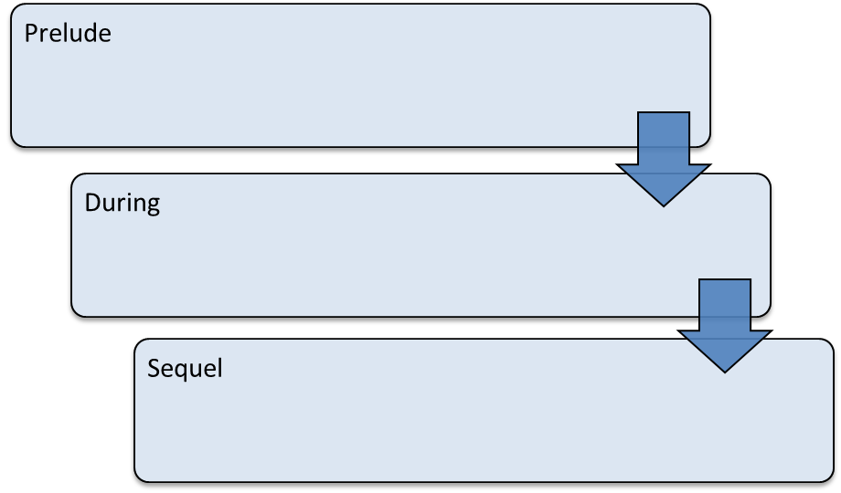

Unless Otherwise Noted All Content © 2022 Florida Virtual School. FlexPoint Education Cloud™ is a trademark of Florida Virtual School.