 | Hackathon Submission on AP Classroom | 

Description: This document is intended for teachers who use AP Classroom. These steps show how to set up a quiz for your students to submit their U5 Hackathon Project Written Responses on AP Classroom using a similar interface they will use to submit the Create PT.

- Log on to AP Classroom at myap.collegeboard.org | 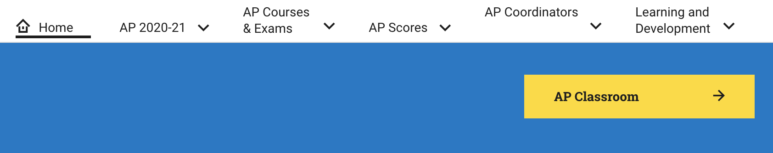
- Open the Question Bank | 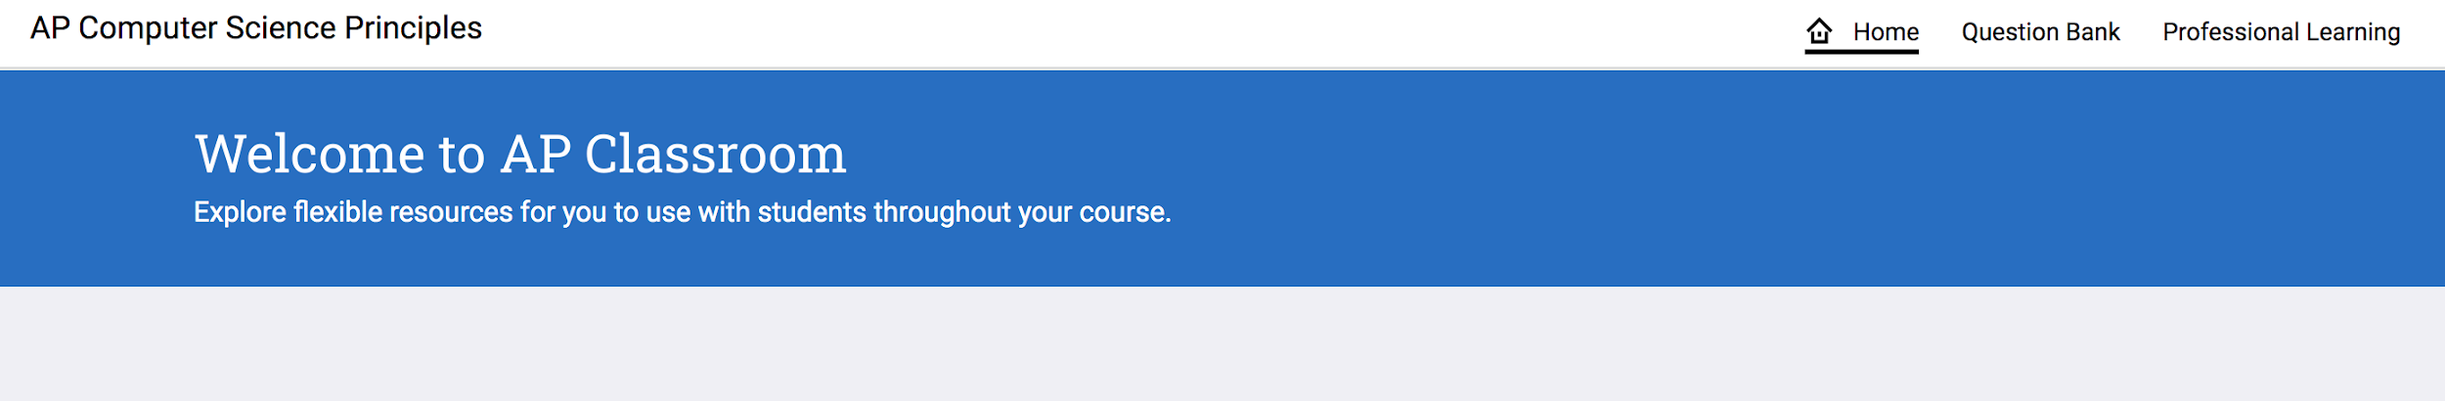
- Filter by Question Type for only “PT: Formative” | 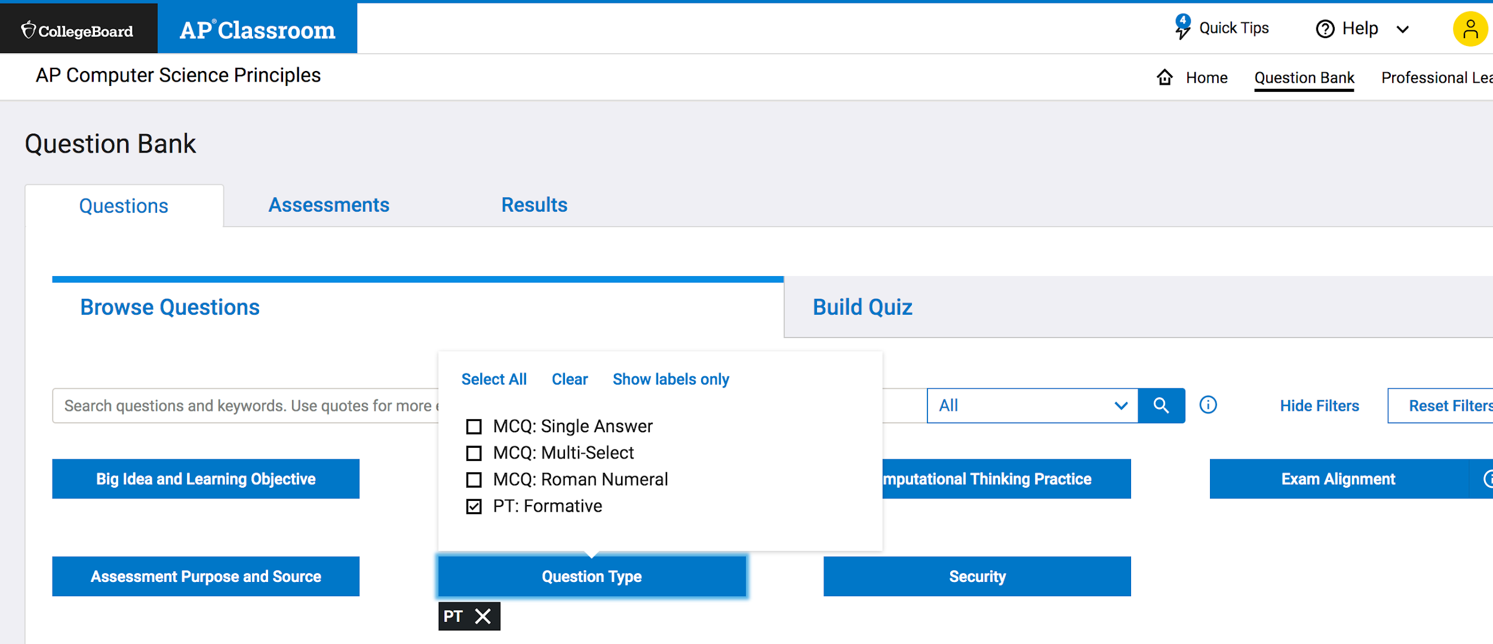
- Make a quiz with 2 questions.  - The question named “3a - Row 1 - 4 Program Purpose” (Note: This question also asks students to upload a video. Choose if you want your students to practice that now or submit this question without the video.)  - The question named “3b - Rows 2 and 3 - 6 Manage Complexity with Lists” | 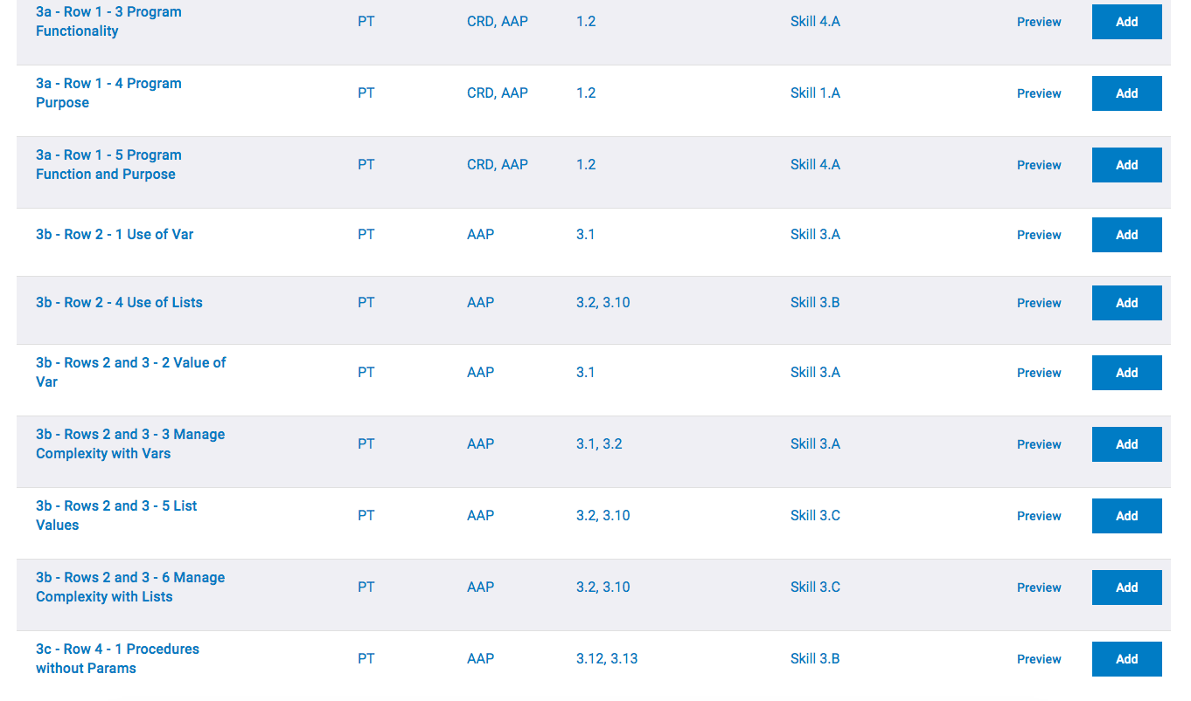
- Assign the quiz before having your students attempt to submit their work. | 