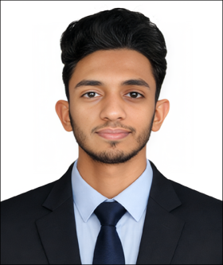

RESUME
OF
MD. RAHIBUL ISLAM

Vill: Atalia, Post: Dupchanchia 5880,
Upazila: Kahaloo, District: Bogura.
Mobile: +8801763113273
E-mail: mdrahibulislam2004@gmail.com
Career Objective:

To build a rewarding career in the Department of Social Services where I can utilize my education, computer skills, honesty, and dedication to serve the community effectively. I am eager to contribute to the organization's goals through hard work, professionalism, and a strong sense of responsibility while continuously developing my knowledge and skills.
Educational Qualification:

Higher Secondary Certificate (H.S.C):
- Name of Institute : Dupchanchia BIAM Laboratory School & College
- Board : Rajshahi
- Passing Year : 2022
- Group : Humanities
- Result : GPA-3.75 (out of 5.00)
Secondary School Certificate (S.S.C):
- Name of Institute : Dupchanchia Govt. Pilot Model High School
- Board : Rajshahi
- Passing Year : 2020
- Group : Humanities
- Result : GPA-3.83 (Out of 5.00)
Professional Training:

Computer Training:
- Institute : Postal Academy, Rajshahi
- Duration : 03 June 2023 – 22 July 2024
Computer Skills:

- Microsoft Word
- Microsoft Excel
- Internet Browsing & Email
- Bangla & English Typing
- Basic Computer Troubleshooting
Language Proficiency:

- Bangla : Native
- English : Good reading, writing, and communication skills

Personal Information:
Full Name : Md. Rahibul Islam
Father's Name : Md. Mahmodul Hasan Khan
Mother's Name : Mst. Rasful Akter
Date of Birth : 03 April 2004
Nationality : Bangladeshi (By Birth)
Sex : Male
Religion : Islam
Marital Status : Single
Blood group : B+ (ve)
Height : 5 Feet 8 Inches
Weight : 54 Kg
Present Address : Village: Atalia, Post Office: Dupchanchia, Union: Birkeder, Upazila: Kahaloo, District: Bogura.
Permanent Address : Village: Atalia, Post Office: Dupchanchia, Union: Birkeder, Upazila: Kahaloo, District: Bogura.
Personal Strengths:

- Honest and Responsible
- Quick Learner
- Good Communication Skills
- Teamwork and Cooperation
- Time Management
- Ability to Work Under Pressure
Declaration:

I hereby declare that all the information stated above is true and correct to the best of my knowledge and belief.
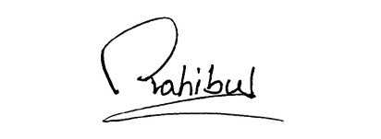

Signature
Md. Rahibul Islam
Date:

