Data Sheet

Use the information from this data sheet to try out your algorithm.

Type of Information | Information
Today’s Date | September 5
Sound | There’s a lot of sound in the environment
Movement | The phone is moving quickly
User’s Location | 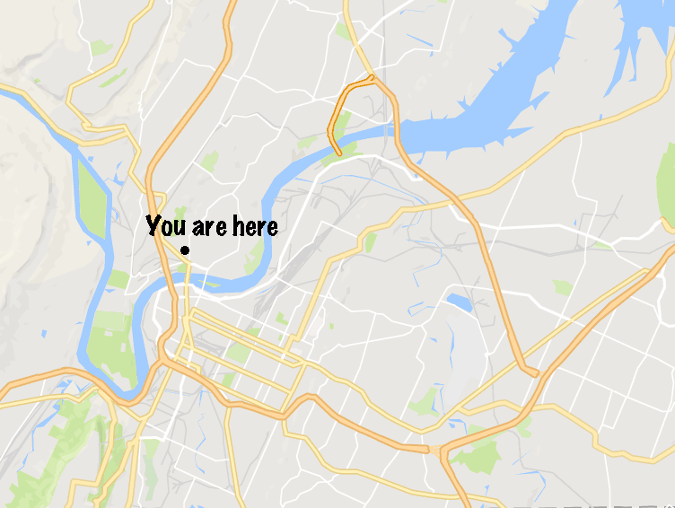
Locations of Area Schools | 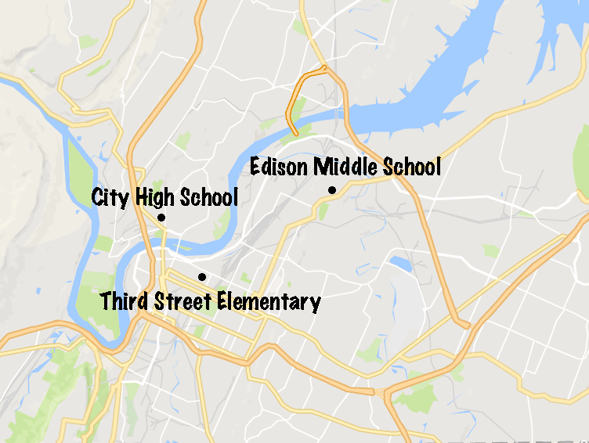

Type of Information | Information
Weather Report | Today: Sunny, 45° F  Tomorrow: Rainy, 42° F
Movie Reviews | Since Then: 4/5 "Hilarious!"  Mills: 5/5 "Even better than the book!"  The Wait: 2/5 "Boring and predictable."  Cargo: 3/5 "Exciting, but not much more."  The Watch 2: 3/5 "If you loved the first one, you'll want to see this."
Movie Showings | Central Cinemas:  - Since Then (PG - Comedy)  - Mills (R - Drama)  - The Wait (PG - Mystery)  - Cargo (Action)  Midtown 5:  - The Watch 2 (PG - Action)  - Since Then (PG - Comedy)  - Mills (R - Drama)  Highlights 8:  - The Wait (PG - Mystery)  - Cargo (Action)  - Since Then (PG - Comedy)  - Mills (R - Drama)
User’s Favorite TV Shows | The Secret Town (Mystery)  100 Years (Drama)
User’s Favorite Books | Whistler (Mystery)  Mills (Drama)
User’s Favorite Movies | The Watch (Action)  Further (Mystery)  The Last Night (Drama)
Cinema Locations | 