**Unit 5 Lesson 9**

Name(s)_______________________________________________ Period ______ Date ___________________

|  | **Activity Guide - Solving a Data Problem** |  |
| --- | --- | --- |

The city is planning a new building for its residents, but the city council isn’t sure what it should build. Some members want a fire station, others want an animal shelter, and others want a library. Your job is to use data to make a convincing recommendation to the city council.

## Image result for fire station

## Define

What is the problem you are trying to solve?

_____________________________________________________

_____________________________________________________

## 

## Prepare



What data do you need to solve your problem?

_____________________________________________________

_____________________________________________________

_____________________________________________________

_____________________________________________________

_____________________________________________________

With your group, find your data on the Internet and record it here. You’ll need to combine your data with data from other groups to make the best possible decision, so don’t make a recommendation until you hear from all the other groups as well.

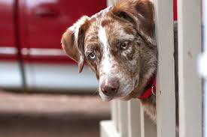

_____________________________________________________

_____________________________________________________

_____________________________________________________

_____________________________________________________

_____________________________________________________

_____________________________________________________

## Try

What should be built in the new location? _______________________________________________________

List two reasons for your choice, and the data that supports that reason.

| Reason 1 | Data for Reason 1 |
| --- | --- |
| Reason 2 | Data for Reason 2 |

## 

## Reflect

What other data might help you to make a better decision?

____________________________________________________________

____________________________________________________________

Where could you find this data?

____________________________________________________________

____________________________________________________________