SUMMATIVE TEST NO. 1
Objectives | CODE | Percentage | No. of Items | Item Placement
distinguish text-types according to purpose and features: classification,  explanation, enumeration and time order | (EN5RC-IIc-3.2.1) | 33.33% | 5 | 1-5
identify the elements of literary texts | (EN5LC-Ib-d-2.17.1-3); | 33.33% | 5 | 6-10
recognize the steps in summarizing | (EN5RC-Ib-2.9.1) | 33.33% | 5 | 11-15
Total |  | 100 | 15 | 1 – 15
GRADE V – ENGLISH
SKAI KRU

SUMMATIVE TEST NO.1
GRADE V – ENGLISH
SKAI KRU

Name :____________________________________________________ Grade and Section:_________

I. Identify what kind of text type is the following paragraph. Encircle the letter of the correct answer.
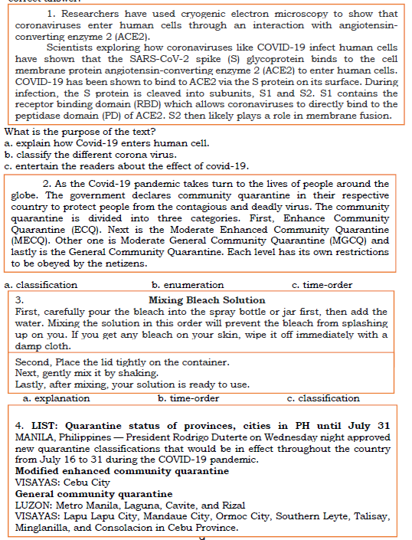

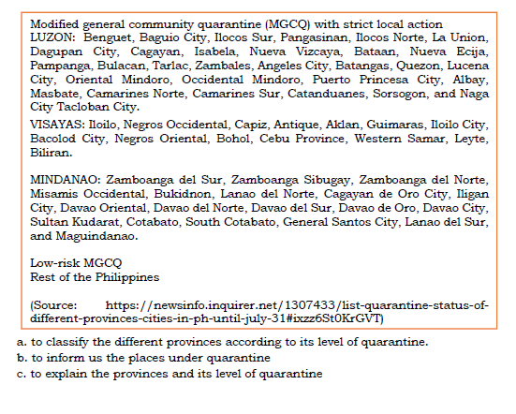

II. Read the story carefully and pay attention to the details of the story. You could also take down important notes while reading. In this way, you can easily identify the elements of a literary text and be able to write your summary.
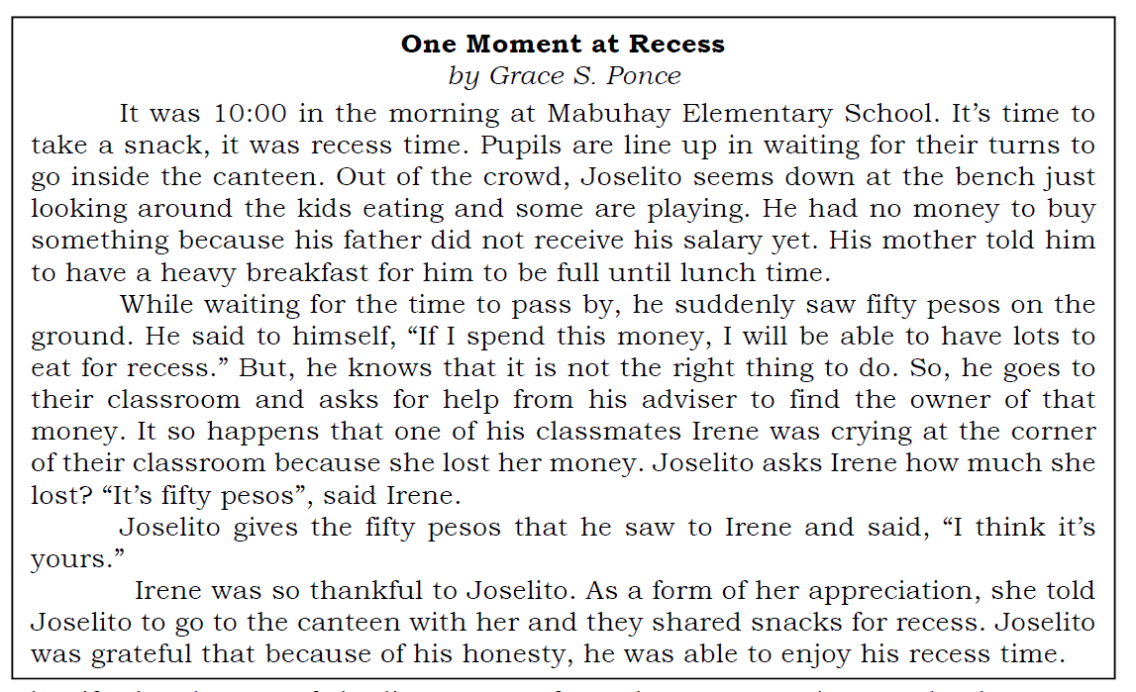

Identify the element of the literary text from the story you just read. Choose your answer from the choices below.

____________________ 1. It was 10:00 in the morning at Mabuhay Elementary School.
____________________ 2. Joselito, a Grade 5 pupil and his classmate, Irene
____________________ 3. While waiting for the time to pass by, he suddenly saw fifty pesos on the ground.
____________________ 4. Joselito gives the fifty pesos that he saw to Irene and said, “I think it’s yours.”
____________________ 5. Honesty. Do not claim what is not yours.
II. B. Match the descriptions provided in Column A with the element of literary text being described in Column B. Write only the letter of your answer.

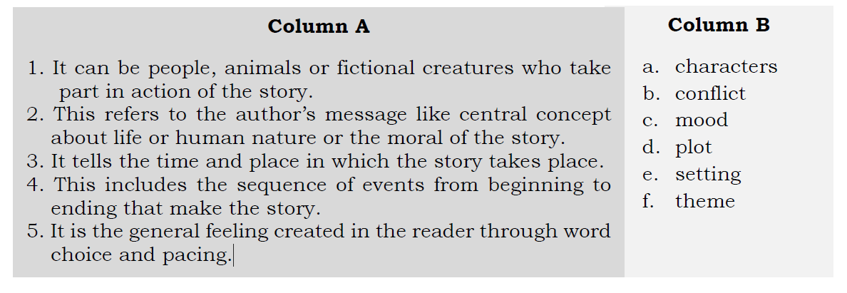

SUMMATIVE TEST 1 ANSWER KEY:
II.
A.
1. setting
2. characters
3. conflict
4. resolution
5. themeB.
B.
1. a
2. b
3. e
4. d
5. c
I.
1. A
2. B
3. B
4. C

