The title of your article here, written in Garamond, font size 16, bold, center
Article Info: |  | Abstract:
Article History:  recevied: 20 January 2020  accepted: 23 Pebruary 2020  Keyword:  keyword1, keyword2, keyword3, keyword4, keyword5 |  | (Summarize the study in 200–250 words: brief background, objective, methods, main results, and conclusion. Write in a single paragraph without citations). Use Garamond font style, size 8, regular. The abstract serves both as a general introduction to the topic and as a brief, non-technical summary of the main results and their implications. Authors are advised to check the author instructions for the journal they are submitting to for word limits and if structural elements like subheadings, citations, or equations are permitted.

Introduction (Example for first Heading: Garamond font size 14 bold)
Describe the research background and problem, include a relevant literature review, and clearly state the research objectives and contribution. The Introduction section of the referenced text, Campbell and Gear (1995), expands on the background of the work (some overlap with the Abstract is acceptable). The introduction should not include subheadings.
Lontar Physics Today does not impose a strict layout as a standard; however, authors are advised to check the individual requirements for the journal to which they plan to submit, as there may be journal-level preferences. We provide an example of the structure submitted here. When preparing your text, please also be aware that some stylistic choices are not supported in the full text.

Theoretical Framework

Scientific Creativity
This is an example (example for third heading). Present the theoretical foundations and/or literature review that support the study. Clearly describe the key concepts, models, or theories relevant to the research topic. Explain how these theories relate to the research objectives and guide the study design. Use recent and relevant sources to strengthen the framework.
Write equations using the equation editor in Word or an equivalent tool, not as images. Number all equations consecutively, placing the equation number in parentheses aligned to the right, as shown in the example below. Refer to each equation in the text using its number, e.g., “as shown in Equation (1)”.
$$A=\int_{0}^{∞}{\frac{α}{γ}(x+e^{αx})dx}$$ | (1)

Method

Example of Heading 2
Example of Heading 3. Provide sufficient details on research design, participants/sample, instruments, procedures, and data analysis techniques to allow replication.
Ensure that all figures are clear and of sufficient resolution (minimum 300 dpi for images). Use a consistent style for labels, legends, and units. Place each figure close to the point of its first mention in the text. Provide a descriptive caption below each figure, and refer to it in the text, e.g., “as shown in Figure 1”. Don’t forget to use font size 8, red color, italic for description dan bold for ‘Figure’ in the figure caption.
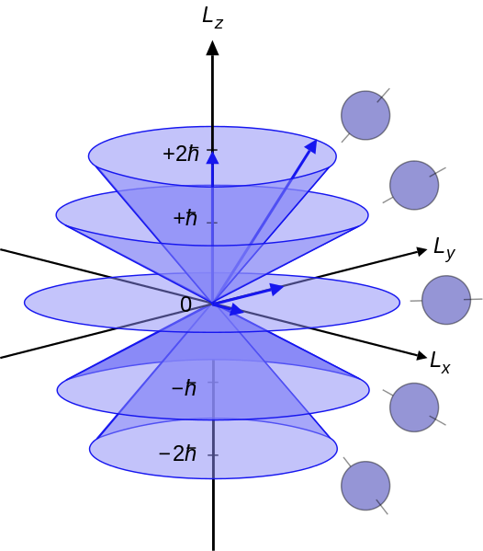
Figure 1. This is an example of a figure.

Result

Example of Heading 2
Present the main findings clearly and logically. Include descriptive data, statistical or numerical analysis, and relevant figures/tables. Explain trends or patterns directly related to the research questions, but avoid extensive comparison with previous studies here. You can write a cross-reference by writing Table 1 or Figure 1.
Using a Table. Tables can be inserted via the normal table. You should use autofit content in the table layout. For an autonumbering table, use a caption by right-clicking on the table and selecting ‘Insert Caption’.
Table 1. Example for the table
Column1 | Column2 | Column3 | Column4
Row1 | Data1 | Data2 | Data2
Row2 | Data4 | Data5 | Data6
Row3 | Data7 | Data8 | Data9

Table 2. Example of a lengthy table that is set to double heading.
Double Heading | Heading1 |  | Heading2
Double Heading | Sub1 heading1 | Sub1 heading2 | Sub2 Heading1 | Su2 Heading2
Item 1 | - | - | - | -
Item 2 | - | - | - | -

Some tricks for the table are to ensure that you use the merge cell after fixing your table, or in the last step of creating the table.

Discussion
Interpret the results in the context of existing literature. Explain how the findings support, contradict, or extend previous work. Discuss theoretical and practical implications, possible limitations, and suggestions for future research

Example of Heading 2
Example of Heading 3. Example text.

Conclusion
Summarize the main findings in direct relation to the research objectives, highlight contributions, and suggest future work.

Acknowledgements (optional)
(Mention individuals or institutions providing funding, facilities, or technical assistance)

References
Use an alphabetical style as required by your field or preference, and a consistent structure. If using the numerical style, list references in the order they are cited in the text. If using the alphabetical style, list them in alphabetical order by the first author’s surname. Using a reference manager, such as Mendeley, Zotero, or a similar tool, is strongly recommended to ensure consistency and correct formatting.
If you use a reference manager such as Mendeley, Zotero, EndNote, or similar software, please also upload the exported reference library file in .ris (or .bib) format along with your manuscript. This file will assist the editorial team in verifying and formatting references accurately. Authors who do not use a reference management tool are exempt from this requirement.
To ensure the novelty of the manuscript, include at least 7 recent references (published within the last 5 years) out of a minimum total of 20 references.
Example -- Alphabetical style (APA-like):
Smith, J., & Lee, K. (2020). Physics education in the digital age. Journal of Science Education, 45(3), 210–225. https://doi.org/10.xxxx
Taylor, M. (2019). Computational methods in mechanics. International Journal of Physics, 12(2), 101–115. https://doi.org/10.xxxx

