Name(s)_______________________________________________ Period ______ Date ___________________

Activity Guide - User Testing Analysis

Interpreting User Feedback

Review your notes from user testing and write down your team’s observations of all of the users’ feedback

User Said / Did | What it Means

Brainstorming Session

Using sticky notes and the analysis above, brainstorm the bugs the user identified in the app and features that the user suggested for the app. Record each bug or feature on a separate sticky note. Make sure to write whether this is a BUG or a FEATURE, and give an estimate of the amount of time the team thinks it would take to implement the fix or new feature. Remember that bugs and features can be about more than code! Confusing text, inconsistent color choice, and confusing layouts are all potential bugs as well.
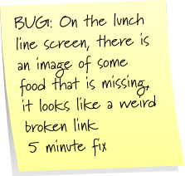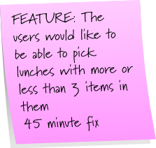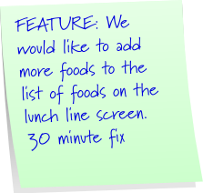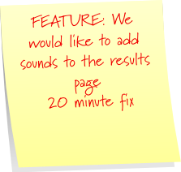

Bug and Feature Analysis

Duplicate the tables below on a piece of poster paper. Discuss amongst your team where you think these bugs and feature requests would go in the table, placing the sticky into the appropriate quadrant. If you are unsure about the difficulty of a feature to implement go with your best guess.

 | Easy to Implement | Difficult to implement
Urgent Fix
Non Urgent Fix

To Do | Doing | Done

Tracking Progress

Using the To Do, Doing, Done chart on the bottom of your poster, start moving sticky notes from the Urgent/Easy quadrant to the To Do column. Choose at least two tasks per group member and write on the sticky who the task is assigned to. As you work on improving the app, you will move the stickies through the stages of this chart.

