The Response of Bison to Fire
Name: KEY | Class/Period: KEY | Date: KEY
The slideshow may be narrated by an instructor or may be viewed individually by students. If students are working with the slideshow on their own, “Slide 2” provides instructions for opening the presentation’s “speaker notes” that can be used as a reference for responding to prompts on this worksheet.

Part A: Background Information/Slideshow Presentation
Use the slideshow in “Step 2” of the activity to help respond to the prompts below.

1) Where is The Nature Conservancy’s Tallgrass Prairie Preserve located?
Examples of possible responses:

The Tallgrass Prairie Preserve [TPP] is found in the Osage Nation near the town of Pawhuska in northeastern Oklahoma.

Students may have stated that TPP is within the Flint Hills ecoregion.

2) What is one way the preserve is managed to help it function more naturally?
Examples of possible responses:

Around 2,500 bison are allowed to roam freely over most of the preserve so that it can function more naturally.

The preserve’s ranch managers attempt to replicate fire frequencies typical of this ecoregion by using prescribed fire.

3) In which ecoregion is the preserve found? What are a few characteristics of this ecoregion?
The Tallgrass Prairie Preserve is found in the Flint Hills ecoregion.

Flint Hills characteristics:
- considered to be the western edge of the tallgrass prairie in Oklahoma
- shallow, stony soils typical of the region are unsuitable for farming
- the landscape is dominated by rangelands used for grazing livestock
- the tallgrass vegetation in the Flint Hills is unlike that found in the mixed grass prairie of the Central Great Plains and in the oak savanna of the Cross Timbers
- fire is a naturally occurring disturbance in the Flint Hills

4) What type of agricultural production is practiced over most of the Flint Hills since the region’s soil is too shallow and stony for farming? Which native animal was reintroduced to the Tallgrass Prairie Preserve to perform this function?
Since the shallow, stony soils typical of the region are unsuitable for farming, the landscape is dominated by rangelands and grasslands used for grazing livestock.

Bison were reintroduced and allowed to roam and graze freely.

5) Why is the natural disturbance of fire used to manage the Tallgrass Prairie Preserve?
Fire is a natural disturbance that produces a variety of habitat types which increases biodiversity. Fire on the prairie helps restrict the distribution of species that are not typically dominant in grassland systems, such as trees.

6) What is prescribed fire?
Prescribed fires are those intentionally ignited by trained personnel in accordance with applicable laws, policies, and regulations to meet specific objectives.

7) How do ranch managers decide where and when prescribed burns will be conducted on the preserve?
The preserve’s ranch managers attempt to replicate fire frequencies typical of this ecoregion by using prescribed fire. Where and when to burn on the preserve is determined randomly.

8) What two types of information was collected by the GPS collars used on the preserve’s bison? How could this information be used to study the response of bison to fire?
The data collected from the collars provides both temporal and spatial information.

Possible applications:

Spatial information can show whether bison are attracted to or repelled from burned areas.

Temporal information can show whether responses of attraction or repulsion are immediate, develop slowly over time, or suddenly occur later.

Part B: Map Analysis
By manipulating the layers of your map appropriately, respond to the prompts below.

9) Using these layers on your map, 1) March GPS - Bison, 2) Bison Unit, and 3) 2009 Winter/Spring Burns, describe any apparent spatial relationship between the bison and burned patches during March. Why do you think the relationship or lack of relationship you described occurs during this month?
Students may determine that there is a relationship for March. If so, their answers should reflect that conclusion. After seeing the map for May, most students will change this prompt’s response to describe “no relationship” or a “weak relationship.” Examples of possible responses: There does not appear to be a spatial relationship between bison locations and the areas burned in the spring and winter. Lack of forage in the burned areas probably encourages bison to graze in the unburned areas. GPS points from bison within the burned areas could be from bison crossing those areas from one unburned area to another. Since fire is often “patchy,” GPS points from bison within the burned areas could result from the likelihood that some areas within the burn units still had forage available for bison after the burns.

The map used for 9) should have looked like this:
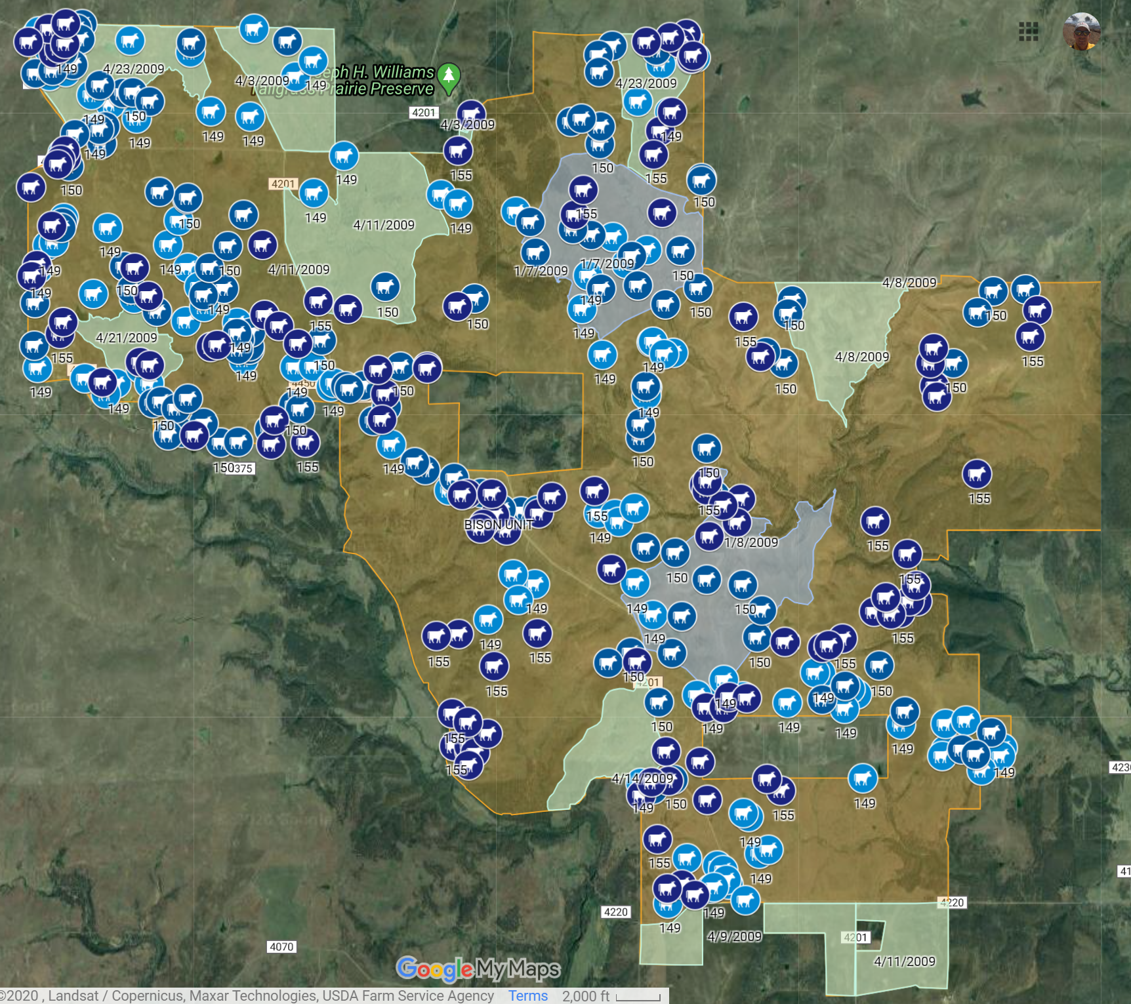

10) Using these layers on your map, 1) April GPS - Bison, 2) Bison Unit, and 3) 2009 Winter/Spring Burns, describe any apparent spatial relationship between the bison and burned patches during April. Why do you think the relationship or lack of relationship you described occurs during this month?
Students may determine that there is a relationship for March. If so, their answers should reflect that conclusion. After seeing the map for May, most students will change this prompt’s response to describe “no relationship” or a “weak relationship.” Examples of possible responses: There does not appear to be a spatial relationship between bison locations and the areas burned in the spring and winter. Lack of forage in the burned areas probably encourages bison to graze in the unburned areas. GPS points from bison within the burned areas could be from bison crossing those areas from one unburned area to another. Since fire is often “patchy,” GPS points from bison within the burned areas could result from the likelihood that some areas within the burn units still had forage available for bison after the burns. Grasses and other plants are beginning to emerge from subsurface structures, so there is some forage available for bison which could attract them to the burned areas.

The map used for 10) should have looked like this:
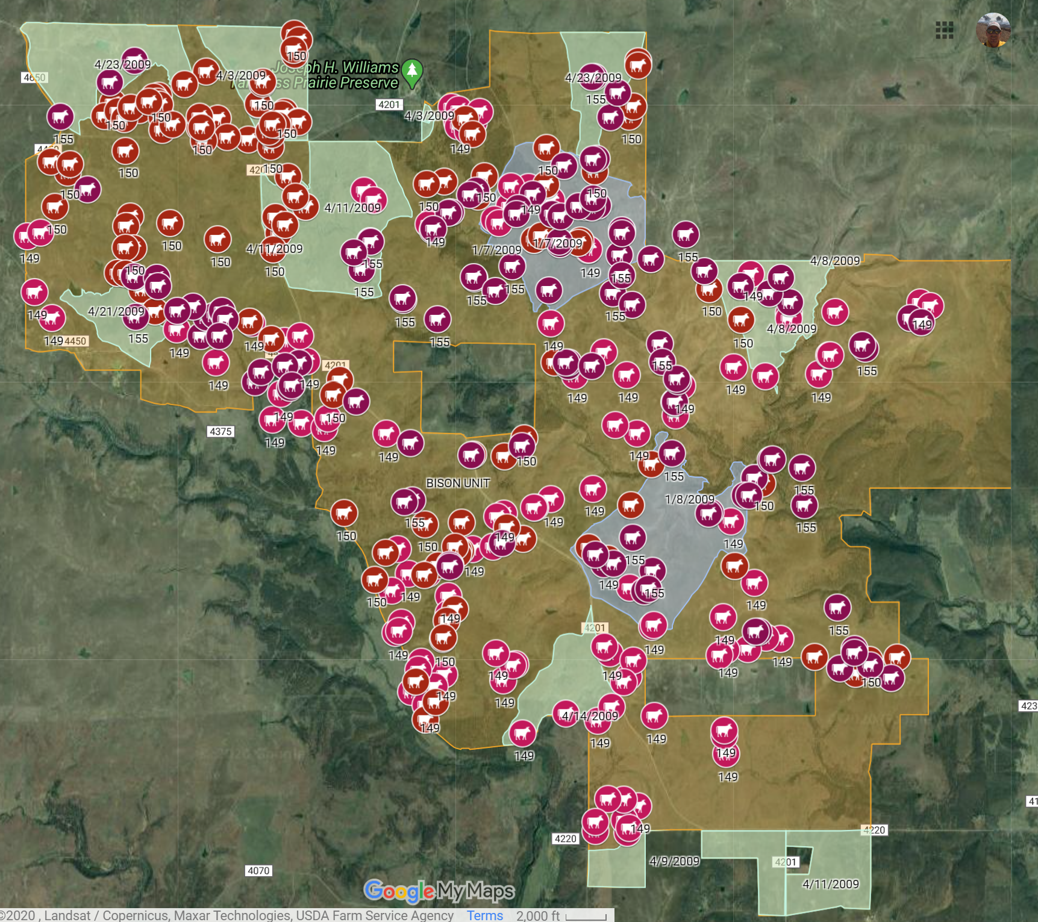

11) Using these layers on your map, 1) May GPS - Bison, 2) Bison Unit, and 3) 2009 Winter/Spring Burns, describe any apparent spatial relationship between the bison and burned patches during May. Why do you think the relationship or lack of relationship you described occurs during this month?
Examples of possible responses: There appears to be a very strong correlation between areas that were burned in the winter and spring and the distribution of bison during the month of May. One factor that could influence bison grazing is the lush, new growth of grasses and other plants during this time of the year. In the burned areas, there is no old growth present to impede the grazing of bison on the new plant growth. This could make grazing easier and more efficient for the bison.

The map used for 11) should have looked like this:
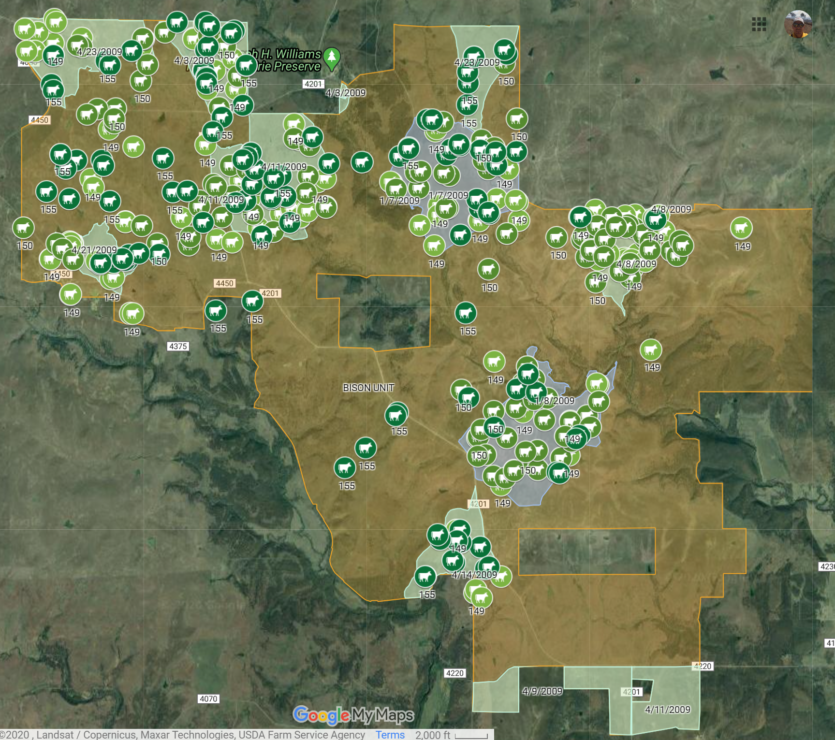

12) What is a question for future research that results from your findings? Describe data that would be needed to answer your question.
There could be a wide variety of responses to this prompt. Common research questions with possible data requirements:

1) Are there differences in forage quality between burned and unburned areas? Data needed: Data comparing the “quality” of forage in burned and unburned areas at any given time. Protein content is a measure of forage quality that could be mentioned to students. Dormant vegetation or dead vegetation from the previous year will have a much lower protein content compared to new growth.

2) Does forage quality change from March to May in burned and unburned areas? Data needed: Data comparing forage quality from March through May for only burned areas and data comparing forage quality during that same time period for only unburned areas.

3) How do bison grazing efficiencies compare between burned and unburned areas? Data needed: The “spatial search pattern” of bison could be recorded to reflect how easily quality forage is encountered. Bison showing “sinuosity” in movements are typically having to spend more time searching for quality forage whereas those grazing “straighter” are having little difficulty and are, thus, grazing more efficiently.

4) Due to the “patchiness” of fire, how much forage remains in burn units immediately after prescribed burns? Data needed: Determine the mass of forage left standing in a burn unit after prescribed fires are conducted.

5) Were bison influenced by other factors such as the availability of water? Data needed: Determine and create a map layer of watering sites available to bison on the Tallgrass Prairie Preserve to determine if there is an apparent relationship.

Part C: Submission of This Student Worksheet
Follow the instructions provided by your instructor to correctly submit your worksheet.

