|  | **Create PT - Sample I - Score: 2/8** |  |
| --- | --- | --- |

| **Total score** | Row 1 | Row 2 | Row 3 | Row 4 | Row 5 | Row 6 | Row 7 | Row 8 | *This document combines student sample, scoring guidelines and scoring commentary from:* [*Create PT Sample I*](https://apcentral.collegeboard.org/courses/ap-computer-science-principles/exam?course=ap-computer-science-principles#anchorSG) |
| --- | --- | --- | --- | --- | --- | --- | --- | --- | --- |
| **Sample: C** | **1** | **0** | **0** | **1** | **0** | **0** | **0** | **0** |

**Video**

Submit one video in .mp4, .wmv, .avi, or .mov format that demonstrates the running of at least one significant feature of your program. **Your video must not exceed 1 minute in length and must not exceed 30MB in size.**

**Program Purpose and Development**

**2a**. Provide a written response or audio narration in your video that:

* identifies the programming language
* identifies the purpose of your program; and
* Explains what the video illustrates.

*(Must not exceed 150 words)*

| **Student Response** | **Scoring Guidelines** | |
| --- | --- | --- |
| <https://youtu.be/_hNSzslOCAA>  I used snap to create my code with putting together different blocks to make it work properly. The purpose of my program was an easy way for people to learn their colors in French. It first goes through and tells you all the colors in English to French and how to pronounce them in French. Then the program allows you to click on the colors presented on the screen and it will say the colors in French. It is a very helpful and simple way to learn how to pronounce all the different colors in French. *(96 words)* | **Row and Task** | **Decision Rules** |
| **Row 1**  **Response 2A**  The video demonstrates the running of at least one feature of the program submitted.  **AND**  The response (audio narration or written response) identifies the purpose of the program (what the program is attempting to do). | Response earns the point if it explains the function of the program instead of identifying the purpose.  Response earns the point if the illustrated feature runs, even if it does not function as intended.  Response earns the point if the video includes a narration or some form of closed captioning that addresses the purpose of the program.  **Do NOT award a point if any one of the following is true:**   * a video is not submitted; * the video does not illustrate the feature mentioned in the response; or * the video does not illustrate the running of the feature (screen shots or storyboards are not acceptable and would not be credited). |
| **The response earned a point for this row.**  The video shows continuous running of the program. The response identifies the purpose of the feature as "helping the user to learn French words for common colors." | |

**2b**. Describe the incremental and iterative development process of your program, focusing on two distinct points in that process. Describe the difficulties and/ or opportunities you encountered and how they were resolved or incorporated. In your description clearly indicate whether the development described was collaborative or independent. At least one of these points must refer to independent program development. *(Must not exceed 200 words)*

| **Student Response** | **Scoring Guidelines** | |
| --- | --- | --- |
| All of my project was independent. I worked on my own to get my project perfect. I had a little bit of difficulties when I tried videoing the project. When I used CamStudio I had a hard time with it speeding up my video since it my project has sound, I had a hard time saving it, and it was too long at one point so I had to lessen the video. But other than that my project ran smoothly. I had to get the time perfectly because my project was a little bit over a minute so I had to decrease the time that it said something. *(108 words)* | **Row and Task** | **Decision Rules** |
| **Row 2 - Response 2B**  Describes or outlines steps used in the incremental and iterative development process to create the entire program. | **Do NOT award a point if any one of the following is true:**   * the response does not indicate iterative development; * refinement and revision are not connected to feedback, testing, or reflection; or * the response only describes the development at two specific points in time. |
| **The response DID NOT earn a point for this row.**  The response does not describe or outline the steps in the development process for the entire program. | |
| **Row 3 - Response 2B**  Specifically identifies at least two program development difficulties or opportunities.  **AND**  Describes how the two identified difficulties or opportunities are resolved or incorporated. | Response earns the point if it identifies two opportunities, or two difficulties, or one opportunity and one difficulty AND describes how each is resolved or incorporated.  **Do NOT award a point if any one of the following is true:**   * only one distinct difficulty or opportunity in the process is identified and described; or * the response does not describe how the difficulties or opportunities were resolved or incorporated. |
| **The response DID NOT earn a point for this row.**  The response describes difficulties encountered during video capture for the artifact submission, not during program development. | |

**2c.** Capture and paste a program code segment that implements an algorithm (marked with an **oval** in **section 3** below) and that is fundamental for your program to achieve its intended purpose. This code segment must be an algorithm you developed individually on your own, must include two or more algorithms, and must integrate mathematical and/or logical concepts. Describe how each algorithm within your selected algorithm functions independently, as well as in combination with others, to form a new algorithm that helps to achieve the intended purpose of the program. *(Must not exceed 200 words)*

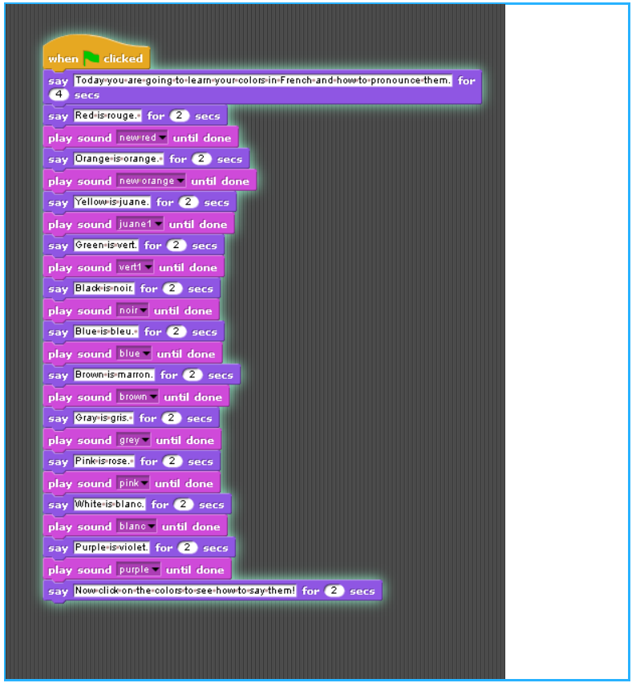

| **Student Response** | **Scoring Guidelines** | |
| --- | --- | --- |
| I had to time my sprites for it to be the exact seconds that things need to be said. If I did not do this then my time would be off for the videoing. Plus I had to let it say what it needed to say in the right amount of time so the viewers can read everything properly. I also had to record myself saying the colors in a right amount of time so it would work with my video and it would not be too long. *(88 words)* | **Row and Task** | **Decision Rules** |
| **Row 4**  **Response 2C**  Selected code segment implements an algorithm. | **Do NOT award a point if any one of the following is true:**   * the algorithm consists of a single instruction; * the code segment consisting of the algorithm is not included in the written responses section or is not explicitly identified in the program code section; or * the algorithm is not explicitly identified (i.e., the entire program is selected as an algorithm, without explicitly identifying the code segment containing the algorithm). |
| **The response earned a point for this row.**  The selected code segment is an algorithm. | |
| **Row 5**  **Response 2C**  Selected code segment implements an algorithm that uses mathematical or logical concepts.  **AND**  Explains how the selected algorithm functions.  **AND**  Describes what the selected algorithm does in relation to the overall purpose of the program. | The algorithm being described can utilize existing language functionality, or library calls. Response earns the point even if the algorithm was not newly developed. (i.e., a student’s reimplementation of the algorithm to find the minimum value)  **Do NOT award a point if any one of the following is true:**   * the selected algorithm consists of a single instruction; * the selected algorithm consists solely of library calls to existing language functionality; * the selected algorithm does not include mathematical or logical concepts; * the response only describes what the selected algorithm does without explaining how it does it; * the response does not explicitly address the program’s purpose; * the code segment consisting of the selected algorithm is not included in the written responses section or is not explicitly identified in the program code section; or * the algorithm is not explicitly identified (i.e., the entire program is selected as an algorithm, without explicitly identifying the code segment containing the algorithm). |
| **The response DID NOT earn a point for this row.**  The selected algorithm does not include mathematical or logical concepts. | |
| **Row 6**  **Response 2C**  Selected code segment implements an algorithm that includes at least two or more algorithms.  **AND**  At least one of the included algorithms uses mathematical or logical concepts.  **AND**  Explains how one of the included algorithms functions independently.. | **Do NOT award a point if any one of the following is true:**   * the selected algorithm consists of a single instruction; * the selected algorithm consists solely of library calls to existing language functionality; * neither of the included algorithms nor the selected algorithm that includes two or more algorithms uses mathematical or logical concepts; * the code segment consisting of the algorithm is not included in the written responses section or is not explicitly identified in the program code section; or * the algorithm is not explicitly identified (i.e., the entire program is selected as an algorithm, without explicitly identifying the code segment containing the algorithm). |
| **The response DID NOT earn a point for this row.**  The selected algorithm does not include two or more algorithms. | |

**2d**. Capture and paste a program code segment that contains an abstraction you developed individually on your own (marked with a **rectangle** in **section 3** below). This abstraction must integrate mathematical and logical concepts. Explain how your abstraction helped manage the complexity of your program. *(Must not exceed 200 words)*

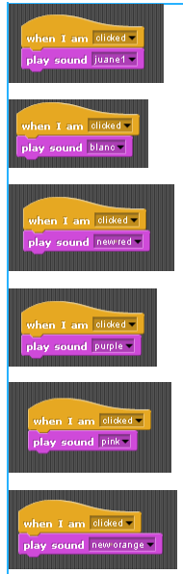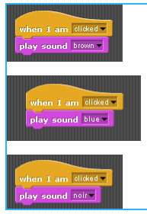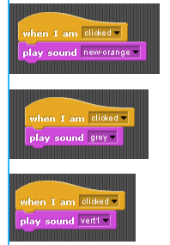

| **Student Response** | **Scoring Guidelines** | |
| --- | --- | --- |
| This allowed the users to interact with the program. This set of programming allowed the users to click on the colors and then it would say the color in French. This I thought would be a great lerningsource if the user forgets how to say the color then it can just click on the color that is presented on the blackboard. I had to think through on how it would work in the best way and where I can get the sounds. I ended up having to record all the sounds using my voice. Then I dound out that by clicking the sprite and it saying the color that it would be the best learning source for the users. *(120 words)* | **Row and Task** | **Decision Rules** |
| **Row 7**  **Response 2D**  Selected code segment is a student-developed abstraction. | Responses that use existing abstractions to create a new abstraction, such as creating a list to represent a collection (e.g., a classroom, an inventory), would earn this point.  **Do NOT award a point if any one of the following is true:**   * the response is an existing abstraction such as variables, existing control structures, event handlers, APIs; * the code segment consisting of the abstraction is not included in the written responses section or is not explicitly identified in the program code section; or * the abstraction is not explicitly identified (i.e., the entire program is selected as an abstraction, without explicitly identifying the code segment containing the abstraction). |
| **The response DID NOT earn a point for this row.**  The selected code segments are not student-developed abstractions | |
| **Row 8**  **Response 2D**  Explains how the selected abstraction manages the complexity of the program. | Responses should not be penalized for explanations of abstractions that are not developed by the student.  **Do NOT award a point if any one of the following is true:**   * the explanation does not apply to the selected abstraction; or * the abstraction is not explicitly identified (i.e., the entire program is selected as an abstraction, without explicitly identifying the code segment containing the abstraction). |
| **The response DID NOT earn a point for this row.**  The response does not explain how abstraction is used for management of complexity. | |

**3. Program Code**

Capture and paste your entire program code in this section.

* Mark with an oval the segment of program code that implements the algorithm you created for your program that integrates other algorithms and integrates mathematical and/or logical concepts.
* Mark with a rectangle the segment of program code that represents an abstraction you developed.
* Include comments or acknowledgments for program code that has been written by someone else.