Just because you **can** share something online doesn’t mean that you **should**!

1) Circle the place you would most like to visit online 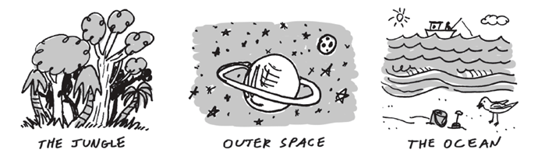

*The Jungle Outer Space The Ocean*

2) Can you spot the private information? Mark “X” through the information that you should not share with people you do not know well.

| My address is 2524 Sycamore Lane | My birthday is February 5th, 2006 | I like watermelon | I like swimming |
| --- | --- | --- | --- |

3) On the back of this paper, draw something that you enjoy and want to share on the Internet.