Unit 5 Lesson 10
Name(s)_______________________________________________ Period ______ Date ___________________
Activity Guide - Structuring Data

Pizza Party Problem
The local pizza parlor has donated a giant one-topping pizza to an eighth grade class for their annual pizza party, and they have to decide what type of topping they will order for the pizza.
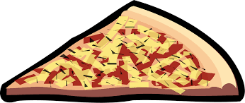
Their choices are: pepperoni, sausage, barbecue chicken, green peppers, mushrooms, pineapple, and extra cheese.

Chart the Data
Use the data to make a bar chart that shows how many votes each topping received.

Pepperoni  Cheese  Bbq chicken  Sausage  Mushrooms  I will be absent :(  Bbq chicken  Pineapple  Olives  Anything is good.  Just cheese  Cheese  Sausage  Barbecue chicken | Pineapple  Peppers  Green peppers  Pepperoni  Mushrooms  I don't like pizza.  Pepperoni  Cheese  Bbq chicken  Pizza party!!!!  Pepperoni  Four  No meat, please!  Pepperoni | pepperoni  cheese  sausage  barbecue chicken  green peppers  mushrooms  pineapple

Hardest to Categorize
Sometimes it can be hard to figure out what to do with some of your data. Choose two votes that were hard to put into the chart. For each vote, explain what made it hard and what you finally did with the answer.

Vote  No meat, please | It was hard because…  I didn’t know whether to make it “cheese” or a vegetable. | I decided to…  Ignore it
Vote  peppers | It was hard because…  It probably means green peppers, but maybe not. | I decided to…  Make it green peppers

