Name(s)_______________________________________________ Period ______ Date ___________________
 | Activity Guide - Determine the User | 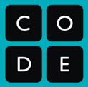

Next to each description of a user, write down the letter of each teapot they might use. Be prepared to justify your answers.
- Someone who wants an individual cup of tea before bed.  - Someone who often drops things  - Someone who likes very ornate objects  - Someone who needs to serve tea at dinner party  - Someone who likes to see their tea brewing  - Someone who is often in a rush.  - Someone who has a kitchen with a lot of black appliances.  - Someone who likes plain objects  - Someone who prefers iced tea  - Someone who can use a stove to heat up water.  - Someone who owns a pot holder.  - Someone who wants to serve tea to a friend who came over to chat.  - Someone who has a modern kitchen.  - Someone who likes tall thin objects.  - Someone who collects antiques.  - Someone who has a very small kitchen. |  | A. 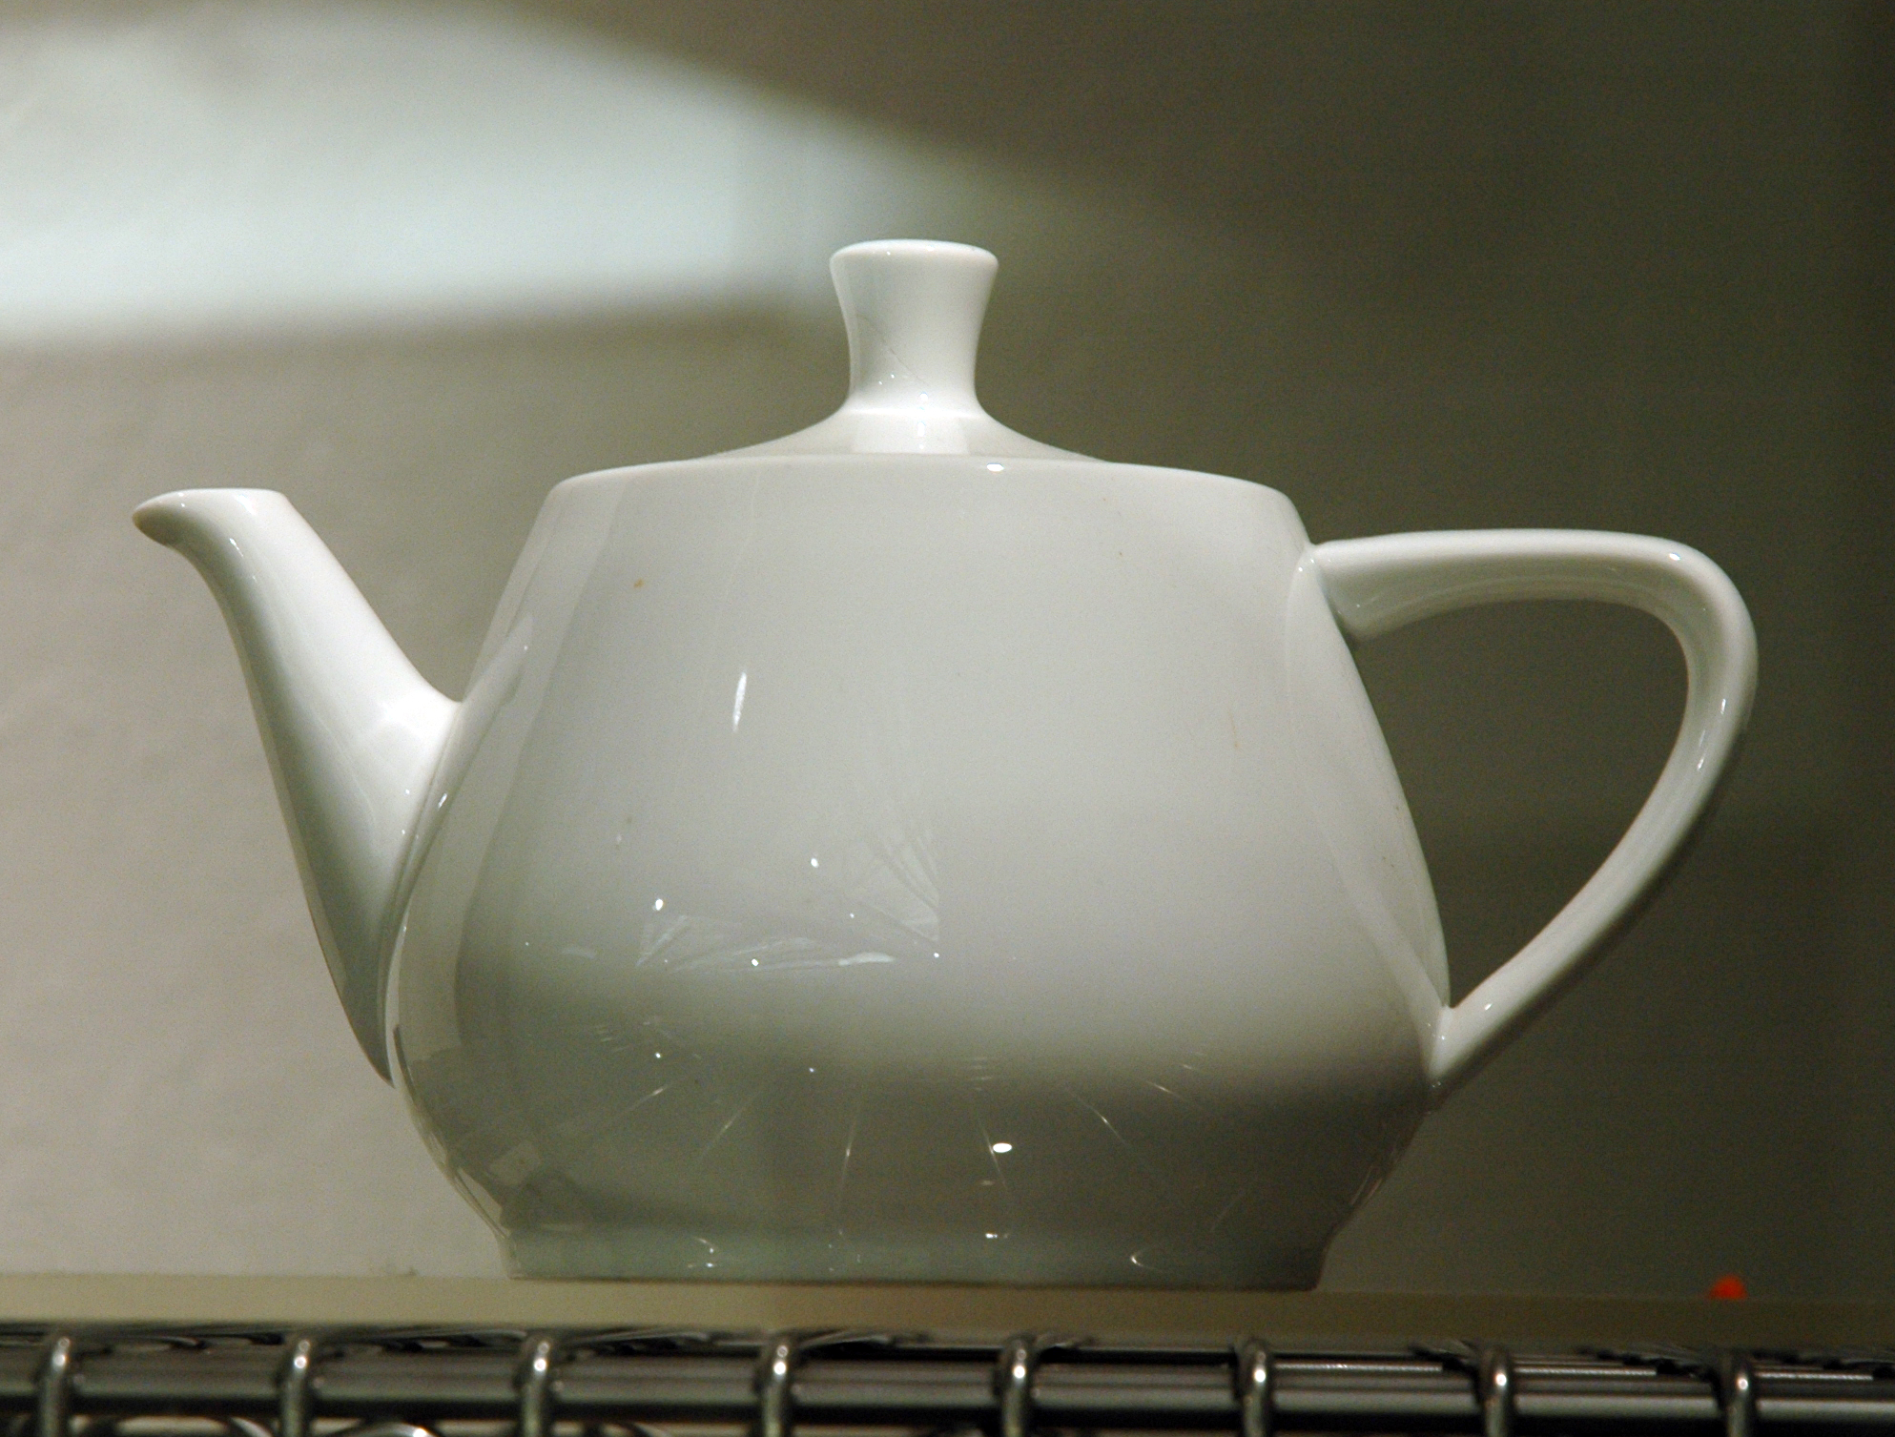
 |  | B. 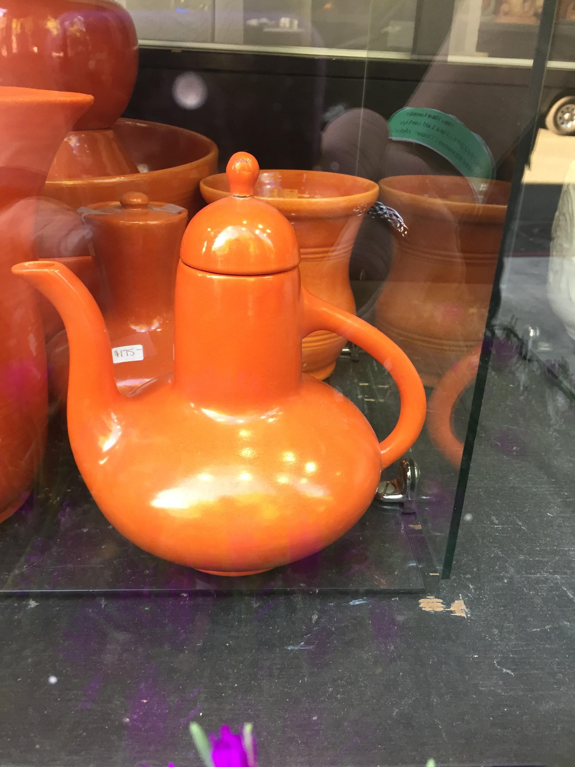
 |  | C. 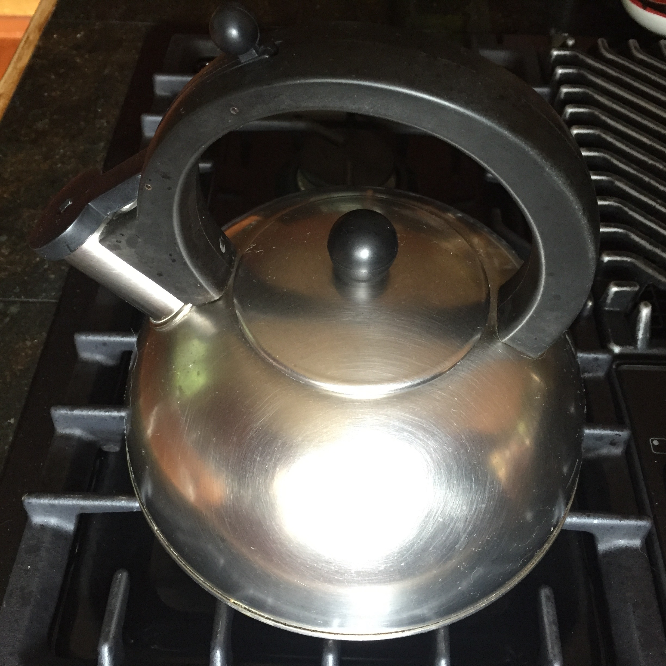
 |  | D. 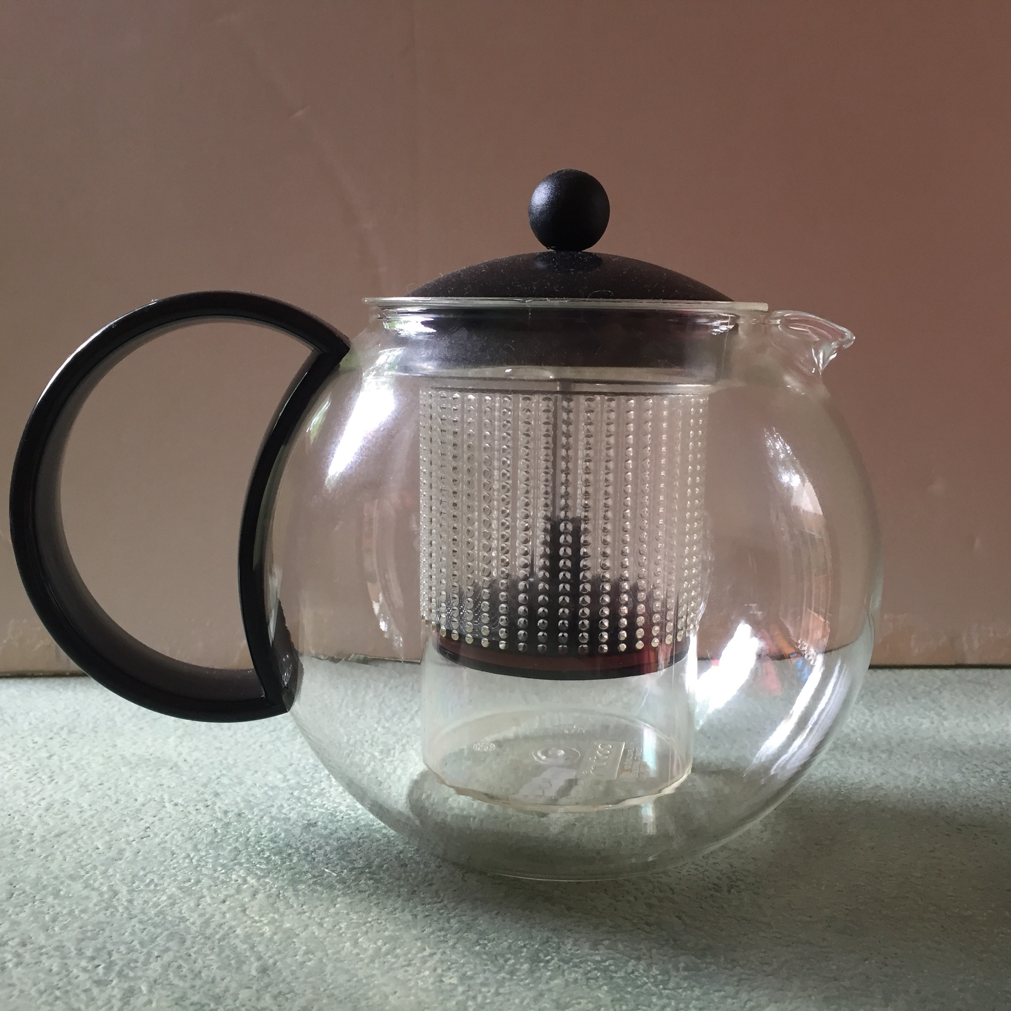
 |  | E. 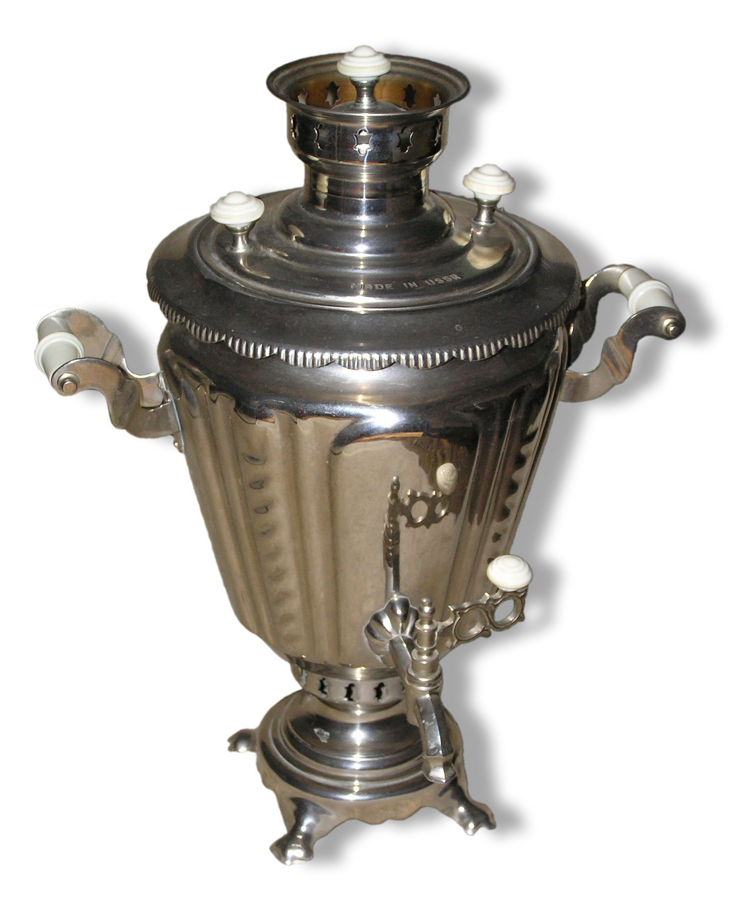
 |  | F. 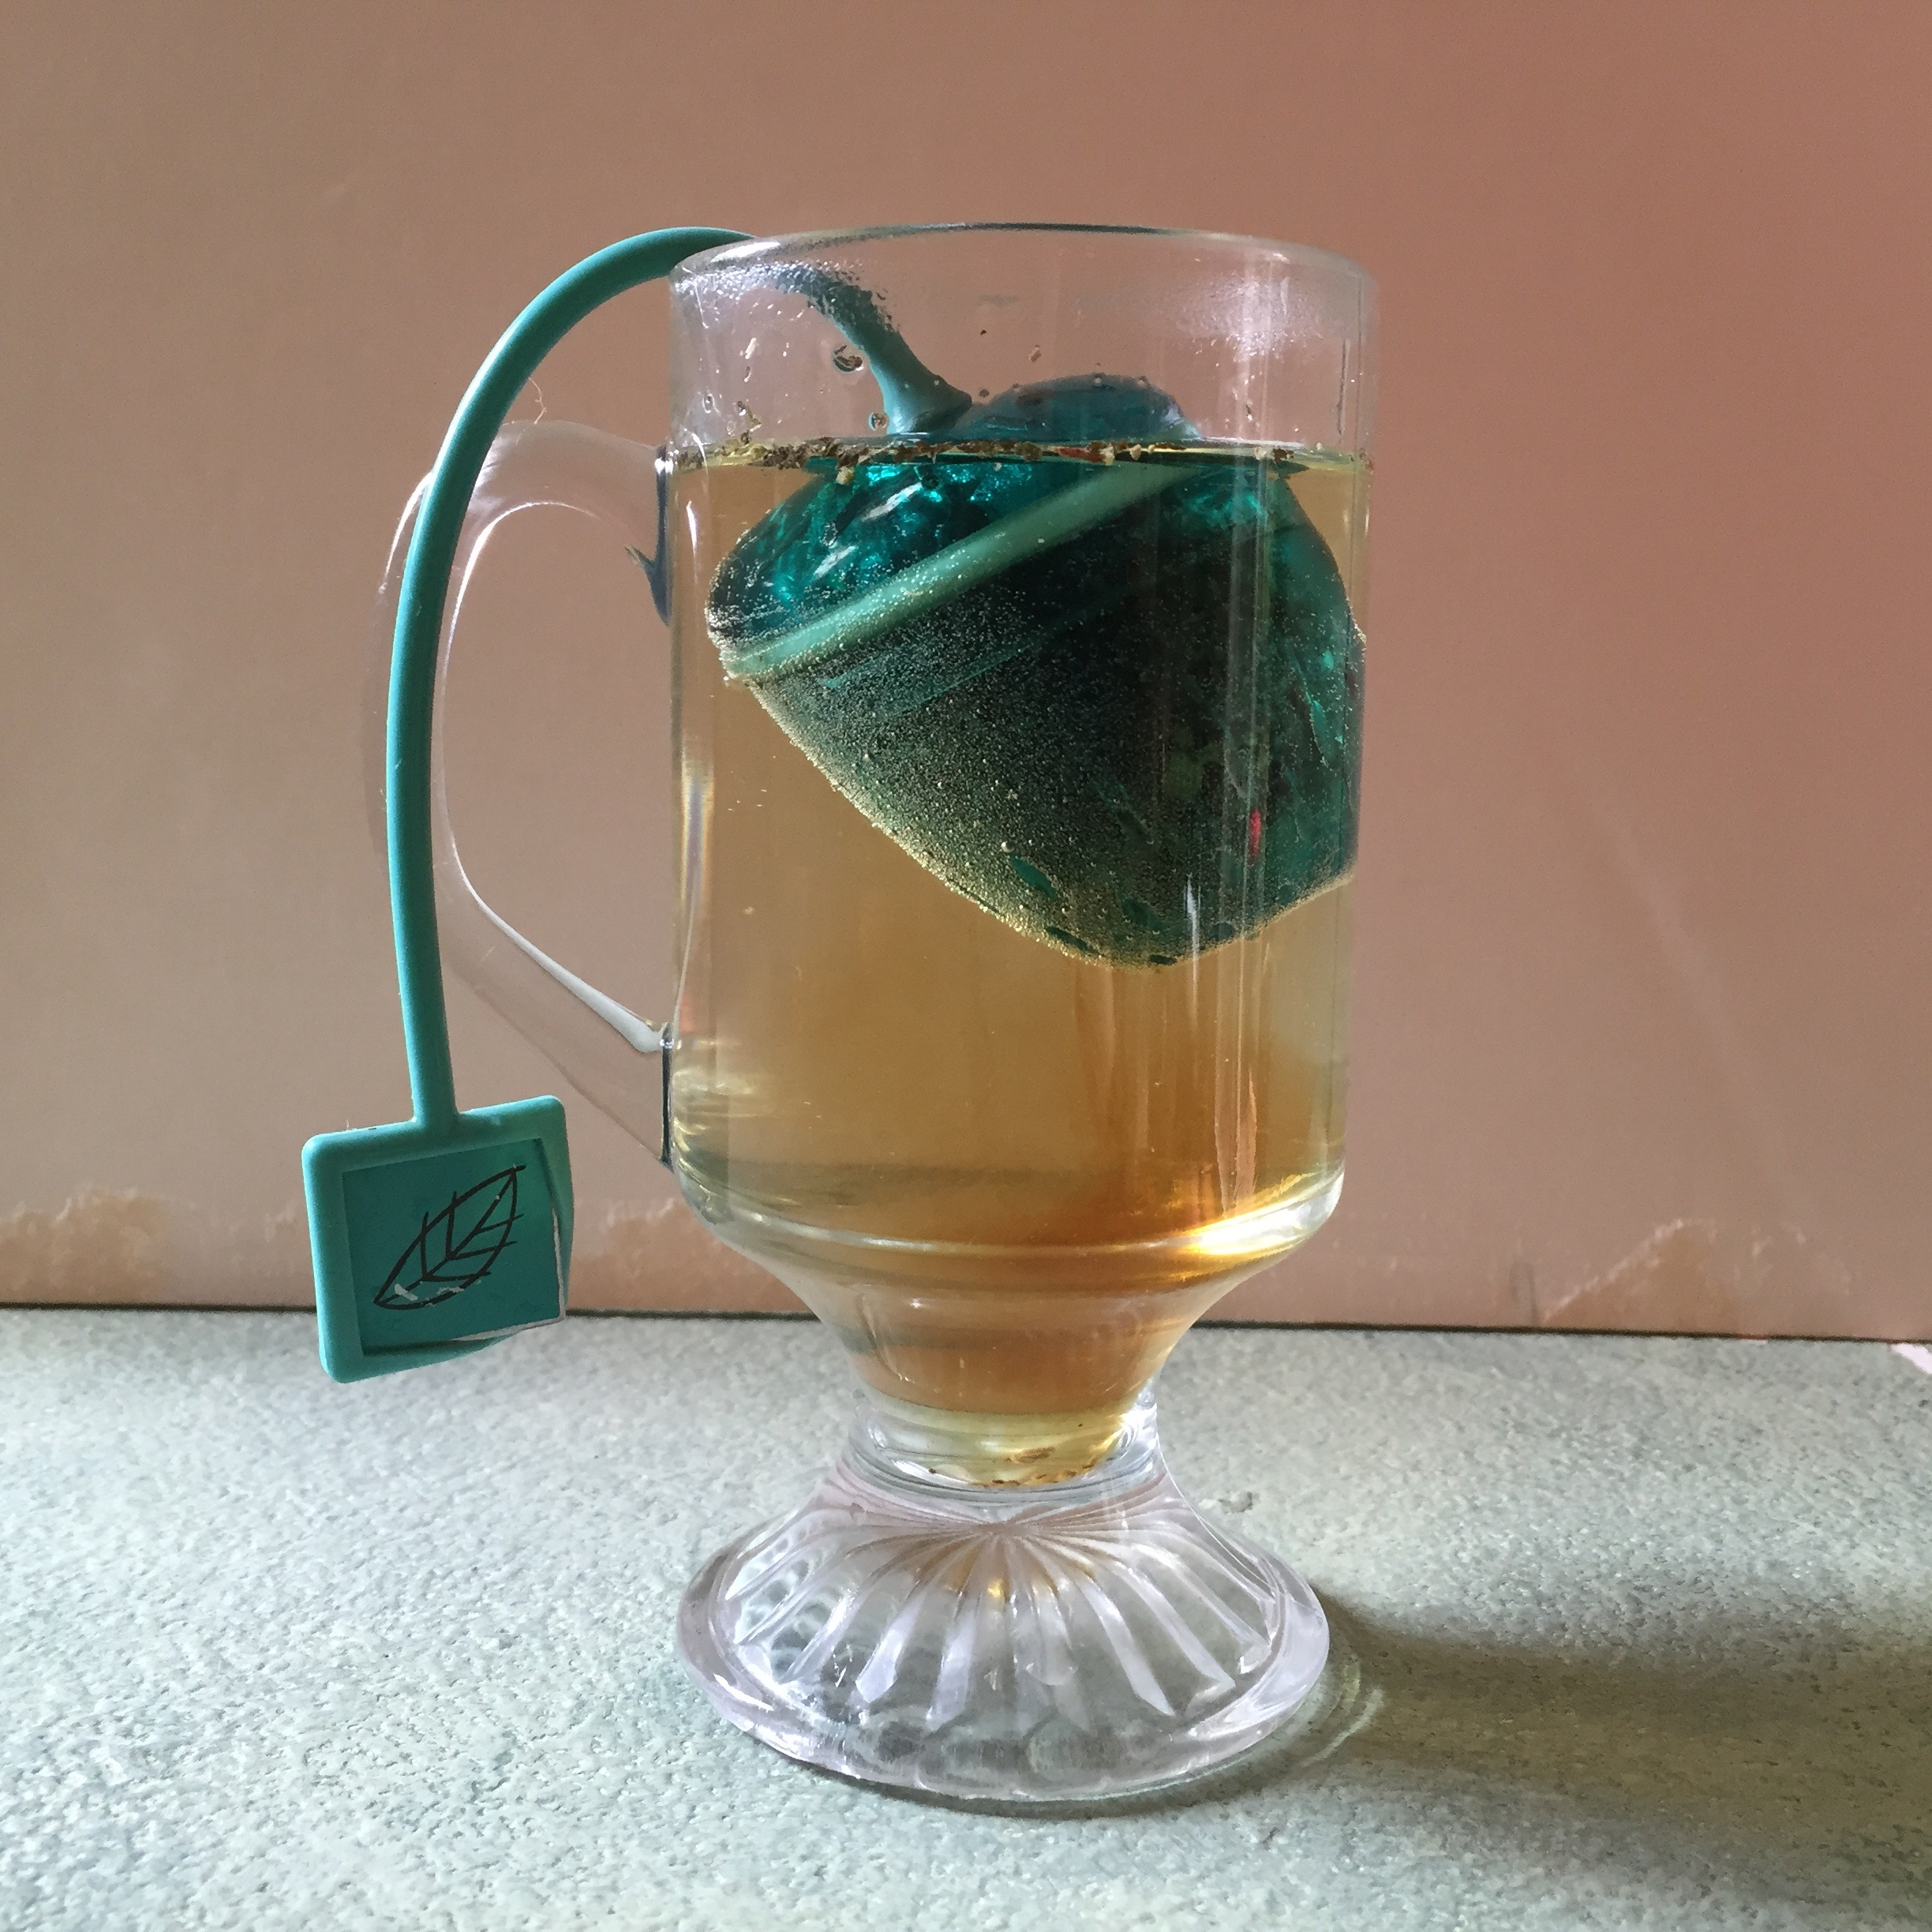
 |  | G. 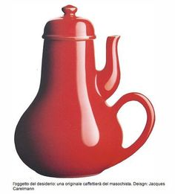
 |  | H. 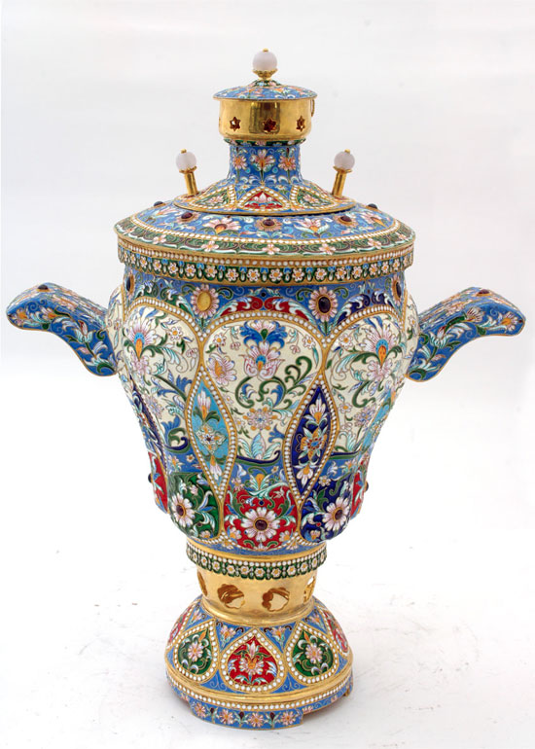

Critiquing Design:
For each of these teapots, finish the statements on the right that critique the object’s design:

I like __________________________________________________________
______________________________________________________________
I wish _________________________________________________________
______________________________________________________________
What if ________________________________________________________
______________________________________________________________
I like __________________________________________________________
______________________________________________________________
I wish _________________________________________________________
______________________________________________________________
What if ________________________________________________________
______________________________________________________________
I like __________________________________________________________
______________________________________________________________
I wish _________________________________________________________
______________________________________________________________
What if ________________________________________________________
______________________________________________________________
I like __________________________________________________________
______________________________________________________________
I wish _________________________________________________________
______________________________________________________________
What if ________________________________________________________
______________________________________________________________

