 | Activity Guide - Inputs and Outputs [Set B] | 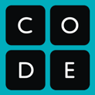

Vocabulary
- Input: A device or component that allows information to be given to a computer
- Output: Any device or component that receives information from a computer

Inputs and Outputs
For each category of computer brainstorm as many inputs and outputs as you can.

Computer | Inputs | Outputs
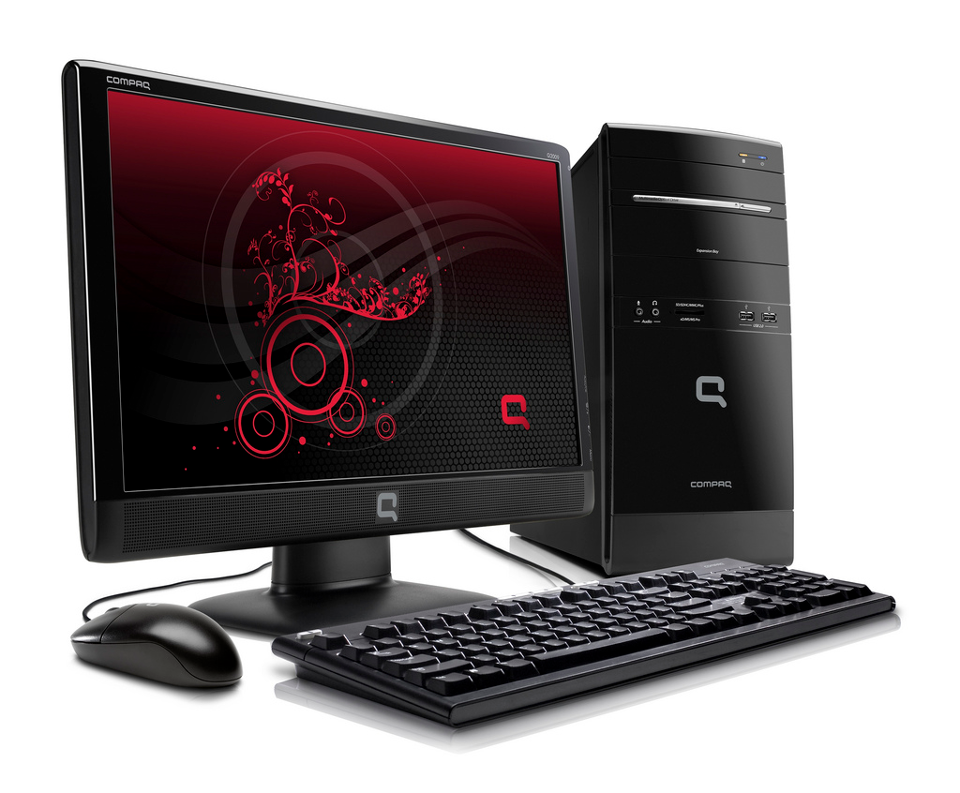  Desktop | Keyboard  Mouse  Scanner  Camera  USB Port  Internet Port  On/Off button | Monitor  Speakers  Printer  USB Port  Internet Port  Power Light
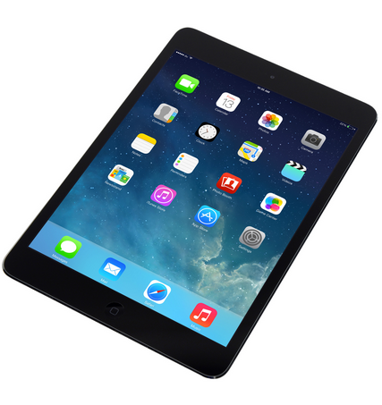  Tablet | Touch screen  Camera  Microphone  GPS  Gyroscope  Motion sensor  Wi-Fi  Phone Connection  Bluetooth | Screen  Speakers  Wi-Fi  Buzzer  Bluetooth
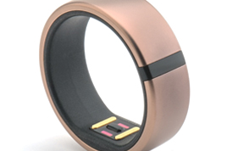  Fitness Tracker | GPS  Motion Sensor  Heartbeat sensor  Bluetooth  On/Off button  Charging port | Screen  Lights  Bluetooth  Buzzer

