Title of the Paper (Times New Roman; font size 14; Bold)

AUTHOR 1 and AUTHOR 2*

Department of Biotechnology, Vellore Institute of Technology, Vellore
Tamil Nadu, India, Email: abcdef@vit.ac.in

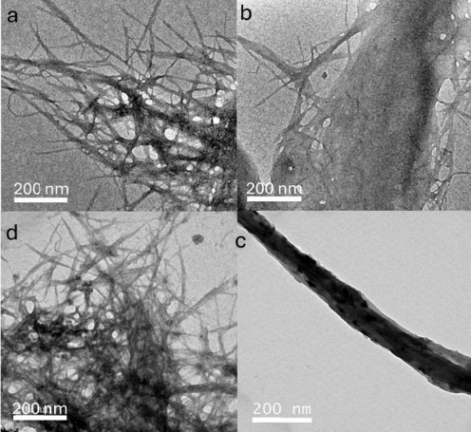
Abstract: (Strictly ≤ 150 words) Alginates are linear anionic polysaccharides, which are well known for their biocompatible, non-toxic, biodegradable nature. The polymer consists of alternating units of β-(1→4)-linked D-mannuronic acid (M) and α-(1→4)-linked L-guluronic acid (G) which have hydroxyl and carboxyl groups as the main functional groups¹. As a large number of free carboxyl and hydroxyl groups are present in the polymeric chain, the polymer is predominantly hydrophilic. The food and pharmaceutical industry have been the most extensive utilizer of alginates to produce gelling and thickening agents. However, by imparting hydrophobicity to alginates, their range of applications can be widened. The commonly used chemical modifications to incorporate hydrophobicity include esterification, Ugi reaction, reductive amination, and graft copolymerization. Therefore, this paper aims to highlight the important chemical modifications and methods that are done to impart hydrophobicity to alginate and the applications of hydrophobically modified alginates in different sectors ranging from drug delivery to food packaging are discussed.²
Keywords: [Keyword 1, Keyword 2, Keyword 3, Keyword 4]

References: 1. (a) Brown, H. C.; Rao, B. C. S. J. Am. Chem. Soc. 1956, 78, 5694-5695. (b) Miyaura, N.; Suzuki, A. Chem. Rev. 1995, 95, 2457-2483. (2). Deri, S.;# Feller, M.;# Panda, S.;# Batya, B.; Iron, M.; Diskin-Posner, Y.; Avram, L.; Shimon, L. J. W.; Mondal, R.; Gnaim, S. J. Am. Chem. Soc. 2025, 147, 23, 19520-19529


Dr. Abcdefg earned his B.Tech. in 2015 ………… provide a short bibliography of the presenting author with 60 words with a clear photo.

