
DOKUMEN SANGAT RAHASIA
U T A M A
11 / U / PTSGs / VII / 20..

SOAL

PENILAIAN TENGAH SEMESTER GASAL SMP TAHUN PELAJARAN 20.. / 202.
K-13

Mata Pelajaran : Bahasa Inggris Hari, tanggal :
K e l a s : VII (Tujuh) W a k t u :

PETUNJUK UMUM:
- Tulislah lebih dahulu nama, nomor peserta, dan kelas pada lembar jawab yang telah tersedia!
- Bacalah lebih dahulu setiap soal sebelum Anda mengerjakan!
- Kerjakan lebih dahulu soal-soal yang Anda anggap mudah!
- Periksalah kembali pekerjaan Anda sebelum diserahkan kepada pengawas!

SELAMAT MENGERJAKAN!

PETUNJUK KHUSUS:

Choose the correct answer by crossing (X) A, B, C or D, do it on your answer sheet!

The text is for questions 1 and 2.
Shakila : (1) dr. Ryan?
dr. Ryan : Morning, Shakila.
Shakila : How is your life, dr. Ryan? dr. Ryan : (2) , thank you. And you?
Shakila : I'm fine, too.
dr. Ryan : Good. Just keep your health. Shakila : Okay. You, too. Thanks
1. ....
  - Good day
  - Good evening
  - Good morning
  - Good afternoon

2. ....
- I'm great
- I'm so long
- I'm not fine
- I'm not so well

The text is for question 3
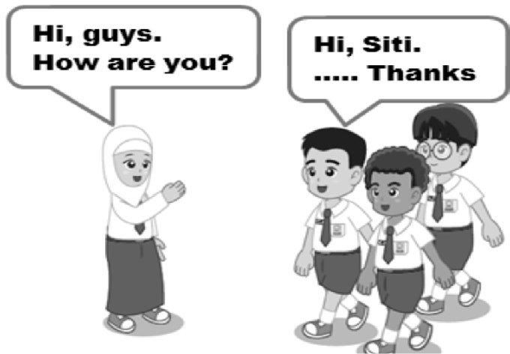

  - The best expression to complete the dia- log is ...
    - I am good
    - We are fine
    - It is no problem
    - You are welcome

The text is for questions 4 and 5.
Tyas : Hello, Ratih. (4) ?
Ratih : Hi, Tyas. I'm doing Ok. And you?
Tyas : As you see, I'm very well. Do you still study from home?
Ratih : Sure, I do. By the way I have to go home now.
Tyas : Ok. (5) ....
Ratih : Bye. Just keep your health.

4. ....
- Who are you
- How do you do
- Who is going with you
- How is everything with you
5. ....
- Don't mention it
- It's my pleasure
- Good bye
- So do we

The dialog is for question 6.
Messi : Dad, may I accompany mother going to market
Father : Sure. But you have to wear your mask
Messi : Okay, Dad. (6) ....
Father : You're welcome
6. ....
- Good bye
- I'm sorry
- See you
- Thanks

The dialog is for question 7.
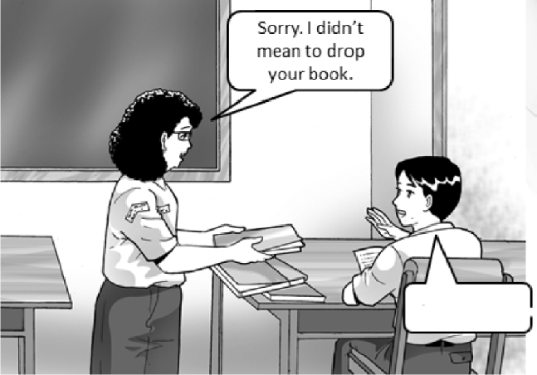

- The best expression to complete the dia- log is ....
  - It doesn't matter
  - See you later
  - Pretty well
  - Not at all

The dialog is for question 8.
Bucin : Please forgive me, Kusut. Kusut : ....
8. ...
- See you.
- It's okay.
- I don't know.
- You're welcome.

The dialog is for question 9.
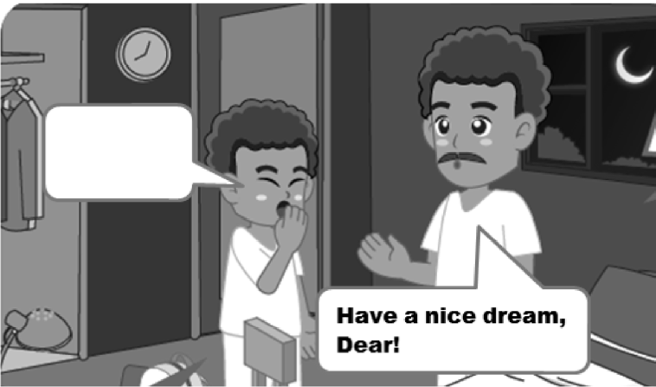

- The best expression to complete the dialog is ...
  - Good job, Dad.
  - Good bye, Dad.
  - Good night, Dad.
  - Good evening, Dad.

The dialog is for question 10.
Heico : Hi, Rio. Long time no see. How are things?
Rangga : (10) ... How about you? Heico : Just fine. Thanks.

10. ….
- I see.
- Not too bad.
- Never mind.
- Nice to meet you.

The dialog is for question 11.
Nindy : Samsu, I would like to introduce Rintan to you. She is my cousin.
Rintan, this is Samsu. He is my classmate.
Rintan : How do you do?
Samsu : (11) . Pleased to meet you Rintan : Pleased to meet you too, Samsu.

11. ….
- How do you do
- I am feeling well
- Very well, thanks
- See you tomorrow

This dialog is for questions 12 - 14
Cantik : Hello, Happy. How is it going? Happy : (12)
Cantik : Why? What is the matter? Happy : (13)
Cantik : Get well soon! Happy : (14)

- The best answer for number 12 is .…
  - I am feeling unwell
  - I am feeling great
  - I am feeling fine
  - I am good

- The best answer for number 13 is ….
  - It's okay
  - Very well
  - Just so good
  - I have got fever

- The most suitable answer for number 14 is ….
  - No, thanks.
  - I am grateful
  - I don't need it
  - Nice to meet you

This dialog is for questions 15 and 16
Iyan : Oops (15) ! I broke your face shield
Amar : Never mind. I still have another one in my drawer

- The best answer for number 15 is …
  - Thanks for the shield
  - I don't have a shield
  - Excuse me
  - I am sorry

- Iyan is probably Amar's …
  - son
  - uncle
  - classmate
  - brother in law

The text is for questions 17 and 18.
Elisa : Hello. Elisa is speaking. Rahma : Hello Elisa. How's life?
Elisa : I am good. What are you doing?
Rahma : I'm staying at home. I'm studying online. How about you?
Elisa : So am I. How is your online study- ing?
Rahma : Not so well. I still like face-to-face learning.
Elisa : I do. I miss our teachers and classmates.

- Where does the text probably takes place?
  - At home
  - At phone
  - At school
  - In test room

- Are Elisa and Rahma studying online?
  - Yes, she is
  - Yes, they are
  - No, she isn't
  - No, they aren't

- Arrange the following words into a good sentence.
Thank - ruler - me - for - you - borrowing - 1 2 3 4 5 6
the 7
A. 1 - 5 - 4 - 6 - 3 - 7 - 2
B. 1 - 5 - 4 - 7 - 2 - 6 - 3
C. 1 - 5 - 4 - 6 - 2 - 7 - 3
D. 1 - 5 - 4 - 7 - 3 - 6 - 2

- Arrange the following sentences into a good dialog.
- Very well, Ma'am. What about you?
- Morning, Sekar. How are you doing?
- Good morning, Ma'am.
- I'm fine. Thank you.
A. 3 - 2 - 4 - 1
B. 3 - 4 - 1 - 2
C. 3 - 2 - 1 - 4
D. 3 - 4 - 2 - 1

The text is for question 21.
Mila : Hi, My name is Kamila Insania.
You can call me Mila.
Dian : Hi, Tiara. I am Dian Indah. My nick- name is Dian. Glad to meet you Mila.
Mila : It is glad to meet you too.

- The underlined expression is the way how Mila … herself.
  - asks
  - greets
  - apologizes
  - introduces

- The best expression to complete the text is ....

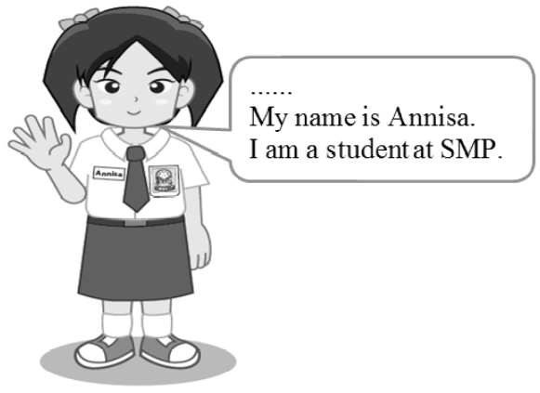

  - Good morning. I have a name
  - I'd like to introduce myself
  - You want to know me
  - Hi, guys. Here is me

The text is for questions 23 - 25.
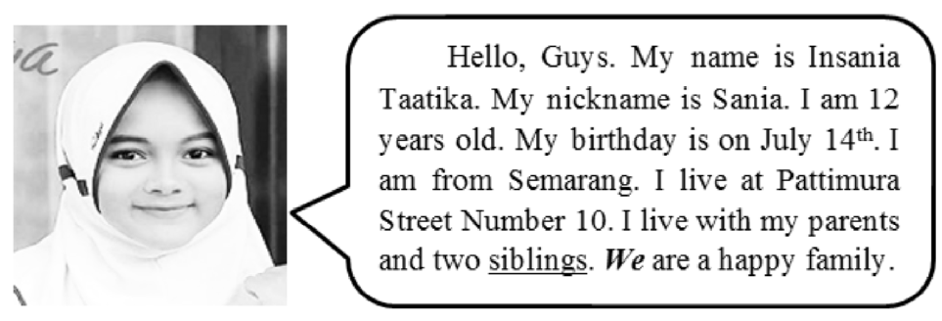

- What is the girl's call name?
  - Insania Taatika
  - Taatika
  - Insania
  - Sania

- "I live with my parents and two siblings". The underlined word means ....
  - grandpa and grandma
  - mother and father
  - brother and sister
  - uncle and aunt

- "We are a happy family" The italic word refers to ….
  - the writer
  - the family
  - Sania and her family
  - Sania's parents and siblings

The text is for question 26.
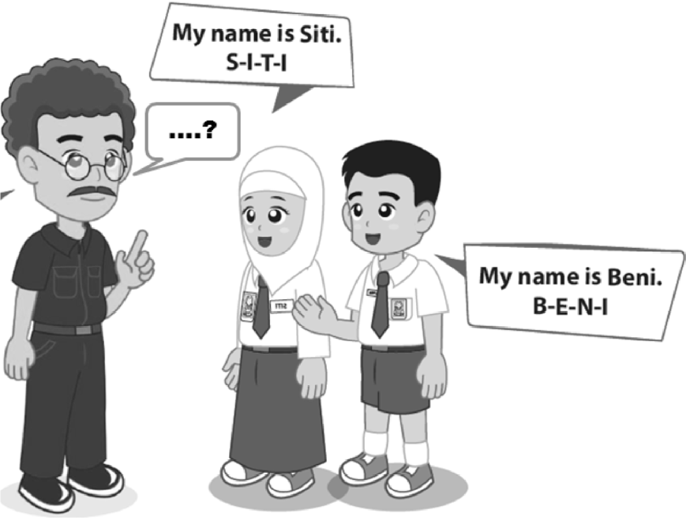

- The best expression to complete the dia- log is ....
  - How do you spell your name
  - Who is your name, students
  - Is your name Siti and Beni
  - My name is Mr. Rully

The text is for questions 27 and 28.
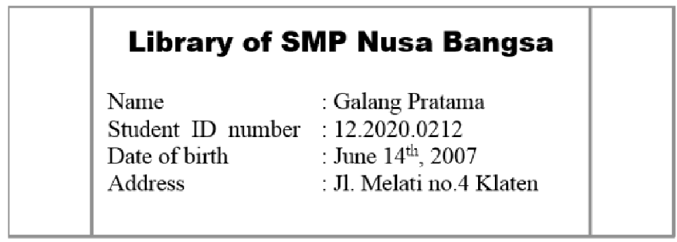

- How old is Galang now?
  - 12 years old
  - 13 years old
  - 14 years old
  - 15 years old

- Where does he live? He lives …
  - Jl. Melati no 4 Klaten
  - in Jl. Melati no 4 Klaten
  - at Jl. Melati no 4 Klaten
  - on Jl. Melati no 4 Klaten

The text is for questions 29 - 31.
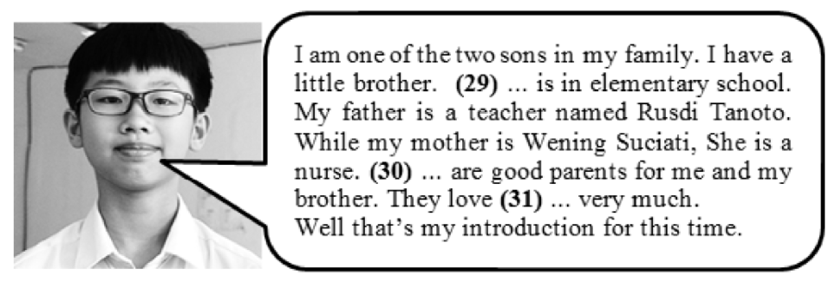

29. ….
    - I C. We
    - He D. She

30. ….
- They C. She
- You D. We

31. ….
- us C. him
- me D. them

The dialog is for question 32.

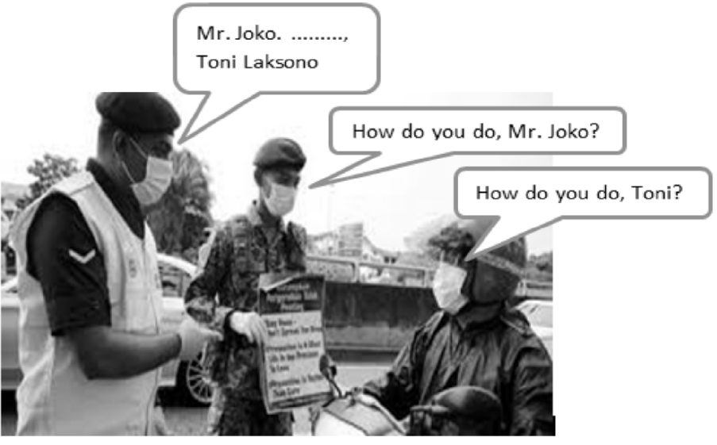

The dialog is for questions 34 and 35.
Fara : I saw your mother in Islam Hospital yesterday. Who was sick?
Fikri : Oh … no one. My mom works there.
Fara : Really?
Fikri : Exactly. She takes care the covid- 19 patients. How about your mom?
Fara : She takes care us at home.

- Based on the dialog, what does Fikri's mother do?
She is a ….
  - surgeon C. doctor
  - dentist D. nurse

- "She takes care us at home" The underlined word refers to….
  - Fara
  - Fikri
  - Fara's mother
  - Fikri's mother

The dialog is for question 36.
Calista : What are you doing in your spare time, Marcel?
Marcel : Well, (36)….
Calista : Wow...you are good racer. Marcel : I don't think so.
It's my way on keeping my health during the Covid 19 pandemic.

- The best expression to complete the dia- log is ...
  - He is your son
  - This is my son
  - You know him
  - My name is Toni

The dialog is for question 33.
Della : Dinda, (33) ....
Dinda : Pleased to meet you. Kirana : Pleased to meet you, too.

33. ....
- Kirana wants to meet you
- Don't you know Kirana, my friend
- Please introduce yourself to Kirana
- I'd like you to meet my friend, Kirana
36. ....
- I love travelling
- I like playing games
- I am fond of riding bike
- I like to cook tasty food

The dialog is for questions 37 and 38.
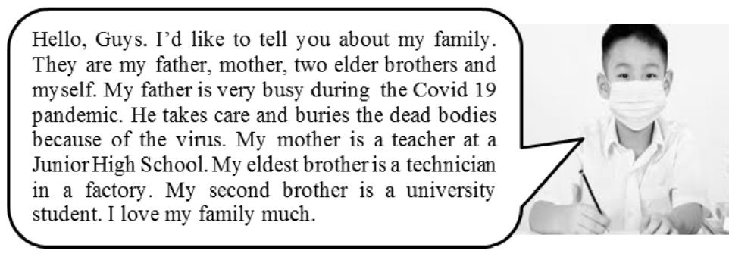
- How many members are in the writer's family?
  - 4 C. 6
  - 5 D. 7

- What is the writer father's job actually? He is a/an ....
  - oculist C. undertaker
  - virologist D. pediatrician
- introduce - me - allow - myself - 1 2 3 4
everyone - to - hello 5 6 7
What is the best arrangement of the words?
A. 7 - 5 - 3 - 2 - 6 - 1 - 4
B. 7 - 5 - 2 - 3 - 6 - 1 - 4
C. 7 - 4 - 3 - 2 - 6 - 1 - 5
D. 7 - 4 - 1 - 2 - 6 - 3 - 5

III. Essay
- Arrange the following sentences into a good dialog.
- I live at No. 5 Jl. Kenari Klaten.
- My name is Bunga Cinta Lestari
- My hobbies are reading, watching TV, and cooking.
- Good morning, my friends.
- I was born in Klaten on 21st March 2008.
- I would like to introduce myself.
- That's all, thank you.
A. 6 - 2 - 5 - 1 - 3 - 4 - 7
B. 6 - 2 - 1 - 5 - 3 - 4 - 7
C. 4 - 6 - 2 - 1 - 5 - 3 - 7
D. 4 - 6 - 2 - 5 - 1 - 3 - 7

- Complete the dialog below with the suitable expression Cinta : Good afternoon, Maam.
Mrs. Lila : (a) How's life?
Cinta : (b) , Maam. Thanks. And you?
Mrs. Lila : Very well. Thank you. Sorry, I have to go now.(c) , Cinta. Cinta : Bye, Maam. (d)
Mrs. Lila : See you.
- Complete the dialog below with the suitable expression Roni : (a) , Sir. I'm late.
Mr. Prapto : (b) , but don't do it again next. Roni : All right. (c) , Sir
Mr. Prapto : (d)
- Match the following statements in column A with the correct responses in column B!

A |  | B
1. How is everything? | (....) | a. Never mind
2. Take care | (....) | b. Don't mention it
3. Good night | (....) | c. Nice to meet you
4. Thanks a lot | (....) | d. Thank you
5. I am so sorry | (....) | e. Have a nice dream
 |  | f. Very well
- Fill in the blank with the suitable words!
Good morning every body. I would like to (a) myself. My name is Samudra Very Putra. People usually call me Sam. I (b) Diponegoro Street Number 20, with my parents and two siblings. My father is a worker. My mother is a teacher at a Junior High School. My eldest brother is a technician in a factory. My second brother is a university (c) . I love my family much.I love (d) books, especially Science Fiction. I usually play games with my siblings. I love spending time with (e) . That's all and thank you.
- Rearrange the following jumbled words into a meaningful sentence!
  - Mahardika - me - you - I - Dika - can - am - call
  - am - first - I - in - child - the - family - my


