IoT Assistant

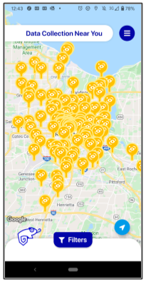
BACKGROUND
"Our research has shown that most people have little awareness about the amount of data collected today by IoT technologies," Norman Sadeh, a CyLab faculty member in Carnegie Mellon's Institute for Software Research and the principal investigator on the project, told CNET. "It also shows that many people would like to be better informed about the collection and use of their data by these technologies, especially in contexts where they don't expect this to happen. In addition, many of them would like the option to possibly opt in or out of some practices."

DESCRIPTION
We will be using the IoT Assistant from Carnegie Mellon. According to their website, there are tracking mechanisms such as “public cameras with facial recognition and scene recognition capabilities, Bluetooth beacons surreptitiously tracking your whereabouts at the mall, or your neighbor’s smart doorbell or smart speaker. The IoT Assistant app will let you discover the IoT devices around you and learn about the data they collect. If the device offers privacy choices like opting in or out of data collection, the app will help you access these choices.”
For a more detailed explanation, you can check out the YouTube informational video:
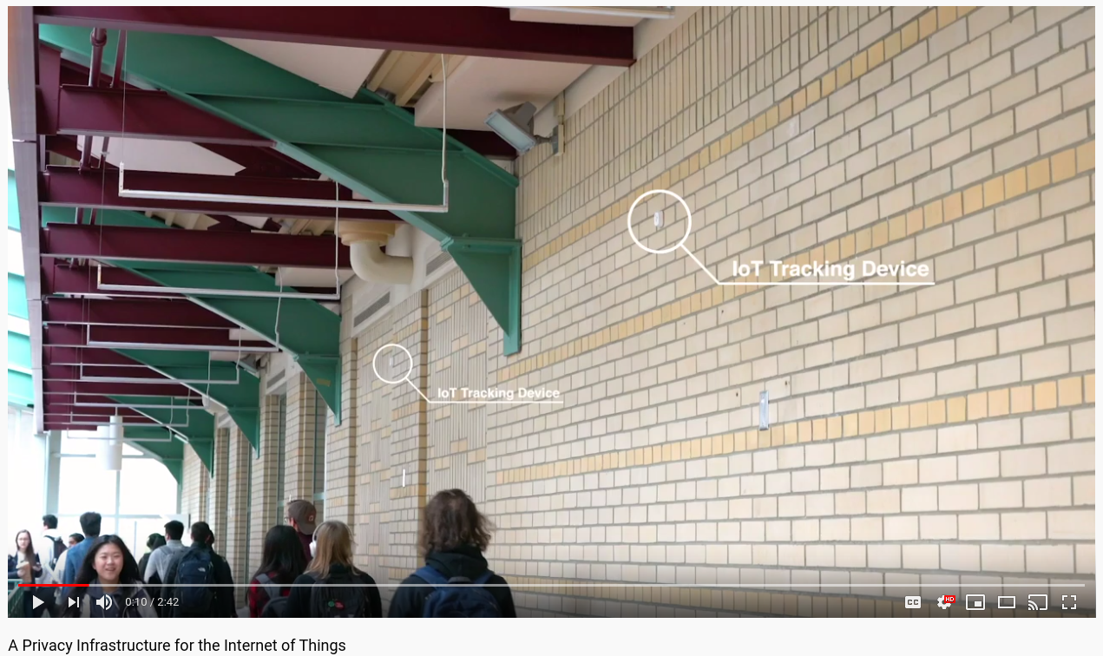
https://www.youtube.com/watch?v=Q34eRGwyUQo

REQUIREMENTS
You will need a smartphone (apps are available at the iOS app store and the Google Play Store). If you have a Chromebook, you can also use the Google Play Store to install the app. Alternatively, you can run the software from their website:
https://www.iotprivacy.io/login
NOTE: Read the terms of service before installing this app. If you are uncomfortable sharing your anonymized information with Carnegie Mellon, then do not proceed. This app grows more accurate when the data is crowdsourced.

PART I: Download and install IoT Assistant
- Download and install IoT Inspector.
Apple | Android | Desktop Website
- Go through the installation process. Be sure to read the privacy agreement.
- Note that you can also create and access your account here:
https://www.iotprivacy.io/login

PART II: Check the list of devices
- Find a device on the map. You may not be able to find a device near you (the app relies on users to report the data, and this is a relatively new app). If you cannot find a device, search for one in a bigger city; you are likely to find a lot of devices near densely populated areas.
  - NOTE: If you are using the website version, you may have to CREATE a resource since SEARCHING for resources might not be available on the website version; any created resource will NOT be published by default
- If you wish, you can filter by device type (visual data, audio data, location data, etc.).
- If you know of a device that is not listed, you can add to their database here:
https://www.iotprivacy.io/resource

EVIDENCE #1
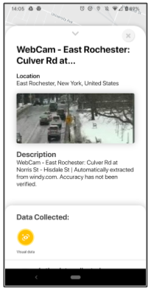
PASTE THE IMAGE OF THE RESULTS OF USING IoT ASSISTANT TO DISCOVER A DEVICE.
[FEEL FREE TO OBSCURE PRIVATE INFORMATION]

- Find out what kind of data is collected and how it is managed by scrolling up on the information card for the device you’ve chosen.

EVIDENCE #2
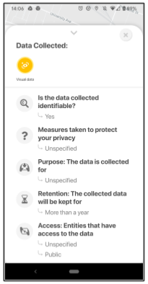
PASTE THE IMAGE OF THE DATA THAT IS SHARED AND HOW IT IS USED
[FEEL FREE TO OBSCURE PRIVATE INFORMATION]

New infrastructure will enhance privacy in today’s Internet of Things
This app lets you see IoT devices around you and what data they're taking

