Article titles should be concise and informative
RESEARCH ARTICLE

Riset Geologi dan Pertambangan (2026) Vol. XX, No. X, XX-XX
DOI: XX.XXXXX/risetgeotam.XXXX. XXXX

Keywords:
Keyword 1
Keyword 2
Keyword 3
Keyword 4
Keyword 5

Corresponding author:
Name of Author
email@domain.com

Article history:
Received: XX XXX 2026
Revised: XX XXX 2026
Accepted: XX XXX 2026

Author Contributions: Conceptualization: XXX
Data curation: XXX
Formal analysis: XXX
Funding acquisition: XXX Investigation: XXX
Methodology: XXX
Supervision: XXX
Visualization: XXX
Writing – original draft: XXX
Writing – review & editing: XXX

Citation:
Authors, 2026. Title of the manuscript. Ris.Geo.Tam., XX, XX, doi: XX.XXXXX/risetgeotam.XXXX.XXXX

©2026 The Author(s). Published by National Research and Innovation Agency (BRIN). This is an open access article under the CC BY-SA license
(https://creativecommons.org/licenses/by-sa/4.0/).


First Author¹, Second Author², Third Author², etc
¹First Affiliation, address, Country
²Second Affiliation, address, Country
NOTES: The author list and order are final and cannot be changed. Please ensure that the complete metadata for all authors is entered in the submission system.

Abstract
The abstract should be concise and informative, and must not exceed 250 words. Avoid including figure numbers, table numbers, references, or mathematical expressions. Refrain from using symbols or special characters. Uncommon abbreviations should be avoided. However, if their use is essential, they must be clearly defined upon their first mention in the abstract.

- Introduction
Briefly introduce the general topic and provide background information to help the reader understand the context and significance of your research. Clearly state the specific problem or research question that your paper addresses. Summarize relevant previous research and highlight the gaps or limitations. Clearly outline the main objectives of your research.
- Geologic setting
Provide a brief overview of the geologic setting of the area. Include maps, cross-sections, and other figures to help illustrate the geologic features of the area. Make sure to cite relevant sources and provide clear, concise explanations.
- Data and methods
Describe where and how you obtained your data. Explain the criteria and methods used for selecting samples. List any tools or instruments used to collect data.
  - Data
  - Method
Outline the overall design of your study. Detail the step-by-step procedures followed during the experiment. Mention any software tools or programs used for data analysis. Discuss any potential limitations or biases in your study. Cite any established methods followed.
- Results
This section should be focused on presenting the data and findings clearly and concisely. All maps need to be accompanied with graphical scale, geographical coordinates, compass rose. Insert one blank line between the previous paragraph and the top of a figure, table, or equation, as well as between the bottom of an equation or figure/table caption and the following paragraph.
4.1 XXX
Ensure that all figures and tables are cited in the main text as Figure 1, Table 1, etc. Include figures in the manuscript file as bitmap images in .jpg or .tiff formats. Any references cited within your article (Anggono et al., 2020; Kopp and Kukowski, 2003) should also be present in your reference list and vice versa.
Table must be created using Word's table tool (not as bitmaps) and included in the manuscript.
Table 1. Text
Xxx | Xxx | Xxx | Xxx | Xxx
Xxx
Xxx
Xxx
4.2 XXX
Each figure should have a concise caption describing accurately what the figure depicts.
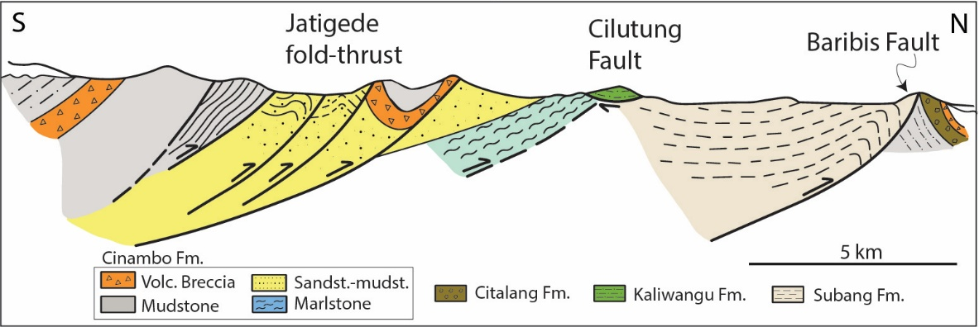
Figure X. A caption should consist of a brief title and a description of the image. We advise you to keep the amount of text in any image to a minimum, though any symbols and abbreviations used should be explained.

- Discussion
The discussion should provide a thoughtful and in-depth analysis of your results, placing them within the larger context of your research field.
- Conclusions
In essence, the conclusion ties together the entire paper, reinforcing the key points and offering a forward-looking perspective. Concisely recap the main findings of your research.
Acknowledgments
Include any individuals helped you during your research and institution provided funding in the acknowledgements section.
Declaration of generative AI and AI-assisted technologies in the manuscript preparation process
During the preparation of this manuscript, the authors used XXX and YYY to improve language’s clarity, readability, and overall organization of the text. After using these tools, the authors reviewed and edited the content as needed and take full responsibility for the published article.

References
Riset Geologi dan Pertambangan follows Earth and Planetary Science Letters (Elsevier) guidelines for its citation and reference style.
(Prakusya et al., 2026)
For journal articles
Anggono, T., Syuhada, S., Febriani, F., Handayani, L., Mukti, M.M., Amran, A., 2020. Crustal shear-wave velocity structure in Western Java, Indonesia from analysis of teleseismic receiver functions. J. Earth Syst. Sci. 129, 6. https://doi.org/10.1007/s12040-019-1288-1
Kopp, H., Kukowski, N., 2003. Backstop geometry and accretionary mechanics of the Sunda margin. Tectonics 22, 11-1-11–16. https://doi.org/10.1029/2002TC001420
Prakusya, F.R., Prassetyo, S.H., Wattimena, R.K., 2026. Numerical Analysis to Determine Squeezing Potential of Deep Tunnel. Ris.Geo.Tam 36, 73. https://doi.org/10.55981/risetgeotam.2026.1410

For books
Koesoemadinata, R.P., 2025. An Introduction Into The Geology of Indonesia – Volume 1. ITB Press, Bandung, 1052 pp.

For reports
Buszka, P.M., Fargen, C.A., Lampe, D.C., Unthank, M.D., Boldt, J.A., Hian, M.E., 2026. Water-withdrawal and groundwater-level fluctuations, physical and infiltration characteristics of Ohio River sediment, and isotope-based estimates of water sources relative to a riverbank filtration system in an alluvial aquifer, Louisville, Kentucky. U.S. Geological Survey Scientific Investigations Report 2026-5024. https://doi.org/10.3133/sir20265024

For web article
U.S. Geological Survey, 2026. 2025 Puerto Rico and U.S. Virgin Islands Long-term National Seismic Hazard Model. https://www.usgs.gov/programs/earthquake-hazards/science/2025-puerto-rico-and-us-virgin-islands-long-term-national (accessed 9 August 2026).

